

Requirement & Design Specification

**Agricultural Warehouse Management System**

###### Version: 1.4

– Hanoi, August 2025 –

# Record of Changes

| **Version** | **Date** | **A* M, D** | **In charge** | **Change Description** |
| --- | --- | --- | --- | --- |
| 1.1 | 17/07 | A | QuangDN | Add and using RDS form |
| 1.2 | 25/07 | A | QuangDN, AnhNH | Add UC Requirement , Functional Requirement, Context Diagram, |
| 1.3 | 1/8 | A,M | QuangDN, HoangDH, ThanhHV, ChienNX, AnhNH. | Add System Functional, BR, Modifiel UC Requirement, Functional Requirement |
| 1.4 | 3/8 | A,M | QuangDN, HoangDH, ThanhHV, ChienNX, AnhNH. | Add Database Design, Code package , Modifiel UC Requirement, Functional Requirement |

*A - Added M - Modified D - Deleted

Contents

Record of Changes 2

I. Overview 6

1. System Context 6

2. User Requirements 7

2.1 Actors 7

2.2 Diagrams 9

2.3 Descriptions 14

2.4 Business Rule 16

3. System Functionalities 24

3.1 Screens Flow 24

3.2 Screen Authorization 24

3.3 Non-UI Functions 26

II. Functional Requirements 27

1. User 27

1.1 Register 27

1.2 Login 34

1.3 Forgot password 38

1.4 HOME PAGE 43

1.5 Shop 47

1.6 Product detail 51

1.7 Cart 56

1.8 Checkout 60

1.9 Map 64

1.10 Order detail 68

1.11 Invoice 74

1.12 Profile 77

1.13 Wish list 83

1.14 Compare product detail 87

1.15 Contact us 89

2. Blog 93

2.1 View Blog List 93

2.2 View Blog Grid 97

2.3 View Blog Detail 101

2.4 View Blog Manager 104

2.4.1 View Dashboard 104

2.4.2 View Dashboard 107

2.4.3 Add blog for user 110

2.4.4 Edit blog for user 116

2.5 View Blog Manager Admin 122

3. Shipper - delivery manager 126

3.1 View Dashboard shipper 126

3.2 Shipper Profile Management 130

3.3 Shipper Order Management 134

4. Seller Dashboard 140

4.1 Profile Management 143

4.2 Product Management 147

4.3 Product Detail Management 162

4.4 User Order Management 173

5. Become To Seller 178

5.1 Seller Registration Form 181

5.2 Seller Application Management 187

6. Product Batch Management 192

6.1 View Product Batch List 192

6.2 View Adjustment List 211

6.3 Create ProductBatch 220

7. Supplier Management 223

7.1 View List Supplier 223

7.2 Add Supplier 226

7.3 Update Supplier 229

7.4 Delete Supplier 233

8. Warehouse StockIn Management 235

8.1 View List Warehouse StockIn 235

Screen description 235

8.2 View List Warehouse StockIn Detail 242

8.3 Add Stockin Receipts 253

9. Warehouse Stock Out Management 259

9.1 View List Stock Out 259

9.2 View List StockOut Detail 262

10. Category Management 265

10.1 View List Category 265

10.2 Edit Category 270

10.3 Delete Category 274

11. Product Management 276

11.1 View List Product 276

11.2 Add New Product 280

11.3 Edit Product 283

12. Role Management 287

12.1 View List Role 287

12.2 Add New Role 290

12.2 Edit Role 293

12.2 Assign Role to User 295

13. User Management 299

13.1 View List User 299

13.2 View User Detail 303

13.3 Add New User 306

13.4 Update User Information 311

14. Voucher Management 315

14.1 View List Voucher 315

14.2 Create New Voucher 318

14.3 Edit Voucher 323

15. Order Management 327

15.1 View List Order 327

15.2 View Order Detail 330

15.3 Update Order Status 335

16. Forgot Password Management 338

16.1 Forgot Password 338

16.2 Verify OTP for Password Reset 341

16.3 Reset/Change Password 344

17. Contact User Management 348

17.1 View List Contact 348

18. Admin DashBoard Management 351

18.1 Admin DashBoard 351

18.2 View latest notifications 353

19. Warehouse DashBoard 357

19.1 Warehouse DashBoard 357

III. System Design 362

1. Database Design 362

1.1 Database Schema 362

1.2 Database ERD 362

1.3 Table Descriptions 362

2. Code Packages 363

2.1 Package Diagram 363

2.2 Package Descriptions 364

# **I. Overview**

## **1. System Context**

## **The Agricultural Warehouse Management System** is a new software solution designed to streamline the management of agricultural product storage and distribution. It replaces traditional manual processes and scattered systems by integrating key functions such as inventory tracking, stock-in/stock-out processing, and user account management into a unified platform. The context diagram below illustrates the external entities and system interfaces for the initial release. As the system evolves, it is expected to incorporate advanced features to improve scalability, traceability, and performance.

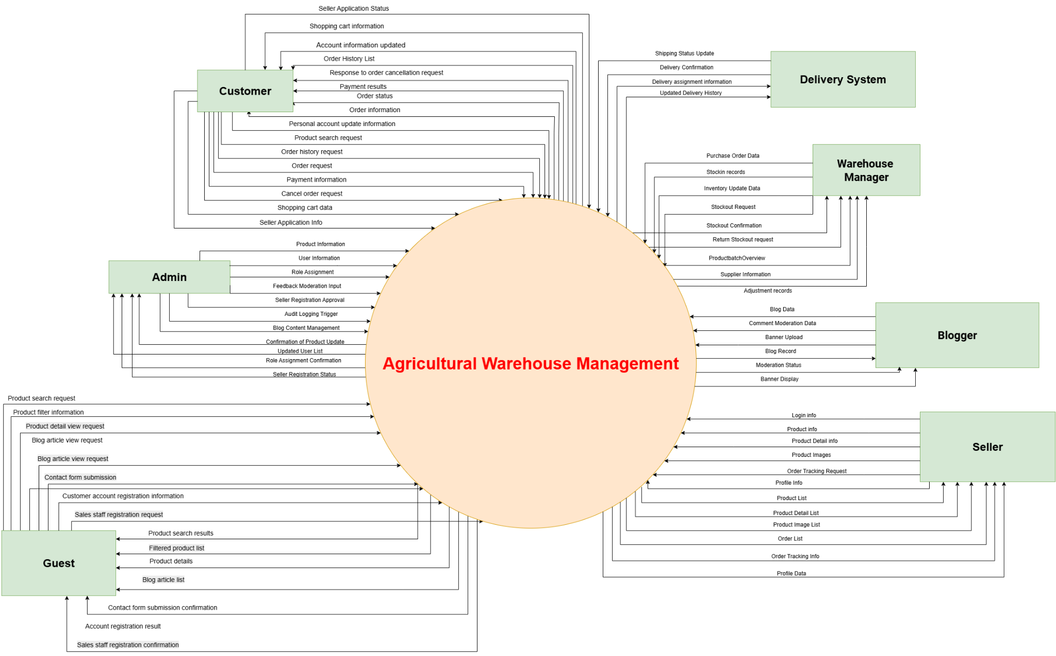

Figure 1.1 - Context diagram of Agricultural Warehouse Management System

## 

## 

## 

## **2.** **User Requirements**

### **2.1** **Actors**

| **#** | **Actor** | **Description** |
| --- | --- | --- |

| 1 | Administrator | Manage the entire system, including users, products, categories, suppliers and orders. In addition, handle user account registration requests and confirm orders. They can assign permissions to other actors in the system. In addition, they can view the revenue and total expenditure statistics of the entire system.Finally, manage pricing and promotion policies to optimize business performance. |
| --- | --- | --- |
| 2 | Customer | Customers are wholesale warehouse owners who can purchase products in bulk at wholesale prices. They can apply vouchers during promotional events to receive additional discounts. In addition, they can place an order, purchase history and have the option to contact sellers directly to negotiate better pricing or receive special offers. |
| 3 | Warehouse Staff | Warehouse staff can perform inventory checks, update actual stock counts into the system, report warehouse-related issues, support stock-in and stock-out management, adjust inventory levels, add new supplier information, and manage product batches. |
| 4 | Seller | The Seller is responsible for managing product information and handling order confirmation. They can add products and product details to the system, allowing the Warehouse Manager to manage stock based on seller inputs. When an order is created, the Seller monitors its status and confirms it (e.g., changes from *Pending* to *Confirmed*), which authorizes the Warehouse Manager to proceed with stock out operations. This ensures that only verified and agreed-upon orders are processed. |
| 5 | Bloger | Users (Blogs) can perform CRUD operations (Create, Read, Update, Delete) on blog posts and view blogs along with comments. Admins can manage blogs, perform CRUD actions on posts, delete inappropriate content, and manage user permissions. Additionally, Admins can configure system settings for blogs and monitor user activity. |

|  |  | updates the order status so that the system can provide tracking information to Customers and related departments. |
| --- | --- | --- |
|  | Delivery Staff | The Delivery Staff is responsible for handling the physical delivery of products and updating the status of orders accordingly. Once the Warehouse Manager completes the stock out process, the Delivery Staff picks up the products and delivers them to the designated recipients (e.g., buyers, distribution centers). They track delivery progress and update order statuses such as "Out for Delivery", "Delivered", or "Delivery Failed" in the system. This ensures that stakeholders are informed of the delivery process and that records are accurately maintained. |

Table 1 - Types of users

### **2.2 Diagrams**

#### 2.2.1 UCs for Customer

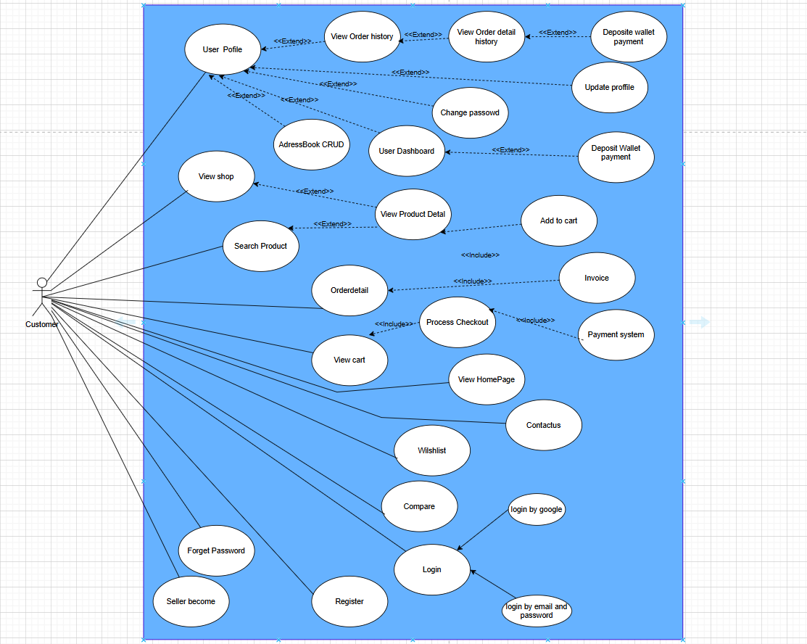

Figure 1.2 - Use case diagram for Customer

#### 2.2.2 UCs for Admin

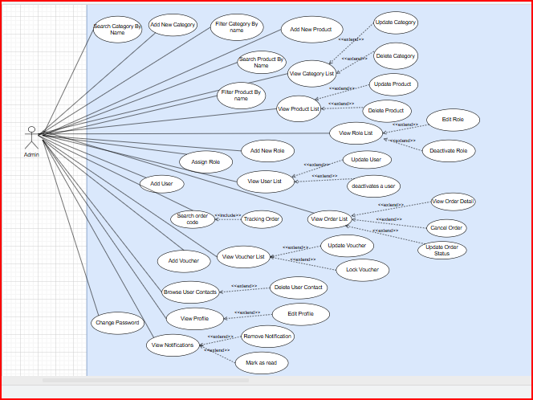

Figure 1.3 - Use case diagram for Admin Administrator

#### 2.2.3 UCs for Seller

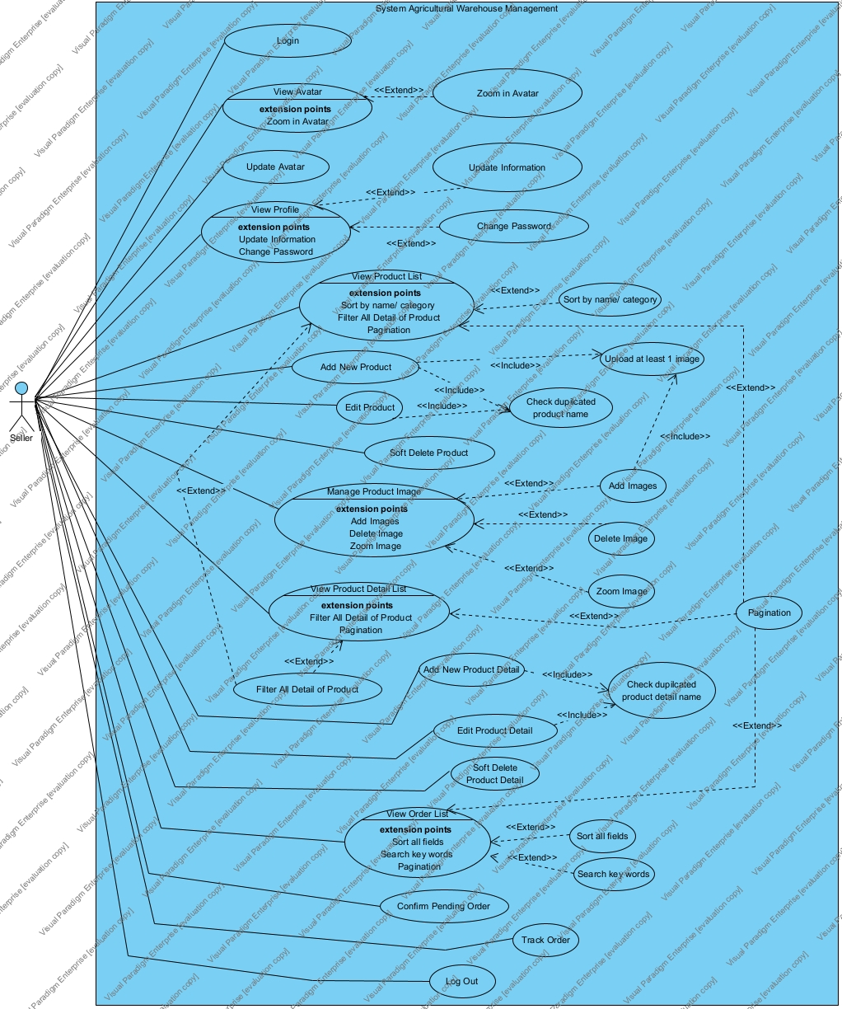

Figure 1.4 - Use case diagram for Seller

#### 2.2.4 UCs for Blogger

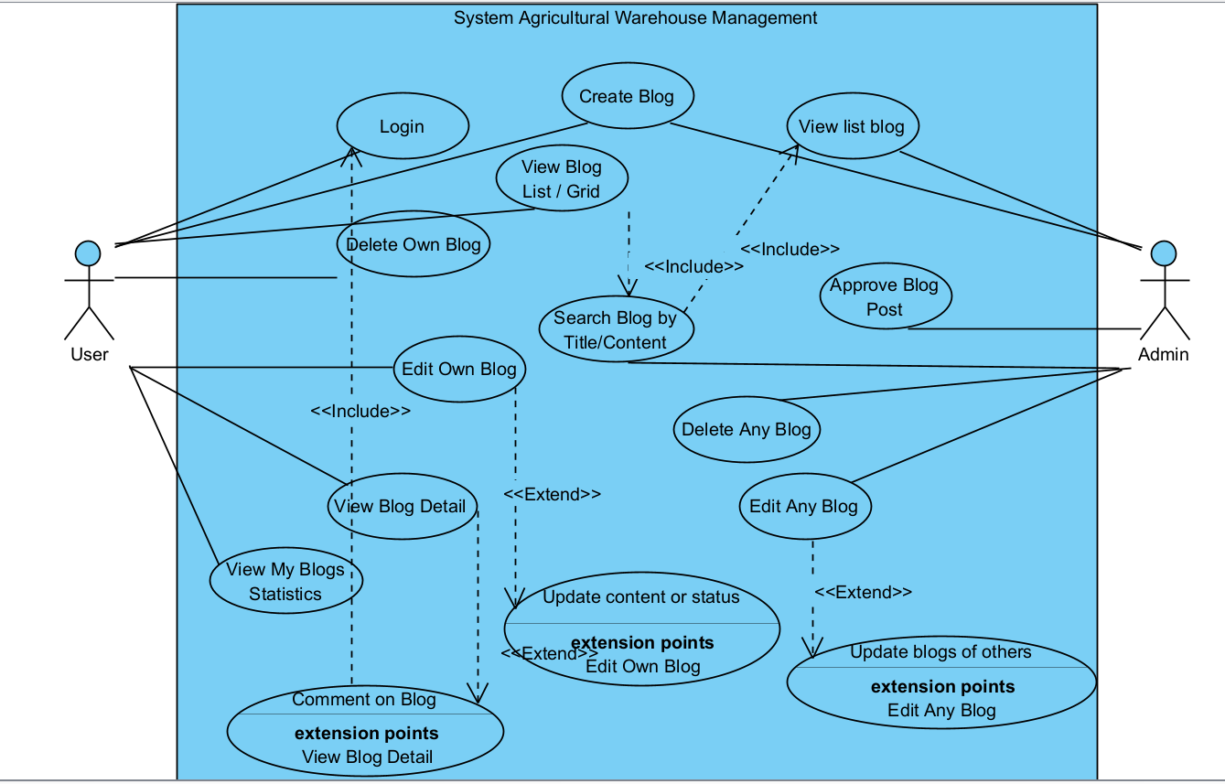

Figure 1.5 - Use case diagram for Blogger

#### 2.2.5 UCs for Warehouse Manager

#### 

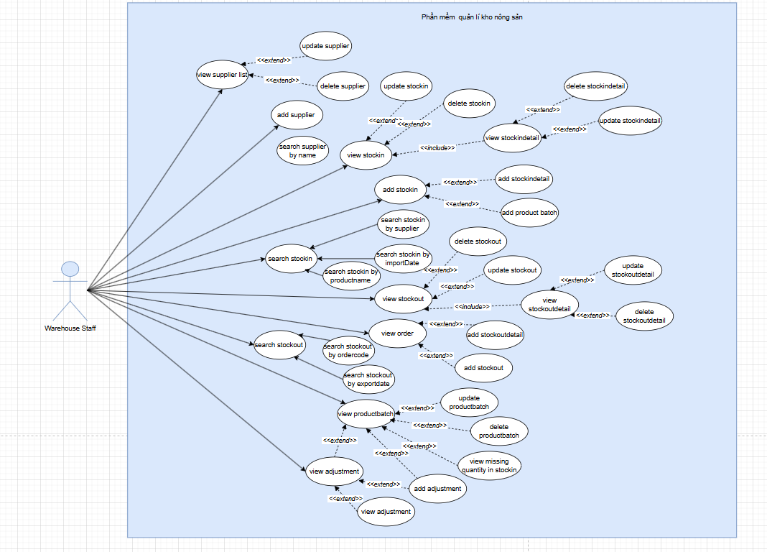

Figure 1.6 - Use case diagram for Admin Administrator

#### 2.2.6 UCs for Delivery Manager

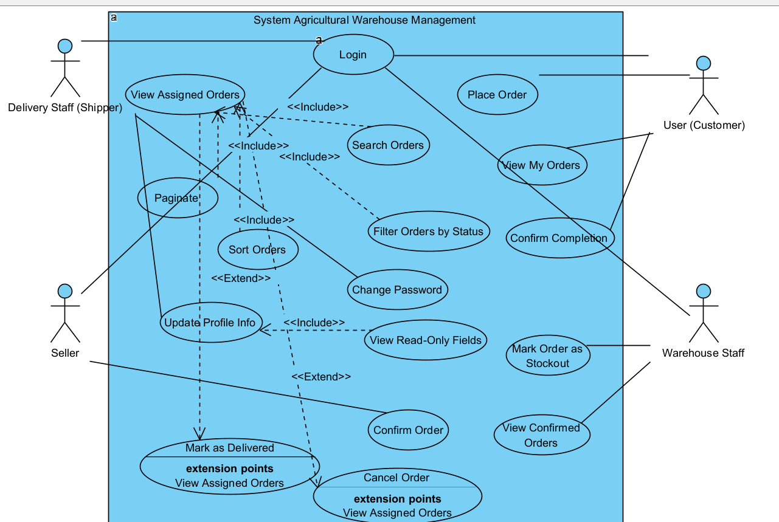

Figure 1.7 - Use case diagram for Delivery Staff

### **2.3 Descriptions**

| **ID** | **Use Case** | **Actor(s)** | **Use Case Description** |
| --- | --- | --- | --- |
| 1 | Add stockIn | Warehouse Manager | As a Warehouse Manager, I want to create a new stock-in record with supplier and product batch, so that I can track incoming inventory accurately. |
| 2 | View StockIn | Warehouse Manager | As a Warehouse Manager, I want to view the list of all stock-in records, so that I can monitor and manage stock receipts. |
| 3 | Update StockIn | Warehouse Manager | As a Warehouse Manager, I want to modify existing stock-in information, so that any errors or changes can be corrected.. |
| 4 | View StockIn Detail | Warehouse Manager | As a Warehouse Manager, I want to see detailed product information of a stock-in record, so that I can verify the accuracy of each item received. |
| 5 | Update StockIn Detail | Warehouse Manager | As a Warehouse Manager, I want to edit product quantity, price, or information in a stock-in detail, so that I can ensure correct inventory and financial records. |
| 6 | View StockOut | Warehouse Manager | As a Warehouse Manager, I want to see the list of all stock-out transactions, so that I can keep track of outgoing inventory. |
| 5 | Add StockOut | Warehouse Manager | As a Warehouse Manager, I want to create a new stock-out record based on confirmed orders, so that items can be dispatched appropriately. |
| 6 | View Stockout  Detail | Warehouse Manager | As a Warehouse Manager, I want to view detailed information of a stock-out record, so that I can confirm which items were issued. |
| 7 | Return Stockout | Warehouse Manager | As a Warehouse Manager, I want to handle and record the return of stock-out items, so that I can update inventory levels accurately. |
| 8 | View ProductBatch | Warehouse Manager | As a Warehouse Manager, I want to display all existing product batches, so that I can manage inventory by batch.. |
| 9 | Update ProductBatch | Warehouse Manager | As a Warehouse Manager, I want to modify the details of an existing product batch, so that any incorrect information can be corrected. |
| 10 | Add ProductBatch | Warehouse Manager | As a Warehouse Manager, I want to create a new batch entry for a product, so that I can track items accurately by batch. |
| 11 | Remove Product Batch | Warehouse Manager | As a Warehouse Manager, I want to delete an existing product batch from the system, so that obsolete or erroneous batches are removed. |
| 12 | View Supplier | Warehouse Manager | As a Warehouse Manager, I want to view the list of all suppliers in the system, so that I can identify sources of my inventory. |
| 13 | Update Supplier | Warehouse Manager | As a Warehouse Manager, I want to edit the information of an existing supplier, so that I can maintain up-to-date contact and business records. |
| 14 | Add Supplier | Warehouse Manager | As a Warehouse Manager, I want to add a new supplier to the system, so that I can expand my procurement network. |
| 15 | Remove Supplier | Warehouse Manager | As a Warehouse Manager, I want to delete a supplier record from the system, so that outdated or unused suppliers are no longer listed. |
| 16 | View Adjustment | Warehouse Manager | As a Warehouse Manager, I want to view all stock adjustment records, so that I can audit changes in inventory quantities. |
| 17 | Add Adjustment | Warehouse Manager | As a Warehouse Manager, I want to create a new stock quantity adjustment, so that I can correct discrepancies in inventory. |
| 18 | Remove Adjustment | Warehouse Manager | As a Warehouse Manager, I want to delete a stock adjustment record, so that invalid or incorrect entries are cleaned up. |
| 19 | Update Adjustment | Warehouse Manager | As a Warehouse Manager, I want to edit an existing adjustment entry, so that I can update the reason or quantity as needed. |
| 20 | View Dashboard | Warehouse Manager | As a Warehouse Manager, I want to view a dashboard with key inventory metrics, recent activities, and system summaries, so that I can quickly assess the overall warehouse status and make informed decisions. |
| 21 | View Product List | Seller | As a seller, I want to view the list of my products so that I can manage them more easily. |
| 22 | Add New Product | Seller | As a seller, I want to add a new product to the system so that I can start selling it. |
| 23 | Edit Product Information | Seller | As a seller, I want to update product details so that information remains accurate and up to date. |
| 24 | Soft Delete Product | Seller | As a seller, I want to mark a product as inactive instead of deleting it permanently so that I can restore it later if needed. |
| 25 | Manage Product Images | Seller | As a seller, I want to upload, remove, and preview product images so that customers see correct visual information. |
| 26 | View Product Detail List | Seller | As a seller, I want to view all the variations (weight/unit) of a product so that I can track inventory more accurately. |
| 27 | Add Product Detail | Seller | As a seller, I want to add new variations (e.g., weight/unit) of a product so that customers can choose based on their needs. |
| 28 | Update Product Detail | Seller | As a seller, I want to update product detail info such as price, expiry, and status so that my stock stays current. |
| 29 | Soft Delete Product Detail | Seller | As a seller, I want to mark product details as inactive so that I can hide outdated items without permanent deletion. |
| 30 | Track All Orders | Seller | As a seller, I want to view all incoming orders so that I can prepare for fulfillment. |
| 31 | Confirm Pending Orders | Seller | As a seller, I want to confirm pending orders so that the system can proceed to shipping and inventory deduction. |
| 32 | View My Seller Profile | Seller | As a seller, I want to view my profile details so that I can verify and manage my personal and business info. |
| 33 | Edit Seller Profile | Seller | As a seller, I want to update my personal information like name, contact, and email so that it reflects changes. |
| 34 | Change Password | Seller | As a seller, I want to securely change my password so that I can protect my account. |
| 35 | Update Avatar | Seller | As a seller, I want to upload and update my profile picture so that buyers can easily recognize my brand. |
| 36 | Apply to Become Seller | User | As a user, I want to submit a registration form to become a seller so that I can sell products on the platform. |
| 37 | Upload CV for Application | User | As a seller applicant, I want to upload my CV and profile so that admins can evaluate my qualifications. |
| 38 | Pay Registration Fee | User | As a seller applicant, I want to complete the registration fee payment so that my application can be approved. |
| 39 | Track Application Status | User | As a seller applicant, I want to see the status of my application so that I know if I’m approved or need to edit anything. |
| 40 | Restore Previous Application | User | As a seller applicant, I want to restore a previously rejected or withdrawn application so that I don’t have to re-enter all data. |
| 41 | Edit Product | Admin | As an admin, I want to edit product details, so that I can update information like name, price, or images when needed. |
| 42 | View Product List | Admin | As an admin, I want to view the list of all products, so that I can manage and monitor the product inventory efficiently. |
| 43 | Delete Product | Admin | As an admin, I want to delete a product, so that I can remove outdated or incorrect products from the system. |
| 44 | View Category List | Admin | As an admin, I want to view all categories, so that I can manage the classification of products. |
| 45 | **Edit Category** | Admin | As an admin, I want to edit category information, so that I can update the names or descriptions as needed. |
| 6 | **Delete Category** | Admin | As an admin, I want to delete a category, so that I can remove unused or irrelevant classifications. |
| 47 | View Role List | Admin | As an admin, I want to view the list of all roles, so that I can manage access permissions within the system. |
| 48 | Edit Role | Admin | As an admin, I want to edit role details like name or description, so that I can reflect organizational changes. |
| 49 | Deactivate Role | Admin | As an admin, I want to deactivate a role if no user is currently assigned to it, so that it cannot be used in the future. |
| 50 | View User List | Admin | As an admin, I want to view the list of all users, so that I can monitor and manage system accounts. |
| 51 | Add New User | Admin | As an admin, I want to add new users, so that I can onboard employees or collaborators into the system. |
| 52 | Edit User | Admin | As an admin, I want to edit user information, so that I can correct or update user details. |
| 53 | Deactivate User | Admin | As an admin, I want to deactivate a user account, so that I can restrict access without permanently deleting data. |
| 54 | View Voucher List | Admin | As an admin, I want to view all available vouchers, so that I can monitor ongoing promotions. |
| 55 | Edit Voucher | Admin | As an admin, I want to edit voucher details, so that I can modify discounts, expiry dates, or usage limits. |
| 56 | Validate Unique Voucher Code & Name | Admin | As an admin, I want to ensure voucher code and name are unique, so that users won’t face conflicts when applying them. |
| 57 | View Order List | Admin | As an admin, I want to view all customer orders, so that I can track transactions and shipping statuses. |
| 58 | View Order Detail | Admin | As an admin, I want to view detailed order information, so that I can verify item quantities, user info, and order status. |
| 59 | Update Order Status | Admin | As an admin, I want to update the order status, so that I can reflect processing, shipping, or cancellation accurately. |
| 60 | Create Blog | User | As a user, I want to create a blog post, so that I can share content on the platform. |
| 61 | Edit Own Blog | User | As a user, I want to edit my blog post, so that I can update its content when needed. |
| 62 | |  | | --- |  | Delete Own Blog | | --- | | User | As a user, I want to soft delete my blog post, so that it won’t appear publicly but can be restored. |
| 63 | View All Blogs (List/Grid) | User | As a user, I want to browse all published blogs, so that I can read content shared by others. |
| 64 | View Blog Detail | User | As a user, I want to see full blog details, so that I can read the entire content and comments. |
| 65 | Comment on Blog | User | As a logged-in user, I want to comment on blog posts, so that I can engage with the content. |
| 66 | Search Blogs by Keyword | User | As a user, I want to search blogs by title or content, so that I can find relevant posts faster. |
| 67 | Track Blog Count & Avatar | User | As a user, I want to see how many blogs I’ve posted and manage my avatar on my dashboard. |
| 68 | Manage All Blogs | Admin | As an admin, I want to view, edit, delete, and update status of any blog, so that I can moderate them. |
| 69 | Filter Blogs by Status | Admin | As an admin, I want to filter blogs by status, so that I can manage content based on workflow stages. |
| 70 | Search Blogs | Admin | As an admin, I want to search blogs by title or content, so that I can locate and review them quickly. |
| 71 | View Assigned Orders | Delivery | As a shipper, I want to see the list of orders assigned to me, so that I can track my deliveries. |
| 72 | Filter Orders by Status | Delivery | As a shipper, I want to filter orders by status, so that I can focus on those I need to handle |
| 73 | Search Orders Realtime | Delivery | As a shipper, I want to search orders by code or phone, so that I can quickly locate a specific order. |
| 74 | Mark Order as Delivered | Delivery | As a shipper, I want to confirm when I deliver an order, so that the system reflects the correct status. |
| 75 | Cancel Order (If Failed) | Delivery | As a shipper, I want to mark an order as cancelled, so that failed deliveries are properly recorded. |
| 76 | Sort Orders by Date | Delivery | As a shipper, I want to sort my orders by order date, so that I can plan deliveries effectively. |
| 77 | View Pagination in Orders | Delivery | As a shipper, I want paginated views of my orders, so that the dashboard remains readable. |
| 78 | Update Profile Info | Delivery | As a shipper, I want to update my personal info (name, phone, gender), so that my profile is up-to-date |
| 79 | Change Password | Delivery | As a shipper, I want to change my password securely, so that I can protect my account. |
| 80 | Logout | Delivery | As a shipper, I want to securely log out, so that my session ends safely. |

Table 2 - User Descriptions

### **2.4 Business Rule**

| **ID** | **Rule Definition** |
| --- | --- |
| BR-01 | Encode Batch ID as Encryption ; fetch batch details and calculate remaining qty |
| BR-02 | Divide data into pages with a fixed number of items |
| BR-03 | Filter data by user input matching any relevant field |
| BR-04 | Sort data by any selected field in ascending or descending order. |
| BR-05 | Redirect to create a new batch. |
| BR-06 | Modify batch data (product, manufacture date, imported quantity). |
| BR-07 | Remove a batch from the system. If don't have in any stockin |
| BR-08 | Add or remove batch quantity with reason and type ( Nhập Thêm / Hủy bỏ). |
| BR-09 | Identify expired batches; allow removal of remaining quantity. |
| BR-10 | Retrieve batch details (product ID, prices, expiry) and adjustment history. |
| BR-11 | Validate inputs (valid date, qty > 0, qty ≤ stock); update via API; refresh data. |
| BR-12 | Create new batch with product detail ID, manufacture date, and imported quantity; encode Batch ID |
| BR-13 | Ensure imported quantity is at least 1. |
| BR-14 | Fetch adjustments (ID, batch ID, quantity, date, reason, type); format dates as HH:mm:ss DD/MM/YYYY; encode batch IDs using related batch data |
| BR-15 | Retrieve batch data (ID, manufacture date) for adjustment formatting. |
| BR-16 | Modify adjustment (batch ID, quantity, reason, type). |
| BR-17 | Remove adjustment from the system. |
| BR-18 | Fetch supplier data (ID, name, contact info, logo); assign sequential STT for ordering. |
| BR-19 | Redirect to create a new supplier. |
| BR-20 | Modify supplier data (name, contact info, logo) |
| BR-21 | Remove suppliers from the system. |
| BR-22 | Create new supplier with name, contact info, and optional logo; normalize name and contact info. |
| BR-23 | Process single image file for supplier logo. |
| BR-24 | A user must complete personal profile (name, gender, DOB, phone, email) before submitting seller application. |
| BR-25 | A seller application must include CV upload and contract selection. |
| BR-26 | Only users with sufficient wallet balance can submit a seller application. |
| BR-27 | When a seller submits an application, system checks if there's a pending or approved application to prevent duplicates. |
| BR-28 | The application status must be pending before admin can approve/reject. |
| BR-29 | Upon approval, the system deducts the application fee from the user's wallet and activates seller role. |
| BR-30 | Sellers can only manage their own products and product details. |
| BR-31 | Sellers can upload max 5 images per product; only PNG, JPG, JPEG, GIF formats are allowed; webp is rejected. |
| BR-32 | Avatar must be square-cropped and named avatar.extension, stored under /Seller/{userId} folder. |
| BR-33 | Product Detail weight-unit combination must be unique per product (except when updating existing record). |
| BR-34 | Product Detail can be added only if the selected product is active. |
| BR-35 | Sellers can only edit their profile after unlocking the edit mode via icon. |
| BR-36 | Password change requires input of current password, new password, and confirmation. |
| BR-37 | Only soft delete is applied for products and product details by updating status field. |
| BR-38 | Sellers can track order statuses through tracking tab; orders are grouped and sorted by Order Date. |
| BR-39 | Product name uniqueness is enforced per seller scope (not globally). |
| BR-40 | When no avatar is uploaded, system displays a default placeholder image. |
| BR-41 | Each Product Detail must have price > 0. |
| BR-42 | A blog post created by a user is saved in DRAFT status by default. |
| BR-43 | Users can only view, edit, or delete their own blog posts. |
| BR-44 | Deleting a blog post performs a soft delete (sets status to DELETED), not a hard delete from the database. |
| BR-45 | Title and content fields are required to create or edit a blog post. |
| BR-46 | Users can only comment on blog posts if logged in. |
| BR-47 | Blog status options are limited to: ACTIVE, INACTIVE, DRAFT, and DELETED. |
| BR-48 | User blog list supports pagination with 5 posts per page, ordered by createdAt DESC. |
| BR-49 | Avatar must be a valid image fileIt is cropped to square and saved with a fixed name. |
| BR-50 | Each user can view a dashboard that displays their total blog count and their avatar. |
| BR-51 | When a blog is viewed, its full content and image must be shown along with all comments. |
| BR-52 | All users can search blog list by title or content, regardless of status |
| BR-53 | The blog list grid layout shows 4 most recent blogs ordered by createdAt. |
| BR-54 | Admin can view, edit, delete (soft), or change the status of any blog post. |
| BR-55 | Admin can filter blog posts by status using a dropdown: ALL, ACTIVE, INACTIVE, DRAFT, DELETED. |
| BR-55 | Admin blog search applies to blog title or content only. |
| BR-56 | Admin blog list has pagination: 5 posts per page, with first, last, previous, next, and numbered navigation. |
| BR-57 | Shipper can only view and update orders assigned to them |
| BR-58 | Action buttons Mark as Delivered and Cancel Order are only shown when status = STOCKOUT. |
| BR-59 | Changing order status to DELIVERED or CANCELLED is logged with timestamp and user info. |
| BR-60 | Orders can be filtered by status: ALL, PENDING, CONFIRMED, CANCELLED, STOCKOUT, DELIVERED, COMPLETED. |
| BR-61 | Orders are sorted by orderDate, in ascending or descending order when user clicks the column header. |
| BR-62 | Real-time search allows querying by phone number or order code, with dynamic suggestions. |
| BR-63 | The order list supports dynamic pagination based on total records with navigation controls |
| BR-64 | Shipper can update their profile info: full name, phone, gender, birthdate. |
| BR-65 | Email and account creation date are view-only. |
| BR-66 | Password updates require entering the old password, new password, and confirmation. Passwords are encrypted using bcrypt |
| BR-67 | Logging out clears the session and redirects to login. |
| BR-68 | Encode the StockIn ID as a custom code in the format for display in the UI. Fetch StockIn details to populate the table and offcanvas form. |
| BR-69 | Provide a button to redirect users to a page for creating a new StockIn record. |
| BR-70 | Allow users to modify StockIn data, including supplier, warehouse, date, time, and note, via an offcanvas form. ( Need Valid time and date before DateNow) |
| BR-71 | Allow users to delete a StockIn record from the system if it is not associated with any stock details. |
| BR-72 | Enable users to export StockIn data to an Excel file, including all relevant fields (StockIn code, supplier, warehouse, date, note). |
| BR-73 | Populate dropdowns in the add and edit modals with available batches that are not already associated with other StockIn details, excluding the current batch in edit mode. |
| BR-74 | Allow users to add a new StockIn detail by selecting a batch, specifying quantity (≥1), and unit price (≥100, multiple of 100, ≤10 digits) via a modal form. |
| BR-75 | Enable users to edit an existing StockIn detail (quantity, unit price, batch ID) through a modal form, with product name displayed as read-only. |
| BR-76 | Allow users to delete a selected StockIn detail after confirmation via a modal. |
| BR-77 | Calculate the total amount for all StockIn details (quantity × unit price) and display it in the table footer and summary section. |
| BR-78 | Redirect users to the StockIn list page if no valid StockIn ID is provided in the URL. |
| BR-79 | Batch dropdown in add/edit modals displays available batches not linked to other StockIn details, except the current batch in edit mode |
| BR-80 | Form to create StockIn with Supplier, Warehouse, StockIn Date (DD/MM/YYYY), Time (HH:MM), Note. Validation: All required, valid date/time formats. |
| BR-81 | New batch: Manufacture Date (DD/MM/YYYY), Imported Quantity (≥1), Product Detail. |
| BR-82 | Remove detail row via "Xóa" button, update used batch IDs. |
| BR-83 | Collect StockIn data, details, and new batches; send as FormData. |
| BR-84 | Show StockOut list in table with columns: StockOut Code, Warehouse, Order Code, Date, Note, Status, View Details; support column sorting |
| BR-85 | Provide a button to redirect users to addstockout for creating a new StockOut record. |
| BR-86 | Enable users to export StockOut data to an Excel file, including all relevant fields |
| BR-87 | Populate table with Product (image, name), Quantity, Batch Code; fetch details |
| BR-88 | Redirect to StockOut list if no stockOutId in URL; handle API failures with notifications and fallback to 'N/A' or error messages in table. |
| BR-89 | Only authenticated admins can view the category list. |
| BR-90 | Each category must have a unique name. |
| BR-91 | Only authenticated admins can update categories. |
| BR-92 | Category description is optional but must not exceed 255 characters. |
| BR-94 | Category name is required and must not be empty. |
| BR-95 | Category must exist before update. |
| BR-96 | Status can only be 'Active' or 'Inactive'. |
| BR-97 | BR-52: Only authorized roles (e.g., Admin) can perform soft delete. |
| BR-98 | Existing products linked to a soft-deleted category remain unchanged. |
| BR-99 | Existing products linked to a soft-deleted category remain unchanged. |
| BR-100 | Soft-deleted categories must retain all historical references. |
| BR-101 | Only users with appropriate permissions can view the product list. |
| BR-102 | Support keyword-based search by name or category. |
| BR-103 | Support pagination to avoid loading too many items at once. |
| BR-104 | Only authorized users can add new products. |
| BR-105 | All required fields must be provided. |
| BR-106 | Product name must be unique within its category. |
| BR-107 | Each product must be assigned to a valid category. |
| BR-108 | System support uploading one or more product images |
| BR-109 | Images must be in allowed formats (e.g., JPG, PNG) and under size limit |
| BR-110 | Product status is set to 'Active' by default unless specified. |
| BR111 | Only authorized users can edit product information. |
| BR112 | Product name must remain unique within its category |
| BR113 | Product name must remain unique within its category |
| BR114 | Image updates must comply with file format and size rules. |
| BR115 | Support search by role name or description. |
| BR116 | Only authorized users can view the role list. |
| BR117 | Role name must be unique across the system. |
| BR118 | Role description is optional but must not exceed 255 characters |
| BR119 | Only users with the "Admin" permission can create new roles. |
| BR120 | Role name 'Admin' is restricted and cannot be added. |
| BR121 | Role status can only be changed if no users are assigned  to it. |
| BR122 | Role name must remain unique. |
| BR123 | Description is optional but must follow length limits. |
| BR124 | BR_119: System roles Admin cannot be assign role. |
| BR125 | Admin role must not appear in the assignable role list. |
| BR126 | Only active roles can be assigned to users. |
| BR127 | A user can only have one role at a time. |
| BR128 | Cannot change role of system admin accounts |
| BR129 | Only authorized users can access the user list. |
| BR130 | Search and filter functionalities must be available. |
| BR131 | Pagination must be applied for large datasets. |
| BR132 | Sensitive data must be protected |
| BR133 | Sorting option is available. |
| BR134 | BR:All relevant user fields must be displayed. |
| BR135 | Sensitive data must be excluded. |
| BR136 | Display user’s current status |
| BR137 | Read-only view |
| BR138 | Only admin roles can add users. |
| BR139 | All required fields must be provided. |
| BR140 | Email must be valid and unique. |
| BR141 | Cannot assign Admin role. |
| BR142 | Default status is Active. |
| BR143 | New user must be assigned a role. |
| BR144 | Editable fields must be validated. |
| BR145 | Cannot edit own role or status. |
| BR146 | Display usage limit and usage count. |
| BR147 | Display voucher status dynamically. |
| BR148 | Start Date must be before End Date. |
| BR149 | Voucher is automatically marked as expired when current date > End Date. |
| BR150 | Start Date and End Date must be in valid date format. |
| BR151 | Voucher Code require and must be unique (case-insensitive) |
| BR152 | Voucher Code cannot be edited. |
| BR153 | Support filter by order status. |
| BR154 | Supports search by Order Code |
| BR155 | Only users with the "System Administrator" role can access the order detail view from the admin interface. |
| BR156 | The system must validate that the order exists before displaying its details. If not found, the system will return a "404 Not Found" page. |
| BR157 | The "Payment Method" must be retrieved from the original order record and shown as a non-editable field. |
| BR158 | Product prices and total amounts must be displayed in the correct currency format (e.g., VND with thousand separators). |
| BR159 | The “Track Order” button is enabled. |
| BR160 | If a voucher was applied to the order, its code and discount value must be included and shown alongside the final amount. |
| BR161 | Sensitive customer data (e.g., phone number, address) must be masked or displayed only to authorized users, depending on system settings. |
| BR162 | Only users with the role Admin may update order status in admin interface |
| BR163 | Orders in COMPLETED or CANCELLED state cannot be updated. |
| BR164 | Orders in PENDING or CONFIRMED state can be cancelled. |
| BR165 | Status transitions must follow the defined flow:   * PENDING → CONFIRMED * CONFIRMED → STOCKOUT * STOCKOUT→ DELIVERED * DELIVERED → COMPLETED * PENDING or CONFIRMED → CANCELLED. |
|  |  |
|  |  |
|  |  |
|  |  |
|  |  |

Table 3 - Business rule

## 

## 

## **3. System Functionalities**

### *3.1 Screens Flow*

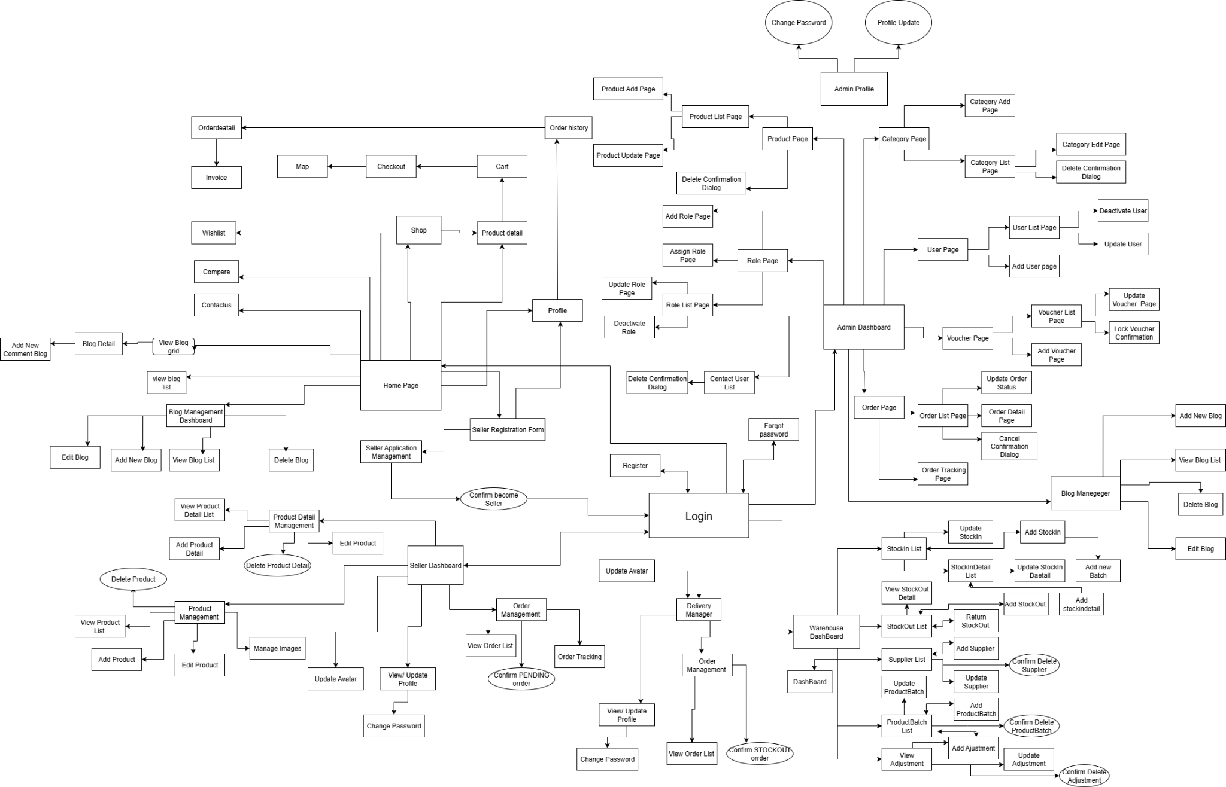

Figure 2.8 - Screen Flow for AgriKho

### *3.2 Screen Authorization*

| **Screen** | **Customers** | **Admin** | **WareHouse**  **Manager** | **Seller** | **Bloger** | **Delivery Manager** |
| --- | --- | --- | --- | --- | --- | --- |
| View Warehouse Dashboard |  |  |  |  |  | X |
| View StockIn |  |  |  |  |  | X |
| Add StockIn |  |  |  |  |  | X |
| View StockInDetail |  |  |  |  |  | X |
| View StockOut |  |  |  |  |  | X |
| Add StockOut |  |  |  |  |  | X |
| Return StockOut |  |  |  |  |  | X |
| View StockOutDetail |  |  |  |  |  | X |
| View ProductBatch |  |  |  |  |  | X |
| Add ProductBatch |  |  |  |  |  | X |
| View Supplier |  |  |  |  |  | X |
| Add Supplier |  |  |  |  |  | X |
| View Adjustment |  |  |  |  |  | X |
| Register | X |  |  |  |  |  |
| Login | X | X | X | X | X | X |
| Forgot password | X | X | X | X | X | X |
| Change password | X | X | X | X | X | X |
| Homepage | X |  |  |  |  |  |
| Shop | X |  |  |  |  |  |
| Product details | X |  |  |  |  |  |
| Cart | X |  |  |  |  |  |
| Checkout | X |  |  |  |  |  |
| Map | X |  |  |  |  |  |
| Order details | X |  |  |  |  |  |
| Invoice | X |  |  |  |  |  |
| Profile | X |  |  | X |  |  |
| Wishlist | X |  |  |  |  |  |
| Compare | X |  |  |  |  |  |
| Contactus | X |  |  |  |  |  |
| View Product |  | X |  | X |  |  |
| Add Product |  | X |  | X |  |  |
| Edit Product |  | X |  | X |  |  |
| Delete Product (soft delete) |  | X |  | X |  |  |
| View Product Detail |  |  |  | X |  |  |
| Add Product Detail |  |  |  | X |  |  |
| Edit Product Detail |  |  |  | X |  |  |
| Delete Product Detail (soft delete) |  |  |  | X |  |  |
| Manage Product Gallery |  | X |  | X |  |  |
| View Orders | X | X | X | X | X | X |
| Update Order Status | X | X | X | X | X | X |
| View Order Detail |  | X |  |  |  |  |
| View Seller Application | X | X |  |  |  |  |
| Submit Seller Application | X |  |  |  |  |  |

Table 4 - Screen authorization

### *3.3 Non-UI Functions*

| **#** | **Feature** | **System Function** | **Description** |
| --- | --- | --- | --- |
| 1 | Sign in via google | Integrate Google OAuth API to authenticate users via their Google account | This feature allows users to sign in to the BulkMart Wholesale website using their existing Google credentials. It provides a secure and convenient way for users to access the system without needing to create a new account, leveraging Google's authentication mechanism to verify user identity. |
| 2 | Export to PDF | Export Invoice PDF | Generate and download PDF file invoice |
| 3 | Export to Excel | Export StockIn to Excel | Generate and download Excel file containing stock-in records and details. |
| Export StockOut to Excel | Generate and download Excel file containing stock-out records and details. |
| Export Data Chart to Excel | Export summarized or visualized data (e.g., monthly totals) into Excel format. |
| 4 | File Upload | Upload Image to Server | Handles uploading and storing of product images or user avatars on the server under predefined directories. |
| 5 | Image Processing | Auto Crop Avatar to Square | Automatically crops uploaded avatar images to a square format before saving. |
| 6 | Notification | Send Email Notification | Sends system-generated email notifications to users (e.g., application updates, status changes, approvals). |
| 7 | Soft Delete Handling | Update Status Instead of Deletion | Applies soft delete logic by changing entity status (e.g., ACTIVE → INACTIVE) instead of physical deletion. |
| 8 | Security Enforcement | Hash Passwords using BCrypt | Secures user passwords by applying one-way hashing before saving them into the database. |
| 9 | Validation & Duplication | Validate Unique Fields Before Insertion | Prevents duplicate entries in critical fields such as product name or weight-unit combinations during product detail creation. |
| 10 | Auto-cancel unapproved application | Scheduled Task: Cancel stale seller applications | Automatically cancels seller applications that have been in APPROVED status for more than 7 days without admin confirmation or wallet deduction. |

Table 5 - Non-UI Functions

# **II. Functional Requirements**

## **1.** **User**

### **1.1** **Register**

*Screen description*

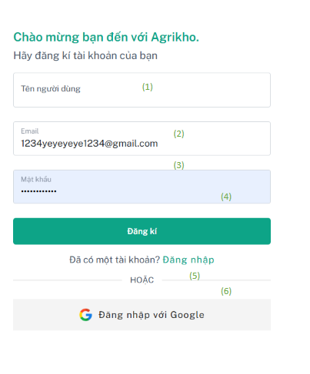

Figure 2.1 - Mockup for user register use case

| **Field Name** | **Field Type** | **Description** |
| --- | --- | --- |
| (1) | Input text | Input field Username |
| (2) | Input text | Input field Email. |
| (3) | Input password | Input field Password. |
| (4) | Button | Button to submit the Register |
| (5) | Hyperlink | Link to login |
| (6) | Button | Button to log in using a Google account (via OAuth). |

Table 6 - Screen description for login

***Use case specification***

| UC ID and Name: | **UC-01 Register** | | |
| --- | --- | --- | --- |
| Created By: | AnhNHHE186216 | Date Created: | 08/02/2025 |
| Primary Actor: | Customer, | Secondary  Actors: | Admin (for account  approval) |
| Trigger: | Customers logs into the system and register to create a new account | | |
| Description: | Allow Customers register the system to use their account | | |
| Preconditions: | * User can access the registration page * The customer has registered with a valid email and password account and must follow the required format | | |
| Postconditions: | * Customer input otp code valid * A new account and stored in database * Customers are redirected to the login page. | | |
| Normal Flow: | 1. Customer navigates to the register “Agrikho” page. 2. The system display a form to input register 3. + Customers fills in all required fields and submits the form (valid)   + Customers login by google(Valid)  4. Customers are redirected to the login.. | | |
| Alternative Flows: | 1, If Customer registers but the account exists, the system displays a conflict warning “Email đã tồn tại !!!”  2, If Customer registers but Username too short, the system displays a conflict warning “Tên người dùng quá ngắn, ít nhất 9 ký tự !!!  ” 3, If Customer registers but Username include space, the system displays a conflict warning “Tên người dùng không được chứa khoảng trắng”  4, If Customer registers but Password under 9 characters, the system displays a conflict warning “Mật khẩu không được ít hơn 9 ký tự  ”  5, If Customer registers but Password not at least 1 character and not 1 digit, the system displays a conflict warning “Mật khẩu phải chứa ít nhất một chữ cái và một số”  6, If Customer registers but Password but Username include space, the system displays a conflict warning “Mật khẩu không được chứa khoảng trắng”  7, If Customer registers but Password not at least 1 character lowercase, the system displays a conflict warning “Mật khẩu phải chứa ít nhất một chữ cái viết hoa”  8, If Customer registers but Password not at least 1 character upper, the system displays a conflict warning “Mật khẩu phải chứa ít nhất một chữ cái thường”  9, If Customer registers but Password not at least 1 character special,the system displays a conflict warning “Mật khẩu phải chứa ít nhất một ký tự đặc biệt.”  10, If Customer input field otp code but otp code not equal otp send email, ,the system displays a conflict warning “Sai otp” | | |

| Priority: | High |
| --- | --- |
| Frequency of Use: | Every day, whenever the user needs to access the system. |
| Business Rules: | 1. Email Already Exists  If a customer attempts to register with an email address that already exists in the system, the system must prevent the registration and display a conflict warning message: **“Email already exists!”**  2. Username Too Short  If the customer enters a username that is shorter than 9 characters, the system should block the registration and notify the user with the warning: **“Username is too short, minimum 9 characters required!”**  3. Username Contains Whitespace  If the username contains any whitespace characters (such as spaces), the system must not accept it and should display a message saying: **“Username must not contain whitespace characters.”**  4. Password Too Short  When the customer provides a password that is less than 9 characters long, the system should reject the input and return a warning: **“Password must be at least 9 characters long.”**  5. Password Must Include Letters and Numbers  If the entered password does not contain at least one alphabetical character (A–Z or a–z) and one digit (0–9), the system should reject the password and display a message: **“Password must contain at least one letter and one number.”**  6. Password Contains Whitespace  If the password includes any whitespace characters, the system must invalidate it and return the warning: **“Password must not contain whitespace characters.”**  7. Password Must Contain at Least One Uppercase Letter  In the case where the password does not include at least one uppercase letter (A–Z), the system should deny the registration and display the warning: **“Password must contain at least one uppercase letter.”**  8. Password Must Contain at Least One Lowercase Letter  If the password lacks at least one lowercase letter (a–z), the system should notify the user by displaying: **“Password must contain at least one lowercase letter.”**  9. Password Must Contain at Least One Special Character  Should the password not contain at least one special character (such as @, #, !, %, etc.), the system must reject the password and provide this feedback: **“Password must contain at least one special character.”**  10. OTP Code Mismatch  If the customer enters an OTP code that does not match the code that was sent to their email, the system should not allow the registration to proceed and should return the error message: **“Incorrect OTP code.”** |
| Other Information: | Encrypt passwords using secure algorithms. |
| Assumptions: | * If Customer forgot or not see otp, Customer can resend new otp code |
| Exeception: | 1. Database connection is lost → the system shows: “Cannot connect to database.” 2. Network issue during save → system shows: “Request failed, please try again.” |

Table 7 - Use case specification for login

### 

### 

### 

### **1.2** **Login**

### 

### 

| **Field Name** | **Field Type** | **Description** |
| --- | --- | --- |
| (1) | Input text | Input field email |
| (2) | Input text | Input field Password. |
| (3) | Button | Submit login |
| (4) | Checkbox | Checkbox field to remember me |
| (5) | Hyperlink | Button to log in using a Google account (via OAuth). |
| (6) | Hyperlink | Link to register |

| UC ID and Name: | **UC-02 Login** | | |
| --- | --- | --- | --- |
| Created By: | AnhNHHE186216 | Date Created: | 08/03/2025 |
| Primary Actor: | Customer,  Admin, Warehouse, Seller, Shipper, Blogger | Secondary  Actors: |  |
| Trigger: | Customers logs into the system and login to account password, email | | |
| Description: | Allow Customers login the system to use their account | | |
| Preconditions: | * User can access the login page * The customer has login with a valid email and password account and must follow the required format | | |
| Postconditions: | * Customer input format valid * Customer Link to home page | | |
| Normal Flow: | 1. The customer navigates to the login “Agrikho” page. 2. The system display a form to input register 3. + Customers fills in all required fields and submits the form (valid)   + Customers login by google(Valid)  + Checkbox remember   1. Customers are redirected to the homepage. | | |
| Alternative Flows: | 1, If a customer loginGG but the account is inactive, the system displays a conflict warning “Tài khoản không hoạt động !!!”  2, If Customer login account but account had use account GG, the system displays a conflict warning “Email đã được Tài khoản Google sử dụng !!!”  3, If Customer login account but Email not exist , the system displays a conflict warning “Email không tồn tại !!!”,  4, If Customer login account but Email and password not match, the system displays a conflict warning “Mật khẩu hoặc email không đúng !!!” | | |

| Priority: | High |
| --- | --- |
| Frequency of Use: | Every day, whenever the user needs to access the system. |
| Business Rules: | 1. Inactive Account  If a customer attempts to log in using a Google account, but the associated user account in the system is marked as inactive, the system must deny the login attempt and display the conflict warning message: **“Account is inactive!”**  2. Account Already Associated with Google Sign-In  If a customer tries to log in with an email and password, but that email has already been registered through Google Sign-In, the system should prevent the login and return the warning: **“Email is already associated with a Google account!”**  3. Email Does Not Exist  When a customer tries to log in with an email address that does not exist in the system, the login attempt must be rejected, and the system should display the warning: **“Email does not exist!”**  4. Incorrect Email or Password  If the customer provides an email and password combination that does not match any existing record, the system should reject the login and display the conflict warning: **“Incorrect email or password!”** |
| Other Information: | The system generation jwt token and encode **SignatureAlgorithm.*HS256*** |
| Assumptions: | * If Customer jwt out of time when login system, Customer will log out and link login page |
| Exception: | 1. Database connection is lost → the system shows: “Cannot connect to database.” 2. Network issue during save → system shows: “Request failed, please try again.” |

### **1.3 Forgot password**

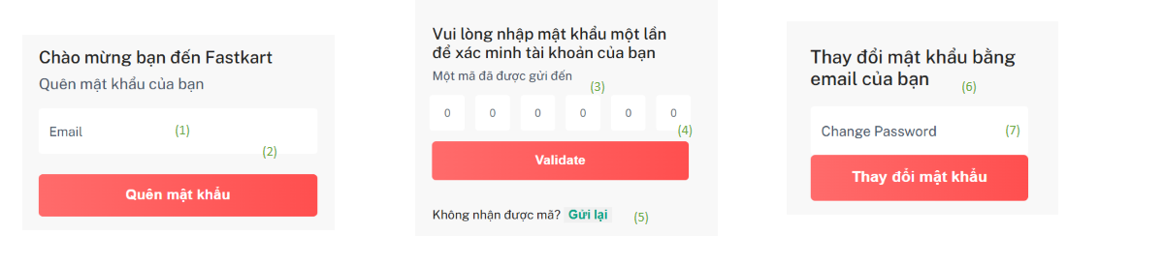

| **Field Name** | **Field Type** | **Description** |
| --- | --- | --- |
| (1) | Input text | Input field email. |
| (2) | Button | Submit forgot password. |
| (3) | Input | Input code otp |
| (4) | Button | Verify code |
| (5) | Button | Resend code |
| (6) | Input | Change new password |
| (7) | Button | Change password |

| UC ID and Name: | **UC-03 Forgot password** | | |
| --- | --- | --- | --- |
| Created By: | AnhNHHE186216 | Date Created: | 08/03/2025 |
| Primary Actor: | Customer,  Admin, Warehouse, Seller, Shipper, Blogger | Secondary  Actors: | Admin send new password |
| Trigger: | Customers logs into the system and forgot password | | |
| Description: | Allow Customers change password the system to use their account | | |
| Preconditions: | * User can access the forgot password page * The customer input opt code valid * The customer has changed password valid email and password account and must follow the required format | | |
| Postconditions: | * Customer input submit change password format valid * Customer Link to login and send message success | | |
| Normal Flow: | 1. The customer navigates to the forgot password“Agrikho” page. 2. The system display a form to input forgot password 3. + Customers fills in required fields email and submits the form (valid)   + Customers fills in required fields otp code and submits the form (valid)  + Customers fills in required fields change password code and submits the form (valid)   1. Customers are redirected to the login page and send success messages. | | |
| Alternative Flows: | 1, If a customer changes password but Email does not exist the system displays a conflict warning “Email không tồn tại !!!”  2, If a customer changes password but input accountGG so can not change password , the system displays a conflict warning “Email đã có trong Google !!!”  3, If a Customer change password account but Email not exist , the system displays a conflict warning “Email không tồn tại !!!”  4, If Customer change password but Password under 9 characters, the system displays a conflict warning “Mật khẩu không được ít hơn 9 ký tự  ”  5, If Customer change password but Password not at least 1 character and not 1 digit, the system displays a conflict warning “Mật khẩu phải chứa ít nhất một chữ cái và một số”  6, If Customer change password but Password but Username include space, the system displays a conflict warning “Mật khẩu không được chứa khoảng trắng”  7, If Customer change password but Password not at least 1 character uppercase, the system displays a conflict warning “Mật khẩu phải chứa ít nhất một chữ cái viết hoa”  8, If Customer change password but Password not at least 1 character lowercase, the system displays a conflict warning “Mật khẩu phải chứa ít nhất một chữ cái thường”  9, If Customer change password but Password not at least 1 character special,the system displays a conflict warning “Mật khẩu phải chứa ít nhất một ký tự đặc biệt.”  10, If Customer change password account but password old same password new, the system displays a conflict warning “Mật khẩu mới không được giống với mật khẩu cũ.”  11, If Customer change password account but password new not match password new verify, the system displays a conflict warning “Mật khẩu không khớp!”  12,, If Customer input field otp code but otp code not equal otp send email, ,the system displays a conflict warning “otp OTP không hợp lệ” | | |

| Priority: | High |
| --- | --- |
| Frequency of Use: | Every day, whenever the user needs to access the system. |
| Business Rules: | 1. Password Change – Email Does Not Exist  If a customer attempts to change their password using an email address that is not registered in the system, the system must deny the request and display a conflict warning: **“Email does not exist!”**  2. Password Change – Google Account Detected  If a customer tries to change the password for an account that was registered via Google Sign-In (OAuth), the system must block the operation and display the warning: **“Email is already linked to a Google account!”**  3. Login – Email Does Not Exist  When a customer tries to log in with an email address that is not present in the system database, the login attempt must be rejected, and the system should display: **“Email does not exist!”**  4. Login – Email and Password Do Not Match  If the customer provides a valid email but an incorrect password (or vice versa), and the credentials do not match any user record, the system must display a warning: **“Incorrect email or password!”**  5. Invalid OTP Code  If a customer enters an OTP code that does not match the one sent to their email, the system must reject the verification attempt and display: **“Invalid OTP code.”**  6. Password Change – Validation Same as Registration  When changing a password, the system must enforce the same validation rules as during registration. This includes minimum length, the presence of uppercase and lowercase letters, digits, and special characters, as well as ensuring there are no whitespace characters. |
| Other Information: | **Send otp by email use object MimeMessageHelper to save content sending email and JavaMailSender to send MimeMessageHelper** |
| Assumptions: | * If Customer forgot or not see otp, Customer can resend new otp code |
| Exceptions: | 1. Database connection is lost → the system shows: “Cannot connect to database.” 2. Network issue during save → system shows: “Request failed, please try again.” |

### **1.4** **HOME PAGE**

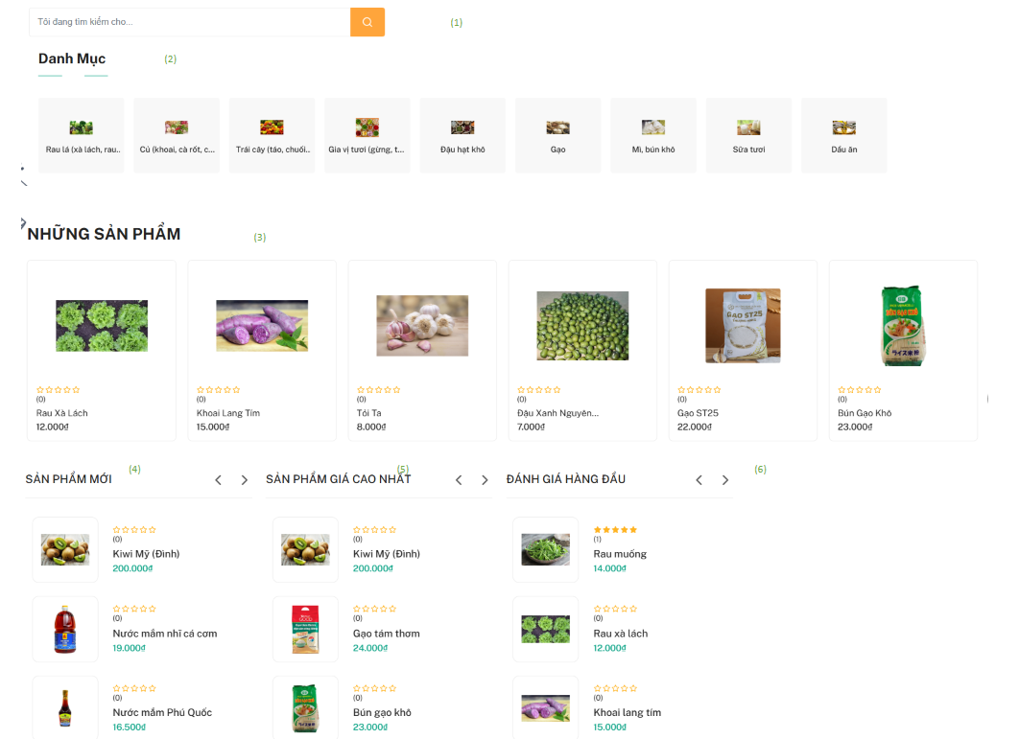

| **Field Name** | **Field Type** | **Description** |
| --- | --- | --- |
| (1) | Input | Input field search product. |
| (2) | Array | List categories |
| (3) | Array | List products |
| (4) | Array | List new products |
| (5) | Array | List high price products |
| (6) | Array | List high review products |

| UC ID and Name: | **UC-04 Home Page** | | |
| --- | --- | --- | --- |
| Created By: | AnhNHHE186216 | Date Created: | 08/03/2025 |
| Primary Actor: | Customer | Secondary  Actors: | Guest |
| Trigger: | The customer logs into the system and is redirected to the homepage. | | |
| Description: | This use case allows customers to access and view the homepage after successfully logging in | | |
| Preconditions: | * User can access the homepage page * The list information product, list categories has already been imported into the system . | | |
| Postconditions: | * The customer is successfully presented with the homepage. * The homepage displays featured products, available categories, and other relevant information (such as promotions or banners). | | |
| Normal Flow: | 1. The customer navigates to the homepage “Agrikho” page. 2. The system display a information of homepage | | |
| Alternative Flows: | 1, Unauthenticated user attempts restricted actions on homepage such as wishlist, add to cart | | |

| Priority: | High |
| --- | --- |
| Frequency of Use: | Every day, whenever the user needs to access the system. |
| Business Rules: | 1, Homepage Access without Login  Customers can view the homepage without logging in, including access to product listings, categories, and promotions.  2, Restricted Actions for Unauthenticated Users  Login is required to add products to the wishlist or shopping cart. If unauthenticated, the system must block the action and prompt the user to log in. |
| Other Information: |  |
| Assumptions: | * Customer authentication status (logged in or not) is accurately managed via session or token. |
| Exceptions: | 1, Database connection is lost → the system shows: “Cannot connect to database.”  2, Network issue during save → system shows: “Request failed, please try again.” |

### 

### **1.5** **Shop**

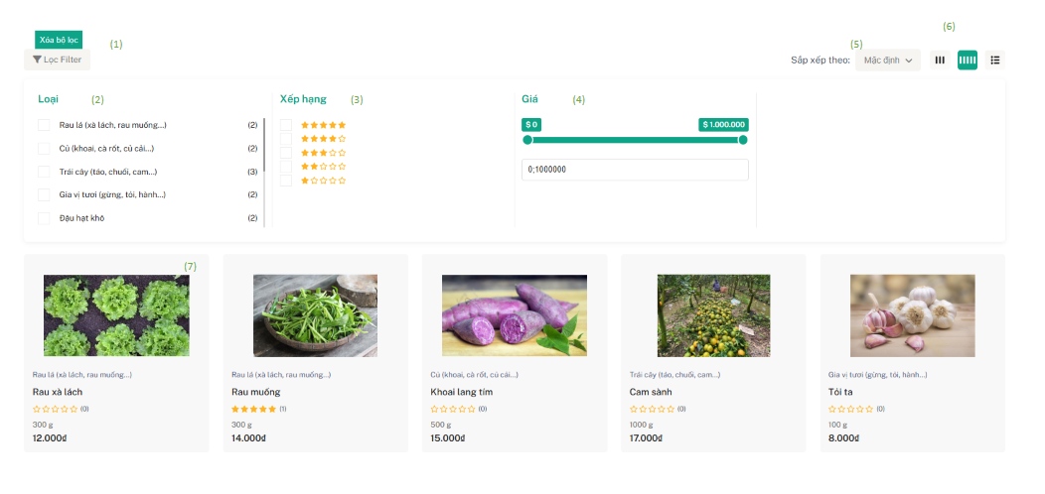

| **Field Name** | **Field Type** | **Description** |
| --- | --- | --- |
| (1) | Button | Delete filter |
| (2) | Array | List categories |
| (3) | Array | List range |
| (4) | Range | Range price |
| (5) | Select option | Select option of sort by |
| (6) | Select | Lets users choose how list products are displayed |

| UC ID and Name: | **UC-05 Shop** | | |
| --- | --- | --- | --- |
| Created By: | AnhNHHE186216 | Date Created: | 08/03/2025 |
| Primary Actor: | Customer, | Secondary  Actors: | Guest |
| Trigger: | The customer logs into the system and is redirected to the shop. | | |
| Description: | This use case allows customers to access and view list product in shop after successfully logs | | |
| Preconditions: | * User can access the shop * The list information product has already been imported into the system and view products by categories, ratings, range price, sort by | | |
| Postconditions: | * The customer is successfully presented with the shop. * The homepage displays list information product has already been imported into the system when filter products by categories, ratings, range price, sort by | | |
| Normal Flow: | 1. The customer navigates to the shop's“Agrikho” page. 2. The system display a information of shop 3. The customer filter products by categories, ratings, range price, sort by 4. The system view list products filter success | | |
| Alternative Flows: | 1, Unauthenticated user attempts restricted actions on homepage such as wishlist, add to cart | | |

| Priority: | High |
| --- | --- |
| Frequency of Use: | Every day, whenever the user needs to access the system. |
| Business Rules: | 1, Shop Access without Login  Customers can view the shop without logging in, including access to product listings, categories, and promotions.  2, Restricted Actions for Unauthenticated Users  Login is required to add products to the wishlist or shopping cart. If unauthenticated, the system must block the action and prompt the user to log in. |
| Other Information: |  |
| Assumptions: | * Customer authentication status (logged in or not) is accurately managed via session or token. |
| Exceptions: | 1, Database connection is lost → the system shows: “Cannot connect to database.”  2, Network issue during save → system shows: “Request failed, please try again.” |

### 

### **1.6** **Product detail**

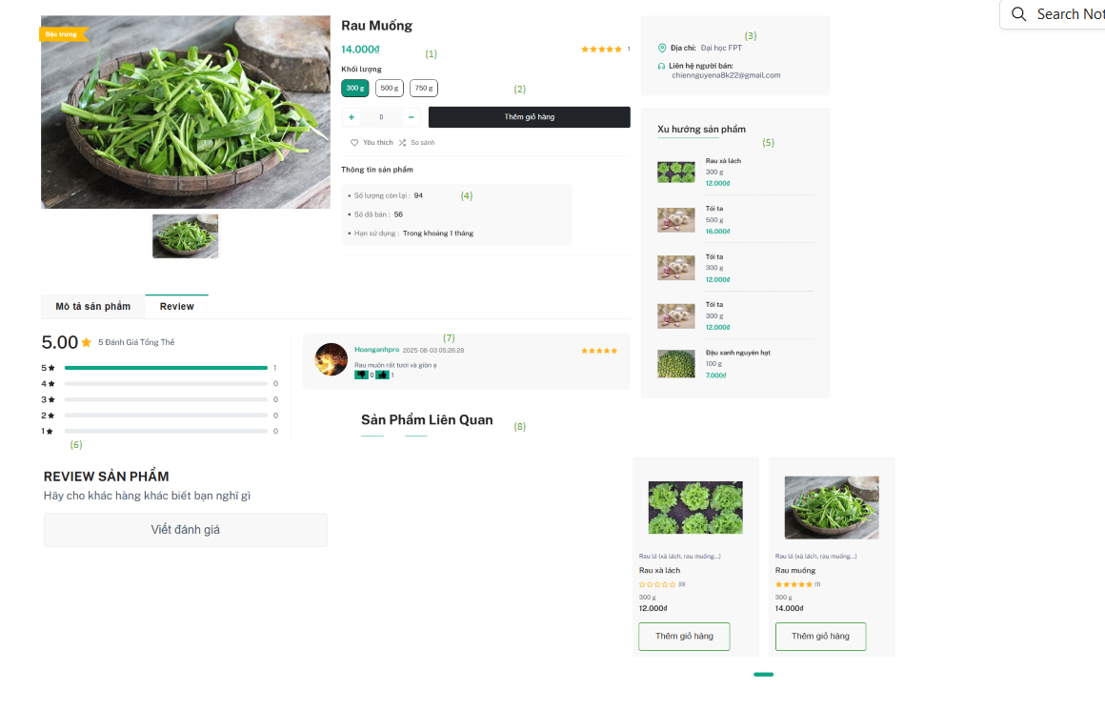

| **Field Name** | **Field Type** | **Description** |
| --- | --- | --- |
| (1) | Object | Object productdetail |
| (2) | Button | Add to cart |
| (3) | Input | Name seller |
| (4) | Input | Quantity remaining, Quantity sold, month expiry |
| (5) | Array | List products trending |
| (6) | Button | Review product |
| (7) | Array | List comment products |
| (8) | Array | List product related |

| UC ID and Name: | **UC-06 ProductDetail** | | |
| --- | --- | --- | --- |
| Created By: | AnhNHHE186216 | Date Created: | 08/03/2025 |
| Primary Actor: | Customer | Secondary  Actors: | Guest |
| Trigger: | The customer logs into the system and is redirected to the product detail. | | |
| Description: | This use case allows customers to access and object product detail in product detail page after successfully logs | | |
| Preconditions: | * User can access the product detail page * The product must exist in the database | | |
| Postconditions: | * The information productDetail has already been imported into the system and view object product detail * The system displays related products based on the product category * The system displays trending products based on the productbatch | | |
| Normal Flow: | 1. The customer navigates to the product detail“Agrikho” page. 2. The system display a information of the product detail, display list comments, display product trending, display product related 3. The customer add to cart success full | | |
| Alternative Flows: | 1, If a customer chooses quantity product detail but product detail is out of stock the system displays a conflict warning “Sản phẩm này hiện không còn hàng. Vui lòng chọn sản phẩm khác”  2, If a customer chooses quantity product detail but product detail quantity input exceeding quantity remain in shop ,the system displays a conflict warning “Số lượng bạn nhập không được lớn hơn số lượng của Shop”  3, If a customer chooses quantity product detail but product detail quantity input exceeding quantity other customers had order status pending confirm ,the system displays a conflict warning “Sản phẩm đã hết vì người dùng đã đặt hàng, vui lòng chọn số lượng nhỏ hơn”  4, If a customer chooses quantity product detail but product detail quantity input exceeding quantity other customers had order status pending confirm ,the system displays a conflict warning “Sản phẩm đã hết vì người dùng đã đặt hàng, vui lòng chọn số lượng nhỏ hơn” | | |
|  |  | | |

| Priority: | High |
| --- | --- |
| Frequency of Use: | Every day, whenever the user needs to access the system. |
| Business Rules: | 1. Product Out of Stock  If a customer selects a product detail that is currently out of stock, the system must prevent the purchase and display the message:  **“This product is currently out of stock. Please choose another product.”**  2. Requested Quantity Exceeds Shop Stock  If the customer inputs a quantity that exceeds the remaining stock available in the shop, the system must reject the request and display:  **“The quantity you entered exceeds the available stock in the shop.”**  3. Requested Quantity Exceeds Stock Reserved in Pending Orders  If the quantity entered by the customer exceeds the available stock after accounting for items reserved in other customers' pending confirmation orders, the system must display:  **“The product is no longer available due to pending customer orders. Please choose a smaller quantity.”** |
| Other Information: |  |
| Assumptions: | * Customer authentication status (logged in or not) is accurately managed via session or token when add to cart |
| Exceptions: | 1, Database connection is lost → the system shows: “Cannot connect to database.”  2, Network issue during save → system shows: “Request failed, please try again.” |

### **1.7** **Cart**

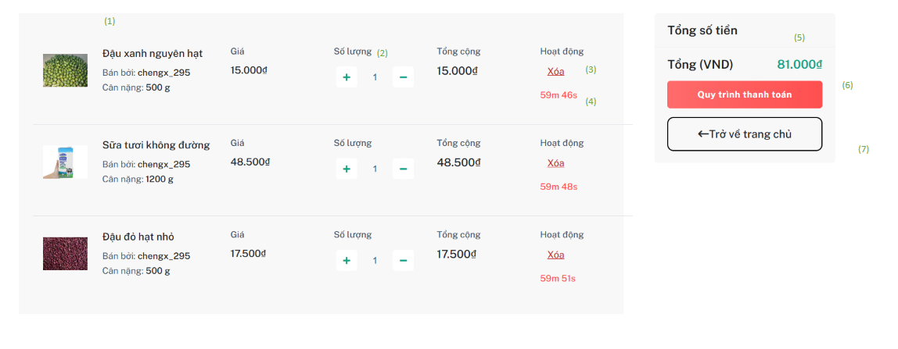

| **Field Name** | **Field Type** | **Description** |
| --- | --- | --- |
| (1) | Object | Object cart |
| (2) | Button | Change quantity product minus or plus |
| (3) | Button | Delete |
| (4) | Input | Auto time reduction |
| (5) | Input | Total amount |
| (6) | Button | Checkout |
| (7) | Hyperlink | Link to cart |

| UC ID and Name: | **UC-07 Cart** | | |
| --- | --- | --- | --- |
| Created By: | AnhNHHE186216 | Date Created: | 08/03/2025 |
| Primary Actor: | Customer | Secondary  Actors: |  |
| Trigger: | The customer logs into the system and is redirected to the cart. | | |
| Description: | This use case allows customers to access cart page after successfully logs | | |
| Preconditions: | * User can access the cart page * The cart must exist in the database | | |
| Postconditions: | * The list information cart has already been imported into the system * The system displays auto time reduction list cart | | |
| Normal Flow: | 1. The customer navigates to the cart “Agrikho” page. 2. The system display a information of the product detail 3. The customer add to cart success full | | |
| Alternative Flows: | 1, If a customer chooses quantity product detail but product detail is less than 1 the system displays a conflict warning “Vui lòng nhập một số hợp lệ lớn hơn 0.”  2, If a customer chooses quantity product detail but product detail quantity input exceeding quantity remain in shop ,the system displays a conflict warning “Số lượng bạn nhập không được lớn hơn số lượng của Shop”  3, If a customer chooses quantity product detail but product detail quantity input exceeding quantity other customers had order status pending confirm ,the system displays a conflict warning “Sản phẩm đã hết vì người dùng đã đặt hàng, vui lòng chọn số lượng nhỏ hơn”  4, If a customer chooses quantity product detail but product detail quantity input exceeding quantity other customers had cart,the system displays a conflict warning “Các sản phẩm đã hết do thêm giỏ hàng quá số lượng, vui lòng kiểm tra lại.” | | |
|  |  | | |

| Priority: | High |
| --- | --- |
| Frequency of Use: | Every day, whenever the user needs to access the system. |
| Business Rules: | 1. Invalid Quantity Input  If a customer enters a quantity less than 1, the system must reject the input and display:  “Please enter a valid number greater than 0.”  2. Quantity Exceeds Available Shop Stock  If the quantity entered exceeds the remaining stock available in the shop, the system must prevent the action and display:  “The quantity you entered exceeds the available stock in the shop.”  3. Quantity Exceeds Stock Reserved in Pending Orders  If the entered quantity exceeds the remaining stock after accounting for pending confirmed orders by other customers, the system must display:  “The product is no longer available due to pending customer orders. Please select a smaller quantity.”  4. Quantity Exceeds Stock Already in Other Customers' Carts  If the quantity input exceeds the available stock after considering items already added to other customers’ carts, the system must display:  “The product is no longer available due to being added to other carts. Please review your quantity.” |
| Other Information: |  |
| Assumptions: | * Customer authentication status (logged in or not) is accurately managed via session or token |
| Exceptions: | 1, Database connection is lost → the system shows: “Cannot connect to database.”  2, Network issue during save → system shows: “Request failed, please try again.” |

### 

### **1.8** **Checkout**

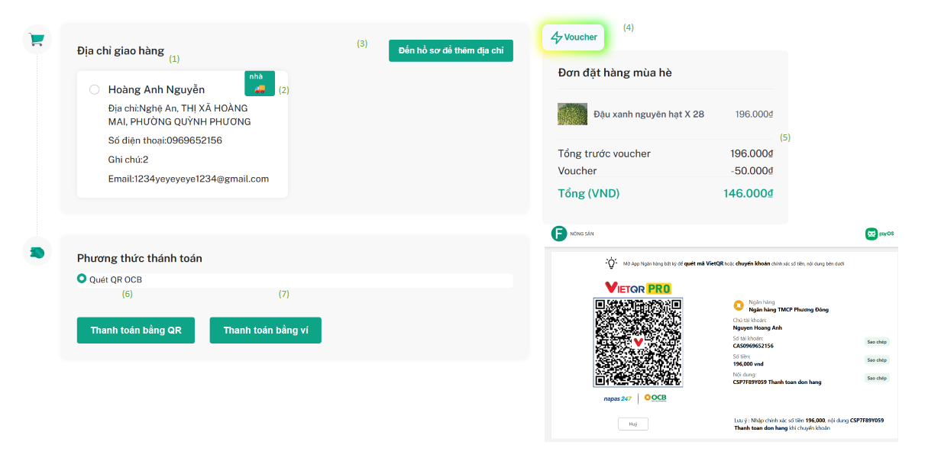

| **Field Name** | **Field Type** | **Description** |
| --- | --- | --- |
| (1) | Object | Object address book order |
| (2) | Button | Map distance |
| (3) | Hyperlink | Link profile of address book order |
| (4) | Button | Click button voucher to view list voucher |
| (5) | Input | Total amount |
| (6) | Button | Payment Scanner QR |
| (7) | Button | Link to cart |

| UC ID and Name: | **UC-08 Checkout** | | |
| --- | --- | --- | --- |
| Created By: | AnhNHHE186216 | Date Created: | 08/03/2025 |
| Primary Actor: | Customer | Secondary  Actors: |  |
| Trigger: | The customer logs into the system and is redirected to the checkout. | | |
| Description: | This use case allows customers to access checkout page after successfully logs | | |
| Preconditions: | * User can access the checkout page * The checkout must exist in the database | | |
| Postconditions: | * The list information address booked order has already been imported into the system * The list information lists voucher has already been imported into the system * The list information list cart has already been imported into the system | | |
| Normal Flow: | 1. The customer navigates to the checkout“Agrikho” page. 2. The customer click radios address 3. The system display a information of the voucher and choose voucher 4. The customer payment scanner QR 5. The customer payment in wallet | | |
| Alternative Flows: | 1, If a customer not chooses address book,the system displays a conflict warning “Hãy nhập thông tin địa chỉ để đặt hàng”  2, If a customer choose payment by wallet but not enough money, the system displays a conflict warning “Hãy nạp thêm tiền để thanh toán” | | |
|  |  | | |

| Priority: | High |
| --- | --- |
| Frequency of Use: | Every day, whenever the user needs to access the system. |
| Business Rules: | 1. Invalid Address Selection  If a customer does not select or enter a shipping address during checkout, the system must block the order and display:  **“Please enter your shipping address to place the order.”**  2. Insufficient Wallet Balance  If a customer selects wallet payment but the wallet balance is insufficient, the system must block the payment and display:  **“Please top up your wallet to complete the payment.”** |
| Other Information: |  |
| Assumptions: | * Customer authentication status (logged in or not) is accurately managed via session or token |
| Exceptions: | 1, Database connection is lost → the system shows: “Cannot connect to database.”  2, Network issue during save → system shows: “Request failed, please try again.” |

### 

### **1.9** **Map**

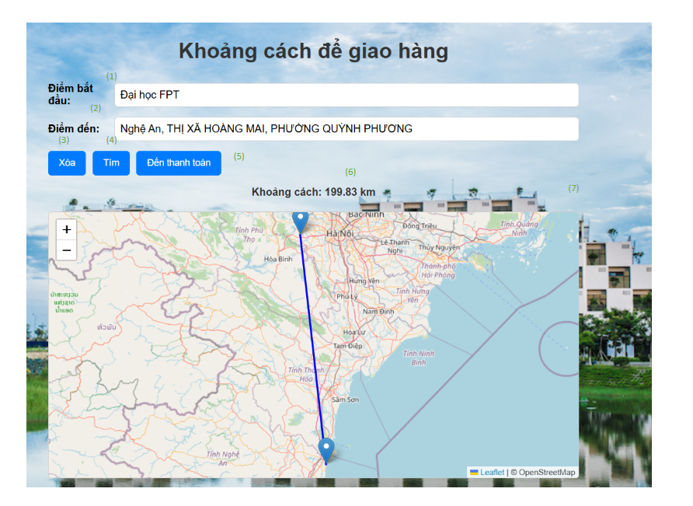

### 

| **Field Name** | **Field Type** | **Description** |
| --- | --- | --- |
| (1) | Input | Origin distance |
| (2) | Input | End point distance |
| (3) | Button | Click delete |
| (4) | Button | Click find |
| (5) | Button | Link checkout |
| (6) | Input | Map distance |
| (7) | div | Show map |

| UC ID and Name: | **UC-09 Map** | | |
| --- | --- | --- | --- |
| Created By: | AnhNHHE186216 | Date Created: | 08/03/2025 |
| Primary Actor: | Customer | Secondary  Actors: |  |
| Trigger: | The customer logs into the system and is redirected to the map. | | |
| Description: | This use case allows customers to access map page after successfully logs | | |
| Preconditions: | * User can access the map page * The map must exist API | | |
| Postconditions: | * The information map origin and end point * The list information distance * The view Show distance traveled | | |
| Normal Flow: | 1. The customer navigates to the map“Agrikho” page. 2. The information map origin and end point 3. Click button “Tìm” and show distance map | | |
| Alternative Flows: | 1, If a customer not find place wrong, the system displays a conflict warning “Không tìm thấy địa điểm” | | |
|  |  | | |

| Priority: | High |
| --- | --- |
| Frequency of Use: | Every day, whenever the user needs to access the system. |
| Business Rules: | Business Rule – Invalid Location Search  If a customer searches for a location but it cannot be found or is invalid, the system must prevent further action and display the following message:  **“Location not found.”** |
| Other Information: |  |
| Assumptions: | * Customer authentication status (logged in or not) is accurately managed via session or token |
| Exceptions: | 1, Database connection is lost → the system shows: “Cannot connect to database.”  2, Network issue during save → system shows: “Request failed, please try again.” |

### 

### **1.10** **Order detail**

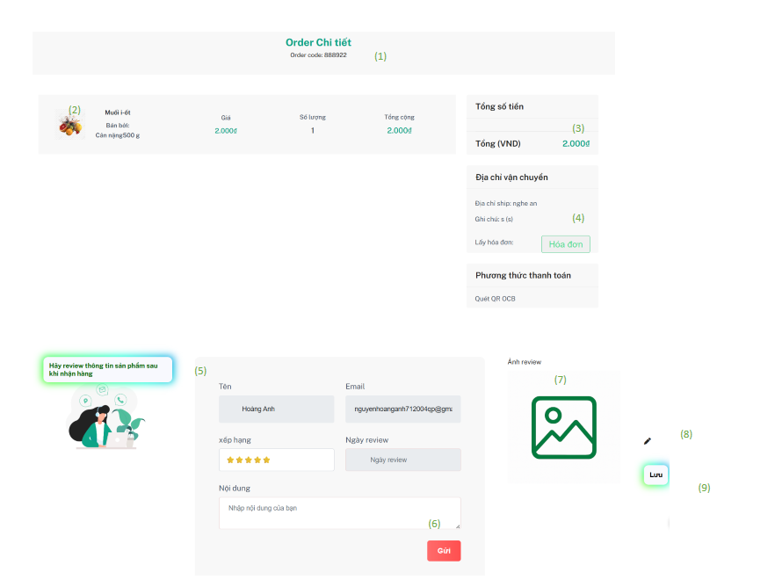

| **Field Name** | **Field Type** | **Description** |
| --- | --- | --- |
| (1) | Input | view order code |
| (2) | Input | view list order detail |
| (3) | Button | View total amount (can use voucher) |
| (4) | Button | Link to the page invoice |
| (5) | Button | Form review order when status confirmed |
| (6) | Button | Submit form review |
| (7) | object | View image order review |
| (8) | Button | Update image review order just only one |
| (9) | Button | Save image review order |

| UC ID and Name: | **UC-10 Order detail** | | |
| --- | --- | --- | --- |
| Created By: | AnhNHHE186216 | Date Created: | 08/03/2025 |
| Primary Actor: | Customer | Secondary  Actors: |  |
| Trigger: | The customer clicks "Xem chi tiết" on an order from the "Lịch sử đơn hàng của tôi" page. | | |
| Description: | This use case allows the customer to view the details of an order, including the order Code, List Order detail, payment, item details, and total amount (Voucher) | | |
| Preconditions: | * User can access the order detail page * The order detail must in database | | |
| Postconditions: | * The information order code * The list information product detail order and total amount | | |
| Normal Flow: | 1. The customer navigates to the order detail“Agrikho” page. 2. The information order code 3. The list information product detail order and total amount | | |
| Alternative Flows: | 1, If a customer attempts to review a product that does not belong to their order, the system must block the action and display“Không thể review vào sản phẩm của người khác”  2,If a customer tries to submit a review for an order that was delivered more than 30 days ago, the system must reject the review and display:“Đơn hàng đã quá 30 ngày không thể review”  3, If a customer tries to review a product more than once with image , form feedback, the system must prevent it and display: “Chỉ được review thông tin ảnh, form một lần duy nhất”  4, If the image uploaded by the customer does not match the product or is invalid, the system must prevent the review and display: “Hãy gửi thông tin ảnh, form sản phẩm ảnh sau khi nhận hàng”  5, If the image uploaded by the customer does not match the product or is invalid, the system must prevent the review and display: “Hãy gửi đúng ảnh để review sản phẩm!!!” | | |
|  |  | | |

| Priority: | High |
| --- | --- |
| Frequency of Use: | Every day, whenever the user needs to access the system. |
| Business Rules: | 1. Reviewing Another Customer's Product  If a customer attempts to review a product that does not belong to their order, the system must block the action and display:  “You cannot review another customer's product.”  2. Review After 30 Days  If a customer tries to submit a review for an order that was delivered more than 30 days ago, the system must reject the review and display:  “Reviews are not allowed for orders older than 30 days.”  3. Duplicate Review Submission  If a customer tries to review a product more than once with image feedback, the system must prevent it and display:  “You can only submit a product image review once.”  4. Review Image Before Receiving Product  If a customer attempts to upload review images before confirming receipt of the product, the system must block the action and display:  “Please submit product images only after receiving the product.”  5. Invalid Image Upload  If the image uploaded by the customer does not match the product or is invalid, the system must prevent the review and display:  “Please upload a valid image of the product for review!” |
| Other Information: |  |
| Assumptions: | * Customer authentication status (logged in or not) is accurately managed via session or token |
| Exceptions: | 1, Database connection is lost → the system shows: “Cannot connect to database.”  2, Network issue during save → system shows: “Request failed, please try again.” |

### 

### **1.11 Invoice**

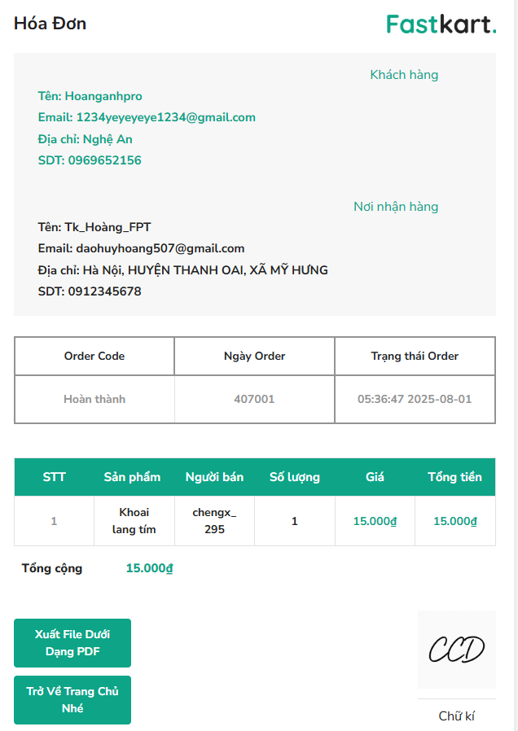

| **Field Name** | **Field Type** | **Description** |
| --- | --- | --- |
| (1) | Input | Object order |
| (2) | Button | Invoice PDF |

| UC ID and Name: | **UC-11 Invoice** | | |
| --- | --- | --- | --- |
| Created By: | AnhNHHE186216 | Date Created: | 08/03/2025 |
| Primary Actor: | Customer | Secondary  Actors: |  |
| Trigger: | The customer clicks invice | | |
| Description: | This use case allows the customer to view the details of an order, and place ship | | |
| Preconditions: | * User can access invoice page * The invoice detail must in database | | |
| Postconditions: | * The information order, place shipe | | |
| Normal Flow: | 1. The customer navigates to the invoice“Agrikho” page. 2. The information order | | |
| Alternative Flows: |  | | |
|  |  | | |

| Priority: | High |
| --- | --- |
| Frequency of Use: | Every day, whenever the user needs to access the system. |
| Business Rules: |  |
| Other Information: |  |
| Assumptions: | * Customer authentication status (logged in or not) is accurately managed via session or token |
| Exceptions: | 1, Database connection is lost → the system shows: “Cannot connect to database.”  2, Network issue during save → system shows: “Request failed, please try again.” |

### 

### 

### 

### **1.12** **Profile**

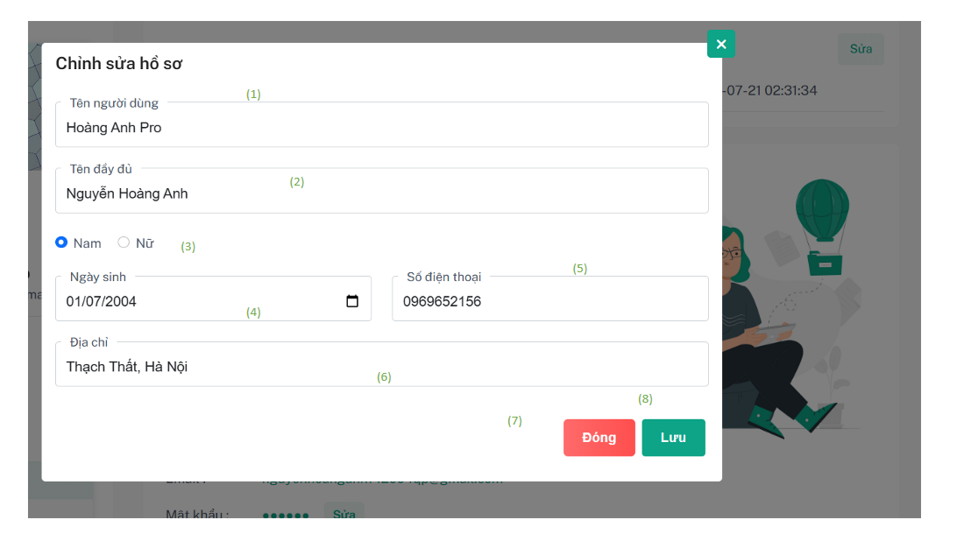

| **Field Name** | **Field Type** | **Description** |
| --- | --- | --- |
| (1) | Input | Username |
| (2) | Input | Full name. |
| (3) | Radios | Gender |
| (4) | Date | Day of birth |
| (5) | Input | Phone number |
| (6) | Input | Address |
| (7) | object | Closes the form without saving any changes. |
| (8) | Button | Saves the updated profile information. |

| UC ID and Name: | **UC-12 Profile** | | |
| --- | --- | --- | --- |
| Created By: | AnhNHHE186216 | Date Created: | 08/03/2025 |
| Primary Actor: | Customer | Secondary  Actors: |  |
| Trigger: | The user initiates profile updates from their dashboard by selecting "Chỉnh sửa hồ sơ" or "Đổi mật khẩu" options. | | |
| Description: | This use case describes the process of users modifying their personal and account information within the Fastkart system. Users can update their profile details or change their account password while maintaining data integrity and security.This use case describes the process of users modifying their personal and account information within the Fastkart system. Users can update their profile details or change their account password while maintaining data integrity and security. | | |
| Preconditions: | * User can access profile page * The profile detail must in database | | |
| Postconditions: | * The view information of profile | | |
| Normal Flow: | ● User must be logged into the system  ● User must have valid authentication credentials  ● User is on the user dashboard  ● User has necessary permissions to modify their profile  ● Network connection is stable  ● System database is operational | | |
| Alternative Flows: | **Username Length Validation**  Ensure the username is at least **9 characters long**.   * If the username is shorter than 9 characters, return an error message and reject the update.   **Full Name Capitalization Validation**  Verify that the full name is properly capitalized (e.g., each word starts with an uppercase letter).   * If the format is incorrect, return an error message.   **Field Change Detection**  Compare the input fields (username, full name, phone, address, gender, date of birth) with the current values in the database.   * For each field with a changed value, record it as part of the profile update.   **Update History Logging**  Save all detected changes into the UpdateProfileHistory table.   * This ensures all profile modifications are logged for auditing purposes.   **User Profile Update Execution**  After all validations pass, update the user’s profile information in the database with the new values provided. | | |
|  |  | | |

| Priority: | High |
| --- | --- |
| Frequency of Use: | Every day, whenever the user needs to access the system. |
| Business Rules: | **Username Length Validation  Ensure the username is at least 9 characters long.**   * **If the username is shorter than 9 characters, return an error message and reject the update.**   **Full Name Capitalization Validation  Verify that the full name is properly capitalized (e.g., each word starts with an uppercase letter).**   * **If the format is incorrect, return an error message.**   **Field Change Detection  Compare the input fields (username, full name, phone, address, gender, date of birth) with the current values in the database.**   * **For each field with a changed value, record it as part of the profile update.**   **Update History Logging  Save all detected changes into the UpdateProfileHistory table.**   * **This ensures all profile modifications are logged for auditing purposes.**   **User Profile Update Execution  After all validations pass, update the user’s profile information in the database with the new values provided.** |
| Other Information: |  |
| Assumptions: | * Customer authentication status (logged in or not) is accurately managed via session or token |
| Exceptions: | 1, Database connection is lost → the system shows: “Cannot connect to database.”  2, Network issue during save → system shows: “Request failed, please try again.” |

### 

### **1.13** **Wish list**

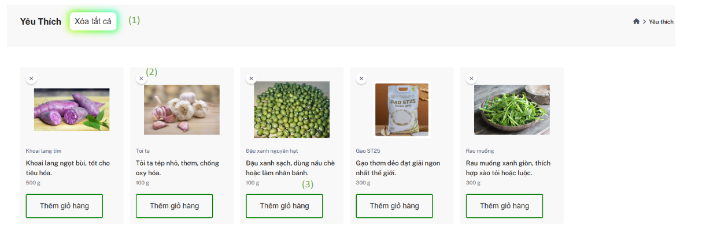

| **Field Name** | **Field Type** | **Description** |
| --- | --- | --- |
| (1) | Button | Delete all |
| (2) | Button | Delete |
| (3) | Button | Add to cart |

| UC ID and Name: | **UC-13 Wishlist** | | |
| --- | --- | --- | --- |
| Created By: | AnhNHHE186216 | Date Created: | 08/03/2025 |
| Primary Actor: | Customer | Secondary  Actors: |  |
| Trigger: | The customer clicks wishlist page | | |
| Description: | This use case allows the customer to wishlist page | | |
| Preconditions: | * User can access wishlist page * The wishlist must in database | | |
| Postconditions: | * The information of wishlist display | | |
| Normal Flow: | 1. The customer navigates to the wishlist“Agrikho” page. 2. The information list of wishlist | | |
| Alternative Flows: | No product, no wishlist added | | |
|  |  | | |

| Priority: | High |
| --- | --- |
| Frequency of Use: | Every day, whenever the user needs to access the system. |
| Business Rules: |  |
| Other Information: |  |
| Assumptions: | * Customer authentication status (logged in or not) is accurately managed via session or token |
| Exceptions: | 1, Database connection is lost → the system shows: “Cannot connect to database.”  2, Network issue during save → system shows: “Request failed, please try again.” |

### **1.14** **Compare product detail**

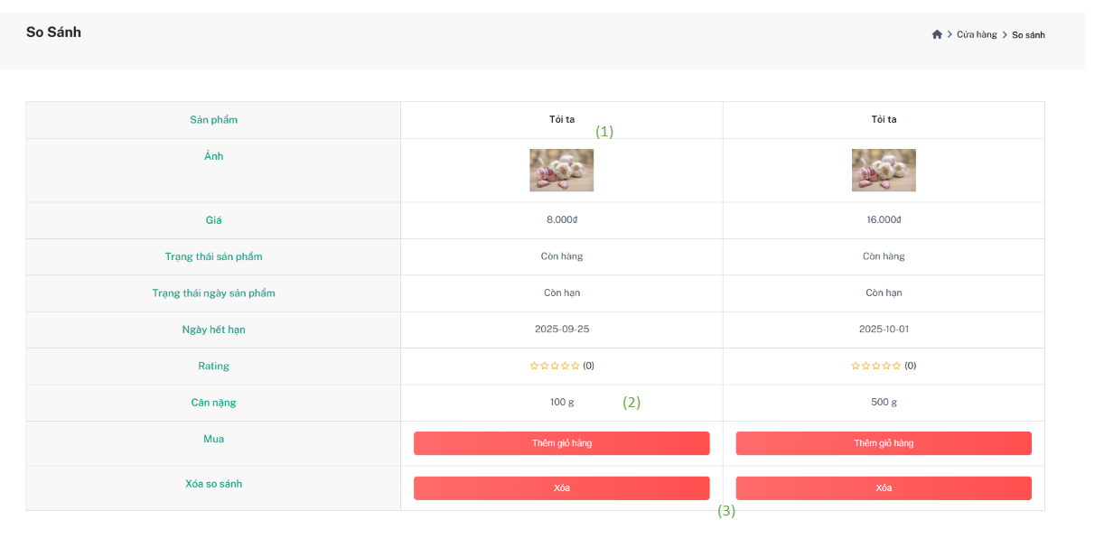

| **Field Name** | **Field Type** | **Description** |
| --- | --- | --- |
| (1) | Arraylist | List compare |
| (2) | Button | Add to cart |
| (3) | Button | Delete compare |

| UC ID and Name: | **UC-14 Compare product detail** | | |
| --- | --- | --- | --- |
| Created By: | AnhNHHE186216 | Date Created: | 08/03/2025 |
| Primary Actor: | Customer | Secondary  Actors: | Guest |
| Trigger: | The customer clicks compare page | | |
| Description: | This use case allows the customer to compare page | | |
| Preconditions: | * User can access compare page * The compare must in database | | |
| Postconditions: | * The information of compare display * Display button delete | | |
| Normal Flow: | 1. The customer navigates to the compare“Agrikho” page. 2. The information list of compare | | |
| Alternative Flows: | No product, no compare added | | |
|  |  | | |

| Priority: | High |
| --- | --- |
| Frequency of Use: | Every day, whenever the user needs to access the system. |
| Business Rules: | 1, If a customer attempts to compare a product detail but product detail not exist, the system must block the action and display“Sản phẩm chi tiết không có nên chưa thể so sánh”  1, If a customer attempts to compare a product detail but product detailout of stock, the system must block the action and display“Sản phẩm chi tiết không còn hàng nên chưa thể so sánh” |
| Other Information: |  |
| Assumptions: | * Customer authentication status (logged in or not) is accurately managed via session or token |
| Exceptions: | 1, Database connection is lost → the system shows: “Cannot connect to database.”  2, Network issue during save → system shows: “Request failed, please try again.” |

### 

### **1.15** **Contact us**

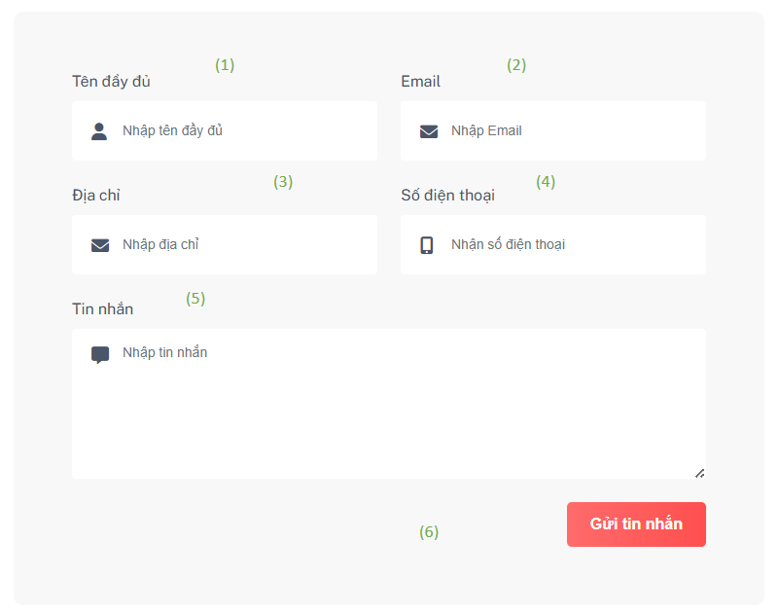

### 

| **Field Name** | **Field Type** | **Description** |
| --- | --- | --- |
| (1) | Input | Fullname |
| (2) | Input | Email |
| (3) | Input | Address |
| (4) | Input | Phone |
| (5) | Input | Message |
| (6) | Button | Send message |

| UC ID and Name: | **UC-15 Contact us** | | |
| --- | --- | --- | --- |
| Created By: | AnhNHHE186216 | Date Created: | 08/03/2025 |
| Primary Actor: | Customer | Secondary  Actors: |  |
| Trigger: | The customer clicks contact us page | | |
| Description: | This use case allows the customer to contact us page | | |
| Preconditions: | * User can access contact us page * The contact us must in database | | |
| Postconditions: | * The information of contact us display * Display button send the message | | |
| Normal Flow: | 1. The customer navigates to the contact us“Agrikho” page. 2. The file information of contact us 3. Submit success send the message | | |
| Alternative Flows: | 1, If a customer send the message but address invalid, the system displays a conflict warning “Địa chỉ không được ít hơn 9 ký tự”  2, If a customer send the message but address invalid, the system displays a conflict warning “Tin nhắn không được ít hơn 9 ký tự” | | |
|  |  | | |

| Priority: | High |
| --- | --- |
| Frequency of Use: | Every day, whenever the user needs to access the system. |
| Business Rules: | 1, If a customer send the message but address invalid, the system displays a conflict warning “Địa chỉ không được ít hơn 9 ký tự”  2, If a customer send the message but address invalid, the system displays a conflict warning “Tin nhắn không được ít hơn 9 ký tự” |
| Other Information: |  |
| Assumptions: | * Customer authentication status (logged in or not) is accurately managed via session or token |
| Exceptions: | 1, Database connection is lost → the system shows: “Cannot connect to database.”  2, Network issue during save → system shows: “Request failed, please try again.” |

### 

### 

## **2.** **Blog**

### **2.1** **View Blog List**

#### 

#### **Screen description**

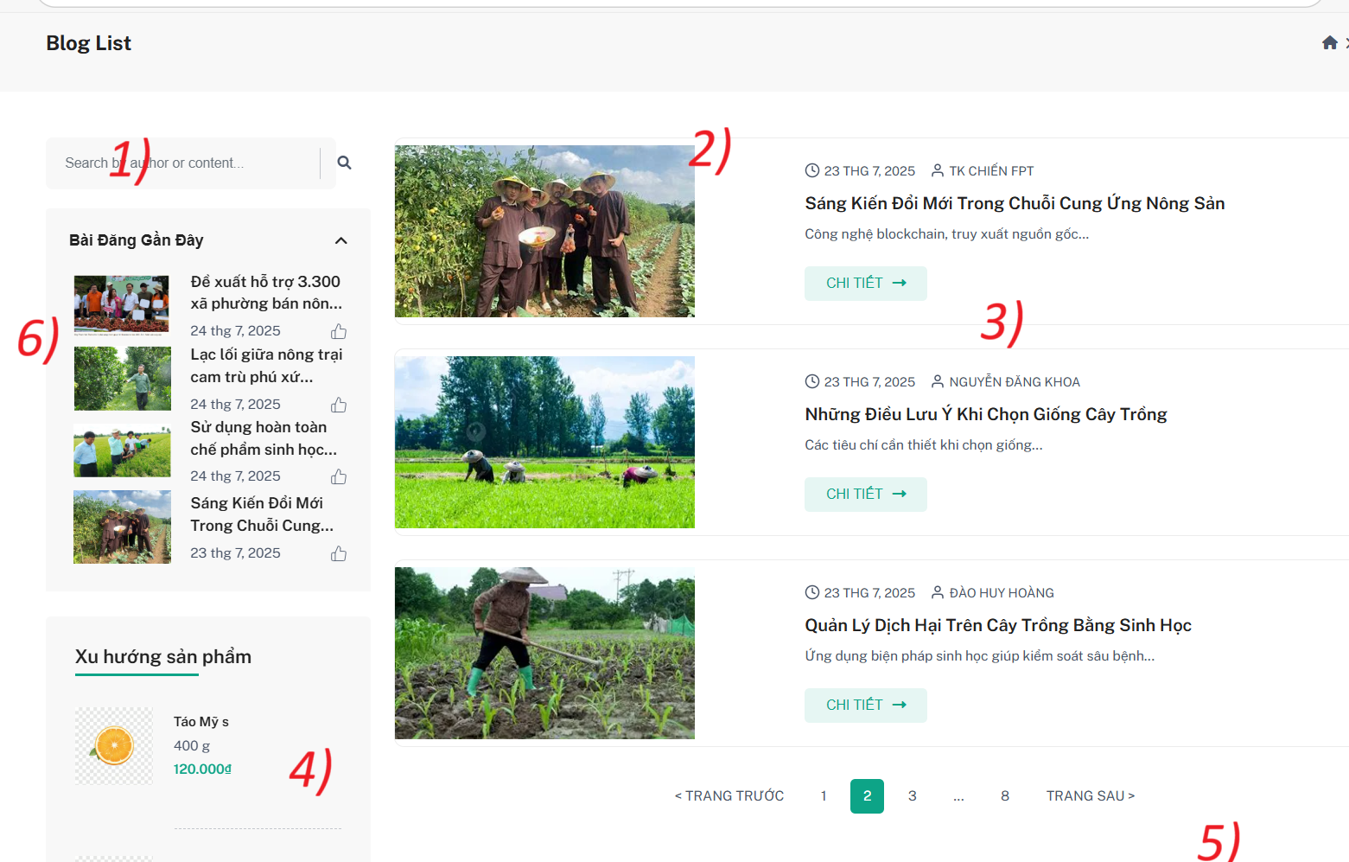

Figure 2.19 - Mockup for view list inventory check use case

***Mockup Fields and Buttons on Blog List Screen:***

| **Field Name** | **Field Type** | **Description** |
| --- | --- | --- |
| (1) **Search** | **Text Input** | Input field for users to search blog posts by title, author, or content. |
| (2) **View List** | **Display** | Displays the list of blog posts with image, title, and date. |
| (3) **View Details** | **Button** | Button that redirects users to the detailed view of the blog post. |
| (4) **Trending Products** | **Slider** | A section showing trending products (e.g., seasonal fruits or other products) with prices. |
| (5) **Pagination** | **Button** | Allows users to navigate between different pages of blog posts. |
| (6) **Recent Blog Posts** | **Display** | Displays 4 recent blog posts with images, titles, and short descriptions, allowing users to click and view more. |

Table 42 - Screen description for view inventory check details

***Use case specification***

| UC ID and Name: | **UC- Blog list** | | |
| --- | --- | --- | --- |
| Created By: | HoangDHHE181245 | Date Created: | 25/07/2025 |
| Primary Actor: | User , Admin | Secondary Actors: | None |
| Trigger: | The user wants to view and interact with the list of available blog posts. | | |

| Description: | This use case describes how a user can view a list of blog posts. Users can browse through the blog list, search for specific blog posts, and click to view detailed posts. Admins can manage the blog list, including creating, updating, and deleting blog posts. |
| --- | --- |
| Preconditions: | * The user must be logged into the system (for Bloger and Admin roles). * A **Guest** user can access and view the blog list without needing to be logged in. * Users (Bloger or Admin) must have the appropriate role to manage blog posts. |
| Postconditions: | * The system successfully displays the blog list. * The user can click on a blog post to view its details. * Admin can manage (CRUD) blog posts by creating, editing, or deleting them. |
| Normal Flow: | 1. The user navigates to the Blog List page. 2. The system displays the list of blog posts with images, titles, and short descriptions. 3. The user can search for specific blog posts using the search bar. 4. The user can click on a blog post to view more details. 5. Admin can manage (CRUD) blog posts by creating, |
| Alternative Flows: | **AF1: Search for a blog**   1. The user enters a keyword in the search bar. 2. The system filters the blog list based on the entered keyword and displays the matching posts. 3. The user can click on any matching post to view its details. |
| Exceptions: | **E1: No blog posts found** If no blog posts match the search query, the system displays: "No blog posts found."  **E2: Server error**  If a server error occurs, the system displays: "An error occurred. Please try again later." |

| Priority: | High |
| --- | --- |
| Frequency of Use: | Frequent |
| Business Rules: | BR_101, BR_102 (for blog list functionality) |
| Other Information: | Blog List is accessible by all user roles mentioned (Admin, Blogger, Guest). |
| Assumptions: | None |

Table 42 - Screen description for view inventory check details

### **2.2** **View Blog Grid**

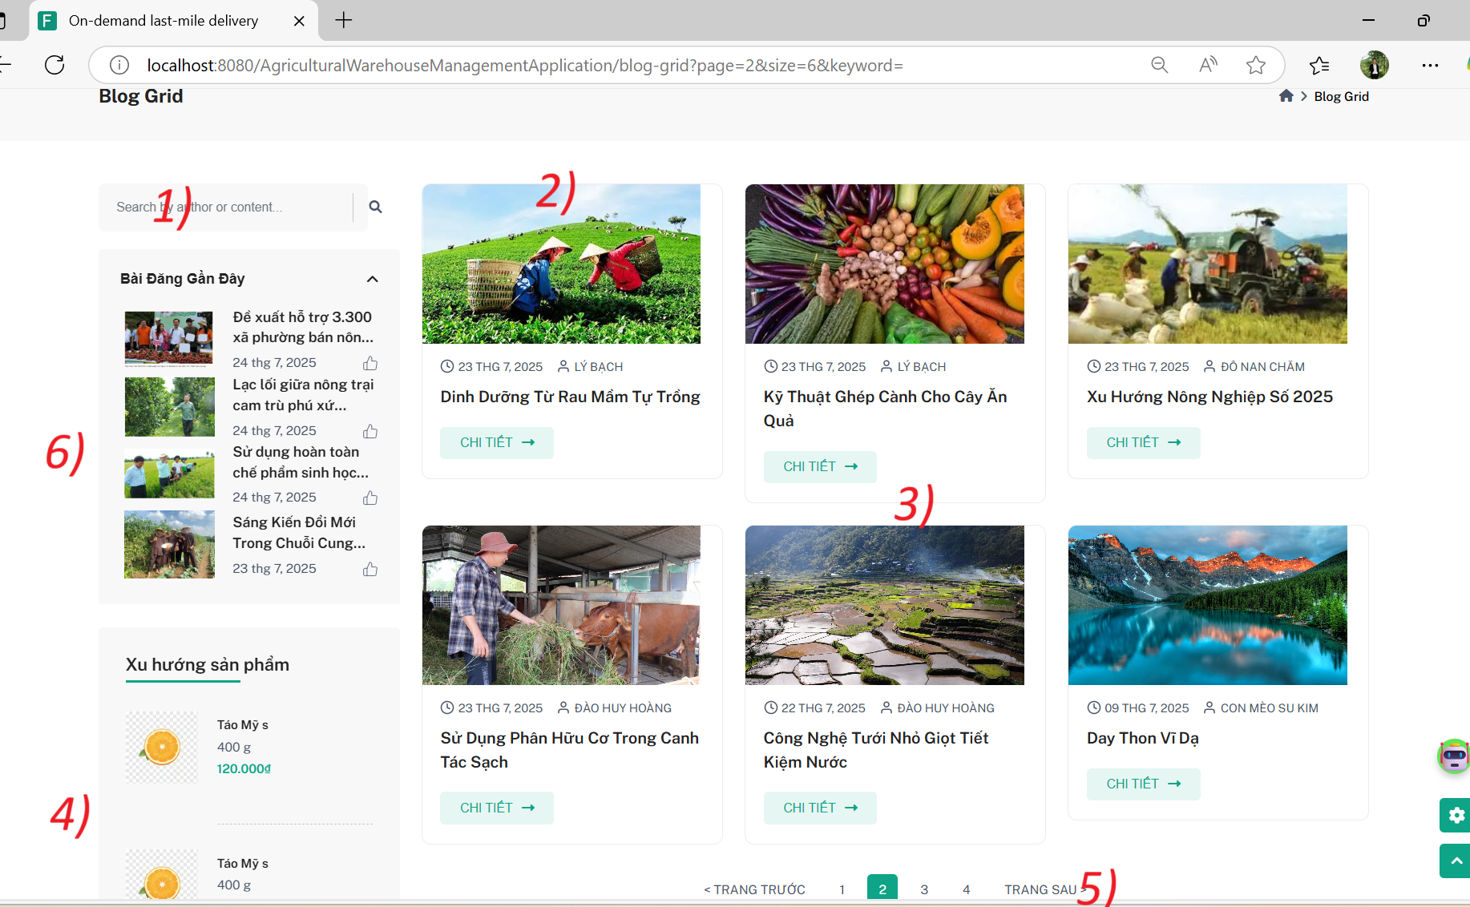

| **Field Name** | **Field Type** | **Description** |
| --- | --- | --- |
| (1) Search | Text Input | Input field for users to search blog posts by title, author, or content. |
| (2) View List | Display | Displays the list of blog posts with image, title, and date. |
| (3) View Details | Button | Button that redirects users to the detailed view of the blog post. |
| (4) Trending Products | Slider | A section showing trending products (e.g., seasonal fruits or other products) with prices. |
| (5) Pagination | Button | Allows users to navigate between different pages of blog posts. |
| (6) Recent Blog Posts | Display | Displays 4 recent blog posts with images, titles, and short descriptions, allowing users to click and view more. |

**Use case specification**

| UC ID and Name: | **UC- Blog grid** | | |
| --- | --- | --- | --- |
| Created By: | HoangDHHE181245 | Date Created: | 25/07/2025 |
| Primary Actor: | User (Blogger), Admin | Secondary Actors: | None |
| Trigger: | The user wants to view and interact with the list of available blog posts. | | |

| Description: | This use case describes how a user can view a list of blog posts. Users can browse through the blog list, search for specific blog posts, and click to view detailed posts. Admins can manage the blog list, including creating, updating, and deleting blog posts. |
| --- | --- |
| Preconditions: | * The user must be logged into the system (for Blogger and Admin roles). * A **Guest** user can access and view the blog list without needing to be logged in. * Users (Blogger or Admin) must have the appropriate role to manage blog posts. |
| Postconditions: | * The system successfully displays the blog list. * The user can click on a blog post to view its details. * Admin can manage (CRUD) blog posts by creating, editing, or deleting them. |
| Normal Flow: | 1. The user navigates to the Blog List page. 2. The system displays the list of blog posts with images, titles, and short descriptions. 3. The user can search for specific blog posts using the search bar. 4. The user can click on a blog post to view more details. 5. Admin can manage (CRUD) blog posts by creating, |
| Alternative Flows: | AF1: Search for a blog   1. The user enters a keyword in the search bar. 2. The system filters the blog list based on the entered keyword and displays the matching posts. 3. The user can click on any matching post to view its details. |
| Exceptions: | E1: No blog posts found  If no blog posts match the search query, the system displays: "No blog posts found."  E2: Server error  If a server error occurs, the system displays: "An error occurred. Please try again later." |

| Priority: | High |
| --- | --- |
| Frequency of Use: | Frequent |
| Business Rules: | BR_101, BR_102 (for blog list functionality) |
| Other Information: | Blog List is accessible by all user roles mentioned (Admin, Blogger, Guest). |
| Assumptions: | None |

### **2.3** **View Blog Detail**

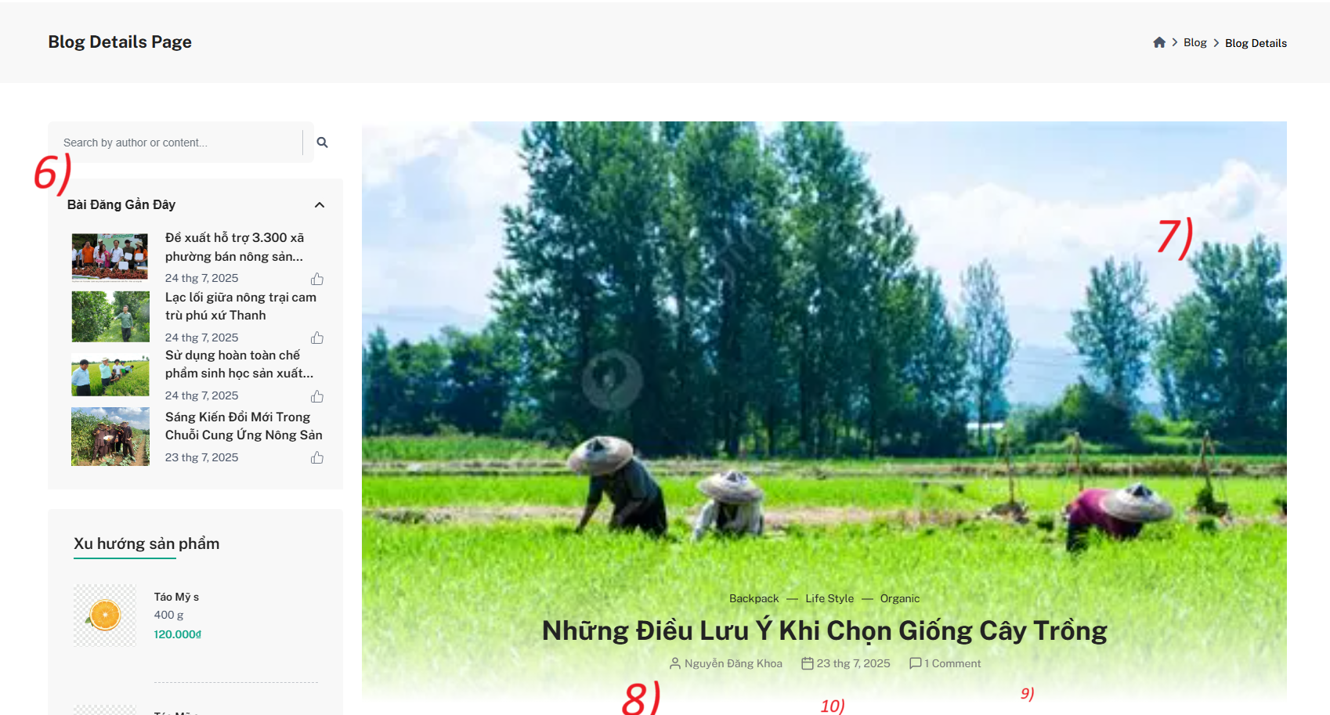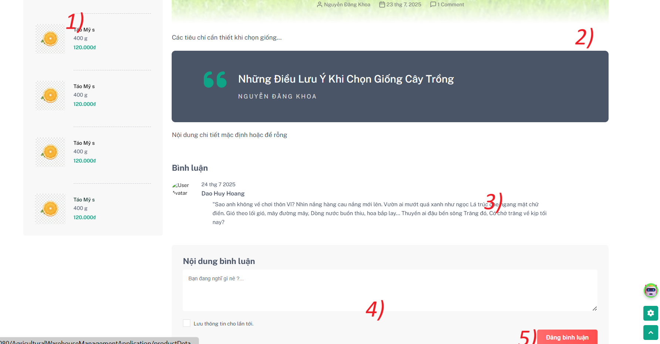

**Mockup Fields and Buttons on Blog Detail Page:**

| **Field Name** | **Field Type** | **Description** |
| --- | --- | --- |
| (1) Trending Products | Slider | Displays trending products like fruits or vegetables with details including weight and price. |
| (2) Blog Content | Text | Displays the full content of the blog post, including images, text, and links, with the title and author information. |
| (3) Comments Section | Display | Shows all user comments on the blog post, including the author and comment content. |
| (4) Comment Field | Text Input | Input field where users can type their comments. |
| (5) Submit Comment Button | Button | Button to submit the comment written by the user. |
| (6) Search Blog | Text Input | A search bar for users to search for blog posts by keywords, author, or content. |
| (7) Image Details | Image | Displays the detailed image or gallery of the blog post. |
| (8) Author Information | Text | Shows the author's name, bio, and other relevant information. |
| (9) Total Comments | Text | Displays the total number of comments on the post. |
| (10) Post Date | Text | Shows the publication date of the blog post. |

***Use Case Specification***

| UC ID and Name: | **UC-02 Blog Detail** | | |
| --- | --- | --- | --- |
| Created By: | HoangDHHE181245 | Date Created: | 25/07/2025 |
| Primary Actor: | User (Bloger), Admin | Secondary Actors: | None |
| Trigger: | The user wants to view a detailed blog post. | | |

| Description: | This use case describes how a user can view the details of a blog post, including reading the content, viewing images, and reading comments. The user can also add their own comments. Admins can manage the blog content. |
| --- | --- |
| Preconditions: | * The user must be logged into the system (for Bloger and Admin roles). * A **Guest** user can access and view the blog details without needing to be logged in. * Users (Bloger or Admin) must have the appropriate role to manage blog posts. |
| Postconditions: | * **The system displays the full blog content.** * **The user can read and add comments to the blog post.** * **Admin can manage (CRUD) blog posts and comments.** |
| Normal Flow: | 1. The user navigates to the Blog Detail page. 2. The system displays the full blog content including text, images, and other media. 3. The user can scroll to view all content and comment sections. 4. The user can view all comments, add their own comment, and submit it using the "Submit Comment" button. 5. Admin can manage (CRUD) the blog and comments |
| Alternative Flows: | AF1: Search for a blog   1. The user enters a keyword in the search bar. 2. The system filters blog posts based on the keyword and displays the matching blogs. 3. The user can select a blog and view its details. |
| Exceptions: | E1: No blog found  If the blog post does not exist or is deleted, the system displays: "Blog not found."  E2: Server error  If a server error occurs, the system displays: "An error occurred. Please try again later." |

### **2.4** **View Blog Manager**

### **2.4.1 View Doashboast**

### 

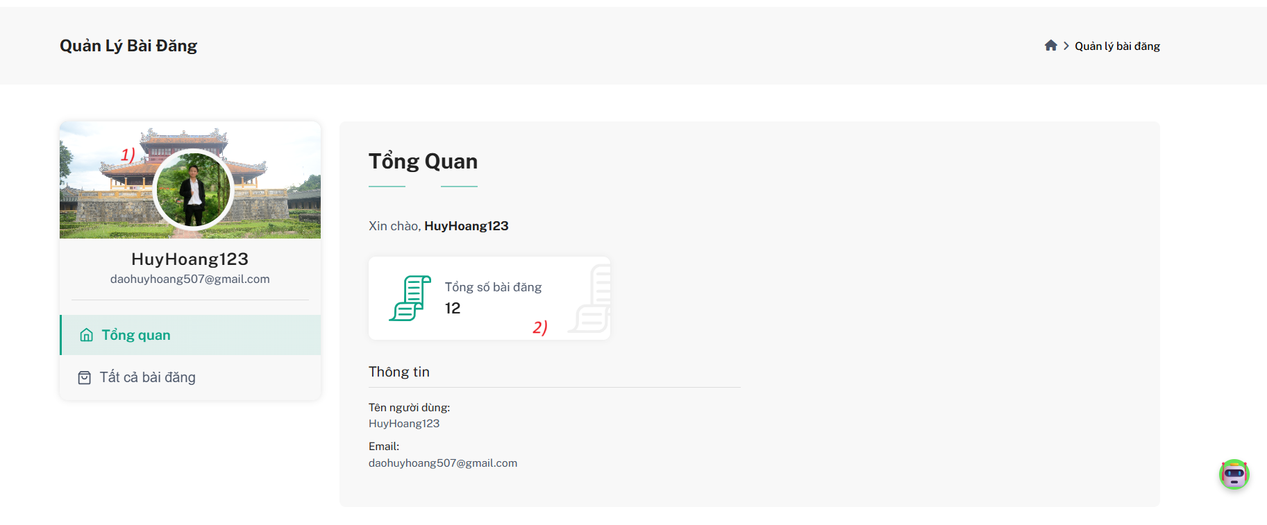

***Mockup Fields and Buttons on "My Blog" Dashboard Tab***

| ***Field Name*** | ***Field Type*** | ***Description*** |
| --- | --- | --- |
| *(1) User Info Display* | *Display Block* | *Loads and displays user's avatar image, full name, and email/username on the left sidebar.* |
| *(2) Total Blog Count* | *API Display / Text* | *Calls an API to retrieve and display the total number of blogs written by the user.* |

**Use Case Specification for Blog DashBoard Page:**

| UC ID and Name: | UC-03 My Blog Dashboard | | |
| --- | --- | --- | --- |
| Created By: | HoangDHHE181245 | Date Created: | 25/07/2025 |
| Primary Actor: | User | Secondary Actors: | None |
| Trigger: | The user accesses the "My Blog" tab from the dashboard to view their blog statistics and profile information. | | |
| Description: | This use case describes how a logged-in user (Bloger or Admin) can view their dashboard, which includes their profile image, name, email, and the total number of blogs they have written. | | |
| Preconditions: | 1. The user must be logged into the system. 2. The user must have a valid account with blog writing privileges. | | |
| Post conditions: | 1.The system loads and displays the user information and total blog count successfully. | | |
| Normal Flow: | 1. The user navigates to the dashboard. 2. The user clicks on the "My Blog" tab. 3. The system retrieves and displays the user's profile (image, name, email). 4. The system calls the API to get the total number of blogs written by the user and displays it. | | |
| Alternative Flows: | None | | |
| Exceptions: | 1. E1: API call failure  If the API call fails, the system displays: "Unable to load blog count. Please try again later." 2. E2: Missing user data  If the user profile data cannot be loaded, the system displays a placeholder with default values. | | |
| Priority: | Medium | | |
| Frequency of Use: | Frequent – Every time the user accesses their dashboard. | | |
| Business Rules: | * BR_201: Only show blog statistics of the logged-in user. * BR_202: Fallback to default avatar if no image is found. | | |
| Other Information: | This feature is only accessible to registered users with blogging privileges. | | |
| Assumptions: | None | | |

### **2.4.2 View Dashboard**

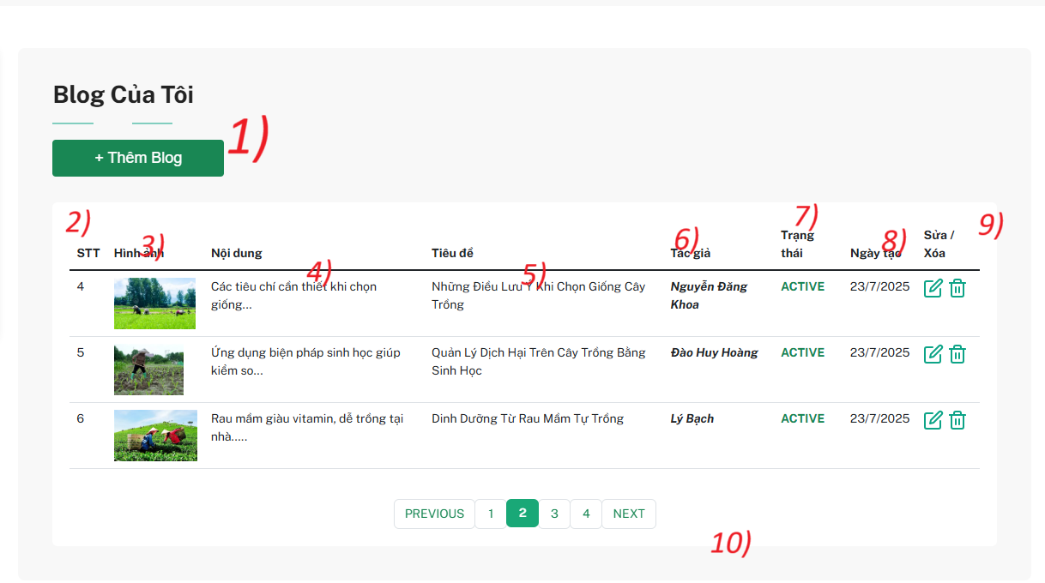

***Mockup Fields and Buttons on "My Blog"***

| *Field Name* | *Field Type* | *Description* |
| --- | --- | --- |
| *(1) Add Blog* | *Button* | *A button that allows the user to create a new blog post. It redirects to the blog creation form.* |
| *(2) Index (No.)* | *Int* | *Displays the serial number (row number) of each blog post in the list.* |
| *(3) Thumbnail Image* | *Image Display* | *Shows the blog post's feature image.* |
| *(4) Content Preview* | *Text* | *A short excerpt or preview of the blog content.* |
| *(5) Title* | *Text* | *Displays the blog post's full title.* |
| *(6) Author* | *Text* | *Displays the name of the blog post’s author.* |
| *(7) Status* | *Status Enum* | *Indicates the status of the blog (e.g., ACTIVE, DRAFT).* |
| *(8) Created Date* | *Date Display* | *Shows the date when the blog was created or published.* |
| *(9) Edit / Delete* | *Icon Buttons* | *Icons for editing (pencil icon) and soft deleting (trash bin icon) the blog post.* |
| *(10) Pagination* | *Button Group* | *Buttons to navigate between multiple pages of blog posts.* |

**Use Case Specification for My Blog Page:**

| UC ID and Name: | UC-04 Manage My Blogs | | |
| --- | --- | --- | --- |
| Created By: | HoangDHHE181245 | Date Created: | 25/07/2025 |
| Primary Actor: | User | Secondary Actors: | None |
| Trigger: | The user wants to manage (view, edit, or delete) their blog posts from their account dashboard. | | |
| Description: | This use case describes how a user can view, manage, and perform CRUD actions on their blogs, including adding a new blog, editing existing ones, or deleting them. | | |
| Preconditions: | 1. The user must be logged in. 2. The user must have permission to write or manage blogs. | | |
| Post conditions: | 1. The system successfully displays all user-created blogs. 2. Any changes (edit/delete/add) are reflected in real time. | | |
| Normal Flow: | 1. User navigates to the My Blog section from the dashboard. 2. System loads and displays the list of blogs created by the user. 3. User can click + Thêm Blog to add a new blog. 4. User can click edit icon to update a blog. 5. User can click delete icon to soft delete a blog. 6. User can use pagination to navigate between multiple pages of blog records. | | |
| Alternative Flows: | AF1: Blog List Empty  If the user has not created any blogs, the system shows a message like “No blogs found.”  AF2: Blog Soft Delete  Deleted blogs are marked as inactive and hidden from the public view, but still stored in the database. | | |
| Exceptions: | * E1: Server Error * If data cannot be loaded or action fails, system shows: "Unable to load your blogs. Please try again later." | | |
| Priority: | High | | |
| Frequency of Use: | Frequent – Used every time a user wants to manage their blogs. | | |
| Business Rules: | * BR_301: Only show blogs created by the logged-in user. * BR_302: Blog deletion should be soft delete (not permanent unless by admin). | | |
| Other Information: | Admin users may have access to view and manage all blogs across the system. | | |
| Assumptions: | None | | |

### **2.4.3 Add blog for user**

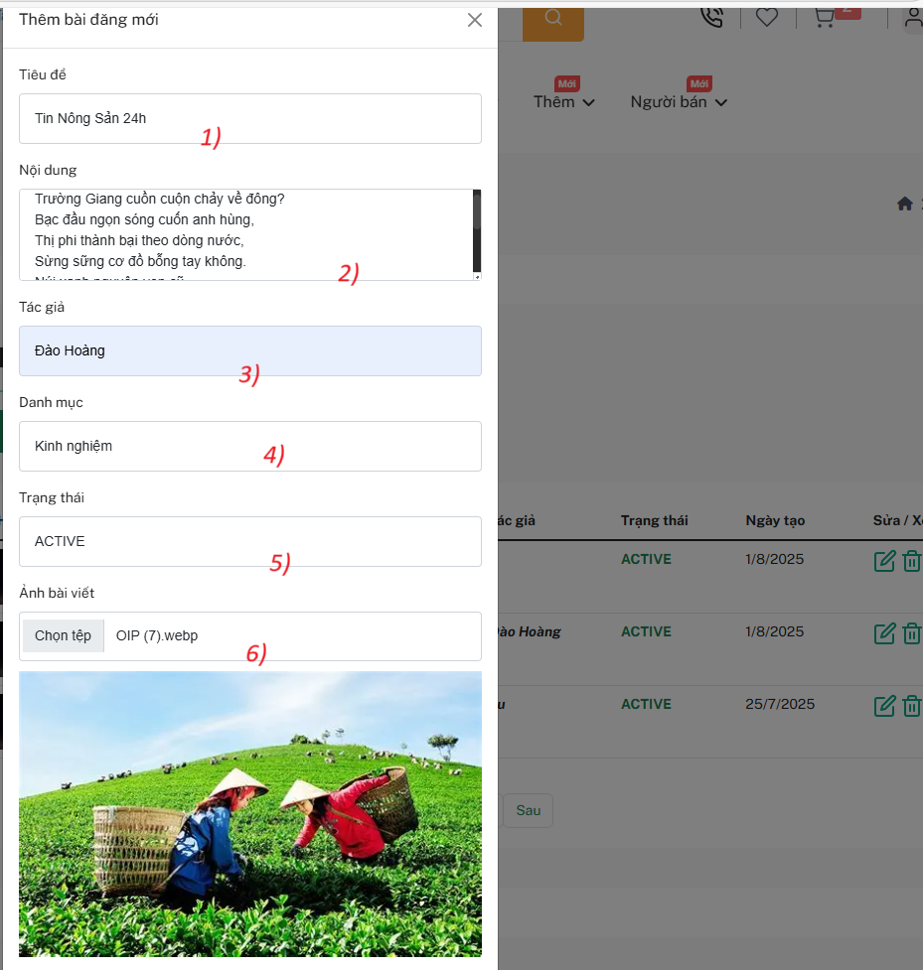

**Mockup Fields and Buttons – Add Blog Form**

| Field Name | Field Type | Description |
| --- | --- | --- |
| (1) Title | Text Input | Required field. User must enter a blog title. |
| (2) Content | Textarea | Required field. The user must enter content (cannot be null). |
| (3) Author Name | Auto-Filled Input | If not manually entered, system auto-fills this with the current logged-in user's full name. |
| (4) Category | Dropdown Select | Loads options from the database dynamically (e.g., Kinh nghiệm, Tin tức, Hướng dẫn, etc.). |
| (5) Status | Enum Dropdown | Loads values from Enum BlogStatus { ACTIVE, INACTIVE, DRAFT, DELETED }. |
| (6) Image Upload | File Upload + Preview | Users can upload an image file and instantly see a preview before saving. |

**Use Case Specification for My Blog Page:**

| **UC ID and Name:** | **UC-12 Add New Blog Post** | | |
| --- | --- | --- | --- |
| **Created By:** | HoangDHHE181245 | **Date Created:** | *25/07/2025* |
| **Primary Actor:** | Logged-in User | **Secondary Actors:** | *None* |
| **Trigger:** | User opens the "Add Blog" form to post a new article. | | |
| **Description:** | This use case allows a user to create and submit a new blog post with image support, title, content, category, and status options | | |
| **Preconditions:** | User must be logged in.  User must have permission to post blogs. | | |
| **Post conditions:** | A new blog post is saved to the database with valid data. | | |
| **Normal Flow:** | User clicks “+ Thêm Blog”.  System opens the blog creation modal.  User fills in the following:   * Tiêu đề (required) * Nội dung (required) * Tác giả (default = fullname from user session) * Danh mục (loaded from blog category table) * Trạng thái (loaded from Enum: ACTIVE, INACTIVE, DRAFT, DELETED) * Ảnh bài viết (upload + preview)   User clicks “Lưu” (Save).  System validates inputs:   * Title & Content are not null * Category is selected * Optional image is processed if uploaded   Blog is saved successfully and shown in user’s blog list. | | |
| **Alternative Flows:** | * AF1: Missing required fields  → System shows validation error messages beside empty fields. * AF2: Invalid image file  → System rejects upload and shows: “Unsupported image format”. | | |
| **Exceptions:** | E1: Server error during save  → System shows: “Unable to save blog. Please try again later.” | | |
| **Priority:** | High | | |
| **Frequency of Use:** | Daily – Shippers access and manage delivery orders regularly. | | |
| **Business Rules:** | BR_201: Title and content are mandatory.  BR_202: If author is not filled, use session.user.fullname.  BR_203: Image preview must work before submission.  BR_204: Only valid categories from the database can be selected.  BR_205: Status options must map to BlogStatus Enum. | | |

### 

### 

### **2.4.4 Edit blog for user**

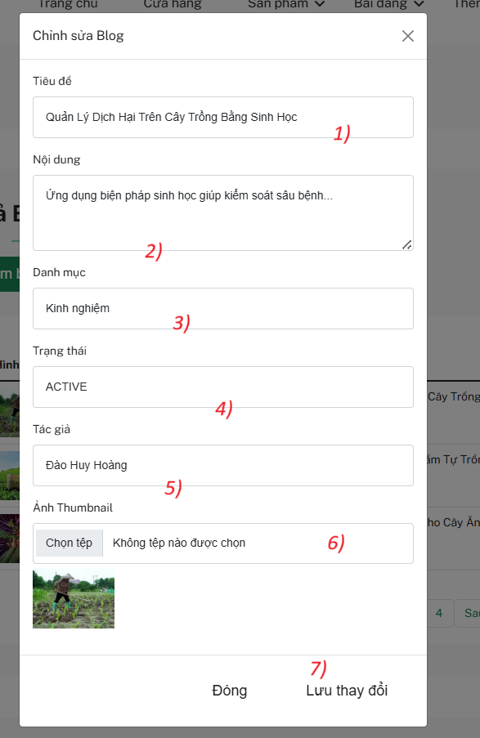

***Mockup Fields and Buttons – Blog Edit Management (Admin Panel)***

| **No.** | **Field Name** | **Type** | **Behavior / Validation Rule** |
| --- | --- | --- | --- |
| 1 | Title | Text input | Required. User can edit. Cannot be left empty. |
| 2 | Content | Textarea | Required. User can edit. Cannot be left empty. |
| 3 | Category | Dropdown | Loaded from database. Can be selected from predefined categories. |
| 4 | Status | Enum select | Options: ACTIVE, INACTIVE, DRAFT, DELETED. Loaded from enum. |
| 5 | Author | Text (view) | Display only. Pre-filled with author name. Cannot be changed. |
| 6 | Thumbnail Image | File upload | Optional. Allows selecting new image. Shows preview of current or selected image. |
| 7 | Action Buttons | Button | Close: Closes the modal.Save changes: Validates and submits updated blog post. |

**Use Case Specification – Blog Edit Management (Admin Panel)**

| **UC ID and Name:** | **UC-08 Edit Blog Post** | | |
| --- | --- | --- | --- |
| **Created By:** | HoangDHHE181245 | **Date Created:** | 25/07/2025 |
| **Primary Actor:** | User | **Secondary Actors:** | None |
| **Trigger:** | User clicks the "Edit" button on a blog entry | | |
| **Description:** | This use case allows a user to edit and submit a new blog post with image support, title, content, category, and status options. | | |
| **Preconditions:** | User is logged in.  The blog post is created by the currently logged-in user | | |
| **Post conditions:** | Blog post data is updated and saved to the database.  UI reflects the changes immediately or after reload. | | |
| **Normal Flow:** | User clicks the Edit Blog button on a blog post.  The system loads the blog post's existing details into the form:   * 1️⃣ Title 2️⃣ Content * 3️⃣ Category (loaded from database) * 4️⃣ Status (loaded from enum values) * 5️⃣ Author (non-editable) * 6️⃣ Thumbnail image (with preview)   User edits any of the editable fields.  User clicks Lưu thay đổi.  The system validates input (e.g., not null for required fields).  If valid, system updates the blog post and shows success message. | | |
| **Alternative Flows:** | AF1 – User cancels changes:  → User clicks Đóng, modal closes without saving.  AF2 – Category list is empty:  → Show message: “No categories available. Please create one first.”  AF3 – No thumbnail selected:  → Keep the existing thumbnail if the user doesn’t upload a new one. | | |
| **Exceptions:** | E1 – Validation Error:  → Required fields (Title, Content) are empty → Show inline error message.  E2 – Save Failed:  → Show message: “Unable to save changes. Please try again later.”  E3 – Unauthorized Access:  → User tries to edit someone else’s blog post → Deny action. | | |
| **Priority:** | Medium | | |
| **Frequency of Use:** | Occasional – Used by content creators to update published or drafted posts. | | |
| **Business Rules:** | BR_901: Title and Content are required fields.  BR_902: Only the post's author can edit it.  BR_903: Status must be one of: ACTIVE, INACTIVE, DRAFT, DELETED.  BR_904: Uploaded images must be validated and previewed before saving | | |
| **Other Information:** | Author name is shown but cannot be modified.  Blog post ID is passed via backend for update reference. | | |
| **Assumptions:** | None | | |

### **2.5** **View Blog Manager Admin**

#### **2.5.1 View All Blog**

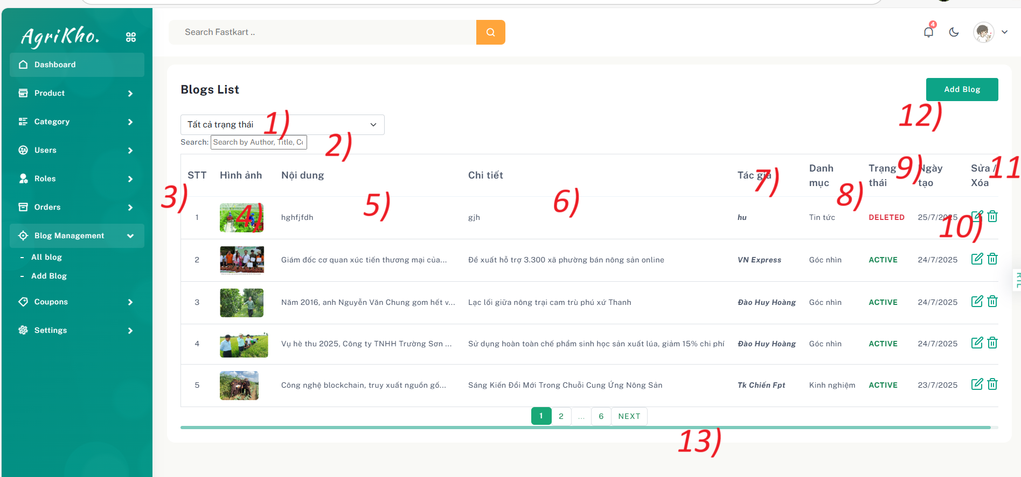

***Mockup Fields and Buttons – Blog Management (Admin Panel)***

| ***Field Name*** | ***Field Type*** | ***Description*** |
| --- | --- | --- |
| (1) Status Filter | Dropdown Select | Allows admin to filter blog posts by their current status (e.g., ALL, ACTIVE, DELETED). |
| (2) Search Bar | Text Input | Enables keyword search by Author, Title, or Content. |
| (3) Index (No.) | Text | Displays the row number (serial order) of blog entries in the table. |
| (4) Thumbnail Image | Image Display | Displays the feature image of the blog post. |
| (5) Blog Content | Text Preview | A short preview/excerpt of the blog’s main content. |
| (6) Blog Title | Text | The full title of the blog post displayed as a linked or static text. |
| (7) Author | Text | Name of the person or entity who created or submitted the blog. |
| (8) Blog Category | Text | Displays the assigned category of the blog post (e.g., News, Insights, Experience). |
| (9) Status Label | Badge / Tag | Indicates the current state of the blog: ACTIVE, DRAFT, or DELETED. |
| (10) Created Date | Date Text | The date when the blog was created or published. |
| (11) Edit / Delete | Icon Buttons | Buttons to update or soft delete a blog post. The delete function typically hides the blog. |
| (12) Add Blog Button | Button | Allows admin to create and add a new blog post. Redirects to the blog creation page or modal. |
| (13) Pagination Control | Navigation Buttons | Provides page navigation for browsing through the blog list. |

**Use Case Specification – Blog Management (Admin Panel)**

| **UC ID and Name:** | **UC-05 Admin Blog Management** | | |
| --- | --- | --- | --- |
| **Created By:** | HoangDHHE181245 | **Date Created:** | 25/07/2025 |
| **Primary Actor:** | Admin | **Secondary Actors:** | None |
| **Trigger:** | The admin wants to view, search, filter, manage, or create blog posts from the Blog Management section. | | |
| **Description:** | This use case describes how an admin can manage all blogs in the system. This includes viewing the blog list, filtering by status, searching by author/title/content, creating new blogs, updating existing ones, and performing soft deletion of blogs. | | |
| **Preconditions:** | Admin must be logged into the system.  Admin must have the necessary blog management permissions. | | |
| **Post conditions:** | The system displays the filtered or searched blog list.  Admin can add a new blog or successfully update/delete an existing one. | | |
| **Normal Flow:** | 1. Admin navigates to Blog Management > All Blog. 2. The system displays a list of all blog posts with full table information.   Admin can:  (a) Use the Filter dropdown to filter by status (ALL, ACTIVE, DELETED).  (b) Use the Search bar to find blogs by author, title, or content.   1. Admin clicks Add Blog to create a new blog. 2. Admin clicks Edit icon to update blog information. 3. Admin clicks Delete icon to soft-delete a blog. 4. Admin uses Pagination controls to navigate through multiple blog pages. | | |
| **Alternative Flows:** | **AF1: No Results Found** If the search or filter yields no results, the system displays:  "No blogs matched your search criteria."  AF2: Add Blog Cancelled  Admin can cancel creating a blog before saving. The system returns to the blog list without changes. | | |
| **Exceptions:** | **E1: Server Error / API Failure**  The system fails to load blog data or process an action.  → System displays: "An error occurred. Please try again later."  **E2: Validation Error on Edit/Add** Admin enters invalid or incomplete data.  → System shows form validation messages. | | |
| **Priority:** | **High** | | |
| **Frequency of Use:** | Daily – Regular activity for content supervision and publishing. | | |
| **Business Rules:** | **BR_501:** Only admin roles can access full blog management.  **BR_502:** Deleted blogs are soft-deleted and hidden from public view.  **BR_503:** Blog statuses must be one of [ACTIVE, DRAFT, DELETED]. | | |
| **Other Information:** | Supports content governance, moderation, and publishing workflows for the blog system. | | |
| **Assumptions:** | Admin is familiar with blog editorial standards.  Blogs with DELETED status are not shown to public users. | | |

4***) Shipper Management***

## **3.** Shipper - delivery manager

### **3.1** **View Dashboard shipper**

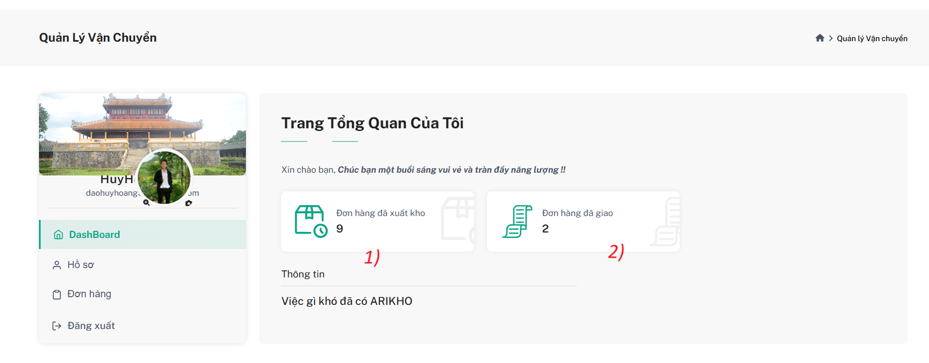

**Mockup Fields and Buttons – Shipper Dashboard (Role: Shipper)**

| **Field Name** | **Field Type** | **Description** |
| --- | --- | --- |
| (1) Stockout Orders Count | Count Display | Displays the number of orders that have been shipped from the warehouse (status = Stockout). |
| (2) Delivered Orders Count | Count Display | Displays the total number of orders that have been either delivered (Delivered) or completed (Completed). |

**Use Case Specification – View Delivery Dashboard (Shipper)**

| UC ID and Name: | UC-05 Shipper Management | | |
| --- | --- | --- | --- |
| Created By: | HoangDHHE181245 | Date Created: | 25/07/2025 |
| Primary Actor: | Shipper | Secondary Actors: | None |
| Trigger: | The Shipper logs into the system and accesses the dashboard to view delivery statistics. | | |
| Description: | This use case describes how the Shipper can view the dashboard that summarizes key delivery metrics, including the number of orders shipped from the warehouse and the number of orders successfully delivered or completed. | | |
| Preconditions: | 1. The Shipper must be logged into the system. 2. The system must have valid order data associated with the logged-in shipper. | | |
| Post conditions: | The system displays real-time statistics including:   * Total number of Stockout orders. * Total number of orders with status Delivered or Completed. | | |
| Normal Flow: | The Shipper logs in and is redirected to the Dashboard.  The system loads all relevant delivery orders assigned to the Shipper.  The system calculates:   * Number of orders with status = Stockout. * Number of orders with status = Delivered or Completed.   The system displays both counts in clearly labeled summary cards. | | |
| Alternative Flows: | E1: No Data Available  → The system displays: “No delivery data available at this time.”  E2: Server/API Error  → The system displays: “Failed to load delivery statistics. Please try again later.” | | |
| Exceptions: | E1: Server Error / API Failure  The system fails to load blog data or process an action.  → System displays: "An error occurred. Please try again later."  E2: Validation Error on Edit/Add  Admin enters invalid or incomplete data.  → System shows form validation messages. | | |
| Priority: | High | | |
| Frequency of Use: | Every time the Shipper logs in or returns to the dashboard. | | |
| Business Rules: | BR_601: Orders are counted only if assigned to the current Shipper.  BR_602: Only orders with valid status values (Stockout, Delivered, Completed) are included in the count. | | |
| Other Information: | This dashboard is designed to help Shippers quickly track delivery performance and status. | | |
| Assumptions: | None | | |

### **3.2** Shipper Profile Manegement

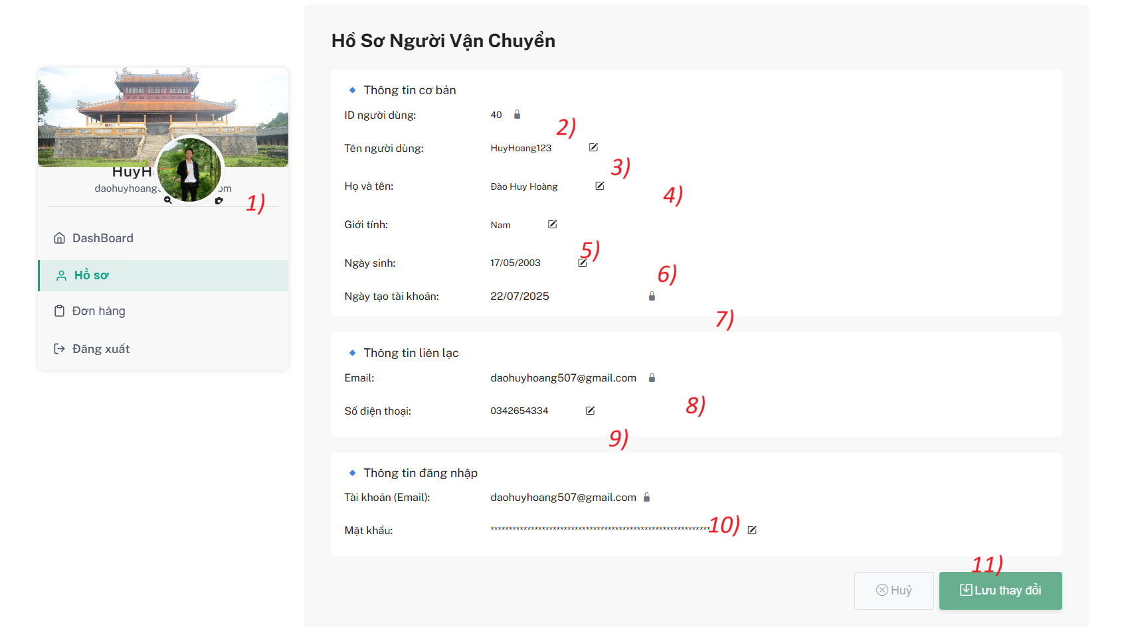

***Mockup Fields and Buttons – User Profile Page (Role: Shipper)***

| ***Field Name*** | ***Field Type*** | ***Description*** |
| --- | --- | --- |
| (1) Avatar & Basic Info | Image + Text Display | Displays user's avatar, full name, and email on the sidebar. |
| (2) User ID | Read-Only Text | Displays unique user ID (non-editable). |
| (3) Full Name | Editable Text | Allows user to edit their full name. |
| (4) Gender | Dropdown Select | Allows user to select gender: Male, Female, or Other. |
| (5) Date of Birth | Date Picker | Allows user to select or update their date of birth. |
| (6) Account Created Date | Read-Only Date | Displays account creation date (non-editable). |
| (7) Email (Contact Info) | Read-Only Text | Shows email address in the contact section (non-editable). |
| (8) Phone Number | Editable Text | Allows user to update their phone number. |
| (9) Login Email | Read-Only Text | Displays login email address (non-editable). |
| (10) Password | Change Link/Button | Opens modal or section to change password. |
| (11) Save Changes | Submit Button | Saves all editable changes made to the profile. |

***Use Case Specification – Update Profile (Shipper)***

| UC ID and Name: | UC-07 Update Profile Shipper | | |
| --- | --- | --- | --- |
| Created By: | HoangDHHE181245 | Date Created: | 25/07/2025 |
| Primary Actor: | Shipper | Secondary Actors: | None |
| Trigger: | The shipper wants to view and update their personal profile information. | | |
| Description: | This use case describes how the shipper can view and update editable fields in their personal profile, including name, gender, birth date, and phone number. They can also initiate a password change. | | |
| Preconditions: | 1. Shipper must be logged into the system. 2. Only allowed fields can be edited. | | |
| Post conditions: | 1. Profile changes are saved successfully. 2. Password is changed if edited and valid. | | |
| Normal Flow: | 1. The shipper opens the Profile page from the dashboard. 2. The system loads all current profile information. 3. The shipper edits their full name, gender, birth date, or phone number. 4. The shipper optionally clicks on “Change Password” to update their password. 5. The shipper clicks Save Changes. 6. The system validates input and updates the profile. 7. A success message is shown. | | |
| Alternative Flows: | AF1: Cancel Changes  The user clicks the “Cancel” button → No changes are saved.  AF2: Open Change Password Modal  Clicking the password field opens a modal for current password + new password + confirm password. | | |
| Exceptions: | E1: Validation Error  → System shows inline messages (e.g., "Phone number is invalid", "Name is required").  E2: Server Error  → System displays: “Unable to update profile. Please try again later.” | | |
| Priority: | High | | |
| Frequency of Use: | Occasional – whenever the user needs to update personal information. | | |
| Business Rules: | BR_701: Only editable fields (name, gender, dob, phone) are allowed.  BR_702: Email and ID must be read-only.  BR_703: Password change requires current password confirmation. | | |
| Other Information: | Supports account personalization and user data accuracy. | | |
| Assumptions: | None | | |

### **3.3 Shipper Order Manegement**

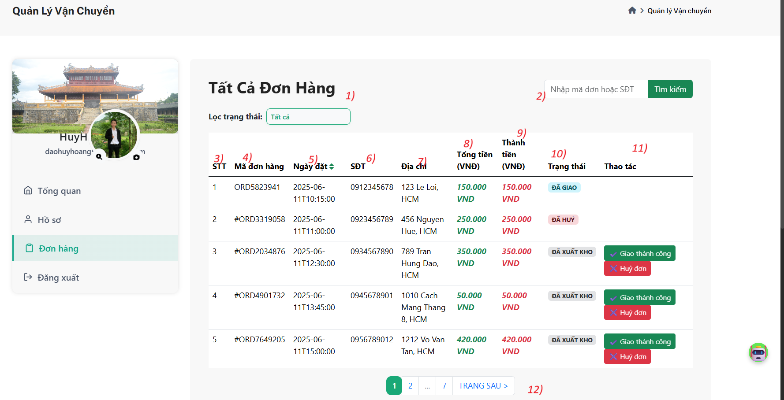

***Mockup Fields and Buttons – Order Management (Role: Shipper)***

| Field Name | Field Type | Description |
| --- | --- | --- |
| (1) Status Filter | Dropdown Select | Allows the shipper to filter orders by status (ALL, PENDING, CONFIRMED, CANCELLED, STOCKOUT, DELIVERED, COMPLETED). |
| (2) Search Bar | Text Input | Realtime search by Order Code or Phone Number. |
| (3) Index (STT) | Text | Row number showing the order’s position in the list. |
| (4) Order Code | Text | Unique code identifying the order. |
| (5) Order Date | Sortable Date Column | Displays the date and time the order was placed. Sortable by ascending/descending. |
| (6) Phone Number | Text | Shows the recipient’s phone number. |
| (7) Address | Text | Displays the full delivery address. |
| (8) Total Amount | Currency Text | Total value of the order. |
| (9) Amount to be Paid | Currency Text | The amount that the customer will pay upon delivery. |
| (10) Order Status | Badge Label | Displays the current status of the order (e.g., ĐÃ GIAO, ĐÃ HUỶ, ĐÃ XUẤT KHO, etc.). |
| (11) Action Buttons | Buttons (Conditional) | If status = STOCKOUT → show: Giao thành công (→ DELIVERED) and Huỷ đơn (→ CANCELLED). Otherwise, hide these buttons. |
| (12) Pagination Controls | Navigation Buttons | Allows navigation through multiple pages of orders. |

***Use Case Specification – Manage Delivery Orders (Shipper)***

| UC ID and Name: | UC-08 Manage Delivery Orders | | |
| --- | --- | --- | --- |
| Created By: | HoangDHHE181245 | *Date Created:* | *25/07/2025* |
| Primary Actor: | Shipper | *Secondary Actors:* | *None* |
| Trigger: | The shipper can to view, search, filter, or update the status of delivery orders. | | |
| Description: | This use case allows the Shipper to view and manage orders assigned for delivery. They can filter and search orders, view details, and change the delivery status of eligible orders (i.e., orders with status STOCKOUT). | | |
| Preconditions: | 1. Shipper is logged in. 2. Orders must be assigned to the shipper and in a valid state (STOCKOUT) to allow delivery actions. | | |
| Post conditions: | Orders are filtered/searched correctly.  If action buttons are used, order status updates successfully. | | |
| Normal Flow: | 1. Shipper accesses the “Orders” section. 2. System loads all assigned orders with default filter ALL. 3. Shipper can:  * Use status filter to refine orders. * Use search bar to find orders by code or phone. * Click on column header to sort by Order Date.  1. For orders with status STOCKOUT:  * Click Giao thành công → status updates to DELIVERED. * Click Huỷ đơn → status updates to CANCELLED.  1. The system updates the order status and refreshes the table. | | |
| Alternative Flows: | * AF1: Status is not STOCKOUT  → Action buttons are not shown. * AF2: No Orders Found  → The system displays: “No orders matched your criteria.” | | |
| Exceptions: | E1: Update Failed  → System shows: “Unable to update order status. Please try again later.”  E2: Invalid Access  → If the order doesn’t belong to the logged-in shipper → deny access. | | |
| Priority: | High | | |
| Frequency of Use: | Daily – Shippers access and manage delivery orders regularly. | | |
| Business Rules: | BR_801: Only show delivery actions for orders with status = STOCKOUT.  BR_802: Orders must belong to the currently logged-in shipper.  BR_803: All status transitions must be logged with timestamp and user info. | | |
| Other Information: | Shippers cannot edit order content – they can only perform delivery confirmation or cancel. | | |
| Assumptions: | None | | |

## **4. Seller Dashboard**

#### **Screen description**

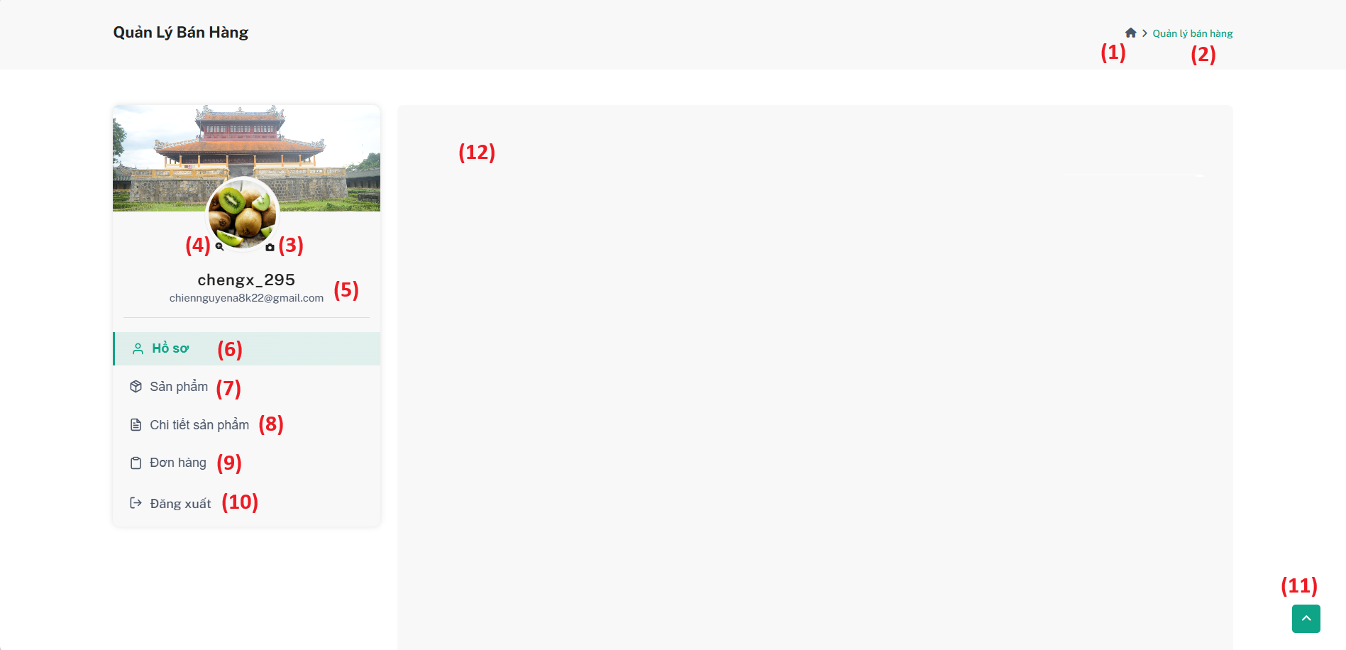

| **Field Name** | **Field Type** | **Description** |
| --- | --- | --- |
| 1 | Icon Button | House icon that navigate to home page as guest |
| 2 | Text | Breadcrumb showing "Seller Management" |
| 3 | Icon Button | Change avatar image |
| 4 | Icon Button | Zoom avatar image |
| 5 | Text | Seller username and email under avatar |
| 6 | Icon + Text Button | Menu item: Profile |
| 7 | Icon + Text Button | Menu item: Product |
| 8 | Icon + Text Button | Menu item: Product Detail |
| 9 | Icon + Text Button | Menu item: Order |
| 10 | Icon + Text Button | Menu item: Logout |
| 11 | Icon Button | Floating scroll-to-top button |
| 12 | Dynamic Content | Data content area that changes based on selected tab |

***Use case specification***

| UC ID and Name: | **UC-30 Seller Dashboard Navigation** | | |
| --- | --- | --- | --- |
| Created By: | ChienNXHE1811121 | Date Created: | 01/08/2025 |
| Primary Actor: | Seller | Secondary  Actors: | N/A |
| Trigger: | The Seller wants to access and manage seller-related features through the dashboard menu. | | |
| Description: | This use case describes how the Seller interacts with the Seller Dashboard interface to navigate between seller management functions. The dashboard contains profile information, navigation menu items, and a floating scroll-to-top button for quick access. | | |
| Preconditions: | * The Seller must be logged into the system. * The Seller account must be active. | | |
| Postconditions: | * The Seller can navigate to the desired module (Profile, Product, Product Detail, Order). * The Seller can log out or update avatar as needed. | | |
| Normal Flow: | **UC-30 Seller Dashboard Navigation**   1. The Seller accesses the Seller Dashboard. 2. The system displays:  * House icon (home page as guest). * Breadcrumb "Seller Management". * Seller avatar + email + username. * Left sidebar navigation menu. * Floating scroll-to-top button.  1. The Seller can:  * Click the **House icon** to navigate to the home page as guest. * Click **Change avatar** button to upload new avatar image. * Click **Zoom avatar** button to enlarge avatar image. * View **username** and **email** under avatar. * Click **Profile** to view/edit profile. * Click **Product** to manage products. * Click **Product Detail** to manage product details. * Click **Order** to view/manage orders. * Click **Logout** to log out of the seller account. * Use **Scroll-to-top button** to quickly return to the top of the page. | | |

| Alternative Flows: | **No Products Found:  -** The system displays default avatar image. **System Error:** - The system displays an error: "Unable to load seller dashboard. Please try again later."  - Seller can retry loading the page. |
| --- | --- |
| Exceptions: | * The system is unable to load data due to network issue. * The system shows an error message and prompts the user to retry. |
| Priority: | High |
| Frequency of Use: | Daily or every login session of Seller |
| Business Rules: | None |
| Other Information: | None |
| Assumptions: | * Menu items are predefined and operational. * Avatar image updates reflect immediately after change. * Scroll-to-top button is always available when page is scrolled down. |

## 

### **4.1 Profile Management**

#### **Screen description**

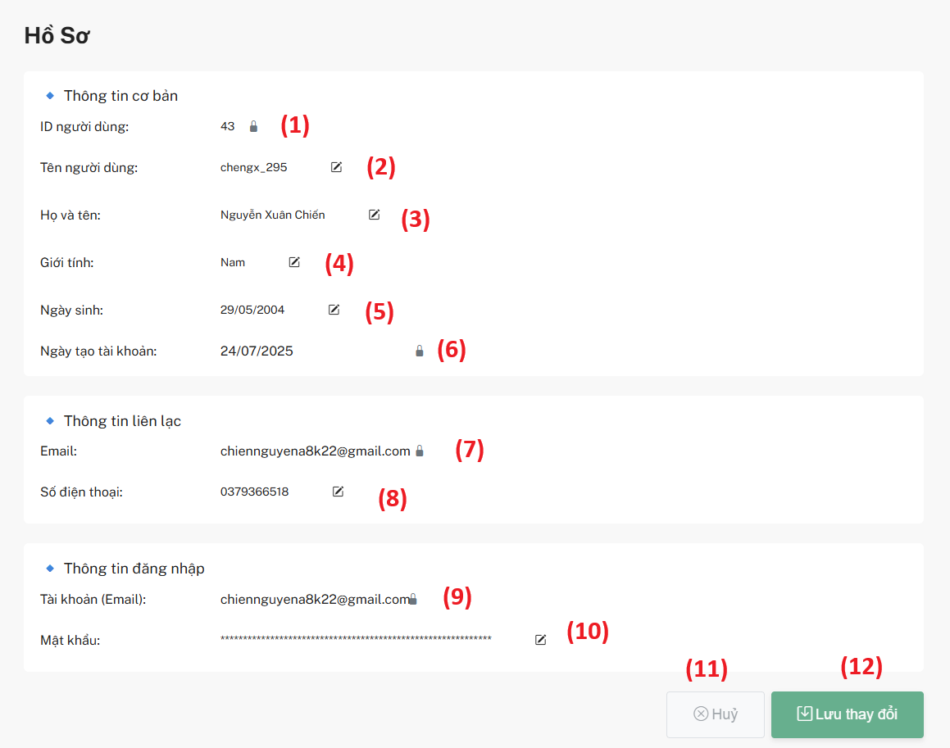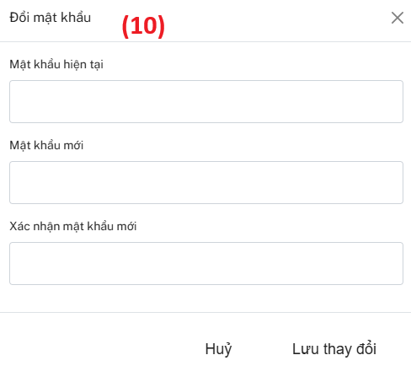

| **Field** | **Field Type** | **Description** |
| --- | --- | --- |
| 1 | Text | Display only, not editable |
| 2 | Text + Edit Icon | Editable username using inline text field |
| 3 | Text + Edit Icon | Editable full name using inline text field |
| 4 | Dropdown + Icon | Editable gender using dropdown selection |
| 5 | Date Picker + Icon | Editable date of birth using date input |
| 6 | Text | Display only, not editable |
| 7 | Text | Display only, not editable |
| 8 | Text + Edit Icon | Editable phone number using inline text field |
| 9 | Text | Display only, same as contact email |
| 10 | Icon Button | Opens modal with 3 fields: current password, new password, confirm password. Password encrypted with bcrypt encryption. |
| 11 | Button | Used to discard changes after editing |
| 12 | Button | Used to save changes after editing |

***Use case specification***

| UC ID and Name: | **UC-10 Update Seller Profile** | | |
| --- | --- | --- | --- |
| Created By: | ChienNXHE1811121 | Date Created: | 01/08/2025 |
| Primary Actor: | Seller | Secondary  Actors: | N/A |
| Trigger: | The seller wants to update their personal profile information such as name, phone number, date of birth, etc. | | |
| Description: | This use case describes how a seller can view and update their personal profile. The profile includes display-only fields (e.g., User ID, Email) and editable fields (e.g., Full Name, Phone Number). Some fields are edited directly via inline input or dropdowns, while password is updated via a modal form. The UI provides a Cancel button to discard changes and a Save button to persist them. | | |
| Preconditions: | * The seller is logged into the system. * The seller has a valid, active profile. | | |
| Postconditions: | * Profile data is successfully updated in the system (if Save is clicked). * Profile data remains unchanged (if Cancel is clicked). | | |
| Normal Flow: | **UC-12 View Product List**   1. Seller opens the “Profile” tab on the dashboard. 2. System displays the seller’s profile info, including editable and read-only fields. 3. Seller clicks edit icons to modify fields like username, full name, gender, date of birth, and phone number. 4. For password change, seller clicks the password icon to open a modal with three fields: current password, new password, confirm password. 5. Seller enters values, submits the form. System validates and encrypts new password using bcrypt. 6. Seller can click **Cancel** to discard all changes or **Save** to apply them. 7. If saved, system updates the profile and reloads the new data. | | |

| Alternative Flows: | **Skipping password update:**   * The seller does not click the password edit icon → modal is never opened → password remains unchanged.   **Password modal canceled:**   * Seller opens the password modal but clicks Cancel → modal closes with no changes saved.   **Invalid data entry:**   * The system detects invalid input (e.g., invalid phone number, unmatched password confirmation) → shows error message → does not proceed with update. |
| --- | --- |
| Exceptions: | **10.E1 – Network error on save:**   * Connection fails during Save → system shows error and data is not saved.   **10.E2 – Password validation failure:**   * Incorrect current password or mismatched new passwords → system shows error message → password is not updated. |
| Priority: | High |
| Frequency of Use: | Occasional (as needed by the seller) |
| Business Rules: | Required fields (e.g., Full Name, Phone Number) must not be empty.  Date of Birth cannot be in the future.  New password must be hashed using bcrypt. |
| Other Information: | None |
| Assumptions: | * Sellers have permission to update their own profile. * The password change modal works independently and updates only if all validations pass. * Role-based access is already in place to ensure only relevant data is shown. |

### **4.2 Product Management**

#### **Screen description**

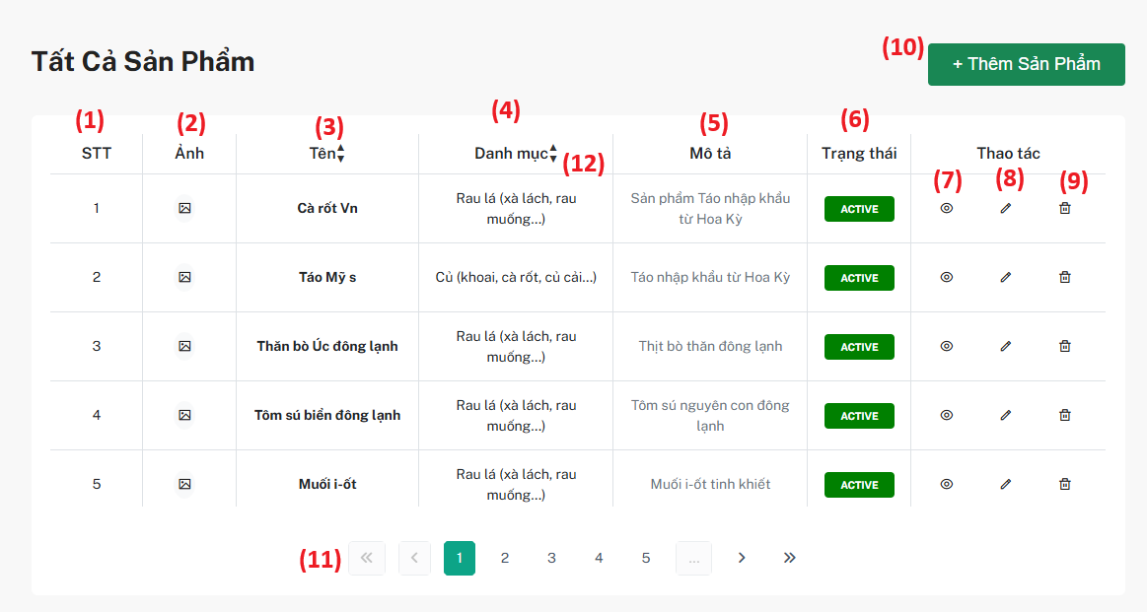

| **Field** | **Field Type** | **Description** |
| --- | --- | --- |
| 1 | Text | Index number of the product in the list |
| 2 | Icon Button | Thumbnail image representing the product |
| 3 | Text + Sort | Product name, sortable by ascending or descending order |
| 4 | Text + Sort | Category name of the product, sortable |
| 5 | Text | Short description of the product |
| 6 | Badge/Text | Product status (ACTIVE / OUT_OF_STOCK / INACTIVE) |
| 7 | Icon Button | View product details by filtering product names in the product details tab |
| 8 | Icon Button | Edit the product information |
| 9 | Icon Button | Soft delete the product |
| 10 | Button | Navigate to “Add Product” form |
| 11 | Navigation | Pagination for navigating through the product list |
| 12 | Icon Button | Sorting icon to reorder rows by name or category |

***Use case specification***

| UC ID and Name: | **UC-12 Product Management** | | |
| --- | --- | --- | --- |
| Created By: | ChienNXHE1811121 | Date Created: | 01/08/2025 |
| Primary Actor: | Seller | Secondary  Actors: | N/A |
| Trigger: | The Seller wants to view the list of all products they have added into the system. | | |
| Description: | This use case describes how a Seller can view a list of their own products in the system. The list displays information such as product image, name, category, description, and status, and provides options to view details, edit, or deactivate the product. Sellers can also search by product name, sort the list, and navigate pages. | | |
| Preconditions: | * The Seller must be logged into the system with an active Seller account. * The system must have product data created by this Seller. | | |
| Postconditions: | * The Seller can view and sort the product list based on product name or category. * The Seller can perform actions such as viewing details, editing, or deactivating products. | | |
| Normal Flow: | **UC-12 Product Management**   1. The Seller navigates to the “Product List” tab in the Seller Dashboard. 2. The system loads and displays the list of products belonging to the Seller. 3. The Seller can:  * View product thumbnail, name, category, description, and status. * Search products by name. * Sort products by name or category. * Navigate through the paginated list. * Click “View Detail” icon to see full product details. * Click “Edit” icon to update product information. * Click “Delete” icon to deactivate (soft delete) a product. * Click “Add Product” button to go to the product creation form. | | |

| Alternative Flows: | **No Products Found:  -** The system displays: "No products found." and disables action buttons.  **System Error:** - The system displays an error: "Unable to load product list. Please try again later."  - Seller can retry loading the list. |
| --- | --- |
| Exceptions: | * The system is unable to load product data due to network failure. * The system shows an error message and allows the Seller to retry. |
| Priority: | High |
| Frequency of Use: | Daily or as needed for product management. |
| Business Rules: | None |
| Other Information: | None |
| Assumptions: | * Search and sorting options are predefined and functional. * Product status updates reflect immediately. * All action buttons work as intended. |

#### 

#### **4.2.1 Add New Product**

#### **Screen description**

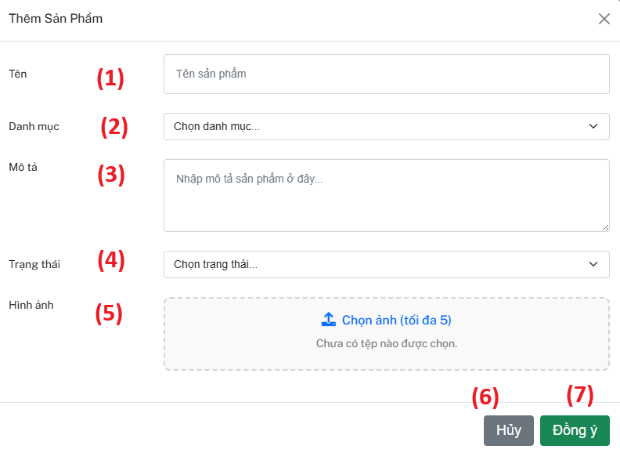

| **Field** | **Field Type** | **Description** |
| --- | --- | --- |
| 1 | Text input | Required. Product name to be displayed. |
| 2 | Dropdown | Required. Select the product's category. |
| 3 | Textarea | Optional. Add details or description about the product. |
| 4 | Dropdown | Required. Product status (ACTIVE, OUT_OF_STOCK, INACTIVE). |
| 5 | File upload  (max 5) | Required. Upload 1 to 5 images. At least one image is needed to save. |
| 6 | Button | Discard all changes and close the modal. |
| 7 | Button | Validate and save the product. Disabled if validation fails (e.g., missing image). |

***Use case specification***

| UC ID and Name: | **UC-12 Add New Product** | | |
| --- | --- | --- | --- |
| Created By: | ChienNXHE1811121 | Date Created: | 01/08/2025 |
| Primary Actor: | Seller | Secondary  Actors: | N/A |
| Trigger: | The Seller clicks the “Add Product” button to create a new product in the system. | | |
| Description: | This use case describes how a Seller adds a new product to the system. The product includes information such as name, category, description, and status. Once the product is added, it becomes available for further configuration (e.g., adding product details or images). | | |
| Preconditions: | * The Seller must be logged into the system with an active Seller account. * The system must provide a valid form for product creation. | | |
| Postconditions: | * A new product is saved into the system and associated with the current Seller. * The product is displayed in the Seller’s product list. | | |
| Normal Flow: | **UC-11 Add New Product**   1. The Seller navigates to the “Product List” tab in the Seller Dashboard. 2. The Seller clicks the “Add Product” button. 3. The system displays the “Add New Product” modal/form. 4. The Seller fills in the required fields:     * Product name    * Category (selected from dropdown)    * Description (optional)    * Status (e.g., ACTIVE) 5. The Seller clicks the “Save” or “Create” button. 6. The system validates the input:     * Checks for duplicate product name under the same Seller.    * Ensures required fields are not empty. 7. If valid, the system saves the product into the database. 8. The system displays a success message and refreshes the product list to include the newly added product. | | |

| Alternative Flows: | **Duplicate Product Name**   * If the Seller enters a product name that already exists under their account:  → The system shows an error: “Product name already exists.”  → The Seller is prompted to enter a different name.   **Missing Required Fields**   * If any required field is left blank:  → The system highlights missing fields and displays a message: “Please fill in all required fields.”   **Cancel Action**   * The Seller clicks “Cancel” or closes the form:  → The form is closed.  → No product is created. |
| --- | --- |
| Exceptions: | * The system cannot save the product due to an internal error.  → The system displays: “Failed to create product. Please try again later.”  → The Seller may retry the operation. |
| Priority: | High |
| Frequency of Use: | Occasional – when the Seller wants to add a new product. |
| Business Rules: | None |
| Other Information: | None |
| Assumptions: | * The form validates inputs on both client and server sides. * Category options are loaded correctly from the system. * Product status is set to ACTIVE by default unless specified. |

#### 

#### **4.2.2 Edit Product**

#### **Screen description**

#### 

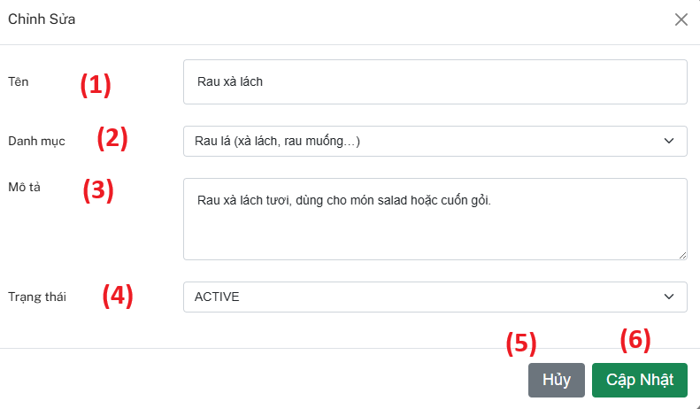

| **Field** | **Field Type** | **Description** |
| --- | --- | --- |
| 1 | Text Field | **Required.** Name of the product (e.g., "Lettuce"). **Must be unique among all existing products.** During edit, it must not duplicate any other product name except itself. |
| 2 | Dropdown List | **Required.** Select the product category (e.g., leafy vegetables, root crops...). |
| 3 | Textarea | Optional. Short product description for buyers. |
| 4 | Dropdown List | **Required.** Current status of the product (ACTIVE, OUT_OF_STOCK, INACTIVE). |
| 5 | Button | Cancels the edit and closes the modal without saving changes. |
| 6 | Button | Saves the changes and updates the product information in the database. |

***Use case specification***

| UC ID and Name: | **UC-13 Edit Product** | | |
| --- | --- | --- | --- |
| Created By: | ChienNXHE1811121 | Date Created: | 01/08/2025 |
| Primary Actor: | Seller | Secondary  Actors: | N/A |
| Trigger: | The Seller clicks the “Edit” button/icon next to an existing product in the product list. | | |
| Description: | This use case describes how a Seller edits an existing product in the system. The Seller may update product information such as name, category, description, or status. Changes are saved and reflected immediately in the Seller’s product list. | | |
| Preconditions: | * The Seller must be logged into the system with an active Seller account. * At least one product exists in the Seller’s product list. * The system provides a valid and pre-filled edit form/modal. | | |
| Postconditions: | * The selected product's information is updated in the system. * The product list is refreshed to reflect the latest data. | | |
| Normal Flow: | **UC-13 Edit Product**   1. The Seller navigates to the “Product List” tab in the Seller Dashboard. 2. The Seller clicks the “Edit” icon/button next to a specific product. 3. The system displays the “Edit Product” modal with the current product data filled in. 4. The Seller modifies one or more of the following fields:     * Product Name (must be unique among Seller’s products)    * Category (dropdown selection)    * Description (optional)    * Status (e.g., ACTIVE, INACTIVE, OUT_OF_STOCK) 5. The Seller clicks the “Save” or “Update” button. 6. The system validates the input:     * Checks for duplicate product name under the same Seller (excluding the current product).    * Ensures required fields are not empty. 7. If valid, the system updates the product in the database. 8. The system shows a success message and refreshes the product list with updated data. | | |

| Alternative Flows: | **Duplicate Product Name**   * If the Seller enters a name that already exists under their account (except the current one):    + → The system shows an error: “Product name already exists.”   + → The Seller is prompted to enter a different name.   **Missing Required Fields**   * If any required field is left blank:    + → The system highlights missing fields and displays: “Please fill in all required fields.”   **Cancel Action**   * The Seller clicks “Cancel” or closes the form:    + → The form is closed.   + → No changes are saved. |
| --- | --- |
| Exceptions: | * The system fails to update the product due to an internal error.  → The system displays: “Failed to update product. Please try again later.”  → The Seller may retry the operation. |
| Priority: | High |
| Frequency of Use: | Occasional – when the Seller wants to update a product. |
| Business Rules: | None |
| Other Information: | None |
| Assumptions: | * Input validation is performed both on client and server sides. * Category options are dynamically loaded. * The status is pre-selected based on the current product status. |

#### 

#### **4.2.3 Manage Product Images**

#### **Screen description**

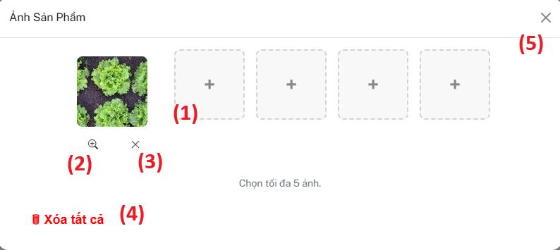

| **Field** | **Field Type** | **Description** |
| --- | --- | --- |
| 1 | Image Slot | Displays current product images. Up to 5 images allowed. Each "+" slot is a button to select an image from the device. Selected images are shown as thumbnails. |
| 2 | Button | Click to preview the image in a larger view |
| 3 | Button | Removes the corresponding image from the current selection |
| 4 | Button | Clears all images. Notification when there are no more images to delete |
| 5 | Button | When clicked, if fewer than 1 image is selected, system prompts: "At least one image is required to proceed." |

***Use case specification***

| UC ID and Name: | **UC-14 Manage Product Images** | | |
| --- | --- | --- | --- |
| Created By: | ChienNXHE1811121 | Date Created: | 01/08/2025 |
| Primary Actor: | Seller | Secondary  Actors: | N/A |
| Trigger: | The Seller clicks the “Management Image” button/icon in the product list. | | |
| Description: | Allows Seller to upload, preview, remove, and validate product images (maximum 5 images, minimum 1 image). | | |
| Preconditions: | * Seller must be logged in and accessing the Add/Edit Product form. | | |
| Postconditions: | * Images are attached to the product and submitted to the server. Minimum 1 image is guaranteed. | | |
| Normal Flow: | **UC-13 Edit Product**   1. Seller opens the **Product Image Management** section in the Add/Edit Product modal. 2. Seller clicks on any available "+" **Image Slot** (Field 1) to select an image from their device. 3. System displays the selected image as a thumbnail in the slot. 4. Seller may click other "+" slots to add more images (up to 5 total). 5. Seller clicks **Preview Button** (Field 2) on any image to open it in larger view. 6. Seller clicks **Remove Button** (Field 3) on any image to remove it from the selection. 7. Seller clicks **Delete All Button** (Field 4) to remove all images.    • If there are no images, system shows notification: "No images to delete." 8. When Seller clicks **Close Button** (Field 5) to exit the modal:    • If at least 1 image remains → modal closes.    • If no images remain → system displays alert: **"At least one image is required to proceed."** 9. Seller clicks Save on Add/Edit Product form; images are sent along with product data to server. | | |

| Alternative Flows: | * If Seller tries to select a 6th image → System shows message: **"Maximum 5 images allowed."** * If Seller selects an image of unsupported format (e.g., .webp) → System shows message: **"Unsupported image format. Please upload PNG, JPG, JPEG, or GIF files."** |
| --- | --- |
| Exceptions: | * Network or server error when saving images → System shows error: **"Failed to upload images. Please try again."** |
| Priority: | High |
| Frequency of Use: | Occasional – when the Seller adds a new product or updates product images. |
| Business Rules: | None |
| Other Information: | * On upload, images are automatically cropped to square before saving. * System provides real-time preview of selected images before submission. |
| Assumptions: | * Input validation is performed on both client and server sides. * Existing product images (when editing) are pre-loaded and shown as thumbnails. * Image slots are dynamically enabled/disabled based on the number of current images. |

### **4.3 Product Detail Management**

#### **Screen description**

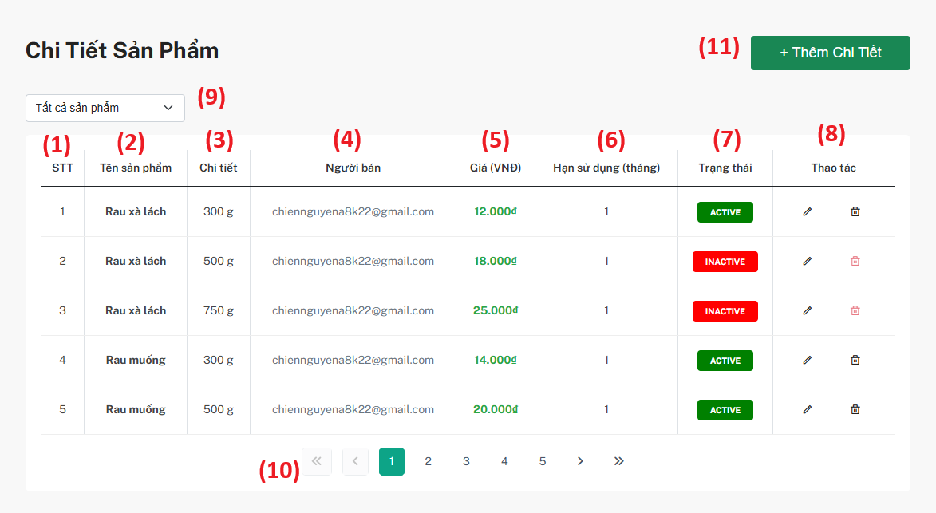

| **Field** | **Field Type** | **Description** |
| --- | --- | --- |
| 1 | Auto Number | Displays the row index of the Product Detail. |
| 2 | Text (bold) | Displays the name of the product. |
| 3 | Text | Displays product weight and unit (e.g., 300 g). |
| 4 | Text | Displays the email of the Seller who add that product detail. |
| 5 | Text (formatted) | Displays the selling price in VND, formatted in green. |
| 6 | Number | Displays the shelf life of the product in months. |
| 7 | Badge (Button style) | Displays current product detail status: **ACTIVE** (green), **INACTIVE** (red). |
| 8 | Icon Buttons | - **Edit (pencil icon)**: Opens modal to edit product detail. - **Delete (trash icon)**: Soft deletes product detail (change to INACTIVE). |
| 9 | Dropdown | Filter list by selected product. |
| 10 | Number + Buttons | Shows total pages and allows navigation through pages. |
| 11 | Button | Opens modal form to create a new Product Detail. |

***Use case specification***

| UC ID and Name: | **UC-13 Product Detail Management** | | |
| --- | --- | --- | --- |
| Created By: | ChienNXHE1811121 | Date Created: | 01/08/2025 |
| Primary Actor: | Seller | Secondary  Actors: | N/A |
| Trigger: | The Seller wants to view and manage the list of product details for their products. | | |
| Description: | This use case describes how a Seller can view, filter, create, edit, and deactivate (soft delete) product details of products they own. Product details include weight, unit, price, shelf life, seller email, and status. The Seller can also filter by product name and navigate through pages of results. | | |
| Preconditions: | * The Seller must be logged into the system with an active Seller account. * The system must have product details associated with the Seller’s products. | | |
| Postconditions: | * The Seller can view and filter the list of product details. * The Seller can add new product details. * The Seller can edit existing product details. * The Seller can deactivate (soft delete) product details. | | |
| Normal Flow: | **UC-13 Product Detail Management**   1. The Seller navigates to the Product Detail tab in the Seller Dashboard. 2. The system loads and displays the list of product details belonging to the Seller. 3. The Seller can:     * View product name, weight & unit, seller email, price (formatted), shelf life, and status.    * Filter product details by selecting a product from the dropdown list.    * Navigate pages using the pagination controls.    * Click the Edit (pencil icon) to open a modal and update product detail information.    * Click the Delete (trash icon) to soft delete the product detail (status changes to INACTIVE).    * Click the Add Product Detail button to open the create product detail modal. | | |

| Alternative Flows: | **No Product Details Found:**   * The system displays: **"No product details found."** and disables action buttons.   **System Error:**   * The system displays an error: **"Unable to load product detail list. Please try again later."** * Seller can retry loading the list. |
| --- | --- |
| Exceptions: | * The system is unable to load product detail data due to network failure. * The system shows an error message and allows the Seller to retry. |
| Priority: | High |
| Frequency of Use: | Daily or as needed for product detail management. |
| Business Rules: | Product Detail Name (Weight + Unit) must be unique for the same Product. |
| Other Information: | None |
| Assumptions: | * Product list in the filter dropdown is dynamically loaded. * Updates (create/edit/delete) reflect immediately in the table. * All action buttons work as intended. |

#### **4.3.1 Add New Product Detail**

#### **Screen description**

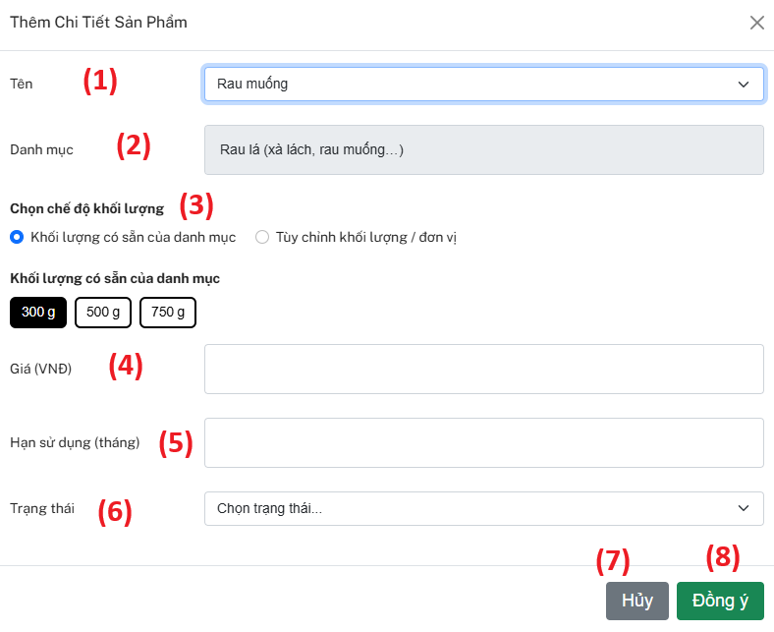

| **Field** | **Field Type** | **Description** |
| --- | --- | --- |
| 1 | Dropdown | Select an existing Product created by Seller. |
| 2 | Text (readonly) | Displays Category name of selected Product. Cannot be edited. |
| 3 | Toggle + Buttons / Input | Select predefined weight & unit from Category OR switch to manual input mode for custom weight & unit. |
| 4 | Number Input | Enter selling price in VND. |
| 5 | Number Input | Enter shelf life of the Product Detail in months. |
| 6 | Dropdown | Select Product Detail status: ACTIVE (green), INACTIVE (red). |
| 7 | Button | Closes the modal form without saving any changes. |
| 8 | Button | Validates and saves the new Product Detail. |

***Use case specification***

| UC ID and Name: | **UC-13 Add Product Detail** | | |
| --- | --- | --- | --- |
| Created By: | ChienNXHE1811121 | Date Created: | 01/08/2025 |
| Primary Actor: | Seller | Secondary  Actors: | N/A |
| Trigger: | The Seller wants to add a new Product Detail for a product they have already created. | | |
| Description: | This use case describes how a Seller can add detailed information for an existing Product. The form includes fields such as Product Name, Category, Weight selection mode (Predefined or Custom), Price, Expiry, and Status. The Seller must select weight, enter price and expiry, and set the status before saving. The system validates that the Product Detail is unique per Product + Weight + Unit combination. | | |
| Preconditions: | * The Seller must be logged into the system with an active Seller account. * The Seller must have at least one Product created. | | |
| Postconditions: | * A new Product Detail is saved and linked to the selected Product. * The Product Detail appears in the Product Detail List of the Seller. | | |
| Normal Flow: | **UC-13 Add Product Detail**   1. The Seller navigates to the “Product Detail” tab in the Seller Dashboard. 2. The Seller clicks the “Add Product Detail” button. 3. The system displays the **Add Product Detail** modal form. 4. The Seller fills out the following fields:     * (1) **Product Name**: select from existing Products.    * (2) **Category**: auto-filled based on Product (read-only).    * (3) **Weight Mode**: choose either:       + Predefined weights of the Category (select by button), OR      + Custom weight/unit input (optional if enabled).    * (4) **Price**: enter price in VND.    * (5) **Expiry**: enter expiry period in months.    * (6) **Status**: select active/inactive. 5. The Seller clicks **Agree (8)** to save or **Cancel (7)** to close without saving. 6. The system validates that the same Product does not already have a Product Detail with identical Weight and Unit. 7. If validation passes, the system saves the new Product Detail and displays success message. 8. The new Product Detail appears in the list. | | |

| Alternative Flows: | **Validation Error:**   * If required fields are empty or data format is invalid, the system highlights errors and prevents submission. * If a Product Detail with the same Weight + Unit already exists   **System Error:**   * If the system fails to save the Product Detail due to server error |
| --- | --- |
| Exceptions: | * The system is unable to save Product Detail due to network failure. * The system shows error message and allows retry. |
| Priority: | High |
| Frequency of Use: | Daily or as needed for product detail management. |
| Business Rules: | Product Detail Name (Weight + Unit) must be unique for the same Product.  Category and Product Name cannot be edited once saved. |
| Other Information: | None |
| Assumptions: | * Predefined weights are retrieved from Category settings. * Price is entered in VND. * All action buttons work as intended. |

#### **4.3.2 Edit Product Detail**

#### **Screen description**

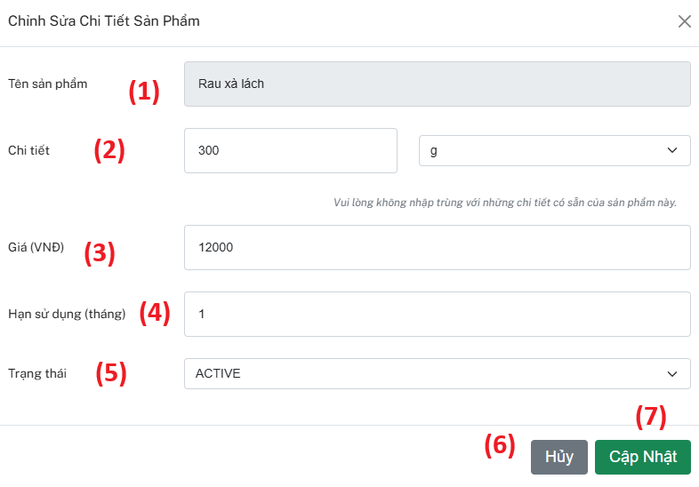

| **Field** | **Field Type** | **Description** |
| --- | --- | --- |
| 1 | Text (readonly) | Displays current Product name. Cannot be edited. |
| 2 | Number Input + Dropdown | Displays weight and unit of Product Detail. Can edit. Must not duplicate existing Product Details of the same Product. |
| 3 | Number Input | Enter new price in VND. |
| 4 | Number Input | Enter new shelf life in months. |
| 5 | Dropdown | Select Product Detail status: ACTIVE (green), INACTIVE (red). |
| 6 | Button | Closes the modal form without saving any changes. |
| 7 | Button | Validates and updates the Product Detail record. |

***Use case specification***

| UC ID and Name: | **UC-14 Edit Product Detail** | | |
| --- | --- | --- | --- |
| Created By: | ChienNXHE1811121 | Date Created: | 01/08/2025 |
| Primary Actor: | Seller | Secondary  Actors: | N/A |
| Trigger: | The Seller wants to update information of an existing Product Detail for one of their products. | | |
| Description: | This use case describes how a Seller can update details of an existing Product Detail, including Weight, Price, Expiry, and Status. The system validates that the updated Weight + Unit combination does not conflict with any other Product Detail of the same Product. | | |
| Preconditions: | * The Seller must be logged into the system with an active Seller account. * The Seller must have at least one Product and corresponding Product Details already created. | | |
| Postconditions: | * The selected Product Detail record is updated with new values. * The updated Product Detail is displayed in the Product Detail List of the Seller. | | |
| Normal Flow: | **UC-14 Edit Product Detail**   1. The Seller navigates to the “Product Detail” tab in the Seller Dashboard. 2. The Seller clicks the Edit icon (pencil icon) next to a Product Detail. 3. The system displays the Edit Product Detail modal form with current values pre-filled. 4. The Seller reviews and updates any of the following fields:     * Product Name: Displayed as readonly.    * Weight: Change weight and unit (must not duplicate existing Product Detail of same Product).    * Price: Enter new price in VND.    * Expiry: Enter new expiry period in months.    * Status: Select active/inactive. 5. The Seller clicks Update (7) to save or Cancel (6) to close without saving. 6. The system validates that no other Product Detail of the same Product has identical Weight + Unit. 7. If validation passes, the system updates the Product Detail and shows success message. 8. The updated Product Detail appears in the list. | | |

| Alternative Flows: | **Validation Error:**   * If required fields are empty or data format is invalid, the system highlights errors and prevents submission. * If a Product Detail with the same Weight + Unit already exists for the same Product, the system shows a duplication error.   **System Error:**   * If the system fails to update the Product Detail due to server error, an error message is shown. |
| --- | --- |
| Exceptions: | * The system is unable to update the Product Detail due to network failure. * The system shows error message and allows retry. |
| Priority: | High |
| Frequency of Use: | Occasional – when the Seller wants to update an existing Product Detail. |
| Business Rules: | Weight + Unit must be unique per Product.  Product Name cannot be edited once created. |
| Other Information: | None |
| Assumptions: | * Price is entered in VND. * All action buttons work as intended. |

### **4.4 User Order Management**

#### **Screen description**

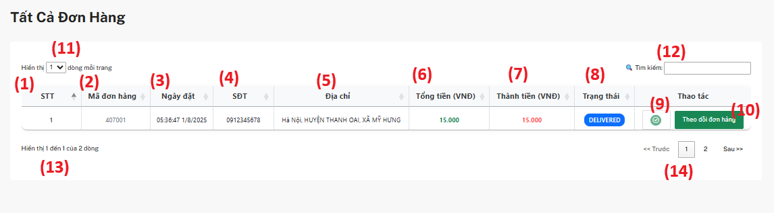

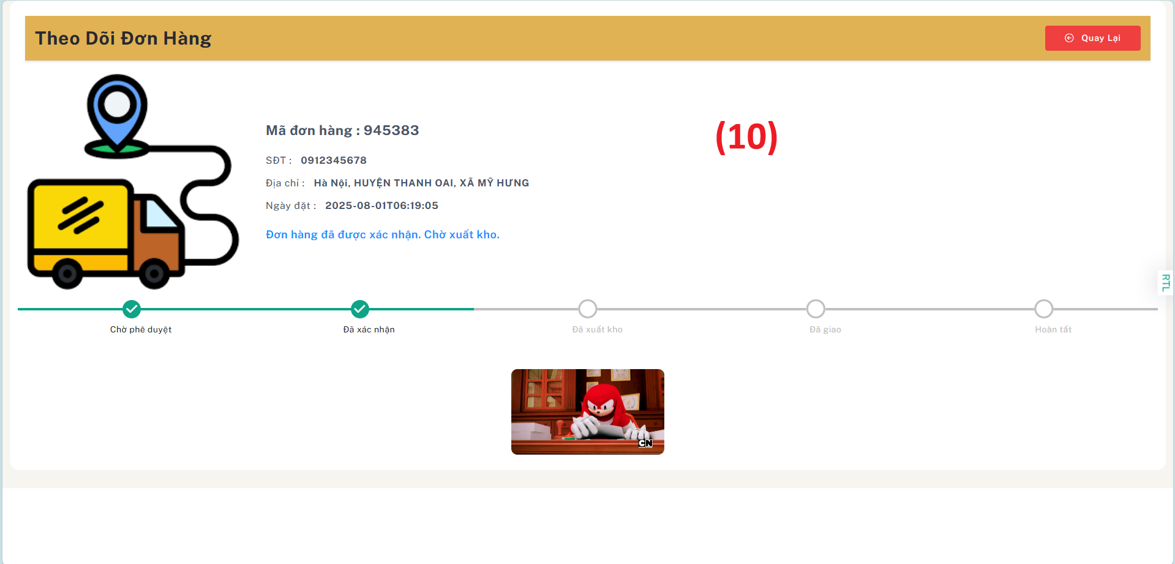

| **Field** | **Field Type** | **Description** |
| --- | --- | --- |
| 1 | Text (readonly) | Displays the serial number (**STT**). Cannot be edited. |
| 2 | Text (readonly) | Displays the order ID (**Order ID**). Cannot be edited. |
| 3 | Text (readonly) | Displays the order date (**Order Date**). Cannot be edited. |
| 4 | Text (readonly) | Displays the customer phone number (**Phone Number**). Cannot be edited. |
| 5 | Text (readonly) | Displays the shipping address (**Address**). Cannot be edited. |
| 6 | Text (readonly) | Displays the total amount (**Total Amount (VND)**). Cannot be edited. |
| 7 | Text (readonly) | Displays the paid amount (**Paid Amount (VND)**). Cannot be edited. |
| 8 | Text (readonly) | Displays the order status (**Order Status**). Cannot be edited. |
| 9 | Button (conditional) | Shows the tick button (**Pending Action**) only if the order status is **PENDING**. Hidden for other statuses. |
| 10 | Button (link) | The **Order Tracking** button navigates to the order tracking page for detailed tracking. |
| 11 | Dropdown + Number Input | Select the number of rows displayed per page (**Rows per page**). Editable. |
| 12 | Text Input | Search box (**Search**) allows filtering the order list by keyword. |
| 13 | Text (readonly) | Displays the number of rows shown vs. total rows (**Showing x of y rows**). Cannot be edited. |
| 14 | Button + Number Input | Pagination controls (**Pagination**: Previous, Next, Page Number). Allows navigating through pages. |

***Use case specification***

| UC ID and Name: | **UC-21 Manage User Orders** | | |
| --- | --- | --- | --- |
| Created By: | ChienNXHE1811121 | Date Created: | 01/08/2025 |
| Primary Actor: | Seller | Secondary  Actors: | N/A |
| Trigger: | The Seller wants to view, comfirm, and track customer orders placed for their products. | | |
| Description: | This use case describes how a Seller can manage all customer orders placed for their products.  The Order Management table displays details such as Order ID, Order Date, Customer Phone Number, Address, Total Amount, Paid Amount, and Status.  The Seller can filter orders by keyword, adjust the number of rows shown per page, and navigate through pages.  For orders in **PENDING** status, the Seller can use the tick button to open the tracking option.  Clicking the **Track Order** button redirects to the Order Tracking page for detailed tracking. | | |
| Preconditions: | * The Seller must be logged into the system with an active Seller account. * The Seller must have at least one order placed by a customer. | | |
| Postconditions: | * The Seller can see up-to-date order information in the Order List. * The Seller can navigate to the Order Tracking page to monitor order progress. | | |
| Normal Flow: | **UC-21 Manage User Orders**   1. The Seller navigates to the “Orders” tab in the Seller Dashboard. 2. The system displays the Order Management table with the following fields:     * (1) Serial Number (STT)    * (2) Order ID    * (3) Order Date    * (4) Customer Phone Number    * (5) Address    * (6) Total Amount (VND)    * (7) Paid Amount (VND)    * (8) Order Status    * (9) Pending Action tick (conditional)    * (10) Track Order button    * (11) Rows per page selection    * (12) Search box    * (13) Rows count display    * (14) Pagination controls 3. The Seller can:     * Adjust the number of rows displayed per page.    * Enter keywords in the Search box to filter orders.    * Navigate between pages using the Pagination controls. 4. If an order is in PENDING status:     * The Pending Action tick button (9) is displayed.    * The Seller can click the tick button to open tracking. 5. The Seller clicks the Track Order button (10) to navigate to the Order Tracking page. 6. The system redirects the Seller to the Order Tracking page for the selected order. | | |

| Alternative Flows: | * **Validation Error:**  If no orders match the search keyword, the system displays a **“No orders found”** message. * **System Error:**  If the system fails to load orders due to a server error, an error message is shown. |
| --- | --- |
| Exceptions: | * If the network is unavailable, the system fails to load the Order List or redirect to the Order Tracking page. * The system displays an error message and allows retry. |
| Priority: | High |
| Frequency of Use: | Daily or as needed for order management. |
| Business Rules: | * The Pending Action tick is only shown for orders with **PENDING** status. * The Track Order button always navigates to the Order Tracking page. * Order data cannot be modified from this view. |
| Other Information: | None |
| Assumptions: | * Order data is up-to-date and synchronized in real time. * Search, pagination, and rows per page controls function correctly. * All action buttons work as intended. |

## **5. Become To Seller**

#### **Screen description**

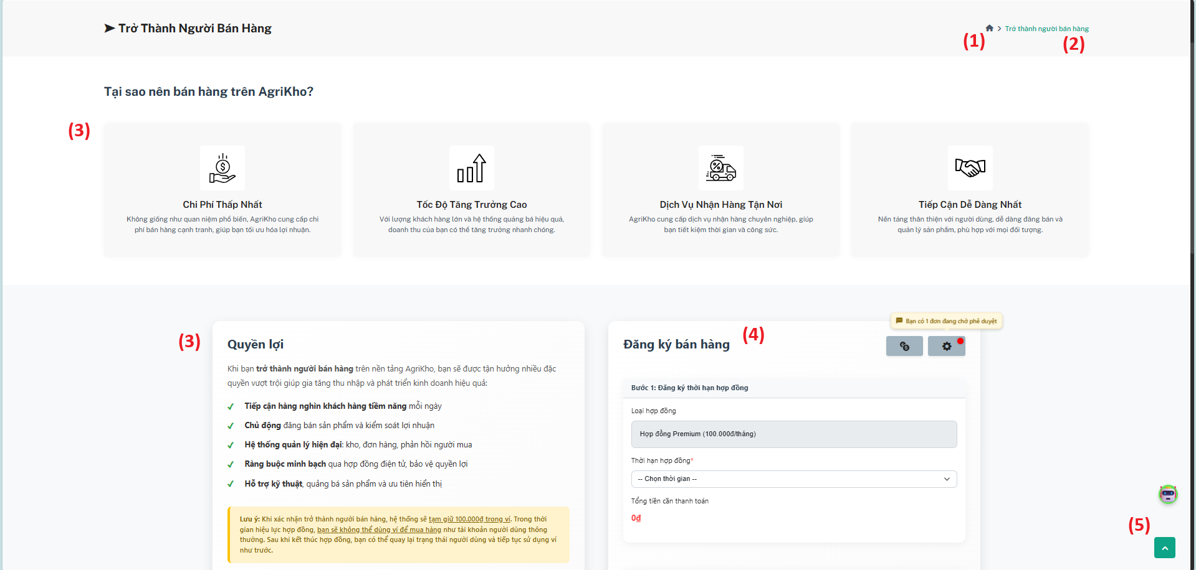

## 

| **Field** | **Field Type** | **Description** |
| --- | --- | --- |
| 1 | Button (link) | Navigate back to the **Homepage**. |
| 2 | Button (link) | Reload or stay on the **Become a Seller** page. |
| 3 | Text Content | Informational content only. Displays benefits, reasons to sell, and explanations. Cannot be edited. |
| 4 | Form | Required for seller account activation. |
| 5 | Button (scroll) | **Scroll to Top** button. Takes the user back to the top of the page. |

***Use case specification***

| UC ID and Name: | **UC-05 Become a Seller** | | |
| --- | --- | --- | --- |
| Created By: | ChienNXHE1811121 | Date Created: | 01/08/2025 |
| Primary Actor: | User | Secondary  Actors: | N/A |
| Trigger: | A User wants to register as a Seller on the platform to sell their products. | | |
| Description: | This use case describes how a User registers to become a Seller on the platform.  The page displays informational content about benefits, cost, and selling conditions.  The User completes the **Seller Registration Form** by selecting a contract type and duration, then submits the form for approval.  The system validates and saves the registration request for admin review. | | |
| Preconditions: | * The User must be logged in with a valid customer account. * The User must not already have an active Seller account. | | |
| Postconditions: | * A new Seller Registration request is created and marked as **Pending Approval**. * The request appears in the system for Admin review. * The User remains on the **Become a Seller** page and can see status messages. | | |
| Normal Flow: | **UC-05 Become a Seller**   1. The User navigates to the **Become a Seller** page from the main website. 2. The system displays:     * **Field (1):** **Back to Homepage** button.    * **Field (2):** **Reload/Stay** button for this page.    * **Field (3):** Informational sections about selling benefits and platform advantages.    * **Field (4):** **Seller Registration Form** with:       + Contract type selection.      + Contract duration selection.      + Total payment calculation.    * **Field (5):** **Scroll to Top** button. 3. The User reads the informational content (**Field 3**) to understand the selling benefits and requirements. 4. The User fills out the **Seller Registration Form**:     * Selects contract type (e.g., Premium).    * Selects contract duration.    * Reviews total amount to pay. 5. The User submits the form. 6. The system validates all required fields:     * Contract type and duration must be selected.    * Data must be valid. 7. If validation passes, the system saves the registration request and marks it as **Pending Approval**. 8. The system displays a confirmation message to the User. | | |

| Alternative Flows: | * **Validation Error:**   If required fields are missing or invalid, the system highlights the errors and prevents submission until corrected.   * **System Error:**   If the system fails to save the request due to a server error, an error message is shown and the User may retry. |
| --- | --- |
| Exceptions: | * If network connectivity is lost during submission: The system shows an error message and allows the User to retry later. |
| Priority: | High |
| Frequency of Use: | Occasional – typically once per User when registering to become a Seller. |
| Business Rules: | * A User cannot register as a Seller more than once. * A Seller Registration must be approved by Admin before the account is activated. * The payment requirement is clearly displayed and must be accepted before submission. |
| Other Information: | None |
| Assumptions: | * Contract types and pricing are defined in system settings. * The User has read and accepted the platform’s terms and conditions for selling. * All action buttons (Back, Reload, Scroll to Top) work as intended. |

### **5.1 Seller Registration Form**

#### **Screen description**

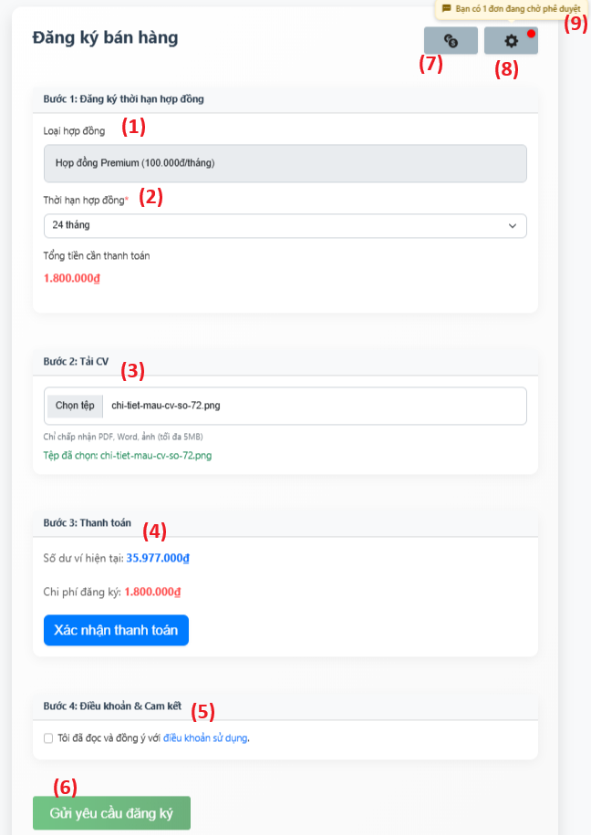

| **Field** | **Field Type** | **Description** |
| --- | --- | --- |
| 1 | Text (readonly) | Displays the **contract type**. Fixed to **Premium contract** only. Cannot be edited or changed. |
| 2 | Dropdown (select) | Select the contract duration (**in months**). The system auto-calculates the total registration fee based on the selected duration. Longer duration may apply a discount. |
| 3 | File Upload | Upload the Seller’s CV or required supporting document (PDF, Word, Image; max size 5MB). |
| 4 | Text (readonly) + Button | Shows current wallet balance and calculated registration fee. The **Confirm Payment** button only confirms that the wallet has enough balance — it does **NOT** deduct the amount yet. The actual deduction occurs only when the Seller clicks **Send Registration Request**. |
| 5 | Checkbox + Modal | Checkbox to accept the **Terms of Service**. Clicking the linked text opens a **modal** displaying the full terms for review. |
| 6 | Button | The **Send Registration Request** button submits the registration form for approval and triggers the wallet deduction if balance is sufficient. |
| 7 | Button (link) | Redirects the Seller to the **Wallet Top-up Page** to add more funds if needed. |
| 8 | Button (link) | Redirects to the **All Seller Registration Management** page, where the Seller can see and manage all their registration requests. |
| 9 | Notification + Link | Shows **Pending** or **Approved** registration status. Clicking redirects to the **Registration Management** page, filtered by the selected status. |

***Use case specification***

| UC ID and Name: | **UC-06 Seller Registration Form** | | |
| --- | --- | --- | --- |
| Created By: | ChienNXHE1811121 | Date Created: | 01/08/2025 |
| Primary Actor: | User | Secondary  Actors: | N/A |
| Trigger: | A User wants to submit a Seller Registration request to become an approved Seller on the platform. | | |
| Description: | This use case describes how a User fills out and submits the **Seller Registration Form** to apply for Seller status.  The form includes selecting a **fixed contract type**, choosing a **contract duration**, uploading a **CV**, confirming payment, accepting **Terms of Service**, and finally submitting the request.  The system validates that the wallet has sufficient balance, confirms the data, and deducts the fee only upon submission.  Notifications inform the User about **Pending** or **Approved** status, and allow them to manage requests. | | |
| Preconditions: | * The User is logged in with an active account. * The User does not already have an active Seller contract. * The User’s wallet has enough balance or they can top up. | | |
| Postconditions: | * A **Seller Registration Request** is created and marked as **Pending**. * The system deducts the registration fee from the User’s wallet after submission. * The User can view request status via the Registration Management page. | | |
| Normal Flow: | **UC-06 Seller Registration Form**   1. The User navigates to the Become a Seller page. 2. The system displays:     * Field (1): Fixed contract type (Premium).    * Field (2): Contract duration selection dropdown.    * Field (3): CV upload.    * Field (4): Wallet balance, registration fee, and Confirm Payment button.    * Field (5): Terms of Service checkbox with modal.    * Field (6): Send Registration Request button.    * Field (7): Wallet top-up link.    * Field (8): Link to Registration Management.    * Field (9): Notification showing Pending or Approved status. 3. The User selects the contract duration. The system auto-calculates the total fee. 4. The User uploads their CV. 5. The User clicks Confirm Payment to check if their wallet balance is sufficient (no deduction yet). 6. If the balance is insufficient, the User can click Top-up (Field 7) to add funds. 7. The User checks the Terms of Service checkbox and can open the modal to read details. 8. The User clicks Send Registration Request. 9. The system validates:     * Contract duration is selected.    * CV is uploaded.    * Terms checkbox is checked.    * Wallet balance is sufficient. 10. If valid, the system:  * Deducts the registration fee. * Saves the request as Pending. * Displays a success message.  1. The notification (Field 9) updates to show Pending status. 2. The User can click the notification or Field 8 to manage all requests. | | |

| Alternative Flows: | * **Validation Error:**   If required fields are missing, CV not uploaded, or Terms not accepted: System highlights errors and prevents submission.   * **Insufficient Balance:**   If balance is insufficient when confirming payment:   * + System shows warning.   + User clicks Top-up (Field 7) to add funds. * **System Error:**   If a server error occurs while saving:   * + System shows error and allows retry. |
| --- | --- |
| Exceptions: | * If connectivity fails during submission, system shows error and allows retry. |
| Priority: | High |
| Frequency of Use: | Occasional — typically once per Seller registration cycle. |
| Business Rules: | * Contract type is fixed (**Premium**) and cannot be changed. * Contract duration affects the final fee. * Fee is **locked** only on final submission. * User must accept the **Terms of Service**. * Notification shows **Pending** or **Approved**, and links to filter requests. |
| Other Information: | None |
| Assumptions: | * Wallet top-up works correctly. * Terms modal displays full valid content. * Approval/rejection is handled by Admin in a separate flow. |

### **5.2 Seller Application Management**

#### **Screen description**

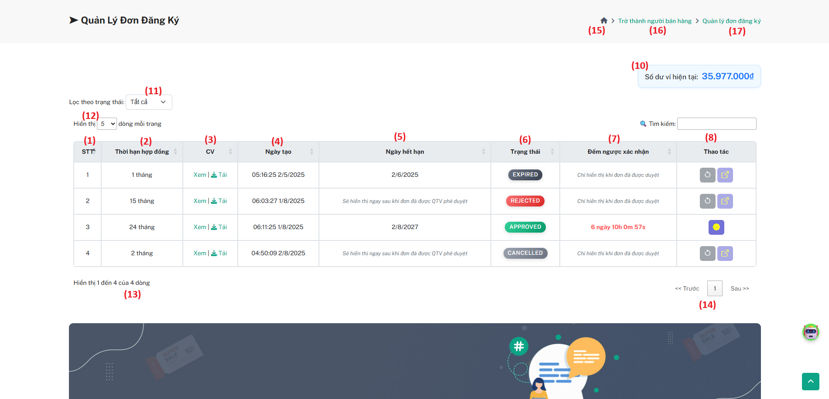

| **Field** | **Field Type** | **Description** |
| --- | --- | --- |
| 1 | Text (readonly) | Serial Number (**STT**) for the registration list. |
| 2 | Text (readonly) | Contract duration (in months). |
| 3 | Link | CV actions: **View** or **Download** the uploaded CV file. |
| 4 | Text (readonly) | Registration creation date and time. |
| 5 | Text (readonly) | Expiry date of the contract. Only shown after Admin approval. |
| 6 | Status Label | Current status of the registration: **PENDING**, **APPROVED**, **REJECTED**, **CANCELLED**, **EXPIRED**. |
| 7 | Text (readonly) | Confirmation countdown timer. Shown only if the request is **APPROVED**. |
| 8 | Action Buttons | Shows or hides icons dynamically based on the registration status: |
| 9 | Text Notification | Displays wallet balance for the current User. |
| 10 | Text (readonly) | Shows the User’s wallet balance. |
| 11 | Dropdown (filter) | Filter registrations by status (**All**, **Pending**, **Approved**, etc.). |
| 12 | Dropdown (pagination) | Select how many rows to display per page. |
| 13 | Text (readonly) | Shows the current count of visible rows and total rows. |
| 14 | Pagination | Navigate between pages of registrations. |
| 15 | Button (link) | Redirect to **Homepage**. |
| 16 | Button (link) | Redirect to the **Seller Registration Form** page. |
| 17 | Button (link) | Refresh or stay on the **this** page. |

***Use case specification***

| UC ID and Name: | **UC-07 Manage Seller Application** | | |
| --- | --- | --- | --- |
| Created By: | ChienNXHE1811121 | Date Created: | 01/08/2025 |
| Primary Actor: | User | Secondary  Actors: | N/A |
| Trigger: | The Seller wants to view, filter, or manage their submitted registration requests. | | |
| Description: | This use case describes how a Seller tracks their registration requests, filters by status, downloads/view CVs, cancels or edits if needed, and especially **confirms an Approved request** within the allowed confirmation period to **complete the registration** and upgrade their account role to **Seller**.  If the Seller fails to confirm within **7 days from Admin approval**, the request expires automatically and 100% money back | | |
| Preconditions: | * The User is logged in with a valid account. * The User has at least one registration request in the system. * Wallet balance is sufficient if required. | | |
| Postconditions: | If confirmed in time:   * The registration status changes to **COMPLETED**. * The User’s role is upgraded to **Seller**.   If not confirmed in time:   * The request automatically switches to **EXPIRED**. * The role remains unchanged. | | |
| Normal Flow: | **UC-07 Manage Seller Registrations**   1. The Seller navigates to the Registration Management page (Field 17). 2. The system displays:     * Field 1-6: List of requests with details.    * Field 7: Countdown timer for Approved requests (7 days from approval).    * Field 8: Valid action icons based on status:       + Pending: Edit, Cancel.      + Approved: Confirm (if within 7 days). 3. The Seller can filter by status (Field 11) and manage pagination (Field 12-14). 4. The Seller clicks Confirm for an Approved request within 7 days:     * The system checks if the confirmation window is still valid.    * If valid:       + Status changes to COMPLETED.      + The User’s account role is upgraded to Seller.      + The system shows a success message.    * If expired:       + The system blocks confirmation and shows that the request is now EXPIRED. 5. The Seller can view or download CV (Field 3), check wallet balance (Field 10), and navigate:     * Field 15: Homepage.    * Field 16: Registration Form.    * Field 17: Stay here. | | |

| Alternative Flows: | **Confirmation Expired:**   * If the Seller tries to confirm an **Approved** request **after 7 days**, the system automatically switches it to **EXPIRED** and blocks the action.   **Edit/Cancel:**   * For **Pending** status: Seller may Edit or Cancel. * For other statuses: Edit/Cancel buttons are hidden.   **No Matching Filter:**   * If no records match the filter, the system shows an empty state. |
| --- | --- |
| Exceptions: | * If confirmation fails due to network issues, the system shows an error and allows retry if within the valid period. |
| Priority: | High |
| Frequency of Use: | Daily — as Sellers often check status and manage requests. |
| Business Rules: | * Confirmation must occur within 7 days of Admin approval. * Role upgrade to **Seller** is automatic once confirmation succeeds. * Statuses: **Pending → Approved → Confirmed (COMPLETED)** or **Expired**. * Expiry date & countdown must be accurate. |
| Other Information: | None |
| Assumptions: | * Admin review happens in a separate flow. * The Seller knows how to interpret each status. * Notifications direct the Seller back to this page with proper filters applied. |

## **6.** **Product Batch Management**

### **6.1** **View Product Batch List**

#### **6.1.1 View Product Batch List**

#### **Screen description**

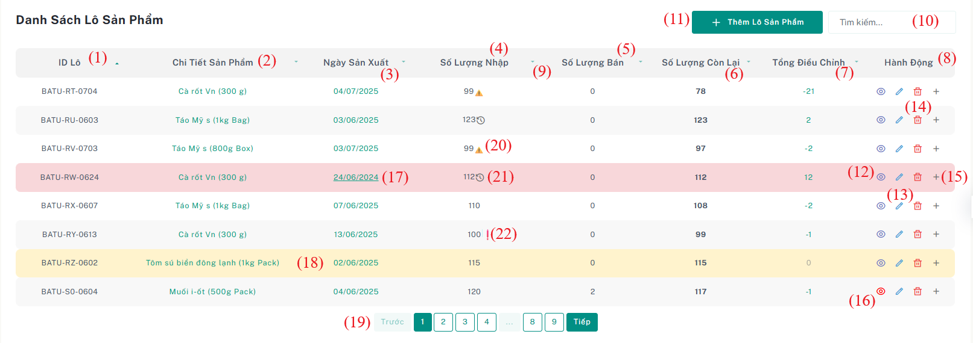

Figure 2.19 - Mockup for view list productbatch

| **Field Name** | **Field Type** | **Description** |
| --- | --- | --- |
| (1) | Text | Unique identifier for each product batch. |
| (2) | Text | Name of product detail |
| (3) | Date | The date when the product was manufactured. |
| (4) | Integer | Initial quantity received for the batch. May show warning icons (see 20–22). |
| (5) | Integer | Total quantity sold from this batch. |
| (6) | Integer | Quantity remaining in stock from the batch. |

| (7) | Integer | Total manual adjustments made to the batch stock. |
| --- | --- | --- |
| (8) | Button | Action buttons:(12-15) |
| (9) | Button | Allows sorting by column |
| (10) | Text Input | Allows filtering product batches by keyword. |
| (11) | Button | **"Thêm Lô Sản Phẩm"** button redirects the user to the form page for creating a new product batch |
| (12) | Icon Button | View product detail information |
| (13) | Icon Button | Opens the form to edit batch information. |
| (14) | Icon Button | Deletes the batch entry if it not have any stockin before |
| (15) | Icon Button | Opens the adjustment entry modal for the batch. |
| (16) | Icon Button | Rows are highlighted in **red** when the **purchase price**  of the product in the batch is **higher than the selling price** |
| (17) | Style | provided to **enable automatic quantity adjustment** for **expired product batches**. |
| (18) | Row Color | Color row indicates near-expiry or special condition. |
| (19) | Navigation | Allows navigating through pages of batches. |
| (20) | Icon | **Quantity Warning** – The imported quantity is **lower than expected** or missing. |
| (21) | Icon | **Adjustment History Available** – The batch has been **adjusted after initial import (6.5)** |
| (22) | Icon | Invalid Quantity Error – The imported quantity is invalid or exceeds the expected amount |

Table 40 - Screen description for view list productbatch

***Use case specification***

| UC ID and Name: | **UC-19** View List of Product Batches | | |
| --- | --- | --- | --- |
| Created By: | QuangDNHE186891 | Date Created: | 23/06/2025 |
| Primary Actor: | Warehouse Manager | Secondary  Actors: |  |
| Trigger: | The Warehouse Staff navigates to the **“Danh sách Lô Sản Phẩm”** (Product Batch List) page from the main menu. | | |
| Description: | The system allows users to view a list of all adjustments in the warehouse, including information about adjustmentID, Batch Code, quantity, adjustment date, reason, and type of adjustment. Additionally, users can create update adjustment,delete adjustment, And user can search adjustment by “Mã Lô Hàng”, “Số Lượng”,”Lý Do”,”Ngày Điều Chỉnh” , sort and navigate through paginated results. | | |
| Preconditions: | The user has successfully logged into the system with account warehouse Staff. Product batches have already been created and stored in the system. | | |
| Postconditions: | The system displays a paginated list of all product batches.  The user can search, sort, and view adjustment or error warnings on batches.  The staff can navigate to edit, view, or create adjustments for each batch. | | |
| Frequency of Use: | Daily | | |
| Business Rules: | BR-01, BR-02, BR-03, BR-04, BR-05,  BR-06, BR-07, BR-08, BR-09, BR-10, | | |
| Other Information: | - Red highlighting is used for batches where purchase price exceeds selling price. And it can automatic create aadjustment  - ⚠️ icon indicates missing or incomplete imported quantity.  - ⏰ icon indicates batch has expired and may need quantity adjustment.  - ❗ icon indicates quantity exceeds expected, requiring user validation. | | |
| Assumptions: | Secondary/support staff may assist operationally in real life, **but the current system does not define roles or grant permissions** to them. | | |

Table 43 - Use case specification for view list productbatch

###### 

#### **6.1.2 Update product batch**

#### **Screen description**

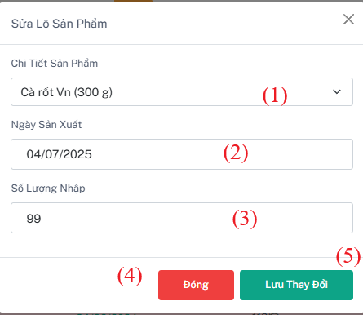

Figure 2.21 - Mockup for update product batch

| **Field Name** | **Field Type** | **Description** |
| --- | --- | --- |
| (1) | Dropdown | Select the product detail to associate with the new batch. |
| (2) | Date | The date the product was manufactured. |
| (3) | Integer | Enter the Integer of products in the batch. |
| (4) | Button | Button for close modal and don’t update anything |
| (5) | Button | Button to update productbatch |

Table 44 - Screen description for update product batch

***Use case specification***

| UC ID and Name: | **UC-21: Update Product Batch** | | |
| --- | --- | --- | --- |
| Created By: | QuangDNHE186891 | Date Created: | 23/06/2025 |
| Primary Actor: | Warehouse Manager | Secondary  Actors: |  |
| Trigger: | The staff selects a product batch to update from the product batch list. | | |
| Description: | This use case allows warehouse staff to create a stock adjustment by entering the quantity, reason, and type of adjustment (“Hủy bỏ” or “Nhập thêm”). | | |
| Preconditions: | 1. The user is logged in and has permission to update product batches. 2. The product batch exists in the system. | | |
| Postconditions: | The product batch information is updated successfully in the system. | | |
| Normal Flow: | **21.0 Update productBatch**   1. The staff opens the update modal for a selected product batch. 2. The system displays the current details of the batch. 3. The staff selects a product detail from the dropdown. 4. The staff selects a manufacturing date. 5. The staff enters a new quantity (integer). 6. The staff clicks the "Update" button. 7. The system validates the input and updates the product batch. 8. A success message is displayed, and the modal is closed. | | |
| Alternative Flows | **(AF1) Product Detail Not Selected:**  – The system prompts the user to select a product detail.  **(AF2) Missing Date or Quantity:**  – The system displays an error if the manufacturing date or quantity is missing. | | |
| Exceptions: | **22.1 E1: Invalid Quantity**  - If type is “Hủy bỏ” so you need input negative integer and “Nhập thêm” is positive number . if not valid display error  **(EX3)** Exceeds Expected Quantity:  - If the entered quantity causes the total received quantity to exceed the planned quantity of the order, the system shows an error and prevents the update. | | |
| Priority: | High | | |
| Frequency of Use: | As needed when batch information needs to be edited. | | |
| Business Rules: | BR-11 | | |
| Other Information: | None | | |
| Assumptions: | The warehouse has no limit on number of batches. | | |

Table 43 - Use case specification forupdate product batch

#### 

#### 

#### **6.1.3 Create Adjustment**

#### **Screen description**

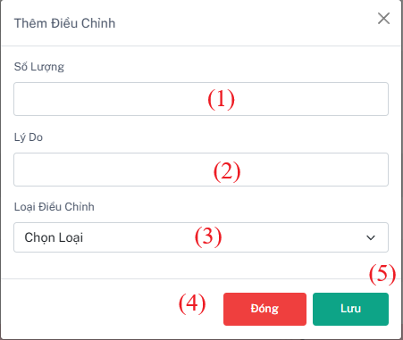

Figure 2.21 - Mockup for create new adjustment

| **Field Name** | **Field Type** | **Description** |
| --- | --- | --- |
| (1) | Integer | Quantity of adjustment (negative for “Hủy bỏ”, positive for “Nhâp thêm”) |
| (2) | Text | Reason why have this adjust |
| (3) | ComboBox | Type of Adjustment “Hủy bỏ” or “Nhâp thêm” |
| (4) | Button | Button for close modal and don’t add anything |
| (5) | Button | Button to add adjustment |

Table 44 - Screen description for create new adjustment

***Use case specification***

| UC ID and Name: | **UC-21: Create inventory check** | | |
| --- | --- | --- | --- |
| Created By: | QuangDNHE186891 | Date Created: | 23/06/2025 |
| Primary Actor: | Warehouse Manager | Secondary  Actors: | Warehouse Staff |
| Trigger: | Warehouse staff detects a mismatch in actual stock and wants to adjust the product batch accordingly. | | |
| Description: | This use case allows warehouse staff to create a stock adjustment by entering the quantity, reason, and type of adjustment (“Hủy bỏ” or “Nhập thêm”). | | |
| Preconditions: | 1. The user is authenticated and has permission to adjust stock 2. The related product batch is selected. | | |
| Postconditions: | A new adjustment record is created and linked to the corresponding product batch.  The remaining quantity of the batch is updated accordingly. | | |
| Normal Flow: | **21.0 Add adjustment**   1. The system displays the stock adjustment modal. 2. The warehouse staff enters the adjustment quantity (can be positive or negative). 3. The warehouse staff enters the reason for the adjustment. 4. The warehouse staff selects the adjustment type via ComboBox (“Hủy bỏ” or “Nhập thêm”). 5. The warehouse staff clicks the **"Add Adjustment"** button. 6. The system validates input. 7. The system creates the adjustment record and updates the stock quantity. 8. The modal closes and the new adjustment is shown in the history. | | |
| Alternative Flows | * 1. **A1:User cancels the operation** * User clicks the **"Close"** button. * Modal is closed without saving any data. | | |
| Exceptions: | **22.1 E1: Invalid Quantity**   * If type is “Hủy bỏ” so you need input negative integer and “Nhập thêm” is positive number . if not valid display error | | |
| Priority: | High | | |
| Frequency of Use: | Occasional – Only used when stock discrepancies are detected. | | |
| Business Rules: | BR-08, BR-09 | | |
| Other Information: | None | | |
| Assumptions: | Only authorized warehouse staff can perform stock adjustments. | | |

Table 43 - Use case specification for create new adjustment

#### **6.1.4 Delete productbatch**

#### **Screen description**

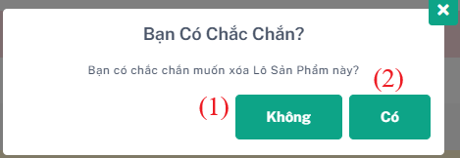

Figure 2.20 - Mockup for delete available adjustment

| **Field Name** | **Field Type** | **Description** |
| --- | --- | --- |
| (1) | Button | Cancel delete productbatch. |
| (2) | Text | Accept Delete productbatch |

Table 42 - Screen description for delete available adjustment

***Use case specification***

| UC ID and Name: | **UC-21: Confirm Deletion of Product Batch** | | |
| --- | --- | --- | --- |
| Created By: | QuangDNHE186891 | Date Created: | 23/06/2025 |
| Primary Actor: | Warehouse Manager | Secondary  Actors: |  |
| Trigger: | User clicks the "Chỉnh sửa mục" icon next to a StockInDetail row. | | |
| Description: | Allows staff to confirm and delete a product batch from the system. | | |
| Preconditions: | The user has permission to delete product batches.  The selected product batch exists and is not referenced in any active stock. | | |
| Postconditions: | Product batch is permanently deleted (if eligible). | | |
| Normal Flow: | **21.0 Delete ProductBatch**  1. The user clicks **"Delete"** on a product batch.  2. System opens a confirmation modal showing the batch code.  3.User clicks **"Confirm Delete"**.  4.The system deletes the batch and displays a success message. | | |
| Alternative Flows | **Alternative Flow:**  – If a batch is in use, the system prevents deletion and shows: "Cannot delete batch with active stock." | | |
| Exceptions: | **None** | | |
| Priority: | High | | |
| Frequency of Use: | Occasionally – when incorrect or unused product batches need to be cleaned up. | | |
| Business Rules: | BR-07 | | |
| Other Information: | Consider implementing soft delete if batch audit history is required | | |
| Assumptions: | The system performs dependency checks before allowing deletion. | | |

Table 42 - Screen description for delete available adjustment

#### **6.1.5 View Adjustment Import of ProductBatch**

#### **Screen description**

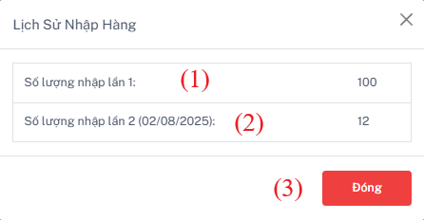

Figure 2.21 - Mockup for View Adjustment Import of ProductBatch

| **Field Name** | **Field Type** | **Description** |
| --- | --- | --- |
| (1) | Number | Quantity of Imported |
| (2) | Number | Quantity of Imported after the firs |

Table 43 - Screen description for View Adjustment Import of ProductBatch

***Use case specification***

| UC ID and Name: | **UC-21: View “Nhập thêm” Adjustment History for Product Batch** | | |
| --- | --- | --- | --- |
| Created By: | QuangDNHE186891 | Date Created: | 23/06/2025 |
| Primary Actor: | Warehouse Manager | Secondary  Actors: |  |
| Trigger: | The user clicks the **“**⏰**”** icon on a Product Batch. | | |
| Description: | This use case allows warehouse staff to view the initial quantity and all subsequent "Nhập thêm" (add quantity) adjustments for a specific product batch, displayed in a modal window. | | |
| Preconditions: | User is logged in with permission to view product batch details.  The selected Product Batch exists in the system.  There are one or more "Nhập thêm" adjustments linked to that batch (optional). | | |
| Postconditions: | A modal window shows the initial quantity and all “Nhập thêm” adjustment records, sorted by date. | | |
| Normal Flow: | **31.0 View Import History Modal**   1. The user navigates to the list of Product Batches. 2. The user clicks the "View Import History" button next to a batch. 3. The system opens a modal window with the title: "Lịch Sử Nhập Hàng". 4. The system displays:     * Số lượng nhập lần 1: (initial quantity of the batch)    * Số lượng nhập lần {n} (dd/MM/yyyy): for each “Nhập thêm” adjustment. 5. The user clicks the “Đóng” button to close the modal. | | |
| Alternative Flows | **Alternative Flow: No Additional Adjustments Found:**  – If there are no "Nhập thêm" records, the modal still opens and displays only the initial quantity.  – Optionally display: *"Không có lần nhập thêm nào sau lần đầu."* | | |
| Exceptions: | **E1: Failed to Load Adjustment Data**  **–** If the system fails to retrieve adjustment history, display:   “Không thể tải lịch sử nhập hàng. Vui lòng thử lại sau.” | | |
| Priority: | Medium | | |
| Frequency of Use: | Occasional – used when users need to review historical quantity changes. | | |
| Business Rules: | BR-07 | | |
| Other Information: | Adjustment data comes from the Adjustment table where type = 'Nhập thêm'.  The modal should remain consistent across all batches, even with 0 adjustments. | | |
| Assumptions: | Adjustments are immutable once created. | | |

Table 42 - Screen description for View Adjustment Import of ProductBatch

#### **6.1.6 View Adjustment productBatch all**

#### **Screen description**

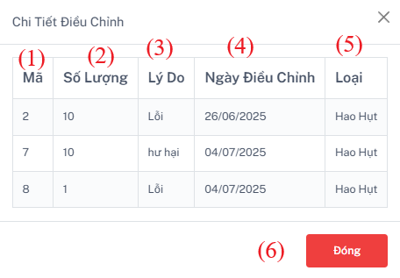

Figure 2.20 - Mockup for View Adjustment productBatch all

| **Field Name** | **Field Type** | **Description** |
| --- | --- | --- |
| (1) | Number | Id of adjustment. |
| (2) | Number | Quantity of this adjustment |
| (3) | Text | Reason of this adjustment |
| (4) | Date | Date of this adjustment |
| (5) | Text | Type of the adjustment |

Table 42 - Screen description for View Adjustment productBatch all

***Use case specification***

| UC ID and Name: | **UC-21: View Adjustment History of Product Batch** | | |
| --- | --- | --- | --- |
| Created By: | QuangDNHE186891 | Date Created: | 23/06/2025 |
| Primary Actor: | Warehouse Manager | Secondary  Actors: |  |
| Trigger: | The user clicks the **“Total Adjustment”** button for a specific Product Batch. | | |
| Description: | This use case allows the user to view all stock adjustment history (both *“Nhập thêm”* and *“Hủy bỏ”*) related to a selected Product Batch. Each record includes the quantity before adjustment, quantity adjusted, reason, type, and date of adjustment. | | |
| Preconditions: | User is logged in with permission to view product batch history.  The selected Product Batch exists in the system. | | |
| Postconditions: | The system displays a list of adjustments for the selected batch. | | |
| Normal Flow: | **View Adjustment History**   1. User navigates to the Product Batch list. 2. The user clicks the **"View History"** button on a specific batch. 3. The system retrieves and displays the adjustment history, showing the following for each entry:    * **Adjustment ID**    * **Quantity Before Adjustment**    * **Quantity of This Adjustment**    * **Adjustment Type**    * **Reason**    * **Date** 4. The user reviews all historical entries in a modal or table. 5. Users may close the view or export the history (optional). | | |
| Alternative Flows | **None** | | |
| Exceptions: | **None** | | |
| Priority: | High | | |
| Frequency of Use: | Occasional – used when reviewing batch modification history, for audit or investigation. | | |
| Business Rules: | BR-07 | | |
| Other Information: | This feature helps track all manual stock modifications to a batch over time. | | |
| Assumptions: | Every adjustment entry is linked to a Product Batch via foreign key. | | |

Table 42 - Screen description for View Adjustment productBatch all

### 

#### **6.1.7 Auto create Adjustment for productBatch expired**

#### **Screen description**

#### 

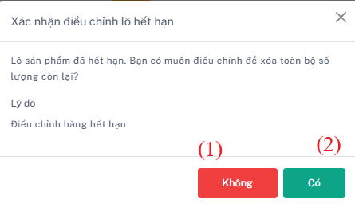

Figure 2.20 - Mockup for Auto create Adjustment for productBatch expired

| **Field Name** | **Field Type** | **Description** |
| --- | --- | --- |
| (1) | Button | Cancel create adjustment |
| (2) | Button | Accept create adjustment |

Table 42 - Screen description for Auto create Adjustment for productBatch expired

***Use case specification***

| UC ID and Name: | **UC-21: Create Adjustment Manually or Automatically When Product Expires** | | |
| --- | --- | --- | --- |
| Created By: | QuangDNHE186891 | Date Created: | 23/07/2025 |
| Primary Actor: | Warehouse Manager | Secondary  Actors: | System Scheduler |
| Trigger: | User clicks **“Date hava underline”** button and proceeds with confirmation. | | |
| Description: | This use case allows the system or a user to create a stock adjustment for a product batch. It can be done **manually by the warehouse staff** (e.g., damaged goods, expiry), or **automatically by the system** when a product expires. | | |
| Preconditions: | **For manual:**  – User is logged in with permission to create stock adjustments.  – Product batch is eligible for adjustment (e.g., in stock, editable).  **For auto:**  – The batch has a valid expiry date and is still active.  – The system runs a scheduled check for expired items. | | |
| Postconditions: | A new adjustment record is created with type “Hủy bỏ” (if expired or rejected), or another specified type. Quantity is reduced from the product batch as per adjustment. | | |
| Normal Flow: | **Create Adjustment Manually**   1. User selects a product batch and clicks **“Create Adjustment”**. 2. System opens a form/modal to enter:    * Adjustment type (e.g., “Hủy bỏ”, “Nhập thêm”)    * Quantity    * Reason 3. User clicks **“Xác nhận” (Accept)**. 4. System validates fields and creates the adjustment. 5. A success message is shown. 6. If the user clicks **“Huỷ” (Cancel)**, the modal is closed without saving. | | |
| Alternative Flows | **Alternative Flow:**  **System Detects Expired Product**   1. A scheduled job checks all product batches with expiry date = today or earlier. 2. For each expired batch that still has quantity > 0:   – System automatically creates an adjustment with:    • Type: “Hủy bỏ”    • Reason: “Expired”    • Quantity = remaining stock 3. Adjustment is saved with a system-generated user (e.g., SystemAuto). 4. A log is written for traceability. | | |
| Exceptions: | **Validation Error (Manual)**  **–** If the user enters invalid quantity (e.g., negative or > remaining), the system displays an error. | | |
| Priority: | High | | |
| Frequency of Use: | Manual: As needed when warehouse staff discover adjustment scenarios.  Auto: Daily (scheduled). | | |
| Business Rules: | BR-07 | | |
| Other Information: | Auto-adjustments may be toggled on/off via system settings. | | |
| Assumptions: | Product expiry is tracked accurately per batch. | | |

Table 44 - Screen description for Auto create Adjustment for productBatch expired

### **6.2 View Adjustment List**

#### **6.2.1 View Adjustment List**

#### **Screen description**

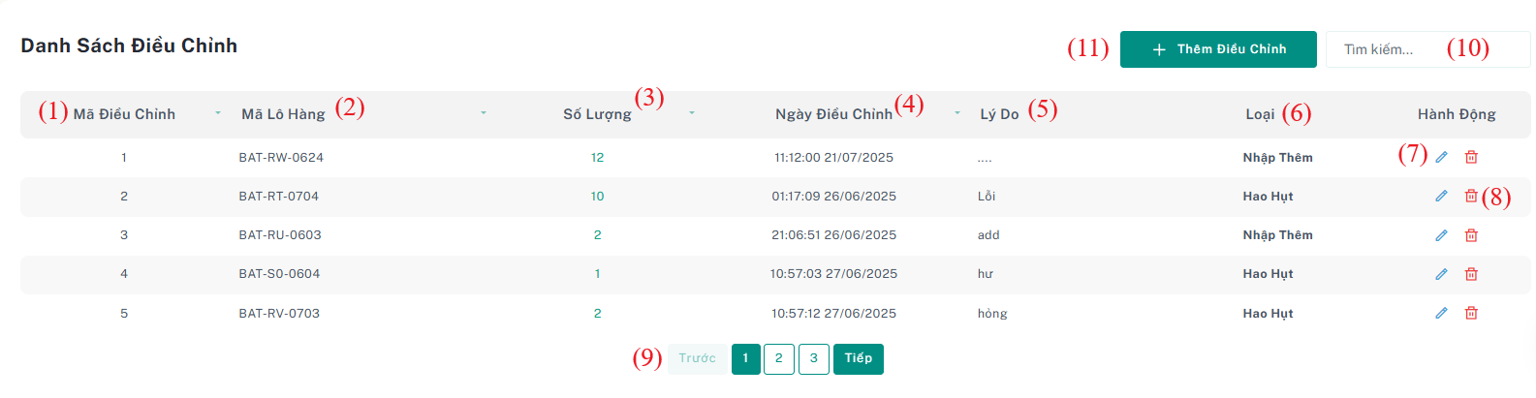

Figure 2.23 - Mockup for view adjustment list

| **Field Name** | **Field Type** | **Description** |
| --- | --- | --- |
| (1) | Number | Unique identifier for each adjustment . |
| (2) | Text | Code of the product batch where the adjustment check was conducted. |
| (3) | Number | Number of quantity adjustment |
| (4) | Date | Date and time when the adjustment was conducted . |
| (5) | Text | Reason why it has this adjustment. |
| (6) | Text | Type of the adjustment (e.g., Nhập Thêm, Hao Hụt). |
| (7) | Button | Button to update the adjustment |
| (8) | Button | Button to delete this adjustment |
| (9) | Button | Button to pagination the page |
| (10) | Text Input | Text input for search adjustment by “Mã Lô Hàng”, “Số Lượng”,”Lý Do”,”Ngày Điều Chỉnh” |
| (11) | Button | Button to navigate to the product batch page to add inventory adjustment. |

Table 42 - Screen description for view adjustment list

***Use case specification***

| UC ID and Name: | **UC-19 View list adjustment** | | |
| --- | --- | --- | --- |
| Created By: | QuangDNHE186891 | Date Created: | 23/06/2025 |
| Primary Actor: | Warehouse Manager | Secondary  Actors: | Warehouse Staff |
| Trigger: | The user selects the "Danh sách điều chỉnh" option from the sidebar into “Điều Chỉnh” . | | |
| Description: | The system allows users to view a list of all adjustments in the warehouse, including information about adjustmentID, Batch Code, quantity, adjustment date, reason, and type of adjustment. Additionally, users can create update adjustment,delete adjustment, And user can search adjustment by “Mã Lô Hàng”, “Số Lượng”,”Lý Do”,”Ngày Điều Chỉnh” , sort and navigate through paginated results. | | |

| Preconditions: | The user has successfully logged into the system with account warehouse Staff |
| --- | --- |
| Postconditions: | The system displays all relevant adjustment data.  Users can access detailed information by clicking on a specific adjustment , updating a new adjustment or search adjustment, and paging filtered records . |
| Normal Flow: | **19.0: View list inventory check**   1. The user navigates to the "Danh sách điều chỉnh" page. 2. The system retrieves and displays the list of adjustments . (see 19.1) 3. For each inventory check, the system shows:    * Adjustment ID    * Batch Code    * Quantity    * AdjustmentDate    * Reason    * Adjustment Type (Nhập Thêm, Hao Hụt) 4. The user search adjustment by Batch Code and AdjustmentDate (see 19.2, 19.3) 5. The system displays searched records. 6. The user selects the sort in search . 7. The system displays sort records according to the search record. |
| Alternative Flows: | * 1. **No inventory checks available**      1. Step 1 is the same as Normal Flow.      2. The system display a message “Không có điều chỉnh nào.”.   2. **Warehouse staff create new adjustment** (see UC-21)   3. **Warehouse staff update adjustment** (see UC-20)   4. **Warehouse staff delete adjustment** (see UC-20) |
| Exceptions: | **19.0.E1: Database Connection Error**   1. Step 1 is the same as Normal Flow. 2. If there is a failure in database connectivity, the system displays the message: "Lỗi dữ liệu. Vui lòng thử lại sau". |
| Priority: | High |

| Frequency of Use: | Daily or as required by warehouse operations. |
| --- | --- |
| Business Rules: | BR-14 , BR-15, BR-16 , BR-17 |
| Other Information: | None |
| Assumptions: | The database is regularly maintained to ensure data accuracy. |

Table 43 - Use case specification for view adjustment list

###### 

#### **6.1.2 Update adjustment**

#### **Screen description**



Figure 2.21 - Mockup for update adjustment

| **Field Name** | **Field Type** | **Description** |
| --- | --- | --- |
| (1) | Dropdown | Select the product detail to associate with the new batch. |
| (2) | Date | The date the product was manufactured. |
| (3) | Integer | Enter the Integer of products in the batch. |
| (4) | Button | Button for close modal and don’t update anything |
| (5) | Button | Button to update productbatch |

Table 44 - Screen description for update adjustment

***Use case specification***

| UC ID and Name: | **UC-21: Update Stock Adjustment** | | |
| --- | --- | --- | --- |
| Created By: | QuangDNHE186891 | Date Created: | 23/06/2025 |
| Primary Actor: | Warehouse Manager | Secondary  Actors: |  |
| Trigger: | The manager selects an adjustment record from the adjustment list to update | | |
| Description: | This use case allows warehouse manager to update an existing stock adjustment by modifying the quantity, reason, and type of adjustment (“Hủy bỏ” – removal or “Nhập thêm” – addition). | | |
| Preconditions: | The user is logged in.  The user has permission to update stock adjustments. | | |
| Postconditions: | The stock adjustment is updated successfully in the system  The updated adjustment is reflected in the adjustment list. | | |
| Normal Flow: | **User accesses the Adjustment list screen.**   * The system displays a table containing existing stock adjustments with fields such as reason, adjustment type, quantity, date, and associated batch. * Each row includes an **Edit** button.   **User clicks the "Edit" button** for a specific adjustment.   * A **modal window** appears with a form to update the selected adjustment.   **In the modal form, the user updates the following fields:**   * (1) **Dropdown:** Select a product batch to associate with the adjustment. * (2) **Date Picker:** Modify the adjustment date. * (3) **Integer Input:** Update the adjustment quantity. * (4) **Dropdown:** Select adjustment type ("Hủy bỏ" or "Nhập thêm"). * (5) **Text Input:** Enter or modify the reason for adjustment.   **User saves the changes:**   * Clicks the **Update** button. * The system validates the input:   + If valid, the adjustment is updated and the modal is closed.   + If invalid, appropriate error messages are displayed.   **System refreshes the adjustment list** to show the updated information. | | |
| Alternative Flows | **(AF1) Product Detail Not Selected:**  – The system prompts the user to select a product detail.  **(AF2) Missing Date or Quantity:**  – The system displays an error if the manufacturing date or quantity is missing. | | |
| Exceptions: | **22.1 E1: Invalid Quantity**  - If type is “Hủy bỏ” so you need input negative integer and “Nhập thêm” is positive number . if not valid display error  **(EX3)** Exceeds Expected Quantity:  - If the entered quantity causes the total received quantity to exceed the planned quantity of the order, the system shows an error and prevents the update. | | |
| Priority: | High | | |
| Frequency of Use: | As needed when batch information needs to be edited. | | |
| Business Rules: | BR-11 | | |
| Other Information: | None | | |
| Assumptions: | The warehouse has no limit on the number of batches. | | |

Table 43 - Use case specification for update adjustment

###### 

#### **6.2.3 Delete Adjustment**

#### **Screen description**



| **Field Name** | **Field Type** | **Description** |
| --- | --- | --- |
| (1) | Button | Cancel delete adjustment |
| (2) | Text | Accept delete adjustment |

Table 42 - Screen description for view inventory check details

***Use case specification***

| UC ID and Name: | **UC-21: Confirm Deletion of Adjustment** | | |
| --- | --- | --- | --- |
| Created By: | QuangDNHE186891 | Date Created: | 23/06/2025 |
| Primary Actor: | Warehouse Manager | Secondary  Actors: |  |
| Trigger: | The user clicks “Delete” on an adjustment record. | | |
| Description: | Allows deletion of a stock adjustment that was added in error or is no longer valid. | | |
| Preconditions: | The user has permission.  Adjustment is not locked/finalized. | | |
| Postconditions: | Adjustment is removed from the system. | | |
| Normal Flow: | **Normal Flow:**   1. The user selects an adjustment and clicks "Delete". 2. Modal shows Adjustment ID and Batch Code. 3. User confirms. 4. System deletes record and updates list. | | |
| Alternative Flows | **Alternative Flow:**  – Select Cancel and don’t accept to delete | | |
| Exceptions: | **None** | | |
| Priority: | High | | |
| Frequency of Use: | Rare – only for correcting mistakes or test data. | | |
| Business Rules: | BR-07 | | |
| Other Information: | Adjustments may affect stock quantity, requiring recalculation post-deletion. | | |
| Assumptions: | Each adjustment is traceable to a user who created it. | | |

Table 42 - Screen description for view inventory check details

###### 

###### 

###### 

###### 

###### 

###### 

###### 

###### 

###### 

###### 

###### 

###### 

###### 

###### 

###### 

### **6.3 Create ProductBatch**

#### **Screen description**

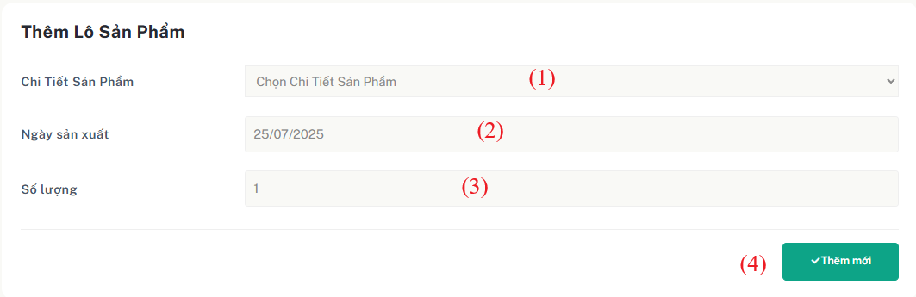

Figure 2.21 - Mockup for create new adjustment

| **Field Name** | **Field Type** | **Description** |
| --- | --- | --- |
| (1) | Dropdown | Select the product detail to associate with the new batch. |
| (2) | Date | The date the product was manufactured. |
| (3) | Integer | Enter the Integer of products in the batch. |
| (4) | Button | Click to submit and create the new product batch with the provided information. |

Table 44 - Screen description for create new product batch

***Use case specification***

| UC ID and Name: | **UC-22: Add New Product Batch** | | |
| --- | --- | --- | --- |
| Created By: | QuangDNHE186891 | Date Created: | 23/06/2025 |
| Primary Actor: | Warehouse Manager | Secondary  Actors: | Warehouse Staff |
| Trigger: | The Warehouse Staff clicks the “Thêm lô mới" button on the product batch entry sidebar, into “Lô sản phẩm”. | | |
| Description: | The Warehouse Manager adds a new product batch by selecting a product detail, entering the manufacturing date and quantity, then confirming the creation. | | |
| Preconditions: | 1. The user must be logged in as Warehouse Staff. 2. The list of product details must be loaded and available. 3. The form for creating a new batch is visible. | | |
| Postconditions: | 1. A new product batch is successfully created and saved to the system. 2. The batch appears in the product batch list. | | |
| Normal Flow: | **21.0 Add productbatch**   1. The Warehouse Staff selects a product detail from the dropdown list. 2. The Warehouse Staff enters the manufacturing date. 3. The Warehouse Staff enters the quantity for the new batch. 4. The Warehouse Staff clicks the "Add New Batch" button. 5. The system validates all inputs. 6. If validation passes, the system creates the batch and displays a success message. And back to page displayProductBath | | |
| Alternative Flows | * 1. **(AF1) Product Detail Not Selected:**The system prompts the user to select a product detail if it is left empty.   **22.2 (AF2) Missing Date or Quantity:** If the manufacturing date or quantity is missing, the system displays an appropriate error message. | | |
| Exceptions: | **None** | | |
| Priority: | High | | |
| Frequency of Use: | Frequently – whenever a new batch arrives. | | |
| Business Rules: | BR-10, BR-12, BR-13 | | |
| Other Information: | Assumes product detail data is maintained elsewhere. | | |
| Assumptions: | The system does not impose any limit on the number of product batches that can be added to the warehouse | | |

Table 43 - Use case specification for view inventory check detail

## 

## **7.** **Supplier Management**

### **7.1** **View List Supplier**

#### **Screen description**

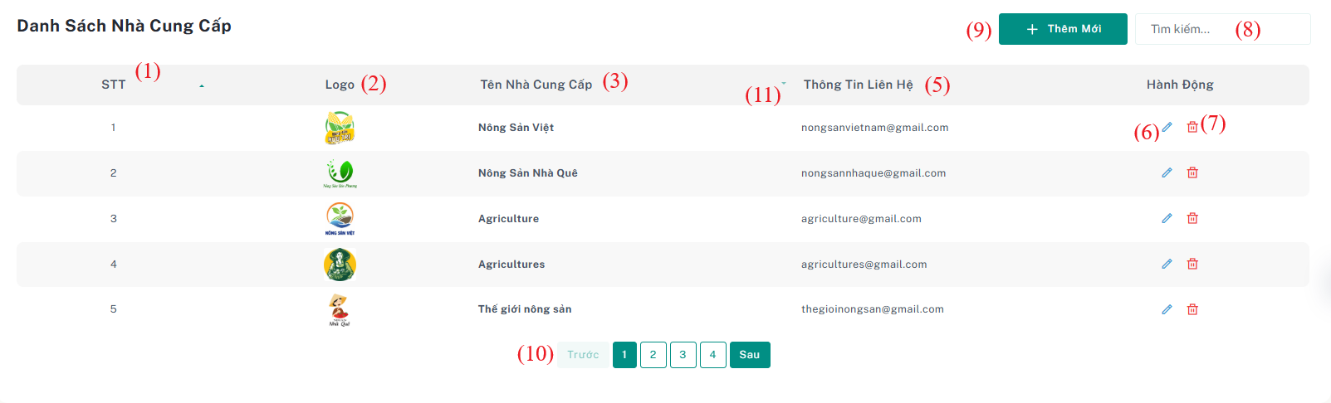

Figure 2.25 - Mockup for view list warehouse receipts use case

| **Field Name** | **Field Type** | **Description** |
| --- | --- | --- |
| (1) | Number | Auto-incremented number representing the order of rows in the list. |
| (2) | Image | Supplier's logo or representative image. |
| (3) | Text | The name of the supplier. |
| (5) | Text | Contact information of the supplier (email or phone). |
| (6) | Button | **Edit** – Button to edit the selected receipt entry |
| (7) | Button | **Delete** – Button to delete the selected receipt entry. |
| (8) | Text input | Search field to enter keywords (e.g., supplier name, date) to filter receipts. |
| (9) | Button | Button to go to the **“Thêm mới”** page. |
| (10) | Component | Navigational buttons to paginate through multiple pages of receipts. |

Table 53 - Screen description for view list warehouse receipts

***Use case specification***

| UC ID and Name: | **UC-26 View Supplier List** | | |
| --- | --- | --- | --- |
| Created By: | QuangDNHE186891 | Date Created: | 17/06/2025 |
| Primary Actor: | Warehouse Manager | Secondary  Actors: | N/A |
| Trigger: | Warehouse Staff wants to view, search, or manage the list of registered suppliers. | | |
| Description: | This use case describes the process by which an authorized user can view the list of suppliers in the system. The user can sort, search, and navigate through suppliers, and may also update or delete a supplier entry. | | |
| Preconditions: | The user must be logged into the system with the appropriate permission.  The system must contain at least one supplier record. | | |
| Postconditions: | The system displays a list of all available suppliers with relevant information.  The user can edit, delete, or navigate to the add supplier form. | | |
| Normal Flow: | **27.0 View Supplier List**   1. The user navigates to the “Danh sách Nhà cung cấp” page. 2. The system loads the list of all suppliers sorted by default filter 3. The system displays the following for each supplier in table format:     * Serial number (auto-increment)    * Supplier logo    * Supplier name    * Supplier contact information (email or phone)    * **Edit** and **Delete** buttons 4. The system provides a **Search** input box and the user uses it to filter suppliers by name or contact info. 5. The system filters and updates the displayed list accordingly. 6. The user can use **pagination controls** to browse through multiple pages if applicable. 7. The user clicks the **Thêm mới** button to navigate to the add supplier form if desired. | | |

| Alternative Flows: | * 1. **No suppliers found** * The system has no existing supplier data. * The system displays the message: “No supplier records found.” and disables search. |
| --- | --- |
| Exceptions: | **26.0.E1. Network connectivity issue**   1. The system is unable to load data due to a network issue. 2. The system shows a error message |
| Priority: | High |
| Frequency of Use: | Frequently used when managing suppliers or preparing to create stock-in records. |
| Business Rules: | BR-18, BR-19, BR-20, BR-21 |
| Other Information: | None |
| Assumptions: | The search and sort features are fully implemented. |

Table 43 - Use case specification for view inventory check detail

### **7.2** **Add Supplier**

#### **Screen description**

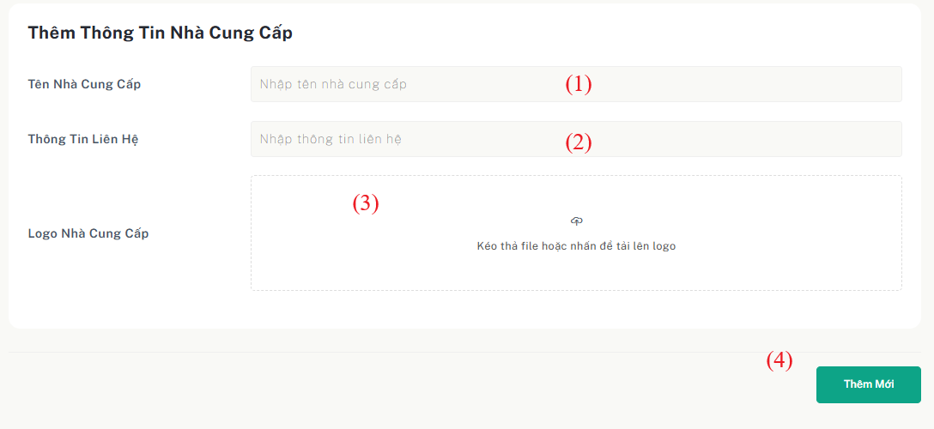

Figure 2.25 - Mockup for view list warehouse receipts use case

| **Field Name** | **Field Type** | **Description** |
| --- | --- | --- |
| (1) | Text Input | Enter the name of the supplier. |
| (2) | Text Input | Enter supplier contact info (email or phone number). |
| (3) | Image Upload | Upload an image representing the supplier’s logo. |
| () | Button | Button to submit the form and add the supplier. |

Table 53 - Screen description for view list warehouse receipts

***Use case specification***

| UC ID and Name: | **UC-26 Add Supplier** | | |
| --- | --- | --- | --- |
| Created By: | QuangDNHE186891 | Date Created: | 17/06/2025 |
| Primary Actor: | Warehouse Manager | Secondary  Actors: | N/A |
| Trigger: | Warehouse Staff wants to view, search, or manage the list of registered suppliers. | | |
| Description: | This use case describes the process by which a Warehouse Staff inputs information to add a new supplier. The required fields include the supplier name, contact information, and logo. | | |
| Preconditions: | The Warehouse Staff is logged into the system with proper permissions.  The "Thêm nhà cung cấp" form is accessible from the Supplier List or system navigation. | | |
| Postconditions: | A new supplier is successfully created and displayed in the Supplier List. | | |
| Normal Flow: | **28.0 Add Supplier**   1. The Admin navigates to the “Thêm Nhà cung cấp” (Add Supplier) page. 2. The system displays a form with the following fields:     * **Tên nhà cung cấp** (Text input)    * **Thông tin liên hệ** (Text input: email or phone)    * **Logo nhà cung cấp** (Image file upload)    * **Gửi** (Submit button) 3. The Admin fills in the fields and clicks the **Gửi** button. 4. The system validates the input:     * All required fields are filled    * Contact info is in a valid format (e.g., email or phone) 5. If validation passes, the system stores the new supplier and displays a success message. 6. The Admin is redirected back to the Supplier List, where the new supplier is shown. | | |

| Alternative Flows: | **Input Validation Failure**   * One or more fields are invalid or empty. * The system displays error messages next to the problematic fields. |
| --- | --- |
| Exceptions: | **26.0.E1. Network connectivity issue**   1. The system is unable to load data due to a network issue. 2. The system shows a error message |
| Priority: | High |
| Frequency of Use: | Frequently used when managing suppliers or preparing to create stock-in records. |
| Business Rules: | BR-22, BR-23 |
| Other Information: | None |
| Assumptions: | The search and sort features are fully implemented. |

Table 43 - Use case specification for view inventory check detail

### **7.3** **Update Supplier**

#### **Screen description**



Figure 2.25 - Mockup for view list warehouse receipts use case

| **Field Name** | **Field Type** | **Description** |
| --- | --- | --- |
| (1) | Number | Auto-incremented number representing the order of rows in the list. |
| (2) | Image | Supplier's logo or representative image. |
| (3) | Text | The name of the supplier. |
| (5) | Text | Contact information of the supplier (email or phone). |
| (6) | Button | **Edit** – Button to edit the selected receipt entry |
| (7) | Button | **Delete** – Button to delete the selected receipt entry. |
| (8) | Text input | Search field to enter keywords (e.g., supplier name, date) to filter receipts. |
| (9) | Button | Button to go to the **“Thêm mới”** page. |
| (10) | Component | Navigational buttons to paginate through multiple pages of receipts. |

Table 53 - Screen description for view list warehouse receipts

***Use case specification***

| UC ID and Name: | **UC-26 View Supplier List** | | |
| --- | --- | --- | --- |
| Created By: | QuangDNHE186891 | Date Created: | 17/06/2025 |
| Primary Actor: | Warehouse Manager | Secondary  Actors: | N/A |
| Trigger: | Warehouse Staff wants to view, search, or manage the list of registered suppliers. | | |
| Description: | This use case describes the process by which an authorized user can view the list of suppliers in the system. The user can sort, search, and navigate through suppliers, and may also update or delete a supplier entry. | | |
| Preconditions: | The user must be logged into the system with the appropriate permission.  The system must contain at least one supplier record. | | |
| Postconditions: | The system displays a list of all available suppliers with relevant information.  The user can edit, delete, or navigate to the add supplier form. | | |
| Normal Flow: | **27.0 View Supplier List**   1. The user navigates to the “Danh sách Nhà cung cấp” page. 2. The system loads the list of all suppliers sorted by default filter 3. The system displays the following for each supplier in table format:     * Serial number (auto-increment)    * Supplier logo    * Supplier name    * Supplier contact information (email or phone)    * **Edit** and **Delete** buttons 4. The system provides a **Search** input box and the user uses it to filter suppliers by name or contact info. 5. The system filters and updates the displayed list accordingly. 6. The user can use **pagination controls** to browse through multiple pages if applicable. 7. The user clicks the **Thêm mới** button to navigate to the add supplier form if desired. | | |

| Alternative Flows: | * 1. **No suppliers found** * The system has no existing supplier data. * The system displays the message: “No supplier records found.” and disables search. |
| --- | --- |
| Exceptions: | **26.0.E1. Network connectivity issue**   1. The system is unable to load data due to a network issue. 2. The system shows a error message |
| Priority: | High |
| Frequency of Use: | Frequently used when managing suppliers or preparing to create stock-in records. |
| Business Rules: | BR-18, BR-19, BR-20, BR-21 |
| Other Information: | None |
| Assumptions: | The search and sort features are fully implemented. |

Table 43 - Use case specification for view inventory check detail

### **7.4** **Delete Supplier**

#### **Screen description**

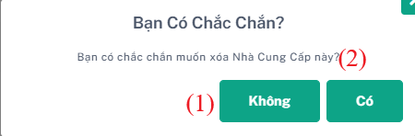

| **Field Name** | **Field Type** | **Description** |
| --- | --- | --- |
| (1) | Button | Cancel delete supplier |
| (2) | Text | Accept delete supplier |

Table 42 - Screen description for view inventory check details

***Use case specification***

| UC ID and Name: | **UC-21: Confirm Deletion of Supplier** | | |
| --- | --- | --- | --- |
| Created By: | QuangDNHE186891 | Date Created: | 17/06/2025 |
| Primary Actor: | Warehouse Manager | Secondary  Actors: |  |
| Trigger: | The user clicks “Delete” on a supplier record. | | |
| Description: | Enables deletion of a supplier that is no longer active or needed. | | |
| Preconditions: | The user has permission.  Supplier is not linked to any active stock-in or purchase orders. | | |
| Postconditions: | Supplier is deleted, and the system reflects the change. | | |
| Normal Flow: | **21.0 Delete Supplier**  1. The user clicks **"Delete"** on a supplier  2. The system opens a confirmation modal showing notification.  3. User clicks **"Confirm Delete"**.  4. The system deletes the supplier and displays a success message. | | |
| Alternative Flows | **Alternative Flow:**  – If the supplier is referenced, the system prevents deletion and shows: "Cannot delete supplier with related transactions." | | |
| Exceptions: | **None** | | |
| Priority: | High | | |
| Frequency of Use: | Occasional – mainly during supplier cleanup or system data migration. | | |
| Business Rules: | BR-07 | | |
| Other Information: | Deleted suppliers may need to be retained in audit logs. | | |
| Assumptions: | The supplier is not actively in use when deletion is requested. | | |

Table 42 - Screen description for view inventory check details

## **8.** **Warehouse StockIn Management**

### **8.1** **View List Warehouse StockIn**

#### **8.3.1 View List Warehouse StockIn**

### ***Screen description***

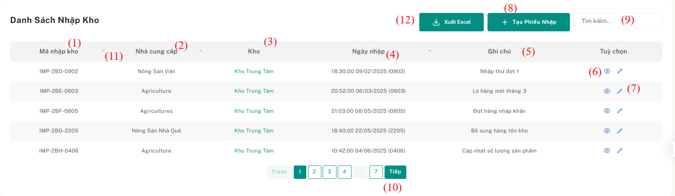

Figure 2.25 - Mockup for view list warehouse stockin receipts use case

| **Field Name** | **Field Type** | **Description** |
| --- | --- | --- |
| (1) | Text | Unique encode identifier for each stock in |
| (2) | Text | Name of the supplier associated |
| (3) | Text | The name of the warehouse where the goods were received.. |
| (4) | DateTime | The date and time the goods were entered into the warehouse. |
| (5) | Text | Additional remarks about the warehouse stockin |
| (6) | Button | Button to navigate to the detailed view page of the selected receipt. |
| (7) | Button | Button to edit the selected stockin entry. |
| (8) | Button | Button to go to create a new stockin page. |
| (9) | Text Input | Input field to search receipts by keyword |
| (10) | Component | Navigational buttons to paginate through multiple pages of receipts. |
| (11) | Icon | Allows sorting the list ascending/descending by the corresponding column. |
| (12) | Button | Allows export stockin data to excel |

Table 53 - Screen description for view list warehouse receipts

***Use case specification***

| UC ID and Name: | **UC-26 View list warehouse receipts** | | |
| --- | --- | --- | --- |
| Created By: | QuangDNHE186891 | Date Created: | 17/07/2025 |
| Primary Actor: | Warehouse Manager | Secondary  Actors: | N/A |
| Trigger: | The Warehouse Manager wants to review the list of all warehouse receipts. | | |
| Description: | This use case describes the process by which the Warehouse Staff views a list of all warehouse receipts in the system. The list can be sorted based on predefined search, and each receipt provides detailed information about reference stock in ID, entry date, supplier name, warehouse, and related notes. | | |
| Preconditions: | * The Warehouse Manager must be logged into the system with appropriate permissions. * The system must have existing warehouse receipt data. | | |
| Postconditions: | * The Warehouse Manager is able to view a list of all warehouse receipts sorted by the selected filter (e.g., by entry date). * The system displays the list of receipts, including their reference code, entry date, supplier, status, total amount, and action buttons. | | |
| Normal Flow: | **26.0 View list warehouse stock-in**  1. The Warehouse Manager navigates to the "Danh sách phiếu nhập hàng" page.  2.The system loads the list of all warehouse **stock-in** sorted by the default filter (e.g., by entry date in descending order).  3. The Warehouse Manager views the list of **stock-in** and verifies the following information for each **stock-in**: (See 26.2)   * + StockIn ID   + Supplier Name   + Warehouse Name   + Entry Date   + Note   + Detail button   + Edit Button | | |

|  | 4. The system displays the list in a table format with pagination (if applicable) and provides the "Tạo Phiếu Nhập Kho" (Create Receipt) button at the top right of the screen.  5. The Warehouse Staff uses the "Tìm kiếm" to search stockin  6. The system filters and updates the displayed list of **stock-in receipts** based on the search criteria. (See 26.2)  7. The Warehouse Staff uses the Sort to sort stock-in  8. The system sorts and displays the updated list of **stock-in receipts** according to the selected attribute. |
| --- | --- |
| Alternative Flows: | * 1. **No receipts found**      1. The system does not have any existing warehouse stock-in.      2. The system displays a message: "Không tìm thấy phiếu nhập kho nào." and disables search options.   2. **System error**      1. The system encounters an error while loading the warehouse receipt list.      2. The system displays an error message: "Không thể load được dữ liệu, Vui lòng kiểm tra ."      3. The Warehouse Manager can retry loading the list |
| Exceptions: | **26.0.E1. Network connectivity issue**   1. The system is unable to load data due to a network issue. 2. The system shows an error message |
| Priority: | High |
| Frequency of Use: | Daily or as needed for warehouse receipt management. |
| Business Rules: | BR-68, BR-69, BR-70, BR-71, BR-72 |
| Other Information: | None |
| Assumptions: | The "Chi tiết" (Detail) button redirects to a functional receipt detail page.  All data is validated and up-to-date in the system. |

Table 43 - Use case specification for view inventory check detail

### 

#### **8.3.2 Update StockIn Receipts**

#### **Screen description**

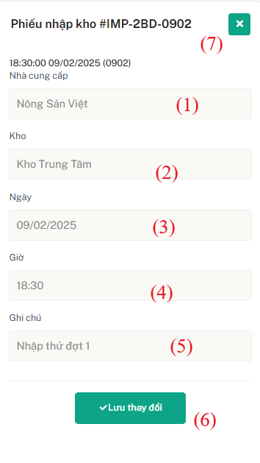

Figure 2.25 - Mockup for update stockin use case

| **Field Name** | **Field Type** | **Description** |
| --- | --- | --- |
| (1) | Dropdown | Dropdown list of available suppliers. |
| (2) | Dropdown | Dropdown list of warehouses. |
| (3) | Date | Date of stock-in (selected via date picker). |
| (4) | Time | Time of stock-in. |
| (5) | Text | Notes or descriptions related to the stock-in (optional). |
| (6) | Button | Button to save changes to the stock-in. |
| (7) | Button | Button to close the modal without saving. |

Table 53 - Screen description for update stockin

***Use case specification***

| UC ID and Name: | **UC-21: Update Stock-In Detail** | | |
| --- | --- | --- | --- |
| Created By: | QuangDNHE186891 | Date Created: | 27/07/2025 |
| Primary Actor: | Warehouse Manager | Secondary  Actors: |  |
| Trigger: | User clicks the "Chỉnh sửa mục" icon next to a StockInDetail row. | | |
| Description: | Allows warehouse staff to update the quantity and price of a product in an existing stock-in batch | | |
| Preconditions: | The stock-in detail record exists.  The product detail and batch code are predefined and locked together. | | |
| Postconditions: | The quantity and price of the product in the stock-in detail are updated successfully | | |
| Normal Flow: | **21.0 Update StockIn**  1. User opens the stock-in detail list from stockin.  2. User selects the row to edit and clicks the "Chỉnh sửa mục".  3. A modal form appears displaying:   * Product Detail (read-only), * Batch Code (read-only), * Quantity (editable), * Price (editable).   4. User updates **Quantity** and/or **Price**.  5. User clicks **Save**.  6. System validates the values and updates the stock-in detail.  7. System shows: *“Stock-in detail updated successfully.”* | | |
| Alternative Flows | **(AF1)** **Cancel Edit**  User clicks **Cancel** → modal closes, no changes applied.  **(AF2)** **No Change Detected**  If the user clicks **Save** without making any changes, system displays: | | |
| Exceptions: | **None** | | |
| Priority: | High | | |
| Frequency of Use: | Used frequently during stock-in audits or corrections.. | | |
| Business Rules: | BR-70 | | |
| Other Information: | The modal closes automatically on successful update. | | |
| Assumptions: | Product Detail only changed during update by Batch Code. | | |

Table 53 - Screen description for update stockin

### 

### **8.2** **View List Warehouse StockIn Detail**

#### **8.2.1 View List Warehouse StockIn Detail**

#### **Screen description**

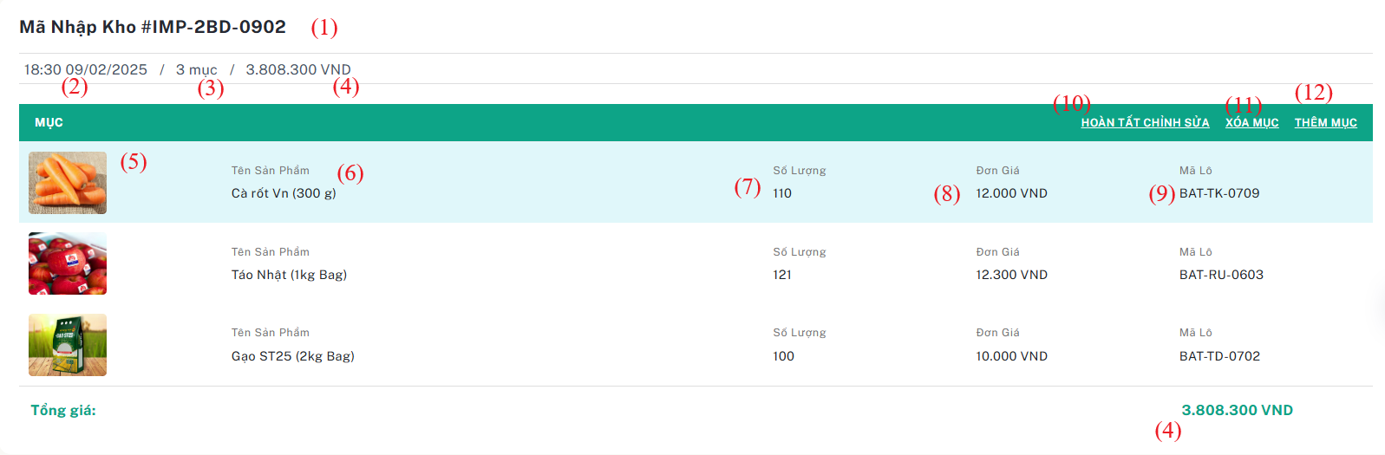

Figure 2.25 - Mockup for view list warehouse receipts use case

| **Field Name** | **Field Type** | **Description** |
| --- | --- | --- |
| (1) | Text | Unique encode identifier for each stock in |
| (2) | DateTime | The date and time the stock was imported |
| (3) | Number | The number of stockins imported |
| (4) | Number | Total spending for this stockin |
| (5) | Image | Image of the product |
| (6) | Number | Quantity of product batch imported |
| (7) | Text | Unique encode identifier for each stock out |
| (8) | Number | Price of productdetail in this batch |
| (9) | Text | Id of productBatch of this stockindetail |
| (10) | Text | Open modal update stockindetail |
| (11) | Text | Delete stockindetail |
| (12) | Text | Add new stock in detail |

Table 53 - Screen description for view list warehouse receipts

***Use case specification***

| UC ID and Name: | **UC-26 Manage Stock-In Details** | | |
| --- | --- | --- | --- |
| Created By: | QuangDNHE186891 | Date Created: | 17/07/2025 |
| Primary Actor: | Warehouse Manager | Secondary  Actors: | N/A |
| Trigger: | The user navigates to the StockIn page, selects a stock-in record, and views the associated stock-in details. | | |
| Description: | This use case allows the warehouse manager to **view**, **add**, **update**, and **delete** stock-in detail records linked to a selected stock-in transaction. | | |
| Preconditions: | The stock-in details are correctly displayed.  New stock-in details can be added.  Existing stock-in details can be updated or deleted. | | |
| Postconditions: | The Warehouse Manager is able to view a list of all warehouse receipts sorted by the selected filter (e.g., by entry date).  The system displays the list of receipts, including their reference code, entry date, supplier, status, total amount, and action buttons. | | |
| Normal Flow: | **23.0 Manage Stock-In Details**   1. The Warehouse Manager selects a stock-in record from the StockIn list. 2. The system displays a table of related StockInDetails, including:    * StockIn ID (Text)    * Imported Date and Time (DateTime)    * Quantity of StockIns (Number)    * Total Spending (Number)    * Product Image (Image)    * Quantity of Product Batch Imported (Number)    * StockOut Code (Text)    * Price per Product Detail in Batch (Number)    * ProductBatch ID (Text) The user can:    * Click **“Thêm mụmục”** → The system opens a form/modal to add a new detail.    * Click **“Chỉnh sửa mục”** on a row → The system opens a modal with existing values for editing.    * Click **“Xóa Mục”** on a row → The system shows a confirmation modal for deletion. 3. After adding/updating/deleting, the system refreshes the StockInDetail list. | | |

| Alternative Flows: | **AF1: Cancel Add/Update**   * The user opens the add/update modal but cancels the action. * The modal is closed with no data changes.   **AF2: Missing Required Fields**   * If required fields are not filled, the system displays validation error messages and prevents saving.   **AF3: Deletion Canceled**   * The user clicks "Delete" but cancels the confirmation. * No change is made. |
| --- | --- |
| Exceptions: | **E1: Invalid Data Entry**   * If a field (e.g., price or quantity) contains invalid characters or negative values, the system prevents saving and shows an error. |
| Priority: | High |
| Frequency of Use: | Frequently during stock management activities. |
| Business Rules: | BR-68, BR-01, BR-73, BR-74, BR-75, BR-76, BR-77, BR-78 |
| Other Information: | None |
| Assumptions: | ProductBatch and ProductDetail must already exist before being used in StockInDetail. |

### 

### 

#### **8.2.2 Update Warehouse StockIn Detail**

#### **Screen description**

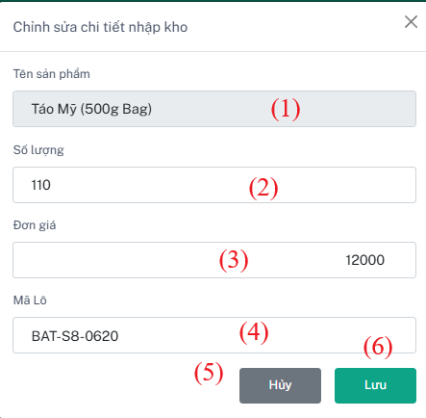

Figure 2.25 - Mockup for view list warehouse receipts use case

| **Field Name** | **Field Type** | **Description** |
| --- | --- | --- |
| (1) | Text Read Only | Name of the product detail associated with the stock-in detail. |
| (2) | Integer | The number of items being stocked in |
| (3) | Price | The unit price for the product. |
| (4) | Batch Code | Code of the batch related to this stock-in detail. |
| (5) | Button | Closes the modal without saving any changes. |
| (6) | Button | Saves the updated quantity and price for the selected stock-in item. |

***Use case specification***

| UC ID and Name: | **UC-21: Update Stock In** | | |
| --- | --- | --- | --- |
| Created By: | QuangDNHE186891 | Date Created: | 17/07/2025 |
| Primary Actor: | Warehouse Manager | Secondary  Actors: |  |
| Trigger: | The user selects an existing stock-in record and clicks the "Edit" button. | | |
| Description: | This use case allows warehouse staff to create a stock adjustment by entering the quantity, reason, and type of adjustment (“Hủy bỏ” or “Nhập thêm”). | | |
| Preconditions: | - User is logged in with permission to edit stock-in.  - The selected stock-in record exists. | | |
| Postconditions: | The selected stock-in record is updated successfully with valid new values. | | |
| Normal Flow: | **21.0 Update StockIn**   1. Warehouse Staff selects a stock-in record and clicks edit. 2. The system opens a modal with existing data filled in. 3. The user updates fields: supplier, warehouse, date, time, and note. 4. The user clicks the **"Save"** button. 5. The system validates all inputs. 6. If valid, the system updates the record and shows a success message. 7. The modal closes and the updated list is shown. | | |
| Alternative Flows | **(AF1)** No Changes Made:   – If the user opens the modal but does not change anything and clicks "Cancel", the system closes the modal without updating.  **(AF2)** Missing Required Fields:   – If supplier, warehouse, or entry date is missing, the system displays appropriate error messages. | | |
| Exceptions: | **22.1 E1: Invalid Time Format**  If the user enters an invalid time format (e.g., non-numeric characters or a time outside the valid range), the system displays an error message: | | |
| Priority: | Medium | | |
| Frequency of Use: | As needed when stock-in records require modification. | | |
| Business Rules: | BR-75 | | |
| Other Information: | The modal closes automatically on successful update. | | |
| Assumptions: | No limit to the number of times a stock-in can be updated. | | |

Table 43 - Use case specification for view inventory check detail

#### **8.2.3 Add Warehouse StockIn Detail**

#### **Screen description**

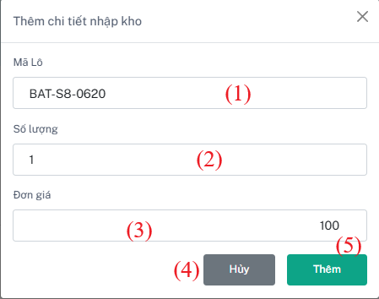

Figure 2.25 - Mockup for view list warehouse receipts use case

| **Field Name** | **Field Type** | **Description** |
| --- | --- | --- |
| (1) | Dropdown | Dropdown to select from available product batches. |
| (2) | Integer | The number of items being stocked in |
| (3) | Price | The unit price for the product. |
| (4) | Button | Closes the modal without saving any changes. |
| (5) | Button | Saves the updated quantity and price for the selected stock-in item. |

Table 43 - Use case specification for view inventory check detail

***Use case specification***

| UC ID and Name: | **UC-21: Add Stock In** | | |
| --- | --- | --- | --- |
| Created By: | QuangDNHE186891 | Date Created: | 17/07/2025 |
| Primary Actor: | Warehouse Manager | Secondary  Actors: |  |
| Trigger: | The user selects an existing stock-in record, opens its details, and clicks the **"Thêm mục"** button. | | |
| Description: | This use case allows warehouse managers to add a new product entry into the selected stock-in record by specifying the product batch, quantity, and unit price. | | |
| Preconditions: | The user is logged in with permission to edit stock-in.  A valid stock-in record has been selected from the stock-in list.  The stock-in detail view is currently open. | | |
| Postconditions: | A new stock-in detail entry is successfully added to the selected stock-in record with valid values. | | |
| Normal Flow: | **22.0 Add StockInDetail**   1. Warehouse Staff opens the stock-in list and selects a specific record. 2. The system displays the detail view of the selected stock-in. 3. The user clicks the **"Add Item"** button. 4. The system opens a modal form for entering new stock-in detail. 5. The user selects the product batch, enters the quantity and unit price. 6. The user clicks the **"Save"** button. 7. The system validates the input fields. 8. If all data is valid, the new stock-in detail is saved. 9. A success message is displayed, and the modal closes. 10. The updated detail list is shown with the new item added. | | |
| Alternative Flows | **AF1) Cancel Operation:**  – If the user opens the modal but clicks "Cancel", the system closes the modal without saving any data.  **(AF2) Missing Required Fields:** – If the product batch, quantity, or unit price is not provided, the system displays appropriate error messages next to each field. | | |
| Exceptions: | **22.1 E1: Invalid Quantity or Price Format**  – If the user enters a non-numeric or negative value in quantity or price fields, the system shows an error message and prevents submission. | | |
| Priority: | Medium | | |
| Frequency of Use: | As needed when stocking in additional products to an existing record. | | |
| Business Rules: | BR-74 | | |
| Other Information: | The modal closes automatically upon successful addition. | | |
| Assumptions: | No limit to the number of times a stock-in can be updated. | | |

Table 43 - Use case specification for view inventory check detail

#### **8.2.4 Delete StockinDetail**

#### **Screen description**

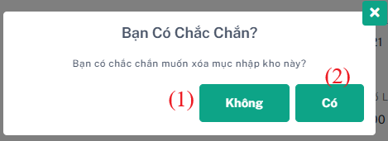

| **Field Name** | **Field Type** | **Description** |
| --- | --- | --- |
| (1) | Button | Cancel delete stockindetail |
| (2) | Text | Accept delete stockindetail |

Table 42 - Screen description for view inventory check details

***Use case specification***

| UC ID and Name: | **UC-21: Delete Stock-In Detail** | | |
| --- | --- | --- | --- |
| Created By: | QuangDNHE186891 | Date Created: | 17/07/2025 |
| Primary Actor: | Warehouse Manager | Secondary  Actors: |  |
| Trigger: | User clicks the “Xóa mục" icon next to a StockInDetail row. | | |
| Description: | Allows user to delete an individual stock-in detail entry (line item) from a stock-in record. | | |
| Preconditions: | User has edit permission on stock-in.  The detail is not part of a finalized stock-in. | | |
| Postconditions: | The detail is removed from the record. | | |
| Normal Flow: | ***Normal Flow:***   1. The user clicks **"Delete"** next to a stock-in detail item. 2. Modal shows batch name, quantity, and price. 3. User confirms. 4. System deletes the item and recalculates the stock-in summary if needed. | | |
| Alternative Flows | **(AF1)** **Cancel delete**  User choose cancel and don’t accept delete stockin detail | | |
| Exceptions: | **None** | | |
| Priority: | Medium | | |
| Frequency of Use: | Moderate – often used during stock-in entry corrections. | | |
| Business Rules: | BR-76 | | |
| Other Information: | The system should prompt recalculation or review of remaining stock-in details. | | |
| Assumptions: | Stock-in details are editable until the full record is finalized. | | |

### **8.3** **Add Stockin Receipts**

#### **Screen description**

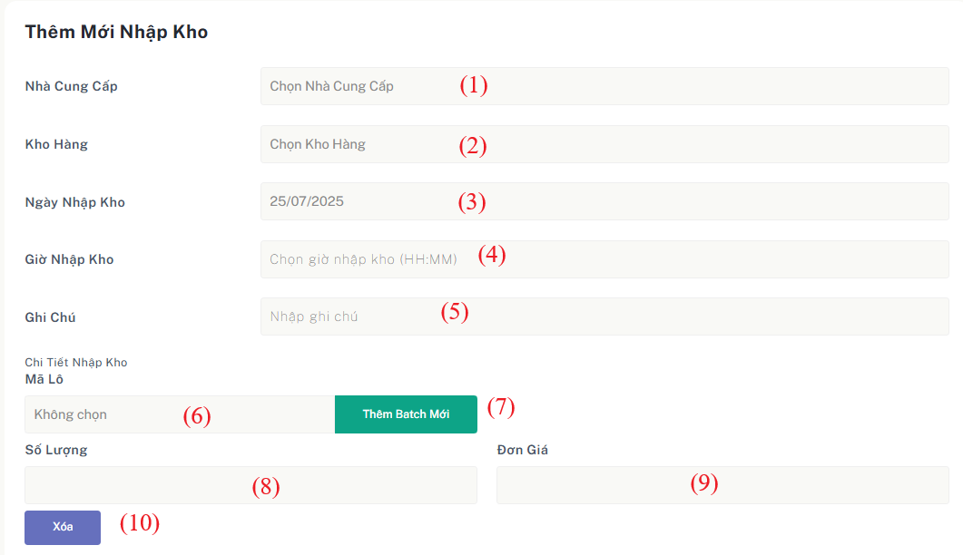

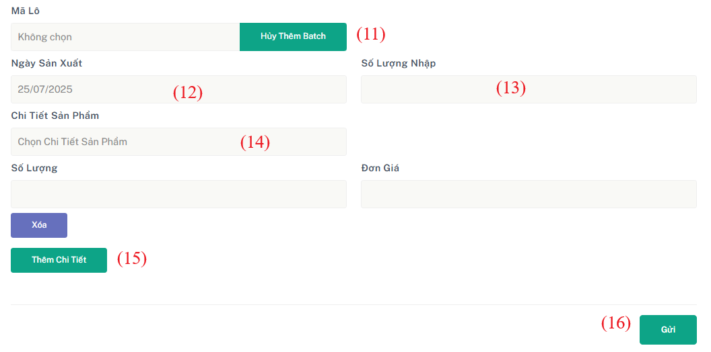

Figure 2.25 - Mockup for view list warehouse receipts use case

| **Field Name** | **Field Type** | **Description** |
| --- | --- | --- |
| (1) | Dropdown | Dropdown list of available suppliers. |
| (2) | Dropdown | Dropdown list of warehouses. |
| (3) | Date | Date of stock-in (selected via date picker). |
| (4) | Time | Time of stock-in. |
| (5) | Text | Notes or descriptions related to the stock-in (optional). |
| (6) | Dropdown | Dropdown list Batch available for stockin |
| (7) | Button | Button to add form add new batch for stockin |
| (8) | Integer | Quantity of products to stock in. |
| (9) | Integer | Price per unit of the product. |
| (10) | Button | Delete form stockindetail add |
| (11) | Button | Remove form to add new batch |
| (12) | Date | The date the product was manufactured. |
| (13) | Integer | Quantity of products in the new batch. |
| (14) | IntegerDropdown | Select the product detail to associate with the new batch. |
| (15) | Button | Adds a new form to enter another stock-in detail. |
| (16) | Button | Confirms and adds the stock-in record. |

Table 53 - Screen description for view list warehouse receipts

***Use case specification***

| UC ID and Name: | **UC-26 Add New Stock-In receipts** | | |
| --- | --- | --- | --- |
| Created By: | QuangDNHE186891 | Date Created: | 17/07/2025 |
| Primary Actor: | Warehouse Manager | Secondary  Actors: | N/A |
| Trigger: | The Warehouse Staff clicks the “Tạo Phiếu Nhập Kho” button. | | |
| Description: | This use case allows warehouse staff to create a new Stock-In record when products are received from suppliers. The process includes selecting the supplier, warehouse, date and time of receipt, and entering one or more stock-in details, such as product batches, quantities, and prices. Staff can either select existing product batches or create new ones directly from the form. | | |
| Preconditions: | The Warehouse Manager must be logged into the system with appropriate permissions.  Product and supplier data exists. | | |
| Postconditions: | A new Stock-In record is added to the system and associated stock in details and new batch saved. | | |
| Normal Flow: | **26.0 View list warehouse receipts**  1.The system displays the **Add Stock-In** form with default empty fields.  2.The user selects a **Supplier** and a **Warehouse** .  3.The user chooses the **Stock-in Date** and **Time** .  4. The user enters any **Notes** .  5.For each stock-in detail, the user:   * Selects an existing **Batch** or clicks **Add New Batch** to input:    + **Product Detail**   + **Manufacture Date**   + **Batch Quantity** * Enters **Stock-in Quantity** and **Unit Price** .   6.The user can use  **Icon** to sort batch/product lists.  7. The user may click  **Add Form** to input more stock-in details or  **Delete** to remove a line.  8.Clicks  **Add** to submit.  9. The system validates and stores the new Stock-In Receipts | | |

| Alternative Flows: | **26.0.E1. Network connectivity issue**   * The system is unable to load data due to a network issue. * The system shows an error message: **"Unable to connect to the server. Please check your network and try again."**   **26.0.E2. Backend service unavailable**   * The system cannot fetch the receipt list due to a backend service error. * Displays: **"Service temporarily unavailable. Please try again later.** |
| --- | --- |
| Exceptions: | **26.0.E1. Network connectivity issue**   1. The system is unable to load data due to a network issue. 2. The system shows an error message |
| Priority: | High |
| Frequency of Use: | Used **multiple times per day**, especially during periods of high inventory intake. |
| Business Rules: | BR-74, BR-79, BR-80, BR-81, BR-82, BR-83 |
| Other Information: | None |
| Assumptions: | The "Chi tiết" (Detail) button opens a fully functional receipt detail view. |

Table 43 - Use case specification for view inventory check detail

### 

## **9.** **Warehouse Stock Out Management**

### **9.1** **View List Stock Out**

#### **Screen description**

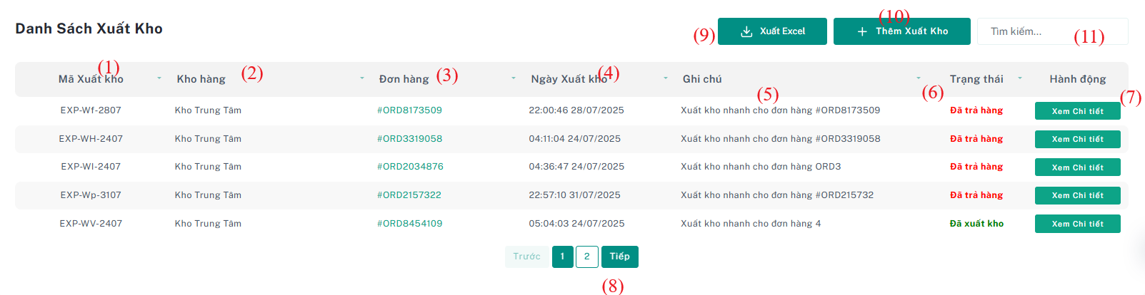

Figure 2.25 - Mockup for view list warehouse receipts use case

| **Field Name** | **Field Type** | **Description** |
| --- | --- | --- |
| (1) | Text | Unique encode identifier for each stock out |
| (2) | Text | Name of the warehouse |
| (3) | Text | Code of the related order |
| (4) | DateTime | The date and time the goods were exported |
| (5) | Text | Additional remarks about the stockout |
| (6) | Text | Status of the stockout |
| (7) | Button | Button to go to detail stockout page. |
| (8) | Component | Navigational buttons to paginate through multiple pages of receipts. |
| (9) | Button | Allows export stockin data to excel |
| (10) | Button | Button to go to add stockout page. |
| (11) | Text Input | Input field to search stockout by keyword |

Table 53 - Screen description for view list warehouse receipts

***Use case specification***

| UC ID and Name: | **UC-26 View list warehouse receipts** | | |
| --- | --- | --- | --- |
| Created By: | QuangDNHE186891 | Date Created: | 17/07/2025 |
| Primary Actor: | Warehouse Manager | Secondary  Actors: | N/A |
| Trigger: | The user navigates to the Stock-Out page from the menu. | | |
| Description: | This use case allows warehouse staff to view a list of stock-out records and perform actions such as viewing details, searching, paginating, and exporting data. | | |
| Preconditions: | User is logged in with permission to view stock-out information. | | |
| Postconditions: | Stock-out records are displayed according to the current filters and pagination.  User may view details or export the data successfully. | | |
| Normal Flow: | **23.0 View StockOut List**   1. Warehouse Staff selects the **Stock-Out** section from the navigation menu. 2. The system displays a list of stock-out records with the following information per record:    – Unique Stock-Out Code    – Warehouse Name    – Order Code    – Export Date & Time    – Notes    – Status 3. The user uses the search bar to filter stock-out records by keyword. 4. The user uses pagination controls to navigate through multiple pages of stock-outs. 5. The user clicks the **“Details”** button on a specific record. 6. The system redirects to the stock-out detail page showing full information about that record. 7. Optionally, the user can click **“Export to Excel”** to download all currently displayed stock-out records. | | |
| Alternative Flows: | **(AF1) No Matching Records:** – If no stock-out records match the keyword search, the system displays a message: “No records found.”  **(AF2) Empty Stock-Out List:** – If there are no stock-out records in the system, the table appears empty with a message: “No stock-out records available.” | | |
| Exceptions: | **E1: Export Failed**  – If the export to Excel fails (e.g., due to network issues), the system **displays** an error message: “Export failed. Please try again.” | | |
| Priority: | Medium | | |
| Frequency of Use: | Frequently – used by warehouse staff during daily operations to check and manage outgoing inventory. | | |
| Business Rules: | BR-02, BR-03, BR-04, BR-84, BR-85, BR-86 | | |
| Other Information: | Detail view provides full visibility of all items in the stock-out. | | |
| Assumptions: | Pagination is always available when total records exceed the page size. | | |

Table 43 - Use case specification for view inventory check detail

### **9.2** **View List StockOut Detail**

#### **Screen description**

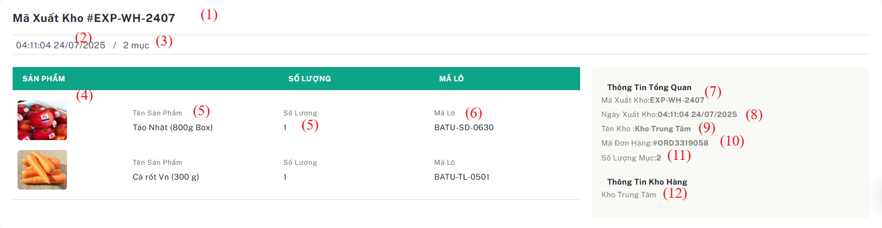

Figure 2.25 - Mockup for view list warehouse receipts use case

| **Field Name** | **Field Type** | **Description** |
| --- | --- | --- |
| (1) | Text | Unique encode identifier for each stock out |
| (2) | DateTime | The date and time the stock was exported |
| (3) | Text | The number of product batches exported |
| (4) | Image | Image of the product |
| (5) | Number | Quantity exported for that specific batch |
| (6) | Text | Code of the batch |
| (7) | Text | Unique encode identifier for each stock out |
| (8) | DateTime | The date and time the stock was exported |
| (9) | Text | Name of the warehouse from which the stock is exported |
| (10) | Text | Code of the related order |
| (11) | Text | Quantity exported for that specific batch |
| (12) | Text | Name of the warehouse from which the stock is exported |

Table 53 - Screen description for view list warehouse receipts

***Use case specification***

| UC ID and Name: | **UC-26 View List of Stock-In Details** | | |
| --- | --- | --- | --- |
| Created By: | QuangDNHE186891 | Date Created: | 17/07/2025 |
| Primary Actor: | Warehouse Manager | Secondary  Actors: | N/A |
| Trigger: | The Warehouse Manager wants to review the list of all warehouse receipts. | | |
| Description: | This use case describes the process by which the **Warehouse Staff** views a comprehensive list of stockin detail available in the system. | | |
| Preconditions: | The user must be logged in with the appropriate permissions.  There must be existing **StockOutDetail** records in the system. | | |
| Postconditions: | The user is able to view a complete list of stock-out details sorted by the selected filter (default: latest export date first). | | |
| Normal Flow: | 1. The Warehouse Staff navigates to the **“Stock-Out Detail List”** page.  2. The system automatically loads and displays all stock-out detail records, sorted by default (e.g., export date descending).  3. For each stock-out detail entry, the system displays the following key information:   * Stock-out detail code (unique identifier) * Export date and time * Supplier name * Warehouse name * Batch code * Product image * Exported quantity * Order code (if applicable)   4. The Warehouse Staff can use the **search bar** to filter the list by batch code, supplier, warehouse, etc.  5. The Warehouse Staff can use **sort options** to reorder the list based on attributes such as export date, supplier name, or quantity.  6. The system immediately updates the displayed list based on the search input or selected sort criteria. | | |
|  | **A1 – No Stock-Out Details Found**   * The system finds no stock-out detail records. * It displays the message: **“No stock-out details found.”** * The search and sort options are disabled.   **A2 – System Error While Loading Data**   * The system encounters an error while retrieving stock-out detail data. * It displays the message: **“Unable to load stock-out details. Please try again later.”** * The user is allowed to retry. | | |

| Exceptions: | **E1 – Network Connectivity Issue**   * The system cannot load data due to network issues. * It shows an appropriate error message indicating a connection problem. |
| --- | --- |
| Priority: | High |
| Frequency of Use: | Daily or as needed. |
| Business Rules: | BR-84, BR-87, BR-88 |
| Other Information: | None |
| Assumptions: | No Create, Edit, or Delete actions are allowed on this screen. |

Table 43 - Use case specification for view inventory check detail

## **10.** **Category Management**

### **10.1** **View List Category**

#### **Screen description**

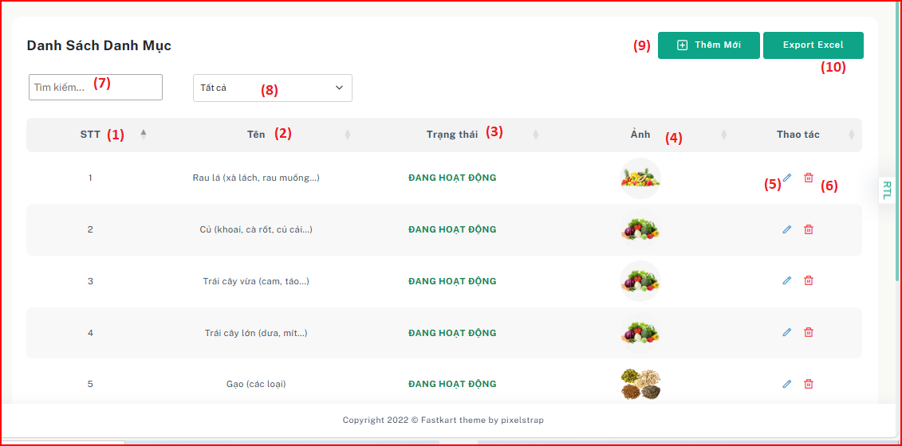

Figure 2.25 - Mockup for view list category use case

| **Field Name** | **Field Type** | **Description** |
| --- | --- | --- |
| (1) | Number | Display order number of each category in the table. |
| (2) | Text | Category name, e.g., Leafy Vegetables, Roots, Large Fruits, etc. |
| (3) | Text | Current status of the category, e.g., ACTIVE. |
| (4) | Image | Representative image of the category (displayed in a circular shape). |
| (5) | Action Icon | Edit icon used to update category information. |
| (6) | Action Icon | Delete icon used to remove the category from the system. |
| (7) | Text Input | Search box to filter categories by name. |
| (8) | Dropdown | Category filter by status (All, Active, Inactive, etc.). |
| (9) | Button | “Add New” button used to add a new category to the system. |
| (10) | Button | “Export Excel” button used to export the category list to an Excel file. |

Table 53 - Screen description for view list category

| UC ID and Name: | **UC-26 View list category** | | |
| --- | --- | --- | --- |
| Created By: | ThanhHVHE186618 | Date Created: | 17/07/2025 |
| Primary Actor: | Admin | Secondary  Actors: | N/A |
| Trigger: | The Admin wants to view the list of all product categories in the system. | | |
| Description: | This use case describes the process by which the Admin views a list of all product categories. | | |
| Preconditions: | * The Admin must be logged into the system with the correct permissions. * The system must contain existing category data. | | |
| Postconditions: | * The Admin is able to view the list of all categories filtered/sorted based on selected criteria. * The system displays the list including category name, status, image, and available actions. | | |
| Normal Flow: | **26.0 View List Category**   1. The Admin navigates to the "Danh sách danh mục" (Category List) page. 2. The system loads and displays the list of all categories sorted by default (e.g., by name or created date). 3. The Admin views the list and sees the following information for each category:     * Serial Number (STT)    * Category Name    * Status    * Image    * Edit Button    * Delete Button 4. The system displays the list in a table format with pagination (if applicable). | | |

| Alternative Flows: | **No categories found**   * The system has no existing category data. * The system displays the message: *"No categories found."* * Search and sort functionalities are disabled. |
| --- | --- |
| Exceptions: | **26.0.E1. Network connectivity issue**   * The system is unable to load data due to a network issue. * The system shows an error message and prompts the user to retry. |
| Priority: | High |
| Frequency of Use: | Daily or as needed for category management. |
| Business Rules: | BR-48, BR-49  BR_201: Only authenticated admins can view the category list.  BR_202: Each category must have a unique name. |
| Other Information: | None |
| Assumptions: | * Sorting options are predefined and functional. * All category data is valid and updated in the system. |

Table 43 - Use case specification for view category list

### **10.2** **Edit Category**

#### **Screen description**

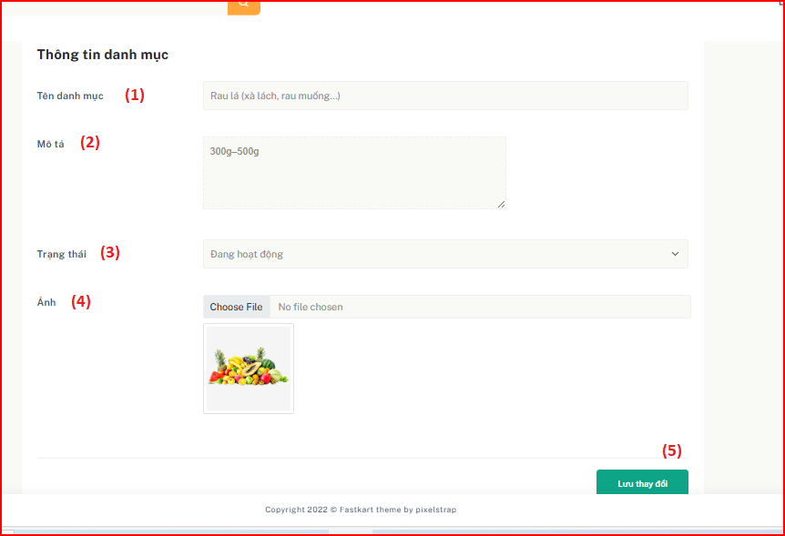

Figure 2.25 - Mockup for view list category use case

| **Field Name** | **Field Type** | **Description** |
| --- | --- | --- |
| (1) | Text Input | Category name input field, e.g., “Leafy Vegetables (lettuce, water spinach...)” |
| (2) | Textarea | Field for entering a description or note about the category, e.g., '300g–500g' |
| (3) | Dropdown | Status selector (e.g., Active, Inactive) to define the availability of the category |
| (4) | File Upload | Upload field to select and preview a new image for the category |
| (5) | Button | Save Changes button to submit updated category information |

| UC ID and Name: | **27.0 Edit Category** | | |
| --- | --- | --- | --- |
| Created By: | ThanhHVHE186618 | Date Created: | 1/08/2025 |
| Primary Actor: | Admin | Secondary  Actors: | N/A |
| Trigger: | The Admin wants to update the details of an existing product category. | | |
| Description: | This use case describes the process by which the Admin edits the details of a product category in the system. The Admin can modify the name, description, status, and image of the category. | | |
| Preconditions: | * The Admin must be logged into the system with proper permissions. * The category must already exist in the system. | | |

| Postconditions: | * The selected category is updated with the new information provided by the Admin. | | |
| --- | --- | --- | --- |
| Normal Flow: | **27.0 Edit Category**   1. The Admin navigates to the "Danh mục" (Category List) page.  2. The Admin clicks the Edit icon corresponding to a specific category.  3. The system opens the Edit Category form populated with current category data.  4. The Admin edits one or more fields: Category Name, Description, Status, Image.  5. The Admin clicks the "Lưu thay đổi" (Save Changes) button.  6. The system validates the input data and updates the category.  7. The updated category is reflected in the category list. | | |

| Alternative Flows: | * **Invalid input data**  - The Admin provides invalid or missing data.  - The system displays appropriate error messages and prompts for correction. * Image upload error  - An issue occurs while uploading the image.  - The system displays an error message and retains previous image if not replaced. * **System error** - The system encounters an error during the update process.  - An error message is shown and the Admin may retry the operation. |
| --- | --- |
| Exceptions: | **27.0.E1. Network connectivity issue** - The system is unable to save changes due to a network issue.  - The system shows an error message and suggests retrying. |
| Priority: | High |
| Frequency of Use: | As needed when managing product categories. |
| Business Rules: | **BR91 -> 96** |
| Other Information: | None |
| Assumptions: | - Image file must be valid and within size limits.  - Status options are predefined and mapped in the backend. |

Table 43 - Use case specification for edit category

### 10.3 Delete Category

#### **Screen description**

Figure 2.25 - Mockup for deactivate category use case

| **Field Name** | **Field Type** | **Description** |
| --- | --- | --- |
| (1) | Button | Yes button to confirm deletion and set category status to Inactive |
| (2) | Button | No button to cancel the deletion process and close the confirmation dialog. |

| UC ID and Name: | **27.0 Delete Category** | | |
| --- | --- | --- | --- |
| Created By: | ThanhHVHE186618 | Date Created: | 1/08/2025 |
| Primary Actor: | Admin | Secondary  Actors: | N/A |
| Trigger: | The Admin wants to delete (deactivate) an existing product category. | | |
| Description: | This use case describes the process by which the Admin deletes a product category from the system. Instead of permanent deletion, the system updates the category’s status to “Inactive” after confirmation. | | |
| Preconditions: | * The Admin must be logged into the system with appropriate permissions. * The category must already exist and be active. | | |

| Postconditions: | * The selected category’s status is changed to “Inactive” and is excluded from active lists. | | |
| --- | --- | --- | --- |
| Normal Flow: | **28.0 Delete Category**  1. The Admin navigates to the "Danh mục" (Category List) page.  2. The Admin clicks the Delete icon for a specific category.  3. The system displays a confirmation dialog with “Yes” and “No” options.  4. The Admin clicks “Yes” to confirm deletion.  5. The system sets the category status to “Inactive” and updates the list view. | | |

| Alternative Flows: | * **Cancel Deletion**  - The Admin clicks “No” in the confirmation dialog.  - The system closes the dialog without making any changes. * **System error**  - The system encounters an error while attempting to update the category.  - An error message is displayed and no changes are made. |
| --- | --- |
| Exceptions: | **28.0.E1. Network connectivity issue**  - The system is unable to update the category status due to network failure.  - The system shows an appropriate error message and suggests retrying. |
| Priority: | Medium |
| Frequency of Use: | Occasionally, when categories need to be removed from active use. |
| Business Rules: | BR97-> 100 |
| Other Information: | None |
| Assumptions: | * Deactivated categories are retained in the database for auditing purposes. * Inactive categories cannot be assigned to new products. |

Table 43 - Use case specification for deactivate category

## **11.** **Product Management**

### **11.1** **View List Product**

#### **Screen description**

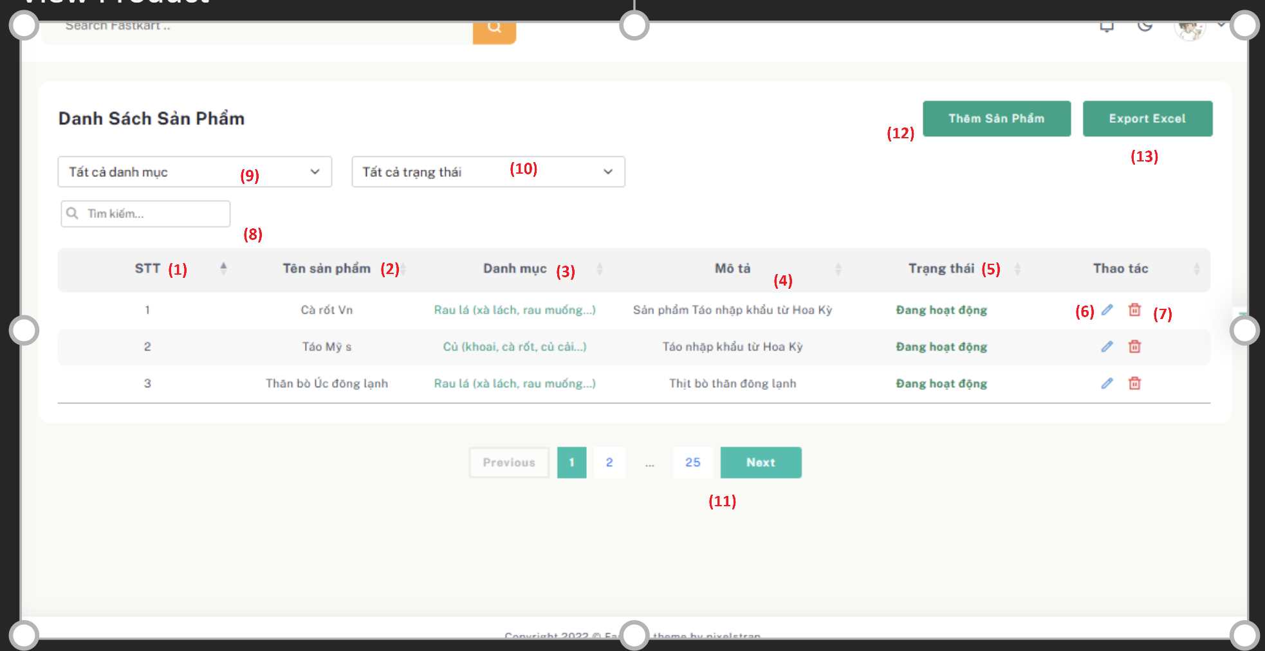

Figure 2.25 - Mockup for view list product use case

| **Field Name** | **Field Type** | **Description** |
| --- | --- | --- |
| (1) | Number | Unique index number for each product in the list. |
| (2) | Text | Name of the product. |
| (3) | Text | Category to which the product belongs. |
| (4) | Text | Brief description or note about the product. |
| (5) | Text | The current status of the product (e.g., Active/Inactive). |
| (6) | Icon Button | Edit button to modify product information. |
| (7) | Icon Button | Delete button to remove or deactivate the product. |
| (8) | Search Field | Search box to find products by name or keyword. |
| (9) | Dropdown | Filter products by category. |
| (10) | Dropdown | Filter products by status. |
| (11) | Pagination | Allows navigation between product list pages. |
| (12) | Button | Add new product to the system. |
| (13) | Button | Export the product list to an Excel file. |

| UC ID and Name: | **UC-29 View Product List** | | |
| --- | --- | --- | --- |
| Created By: | ThanhHVHE186618 | Date Created: | 1/08/2025 |
| Primary Actor: | Admin | Secondary  Actors: | N/A |
| Trigger: | The Admin wants to review the list of all products. | | |
| Description: | This use case describes how the Admin can view a list of all products in the system. The list displays product information such as product name, category, description, status, and provides options to edit or delete products. Admin can also search, filter by category and status, and navigate pages. | | |
| Preconditions: | * The Admin must be logged into the system with appropriate permissions. * The system must have existing product data. | | |
| Postconditions: | * The Admin can view and filter the product list based on selected criteria. * The Admin can take actions such as editing or deleting products. | | |
| Normal Flow: | **UC-29 View Product List**  1. The Admin navigates to the Product List page.  2. The system loads and displays the list of all products sorted by default criteria.  3. The Admin can:  - View product details including name, category, description, and status.  - Search for products using the search field.  - Filter products by category and status.  - Navigate through the paginated list.  - Click Edit or Delete to manage specific products.  - Export the list to Excel.  - Click 'Add Product' to go to the product creation form. | | |

| Alternative Flows: | **No Products Found:  -** The system displays: 'No products found.' and disables edit/delete options.  **System Error:** - The system displays an error: 'Unable to load product list. Please try again later.'  - Admin can retry loading the list. |
| --- | --- |
| Exceptions: | **26.0.E1. Network connectivity issue**   * The system is unable to load data due to a network issue. * The system shows an error message and prompts the user to retry. |
| Priority: | High |
| Frequency of Use: | Daily or as needed for product management. |
| Business Rules: | **BR101, BR102, BR103** |
| Other Information: | None |
| Assumptions: | * Filtering options are predefined and operational. * Product status updates reflect immediately. * The 'Edit' and 'Delete' buttons work as intended. |

Table 43 - Use case specification for view product list

### **11.2** **Add New Product**

#### **Screen description**

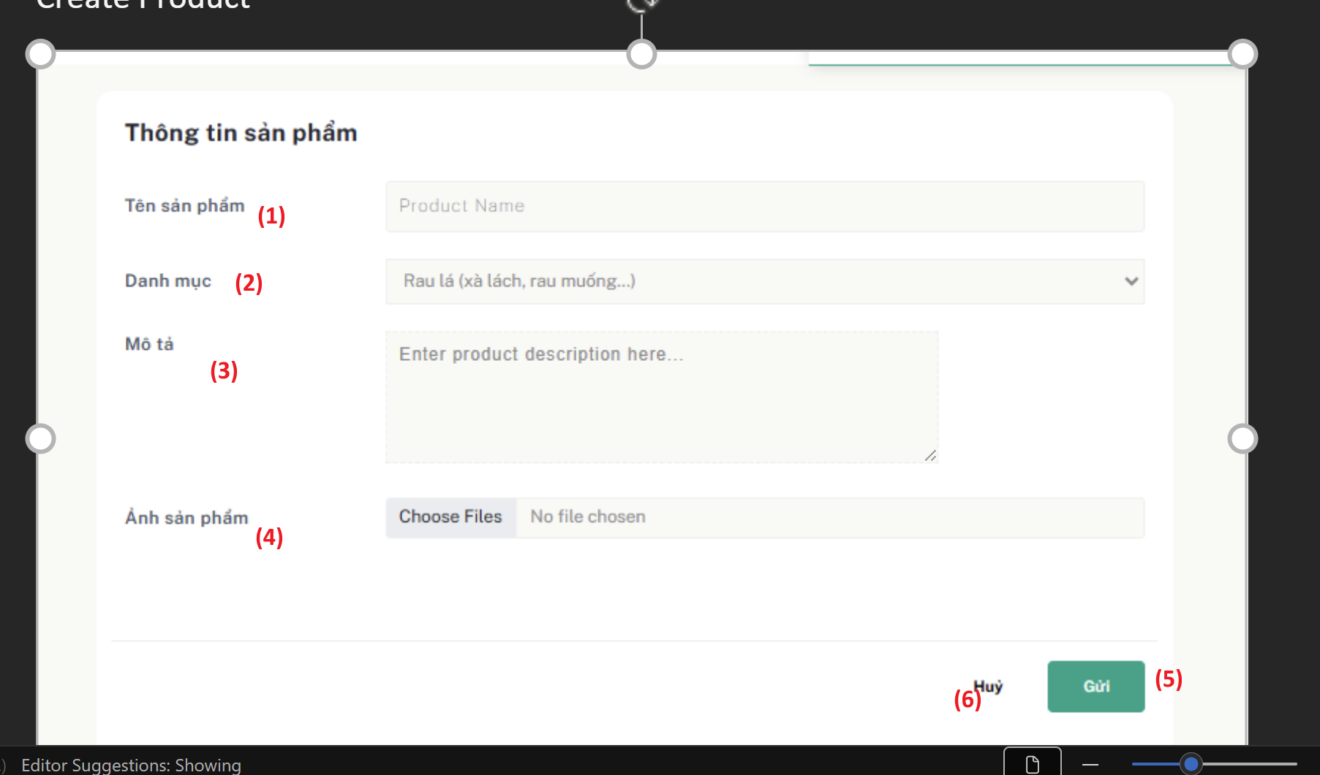

Figure 2.25 - Mockup for add new product use case

| **Field Name** | **Field Type** | **Description** |
| --- | --- | --- |
| (1) | Text Input | Product Name – required field to specify the name of the product. |
| (2) | Dropdown | Category – select a product category from the list. |
| (3) | Textarea | Description – detailed information about the product. |
| (4) | File Upload | Product Image – upload one or more images representing the product. |
| (5) | Button | Submit – to save the product and add it to the system. |
| (6) | Button | Cancel – abort the process and return to the previous page. |

| UC ID and Name: | **UC-30 Add New Product** | | |
| --- | --- | --- | --- |
| Created By: | ThanhHVHE186618 | Date Created: | 1/08/2025 |
| Primary Actor: | Admin | Secondary  Actors: | N/A |
| Trigger: | The Admin wants to add a new product to the system. | | |
| Description: | This use case describes how an Admin can add a new product by filling in product information such as name, category, description, image, and then submitting the form. | | |
| Preconditions: | * The Admin is logged into the system with permission to manage products. * The category list must be available and populated. | | |
| Postconditions: | A new product is created in the system with a default status of "Active". | | |
| Normal Flow: | **UC-30 Add New Product**  1. Admin navigates to the “Add New Product” page.  2. Admin enters product details including name, category, description, and uploads product images.  3. Admin clicks the “Submit” button to create the product.  4. The system validates the input, saves the product information, and returns to the product list view with the new product added. | | |

| Alternative Flows: | - If required fields are missing or invalid, the system displays appropriate error messages and prompts for correction.  - If there is a system error during product creation, display: "Unable to create product. Please try again later." |
| --- | --- |
| Exceptions: | **26.0.E1. Network connectivity issue**   * The system is unable to load data due to a network issue. * The system shows an error message and prompts the user to retry. |
| Priority: | High |
| Frequency of Use: | Whenever new products need to be added. |
| Business Rules: | BR104 -> 110 |
| Other Information: | None |
| Assumptions: | * All input validations are in place. * Images are stored and processed correctly. * Admin has appropriate role permissions. |

Table 43 - Use case specification for add new product

### **11.3** **Edit Product**

#### **Screen description**

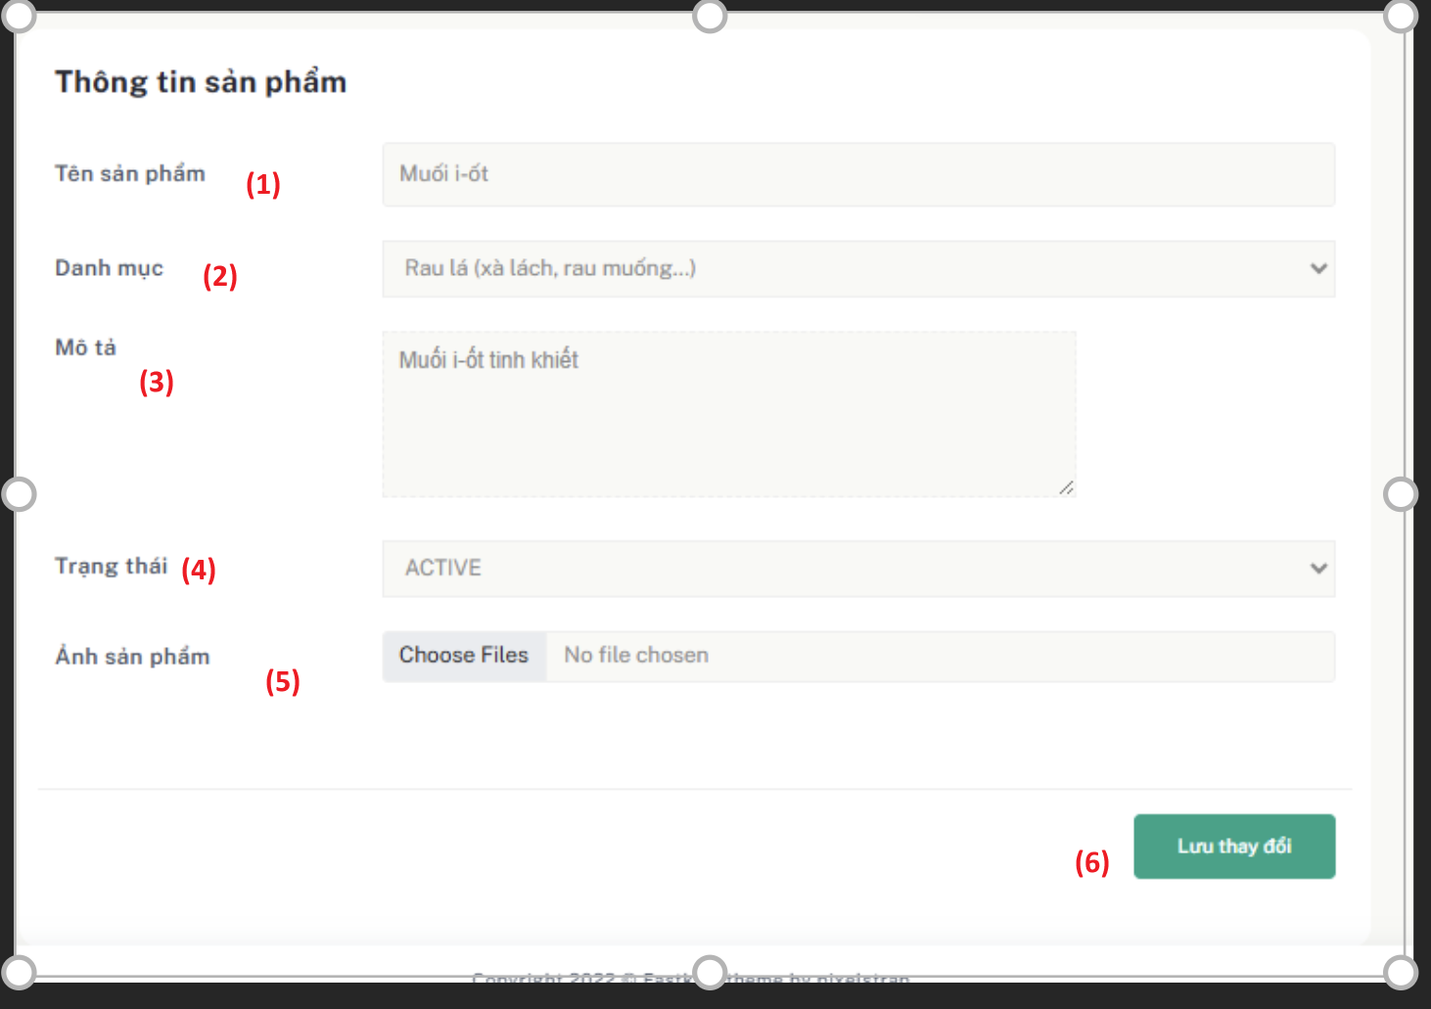

Figure 2.25 - Mockup for edit use case

| **Field Name** | **Field Type** | **Description** |
| --- | --- | --- |
| (1) | Text Input | Product Name – required field to specify the name of the product. |
| (2) | Dropdown | Category – select a product category from the list. |
| (3) | Textarea | Description – detailed information about the product. |
| (4) | File Upload | Product Image – upload one or more images representing the product. |
| (5) | Button | Submit – to save the updated product information. |
| (6) | Button | Cancel – abort the process and return to the product list page. |

| UC ID and Name: | **UC-31 Edit Product** | | |
| --- | --- | --- | --- |
| Created By: | ThanhHVHE186618 | Date Created: | 1/08/2025 |
| Primary Actor: | Admin | Secondary  Actors: | N/A |
| Trigger: | The Admin wants to edit product information. | | |
| Description: | This use case describes how an Admin can edit a product by filling in product information such as name, category, description, image, and then submitting the form. | | |
| Preconditions: | * The Admin is logged into the system with permission to manage products. * The category list must be available and populated, selected product is exist in the system. | | |
| Postconditions: | * Product information is updated in the system. * The system show the modal success message. | | |
| Normal Flow: | **UC-30 Edit Product**  1. Admin navigates to the list products page.  2. Admin click to the pen icon to edit selected product information.  2. Admin enters product details including name, choose category, description, and uploads product images.  3. Admin clicks the “Lưu thay đổi” button to update the product information.  4. The system validates the input.  5. If valid, the system updates the product in the database.  6. A success message shown to the admin. | | |

| Alternative Flows: | - If required fields are missing or invalid, the system displays appropriate error messages and prompts for correction. |
| --- | --- |
| Exceptions: | **26.0.E1. Network connectivity issue**   * The system is unable to load data due to a network issue. * The system shows an error message and prompts the user to retry. |
| Priority: | High |
| Frequency of Use: | Whenever an administrator wants to edit a product. |
| Business Rules: | BR111, BR112, BR113 |
| Other Information: | None |
| Assumptions: | * All input validations are in place. * Images are stored and processed correctly. * Admin has appropriate role permissions. |

Table 43 - Use case specification for add new product

## **12.** **Role Management**

### **12.1** **View List Role**

#### **Screen description**

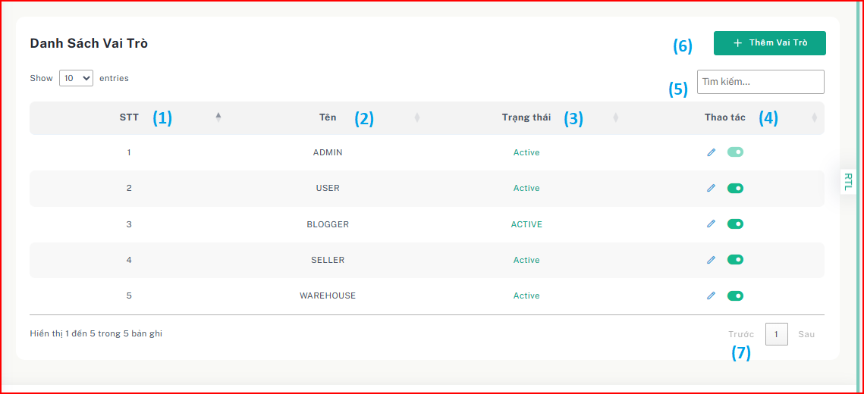

Figure 2.51 - Mockup for view role list use case

| **Field Name** | **Field Type** | **Description** |
| --- | --- | --- |
| (1) | Numeric Index | Sequential number/order of roles |
| (2) | Text | Name of the system role |
| (3) | Status | Status of role include ‘Active’ and ‘Inactive’ |
| (4) | Action | Edit button for each role |

| (5) | Search Input | Search role by name, status, ... |
| --- | --- | --- |
| (6) | Add Role Button | Button to redirect to add role page. |
| (7) | Pagination Control | Controls to navigate through role pages |

Table 109 - Screen description for view role list

**Use case specification**

| UC ID and Name: | **UC-55 View role list** | | |
| --- | --- | --- | --- |
| Created By: | ThanhHVHE186618 | Date Created: | 25/7/2025 |
| Primary Actor: | System Administrator | Secondary Actors: | None |
| Trigger: | The System Administrator wants to view the list of user roles. | | |
| Description: | This use case describes how the System Administrator accesses and views the list of roles in the system. | | |
| Preconditions: | The administrator must be logged into the system. | | |
| Postconditions: | The system displays a list of all roles with relevant details. | | |
| Normal Flow: | **55.0 View role list**   1. The System Administrator navigates to the “Vai trò” section. 2. The system retrieves the list of available roles. 3. The system displays the Role List table, including role names, status and actions. | | |
| Alternative Flows: | **55.1 Search by role name**  1. The system displays the Role List table, including role names and actions suitable with role name  **55.2 Filter by role name**   1. The system displays the Role List table according to the filtered role name. | | |
| Exceptions: | **55.0.E1 System error**  1. If a server error occurs, the system displays: "An error occurred. Please try again later." | | |

|  | **55.0.E2 No roles exist**  1. The system displays a message: "Không tìm thấy kết quả phù hợp" |
| --- | --- |
| Priority: | High - Essential for user management |
| Frequency of Use: | Frequent - Used whenever role management is required |
| Business Rules: | BR115, BR116 |
| Other Information: | None |
| Assumptions: | None |

Table 110 - Use case specification for view role list

### **12.2** **Add New Role**

#### **Screen description**

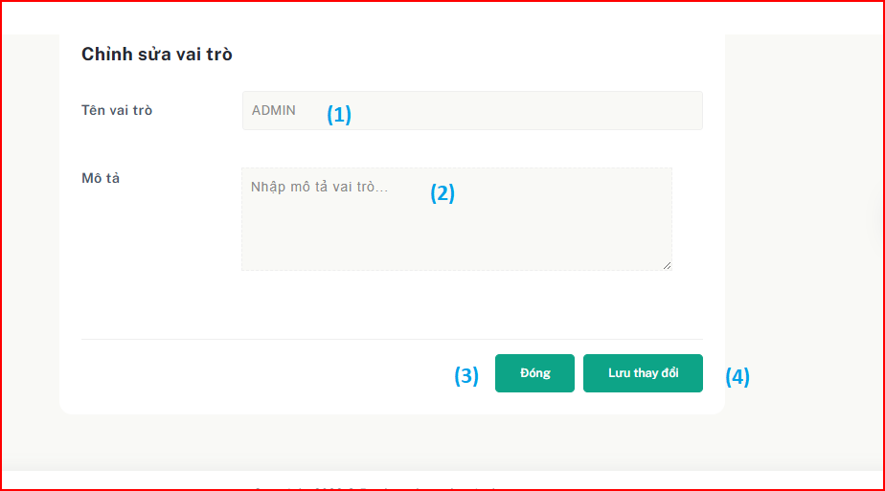

Figure 2.52 - Mockup for add role use case

| **Field Name** | **Field Type** | **Description** |
| --- | --- | --- |
| (1) | Text Input | Role name input field |
| (2) | Text Area | Role description input field |
| (3) | Cancel Button | Button to close the edit page without saving changes |
| (4) | Submit Button | Button to add new role |

Table 111 - Screen description for add role

**Use case specification**

| UC ID and Name: | **UC-56 Add new role** | | |
| --- | --- | --- | --- |
| Created By: | ThanhHVHE186618 | Date Created: | 25/7/2025 |
| Primary Actor: | System Administrator | Secondary Actors: | None |
| Trigger: | The administrator wants to create a new role in the system. | | |
| Description: | This use case describes how the administrator can add a new role. | | |
| Preconditions: | The administrator must be logged into the system. | | |
| Postconditions: | The new role is successfully created and added to the role list. | | |
| Normal Flow: | **49.0 Create New Role**   1. The administrator navigates to the "Tạo Vai Trò Mới" page. 2. The administrator enters the role name, description then clicks "Tạo mới". 3. The system processes the input and creates a new role record. 4. TThe system displays a success modal message and redirects the administrator to the role list. | | |
| Alternative Flows: | * 1. **Cancel role creation**      1. The administrator cancels the role creation process at any step.      2. The system discards entered data and returns to the role list.   2. **Missing required fields**      1. If the administrator leaves required fields empty, the system displays an error message and prevents form submission.   3. **Role name already exists**      1. If the entered role name is already in use, the system notifies the administrator and shows the message “Role name already exists”.      2. Return to the step 3 of Normal Flow. | | |

| Exceptions: | **49.0.E1 System error**  1. If a server error occurs, the system displays: "An error occurred. Please try again later."  **E2 – Unauthorized access**   1. If a user without sufficient privileges accesses the create role page, the system redirects to an access denied page. |
| --- | --- |
| Priority: | High - Essential for product management |
| Frequency of Use: | Regular - Whenever new role are added |
| Business Rules: | BR_117, BR_118, BR_119, BR_120 |
| Other Information: | None |
| Assumptions: | None |

###### 

### **12.3** **Edit Role**

#### **Screen description**

Figure 2.52 - Mockup for edit role use case

| **Field Name** | **Field Type** | **Description** |
| --- | --- | --- |
| (1) | Text Input | Role name input field |
| (2) | Text Area | Role description input field |

| (2) | Cancel Button | Button to close the edit modal without saving changes |
| --- | --- | --- |
| (3) | Submit Button | Button to save the edited role |

Table 111 - Screen description for edit role

**Use case specification**

| UC ID and Name: | **UC-56 Edit role** | | |
| --- | --- | --- | --- |
| Created By: | ThanhHVHE186618 | Date Created: | 25/7/2025 |
| Primary Actor: | System Administrator | Secondary Actors: | None |
| Trigger: | The System Administrator wants to modify the role name, description of an existing role. | | |
| Description: | This use case describes how the System Administrator can edit and update a role's name. | | |
| Preconditions: | The administrator must be logged into the system. | | |
| Postconditions: | The updated role is saved and reflected in the system. | | |
| Normal Flow: | **56.0 Edit role**   1. The System Administrator navigates to the “Vai trò” section. 2. The System Administrator selects the role they want to edit and clicks the edit pen icon. 3. The system displays a Edit Role Page with the current role name. 4. The System Administrator modifies the role name, description in the input field. 5. The System Administrator click “Lưu thay đổi” Button. 6. The system displays a success modal message and updates the role list. | | |
| Alternative Flows: | * 1. **Search role name**  1. The System Administrator search role name wants to edit.   2. Return to the step 1 of Normal Flow. | | |

| Exceptions: | **56.0.E1 System error**  1. If a server error occurs, the system displays: "An error occurred. Please try again later." |
| --- | --- |
| Priority: | High - Essential for role management |
| Frequency of Use: | Occasional - Used when renaming roles, change description of role. |
| Business Rules: | **BR_121, BR_122, BR_123** |
| Other Information: | None |
| Assumptions: | None |

Table 112 - Use case specification for edit role

### **12.4** **Assign Role to User**

#### **Screen description**

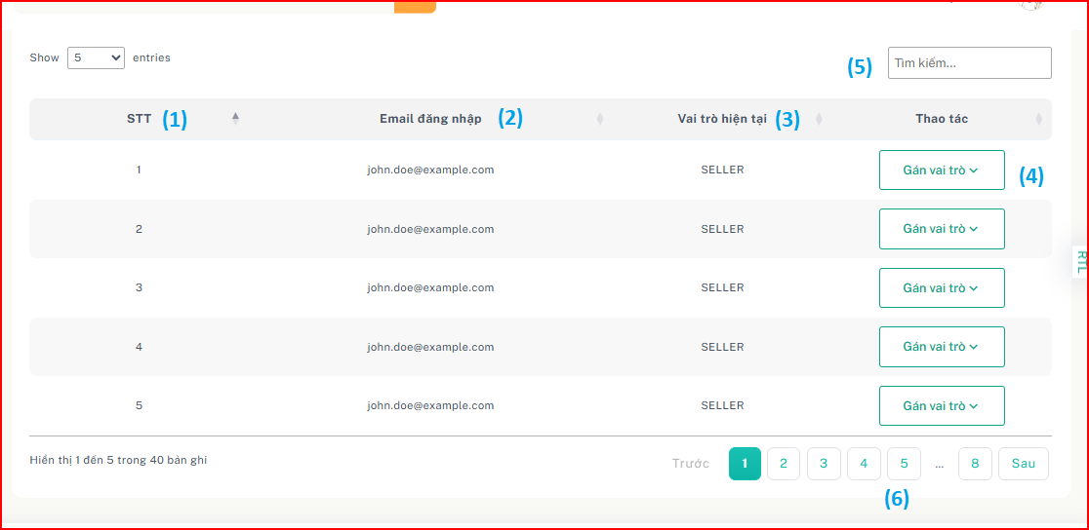

Figure 2.52 - Mockup for assign role use case

| **Field Name** | **Field Type** | **Description** |
| --- | --- | --- |
| (1) | INDEX | Sequential number/order of roles |
| (2) | TEXT INPUT | Shows the user's login email. |
| (3) | TEXT INPUT | Displays the user's current assigned role (e.g., SELLER). |
| (4) | DROPDOWN | Allows the admin to assign a new role to the user. |
| (5) | TEXT INPUT | Filters users by keyword (email, role, etc.). |
| (6) | PAGINATION | Navigates through multiple pages of user records. |

Table 111 - Screen description for Assign role

**Use case specification**

| UC ID and Name: | **UC-56 Assign Role to User** | | |
| --- | --- | --- | --- |
| Created By: | ThanhHVHE186618 | Date Created: | 25/7/2025 |
| Primary Actor: | System Administrator | Secondary Actors: | None |
| Trigger: | The System Administrator wants to assign or update roles for user. | | |
| Description: | This use case describes how the System Administrator can assign a role to a user. | | |
| Preconditions: | The administrator must be logged into the system.  That user must be exist in the system. | | |
| Postconditions: | The updated role is saved and reflected in the system.  The system display the success modal after admin completed assign role.  The user has permission of new role. | | |
| Normal Flow: | **56.0 Assign role**   1. The System Administrator navigates to the “Gán Vai trò” section. 2. The System Administrator retrieve list of user in system and displays them in the table. 3. Admin select one role in dropdown contain role list to assign for user. 4. The system show the Confirmation modal. 5. The admin confirm that want to assign role. 6. The system displays a success modal message and updates the role list. | | |
| Alternative Flows: | * 1. **Filter by Role name**      1. The System Administrator choose role name in dropdown list role.      2. The system process and show the list corresponding filter condition.      3. Return to the step 3 of Normal Flow. | | |

| Exceptions: | **56.0.E1 System error**  1. If a server error occurs, the system displays: "An error occurred. Please try again later." |
| --- | --- |
| Priority: | High - Essential for role management |
| Frequency of Use: | Occasional - Used when admin want to assign role for user. |
| Business Rules: | BR_124, BR_125, BR_126, BR127, BR_128 |
| Other Information: | None |
| Assumptions: | None |

Table 112 - Use case specification for assign role to user

## **13.** **User Management**

### **13.1** **View List User**

#### **Screen description**

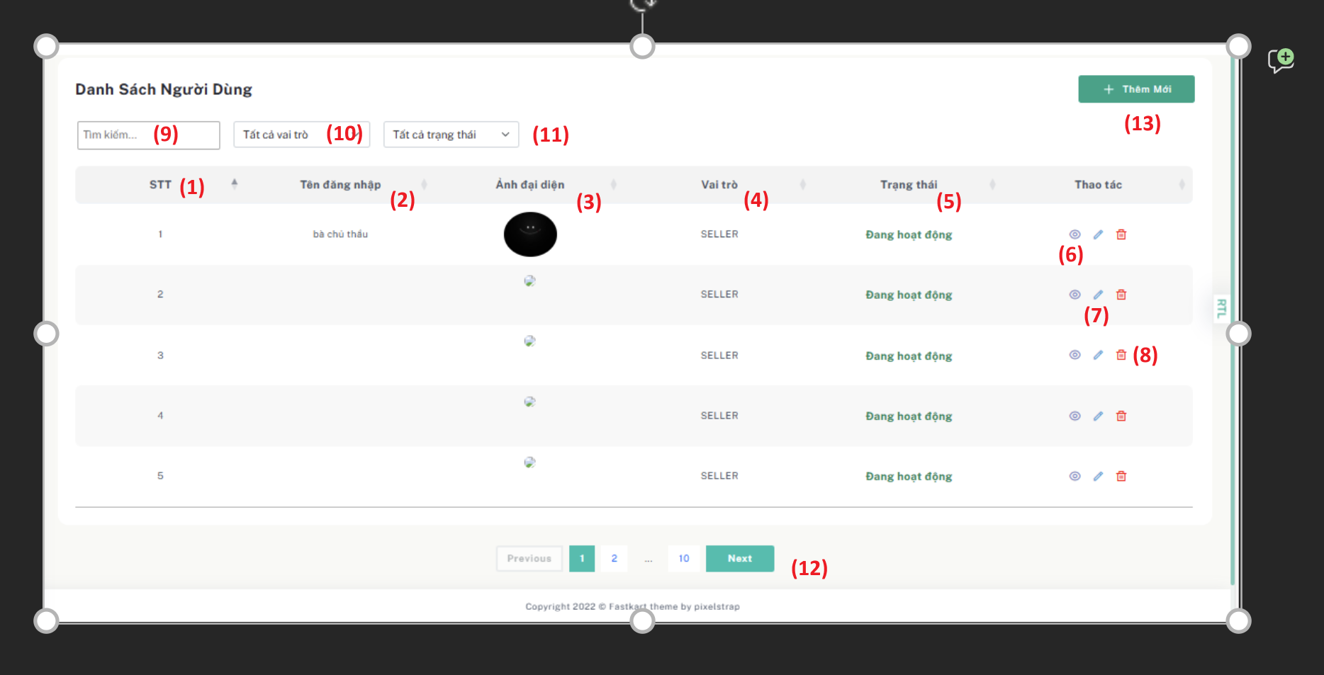

| **Field Name** | **Field Type** | **Description** |
| --- | --- | --- |
| (1) | NVARCHAR | Unique index number in the list. |
| (2) | NVARCHAR | User's username |
| (3) | FILE UPLOAD | User's image |
| (4) | NVARCHAR | User's Role |
| (5) | NVARCHAR | Current account status (Active,Inactive) |
| (6) | ICON BUTTON | Button to view user information. |
| (7) | ICON BUTTON | Button to edit user information. |
| (8) | ICON BUTTON | Button to deactivate user information. |
| (9) | TEXT INPUT | Search users by username, status, role. |
| (10) | DROPDOWN | Filter users by account role |
| (11) | DROPDOWN | Filter users by account status |
| (12) | PAGINATION | Allows navigation between user list pages. |
| (13) | BUTTON | Button to access to add a new user account page. |

| UC ID and Name: | **UC-31 View User List** | | |
| --- | --- | --- | --- |
| Created By: | ThanhHVHE186618 | Date Created: | 1/08/2025 |
| Primary Actor: | Admin | Secondary  Actors: | N/A |
| Trigger: | The Admin wants to review the list of all users e. | | |
| Description: | This use case describes the process by which the Admin views the list of all users registered in the system. The list provides detailed information such as full name, role, status, and available actions for each user. | | |
| Preconditions: | * The Admin must be logged into the system with appropriate permissions. * There must be at least one registered user in the system. | | |
| Postconditions: | * The Admin is able to view a list of all users. * The system displays the list in a tabular format with user information and available actions such as edit or deactivate. | | |
| Normal Flow: | **UC-31 View Product List**  The Admin navigates to the "List Users" page.   1. The system loads and displays the list of all users in a table format, sorted by default filter (e.g., newest first). 2. The Admin views the following information for each user:    * Username    * Image    * Role    * Status (Active/Inactive)    * Action buttons (Edit, Deactivate) | | |

| Alternative Flows: | **No User Found:  -** If there are no users in the system, the system displays a text: "No users found."  **System Error:** -If the system encounters an error while loading the list, it displays: "Unable to load user list. Please try again later."  - Admin can retry loading the list. |
| --- | --- |
| Exceptions: | **28.0.E1. Network Issue**   * The system fails to load due to a network error. * An error message is displayed to the Admin. |
| Priority: | High |
| Frequency of Use: | Daily or as needed for user management. |
| Business Rules: | BR_129, BR_130, BR_131, BR_132, BR_133 |
| Other Information: | None |

Table 43 - Use case specification for view user list

### 

### 

### 

### 

### 

### 

### 

### 

### 

### 

### 

### 

### 

### 

### 

### **13.2** **View User Detail**

#### **Screen description**

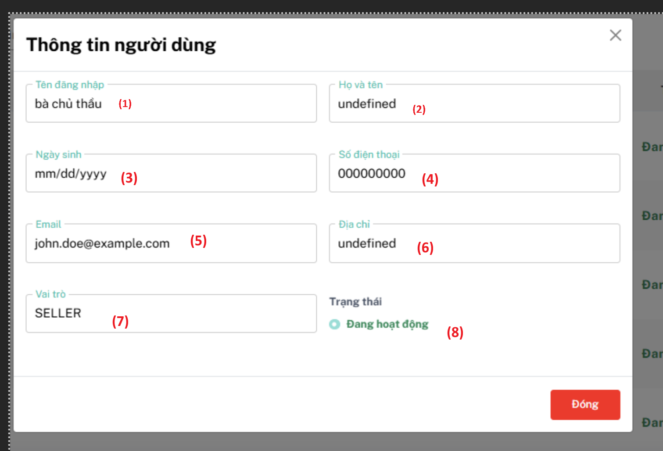

| **Field Name** | **Field Type** | **Description** |
| --- | --- | --- |
| (1) | NVARCHAR | User's username |
| (2) | NVARCHAR | User's full name |
| (3) | DATETIME | User's date of birth |
| (4) | NVARCHAR | User's phone |
| (5) | NVARCHAR | User’s email |
| (6) | NVARCHAR | User’s address |
| (7) | NVARCHAR | User’s role |
| (8) | NVARCHAR | User’s status |

| UC ID and Name: | **UC-31 View User Detail** | | |
| --- | --- | --- | --- |
| Created By: | ThanhHVHE186618 | Date Created: | 1/08/2025 |
| Primary Actor: | Admin | Secondary  Actors: | N/A |
| Trigger: | The Admin wants to view details of a specific user. | | |
| Description: | This use case describes the process by which admin views the full details of a selected user in a modal popup. | | |
| Preconditions: | * The Admin must be logged into the system with appropriate permissions. * There must be at least one registered user in the system. | | |
| Postconditions: | The Admin is able to view all information of the selected user. | | |

| Normal Flow: | **UC-32 View User Detail**   * The Admin navigates to the "List Users" page. * Click on the eye icon. * The system displays the modal user detail with information of the selected user. * The Admin reviews the user information. | | |
| --- | --- | --- | --- |

| Alternative Flows: | **System Error:** - If the system encounters an error while loading the user info, it displays: "Unable to load user detail. Please try again later."  - Admin can retry loading the data. |
| --- | --- |
| Exceptions: | **28.0.E1. Network Issue**   * The system fails to load due to a network error. * An error message is displayed to the Admin. |
| Priority: | High |
| Frequency of Use: | Daily or as needed for user management. |
| Business Rules: | BR_134, BR_135, BR_136, BR_137 |
| Other Information: | None |
| Assumptions | The view detail icon can trigger a modal with user information. |

Table 43 - Use case specification for view user detail

### 

### **13.3** **Add New User**

#### **Screen description**

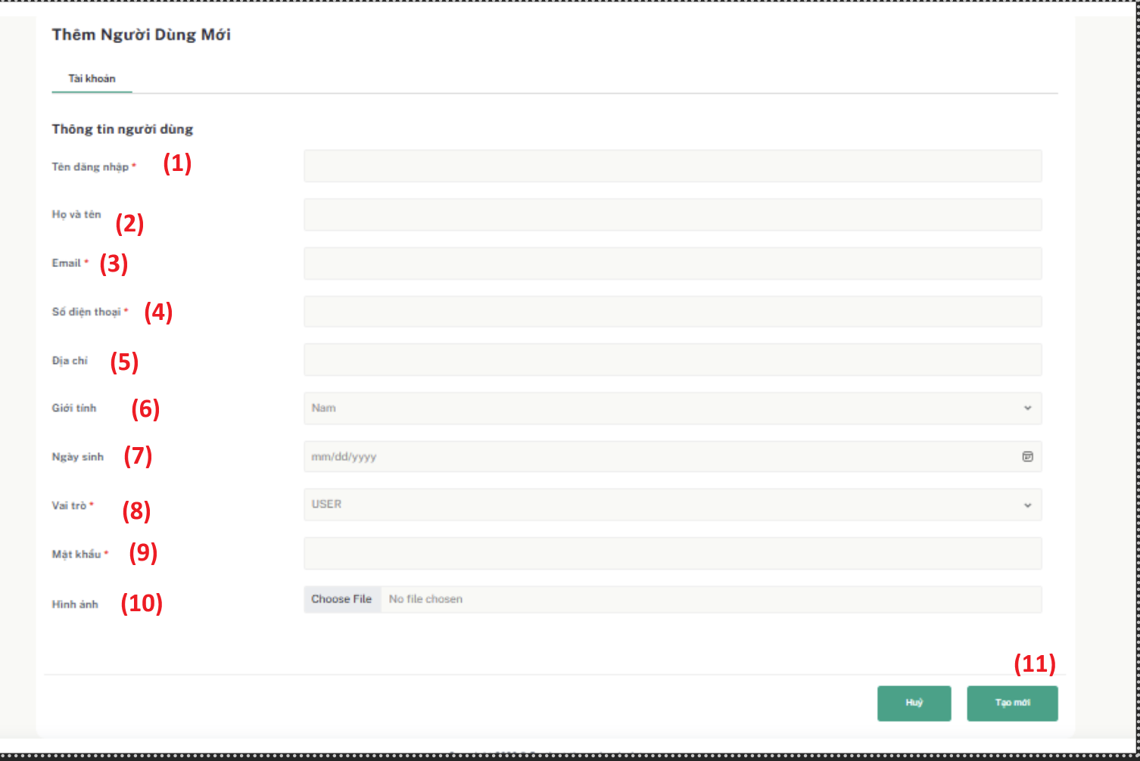

| **Field Name** | **Field Type** | **Description** |
| --- | --- | --- |
| (1) | TEXT INPUT | Input username |

| (2) | TEXT INPUT | Input full name |
| --- | --- | --- |
| (3) | TEXT INPUT | Input email |
| (4) | TEXT INPUT | Input phone number |
| (5) | TEXT INPUT | Input address |
| (6) | DROPDOWN | Select gender |
| (7) | DATETIME | Choose date of birth |
| (8) | DROPDOWN | Choose role |
| (9) | TEXT INPUT | Enter password |
| (10) | FILE UPLOAD | Choose image |
| (11) | BUTTON | Submit to add new user into database |

**Use case specification**

| UC ID and Name: | **UC-44 Add new user** | | |
| --- | --- | --- | --- |
| Created By: | ThanhHVHE186618 | Date Created: | 1/08/2025 |
| Primary Actor: | Admin | Secondary Actors: | None |
| Trigger: | The administrator wants to add a new user member. | | |
| Description: | This use case describes the process by which the system administrator can create a new user account, including assigning a username, fullname, email, role, phone number, date of birth, address , status and image. | | |
| Preconditions: | * The user has system administrator privileges. * The user member does not already exist in the system. | | |
| Postconditions: | The new user account is successfully created and added to the system. | | |
| Normal Flow: | **44.0 Add new User**   1. The administrator accesses the "Danh sách người dùng" page. 2. The administrator clicks the "Add New User" button. | | |

|  | 1. The system displays the "Tạo tài khoản người dùng" form with the following fields:    * Tên đăng nhập    * Họ và tên    * Email    * Số điện thoại    * Ngày sinh    * Địa chỉ    * Vai trò    * Ảnh 2. The administrator enters the required information. 3. The administrator clicks the "Tạo mới" button. 4. The system creates the new user account and displays a success message. |
| --- | --- |
| Alternative Flows: | * 1. **Cancel adding user**      1. The administrator clicks the "Danh sách người dùng" button or “Hủy” button.      2. The system closes the edit form without saving changes.      3. Return to the step 1 of Normal Flow. |
| Exceptions: | **44.0.E1 Duplicate email**  1. 1. If the entered username or email already exists, the system displays an error message: "Tên tài khoản hoặc email đã tồn tại!"  **44.0.E1 Data validation error**  1. If the entered information is invalid, the system displays a specific error message and does not allow creating the user account. |
| Priority: | High - Essential for managing user in the system. |
| Frequency of Use: | Frequent - Whenever a new user member needs to be added. |
| Business Rules: | BR_138, BR_139, BR_140, BR_141, BR_142, BR_143 |
| Other Information: | None |
| Assumptions: | None |

Table 90 - Use case specification for add new user

### 

### **13.4** **Update User Information**

#### **Screen description**

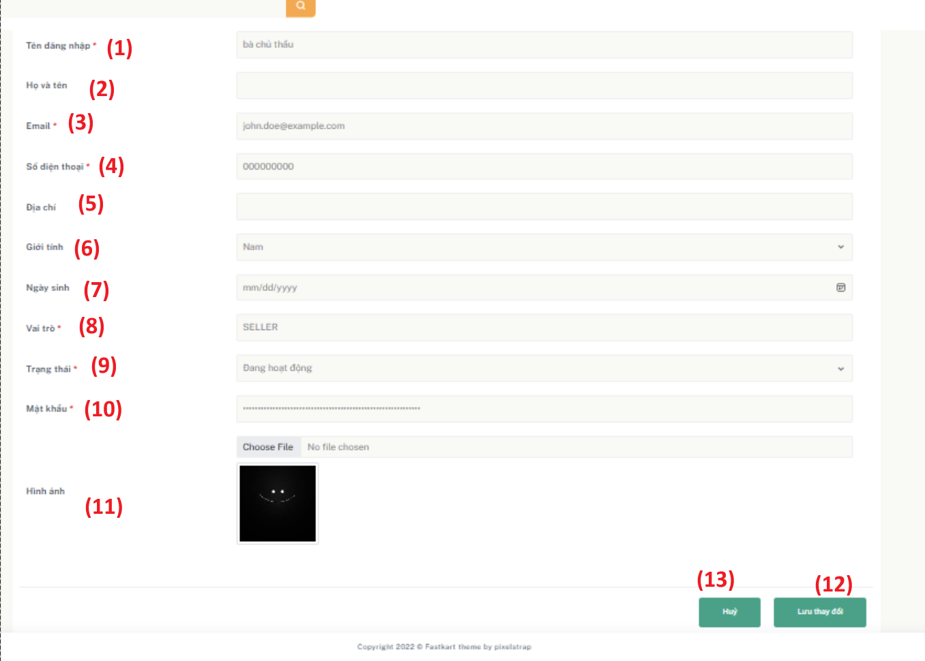

| **Field Name** | **Field Type** | **Description** |
| --- | --- | --- |
| (1) | TEXT INPUT | User’s username |

| (2) | TEXT INPUT | User’s full name |
| --- | --- | --- |
| (3) | TEXT INPUT | User’s email |
| (4) | TEXT INPUT | User’s phone number |
| (5) | TEXT INPUT | User’s address |
| (6) | DROPDOWN | Select user’s gender |
| (7) | DATETIME | Choose User’s date of birth |
| (8) | DROPDOWN | User’s role |
| (9) | DROPDOWN | User’s status |
| (10) | TEXT INPUT | User’s password |
| (11) | FILE UPLOAD | User’s image |
| (12) | BUTTON | Save changes |
| (13) | BUTTON | Cancel |

Table 87 - Screen description for update user

| UC ID and Name: | **UC-43 Update User Information** | | |
| --- | --- | --- | --- |
| Created By: | ThanhHVHE186618 | Date Created: | 1/08/2025 |
| Primary Actor: | System Administrator | Secondary Actors: | None |
| Trigger: | The administrator needs to edit user information. | | |
| Description: | This use case describes the process by which the system administrator can edit user information.. | | |
| Preconditions: | * The user has system administrator privileges. * The user member exists in the system. | | |
| Postconditions: | The user information is successfully updated. | | |
| Normal Flow: | **43.0 Update user information**   1. The administrator accesses the “Danh sách người dùng" page. 2. The administrator selects a user member to edit and clicks the "Pen" button. 3. The system displays the user edit form with the following fields: | | |

|  | * Tài khoản * Họ và tên * Vai trò * SĐT * Email * Địa chỉ * Trạng thái  1. The administrator modifies the necessary information. 2. The administrator clicks "Lưu thay đổi" button. 3. The system updates the user information and displays a success message. |
| --- | --- |
| Alternative Flows: | * 1. **Cancel editing**      1. The administrator clicks the "Hủy" button.      2. The system closes the edit form without saving changes.      3. Return to the step 2 of Normal Flow. |

| Exceptions: | **44.0.E1 Data validation error**   * If the entered information is invalid, the system displays a specific error message and does not allow updating the user account. |
| --- | --- |
| Priority: | High - Essential for managing users in the system. |
| Frequency of Use: | Frequent - Whenever user information needs updating. |
| Business Rules: | BR_144, BR_145, BR_146 |
| Other Information: | None |
| Assumptions: | None |

## **14. Voucher Management**

### **14.1** **View List Voucher**

#### **Screen description**

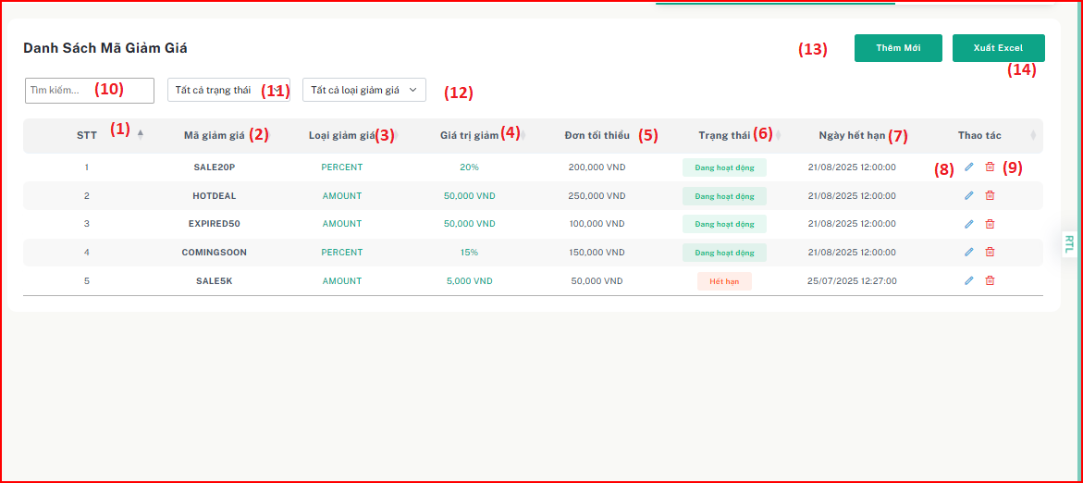

| **Field Name** | **Field Type** | **Description** |
| --- | --- | --- |
| (1) | INDEX | Unique index number in the list. |
| (2) | NVARCHAR | Voucher code |
| (3) | NVARCHAR | Discount type |
| (4) | NVARCHAR | Discount amount |
| (5) | NVARCHAR | Min order amount |
| (6) | NVARCHAR | Voucher’s status |
| (7) | NVARCHAR | Voucher’s expire date |
| (8) | ICON BUTTON | Button to access edit voucher information page. |
| (9) | ICON BUTTON | Button to lock or delete voucher. |
| (10) | TEXT INPUT | Search for a voucher by voucher code, status, discount type,.... |
| (11) | DROPDOWN | Filter vouchers by status. |
| (12) | DROPDOWN | Filter vouchers by discount type. |
| (13) | BUTTON | Button to access add new voucher page. |
| (14) | BUTTON | Button to export data to Excel. |

Table 113 - Screen description for view order discount list

**Use case specification**

| UC ID and Name: | **UC-57 View vouchers list** | | |
| --- | --- | --- | --- |
| Created By: | ThanhHVHE186618 | Date Created: | 1/08/2025 |
| Primary Actor: | System Administrator | Secondary Actors: | None |
| Trigger: | The System Administrator wants to view the list of available vouchers for orders. | | |
| Description: | This use case describes how a System Administrator can view and filter the list of vouchers applied to orders. | | |
| Preconditions: | The administrator must be logged into the system. | | |
| Postconditions: | The System Administrator successfully views the vouchers list and may take further actions such as filtering, editing, or creating new voucher. | | |
| Normal Flow: | **57.0 View vouchers list**   1. The System Administrator navigates to the “Danh sách mã giảm giá” section. 2. The system retrieves and displays a table containing all vouchers with relevant details (mã, % giảm, giá trị đơn hàng, ngày bắt đầu, ngày kết thúc, số lượng mã, cập nhật lần cuối, trạng thái, thao tác). | | |
| Alternative Flows: | * 1. **Search for a voucher code**      1. The System Administrator types a voucher code or related keyword.      2. The system filters the discount list and displays matching results.      3. If no results are found, the system displays a "No matching records found" message.   2. **Filter vouchers codes by status**      1. The System Administrator chooses a status (Active, Inactive, Expired). | | |

|  | 1. The system updates the table to display only discount codes matching the selected status. 2. If no results match the filter, the system shows a "No records found" message. |
| --- | --- |
| Exceptions: | **57.0.E1 System error**  1. If a server error occurs, the system displays: "An error occurred. Please try again later." |
| Priority: | High - Essential for voucher management |
| Frequency of Use: | Regular - Used whenever the System Administrator needs to monitor discounts |
| Business Rules: | **BR_146, BR_147** |
| Other Information: | None |
| Assumptions: | None |

Table 114 - Use case specification for view voucher list

### **14.2** **Create New Voucher**

#### **Screen description**

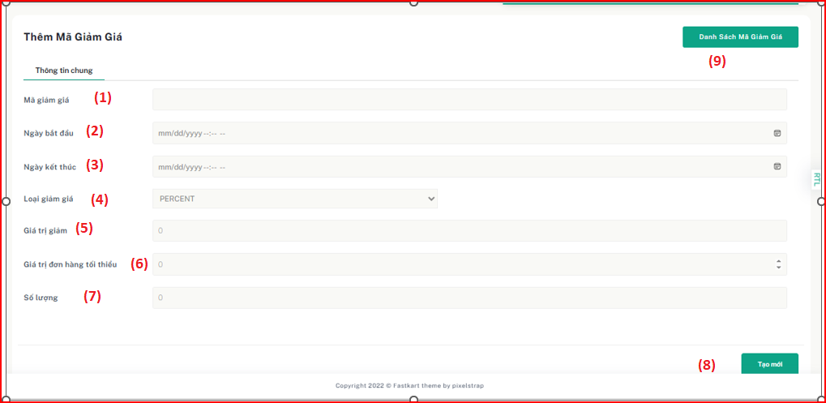

Figure 2.55 - Mockup for view add voucher use case

| **Field Name** | **Field Type** | **Description** |
| --- | --- | --- |
| (1) | TEXT INPUT | Input voucher code |
| (2) | DATETIME | Input start date |
| (3) | DATETIME | Input end date |
| (4) | DROPDOWN | Select discount type (PERCENT, AMOUNT) |
| (5) | NUMBER INPUT | Input discount value |
| (6) | NUMBER INPUT | Input min order value |
| (7) | NUMBER INPUT | Input voucher’s quantity |
| (8) | BUTTON | Button to submit form |
| (9) | BUTTON | Button to export all voucher’s data to Excel file. |

Table 119 - Screen description for create new voucher

**Use case specification**

| UC ID and Name: | **UC-60 Create voucher** | | |
| --- | --- | --- | --- |
| Created By: | ThanhHVHE186618 | Date Created: | 1/08/2025 |
| Primary Actor: | System Administrator | Secondary Actors: | None |
| Trigger: | The System Administrator wants to create a new voucher for customer orders. | | |
| Description: | This use case describes the process of adding a new voucher. | | |
| Preconditions: | The administrator must be logged into the system.  The voucher must not exist in the system. | | |
| Postconditions: | A new voucher code is successfully created and stored in the system. | | |
| Normal Flow: | **60.0 Create voucher**   1. The System Administrator navigates to the “Danh sách mã giảm giá” section. 2. The System Administrator clicks on the “Tạo mã giảm giá” button. 3. The system displays the Create Voucher form. 4. The System Administrator enters the discount details: mã giảm giá, Giảm giá(% or amount), giá trị đơn hàng tối thiểu,ngày bắt đầu, ngày kết thúc, số lượng, trạng thái. 5. The System Administrator clicks “Gửi” button. 6. The system saves the new discount in the database. | | |
| Alternative Flows: | * 1. **Close form**      1. The system closes the form without saving any data.   2. **Enter invalid** | | |

|  | 1. The system displays an error message indicating the invalid fields. 2. Return to the step 3 of Normal Flow. |
| --- | --- |
| Exceptions: | **60.0.E1 System error**  1. If a server error occurs, the system displays: "An error occurred. Please try again later."  **60.1.E2 Voucher code already exist in the system.**  1. The system show the error message “Voucher code already exist!”. |
| Priority: | High - Essential for voucher management |
| Frequency of Use: | Regular - Used whenever a new voucher is introduced |
| Business Rules: | BR_148, BR_149, BR_150, BR_151 |
| Other Information: | None |
| Assumptions: | None |

Table 120 - Use case specification for create new voucher

### 

### 

### 

### 

### 

### 

### 

### 

### 

### 

### 

### 

### **14.3** **Edit Voucher**

#### **Screen description**

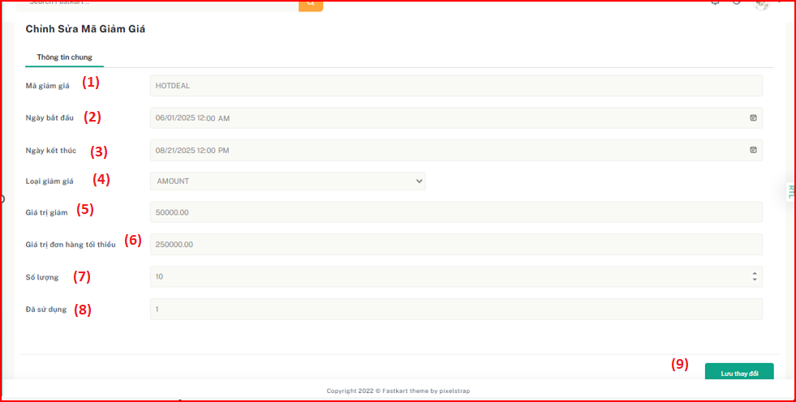

Figure 2.55 - Mockup for view update voucher use case

| **Field Name** | **Field Type** | **Description** |
| --- | --- | --- |
| (1) | VARCHAR | Input voucher code |
| (2) | DATETIME | Input start date |
| (3) | DATETIME | Input end date |
| (4) | DROPDOWN | Select discount type (PERCENT, AMOUNT) |
| (5) | NUMBER INPUT | Input discount value |
| (6) | NUMBER INPUT | Input min order value |
| (7) | NUMBER INPUT | Input voucher’s quantity |
| (8) | NUMBER INPUT | Input voucher’s used. |
| (9) | BUTTON | Button to submit form. |

Table 119 - Screen description for update voucher

**Use case specification**

| UC ID and Name: | **UC-59 Update voucher** | | |
| --- | --- | --- | --- |
| Created By: | ThanhHVHE186618 | Date Created: | 1/08/2025 |
| Primary Actor: | System Administrator | Secondary Actors: | None |
| Trigger: | The System Administrator wants to modify an existing voucher code. | | |
| Description: | This use case describes how a System Administrator updates an order discount's details, such as percentage, quantity, and status. | | |
| Preconditions: | The administrator must be logged into the system.  The voucher must be exist in system. | | |
| Postconditions: | The order discount details are updated successfully and recorded in the system. | | |
| Normal Flow: | **59.0 Update voucher**   1. The System Administrator navigates to the “Mã giảm giá” section. 2. The System Administrator selects an existing voucher code to update. 3. The system displays the Edit Voucher form with the current values pre-filled. 4. The System Administrator modifies the discount details (Giảm giá   % or amount, số lượng mã, trạng thái). | | |

|  | 1. The System Administrator click “ Lưu thay đổi” Button. 2. The system updates the voucher details in the database. |
| --- | --- |
| Alternative Flows: | * 1. **Update canceled**      1. If the System Administrator cancels the creation process, the system discards the input and returns to the vouchers list page.   2. **Enter invalid**      1. The system displays an error message indicating the invalid fields.      2. Return to the step 3 of Normal Flow. |
| Exceptions: | **59.0.E1 System error**  1. If a server error occurs, the system displays: "An error occurred. Please try again later." |
| Priority: | High - Essential for voucher management |
| Frequency of Use: | Regular - Used whenever voucher changes need to be reviewed |
| Business Rules: | BR_152 |
| Other Information: | None |
| Assumptions: | None |

Table 118 - Use case specification for view update voucher

## **15. Order Management**

### **15.1** **View List Order**

#### **Screen description**

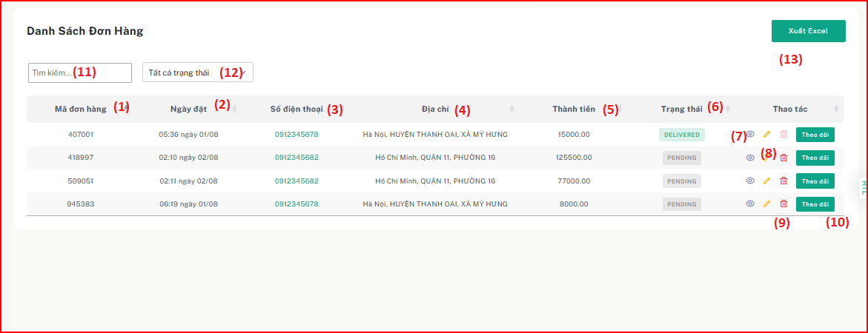

| **Field Name** | **Field Type** | **Description** |
| --- | --- | --- |
| (1) | NVARCHAR | Order code |
| (2) | DATETIME | Start date |
| (3) | NVARCHAR | Phone number |
| (4) | NVARCHAR | Address |
| (5) | NUMBER | Final amount |
| (6) | NVARCHAR | Order’s status |
| (7) | ICON BUTTON | Button to view order detail information. |
| (8) | ICON BUTTON | Button to edit order status. |
| (9) | ICON BUTTON | Button to cancel order. |
| (10) | BUTTON | Tracking order |
| (11) | TEXT INPUT | Search for an order by order code, status, address,.... |
| (12) | DROPDOWN | Filter vouchers by status. |
| (13) | BUTTON | Export data to excel. |

Table 113 - Screen description for view order list

**Use case specification**

| UC ID and Name: | **UC-57 View Order list** | | |
| --- | --- | --- | --- |
| Created By: | ThanhHVHE186618 | Date Created: | 1/08/2025 |
| Primary Actor: | System Administrator | Secondary Actors: | None |
| Trigger: | The System Administrator wants to view the list of available orders. | | |
| Description: | This use case describes how a System Administrator can view and filter the list of orders. | | |
| Preconditions: | The administrator must be logged into the system. | | |
| Postconditions: | The System Administrator successfully views the order list and may take further actions such as filtering, editing, or creating new order. | | |
| Normal Flow: | **57.0 View orders list**   1. The System Administrator navigates to the “Danh sách đơn hàng” section. 2. The system retrieves and displays a table containing all orders with relevant details (mã, ngày đặt, số điện thoại, địa chỉ, tổng giá trị đơn hàng ,trạng thái, thao tác). | | |
| Alternative Flows: | * 1. **Search for a order code**      1. The System Administrator types an order code or related keyword.      2. The system filters the orders list and displays matching results.      3. If no results are found, the system displays a "No matching records found" message.   2. **Filter orders by status**      1. The System Administrator chooses a status (pending, confirmed, stockout, delivered, completed or cancelled). | | |

|  | 1. The system updates the table to display only orders matching the selected status. 2. If no results match the filter, the system shows a "No records found" message. |
| --- | --- |
| Exceptions: | **57.0.E1 System error**  1. If a server error occurs, the system displays: "An error occurred. Please try again later." |
| Priority: | High - Essential for orders management |
| Frequency of Use: | Regular - Used whenever the System Administrator needs to monitor orders list. |
| Business Rules: | BR_153, BR_154 |
| Other Information: | None |
| Assumptions: | None |

Table 114 - Use case specification for view order list

### **15.2** **View Order Detail**

#### **Screen description**

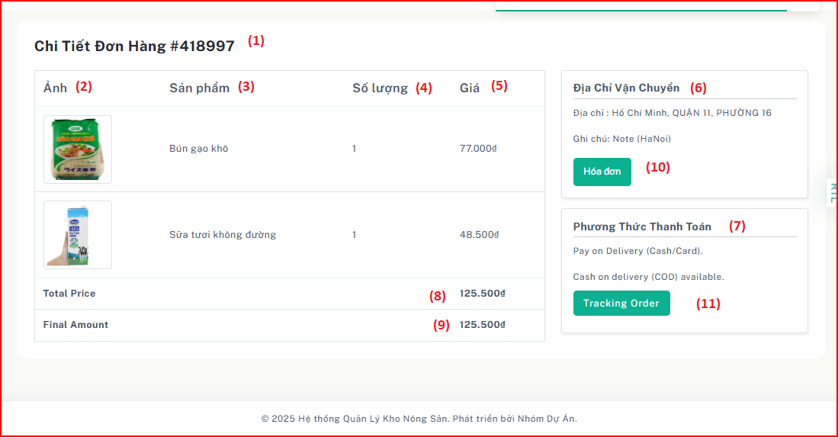

| **Field Name** | **Field Type** | **Description** |
| --- | --- | --- |
| (1) | NVARCHAR | Unique code identifying the order. |
| (2) | IMAGE | Display of the product’s image. |
| (3) | NVARCHAR | Name of the product. |
| (4) | NUMBER | Quantity of the product ordered. |
| (5) | NUMBER | Unit price of the product. |
| (6) | NVARCHAR | Address where the order will be delivered. |
| (7) | NVARCHAR | Method used for payment (e.g., QR code). |
| (8) | NUMBER | Total price before applying vouchers. |
| (9) | NUMBER | Final total after discounts or vouchers applied. |
| (10) | BUTTON | Open the invoice page. |
| (11) | BUTTON | Opens order tracking information. |

Table 113 - Screen description for view order detail

**Use case specification**

| UC ID and Name: | **UC-57 View Order Detail** | | |
| --- | --- | --- | --- |
| Created By: | ThanhHVHE186618 | Date Created: | 1/08/2025 |
| Primary Actor: | System Administrator | Secondary Actors: | None |
| Trigger: | The System Administrator wants to view detailed information of a specific order. | | |
| Description: | This use case describes how a System Administrator can view the details of an existing order in the system. | | |
| Preconditions: | The System Administrator is logged into the system.  The selected order exists in the system. | | |
| Postconditions: | The System Administrator successfully views the order details.  The administrator may choose to view the order invoice or track the order. | | |
| Normal Flow: | **57.0 View Order Detail**   1. The System Administrator navigates to the “Order List” section. 2. The system retrieves and displays all orders with key information: order code, order date, phone number, address, total price, status, and actions. 3. The Administrator selects an order and clicks the "View" (eye icon) button. 4. The system displays the order detail page with the following fields: order code, product image, product name, quantity, product price, shipping address, payment method, total price, final amount. 5. The page also includes action buttons: View Invoice and Track Order. | | |
| Alternative Flows: | * 1. **Search for a order code**      1. The System Administrator types an order code or related keyword.      2. The system filters the orders list and displays matching results.      3. If no results are found, the system displays a "No matching records found" message.   2. **Filter orders by status**      1. The System Administrator chooses a status (pending, confirmed, stockout, delivered, completed or cancelled). | | |

|  | 1. The system updates the table to display only orders matching the selected status. 2. If no results match the filter, the system shows a "No records found" message. |
| --- | --- |
| Exceptions: | **57.0.E1 System error**  1. If a server error occurs, the system displays: "An error occurred. Please try again later." |
| Priority: | High - Essential for orders management |
| Frequency of Use: | Regular - Used whenever the System Administrator needs to monitor order details. |
| Business Rules: | BR_155, BR_156, BR_157, BR_158, BR_159, BR_160, BR_161 |
| Other Information: | None |
| Assumptions: | None |

Table 114 - Use case specification for view order detail

### **15.3** **Update Order Status**

#### **Screen description**

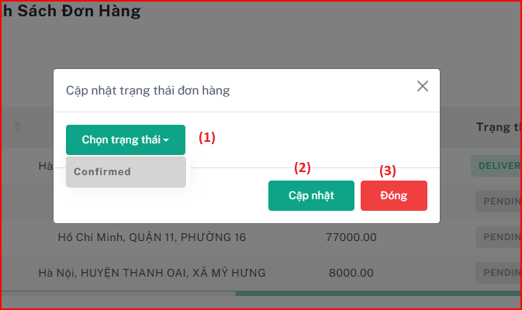

| **Field Name** | **Field Type** | **Description** |
| --- | --- | --- |
| (1) | DROPDOWN | Allows the user to select a new order status. |
| (2) | BUTTON | Apple the selected status to the order. |
| (3) | BUTTON | Close the modal without making changes. |

Table 113 - Screen description for update order status

**Use case specification**

| UC ID and Name: | **UC-57 Update Order Status** | | |
| --- | --- | --- | --- |
| Created By: | ThanhHVHE186618 | Date Created: | 1/08/2025 |
| Primary Actor: | System Administrator | Secondary Actors: | None |
| Trigger: | The System Administrator wants to update the status of a specific order. | | |
| Description: | This use case describes how a System Administrator can update order status. | | |
| Preconditions: | The System Administrator is logged into the system.  The selected order exists in the system. | | |
| Postconditions: | The System Administrator successfully updated in the system.  A success message is shown, and the list is refreshed. | | |
| Normal Flow: | **58.0 Update Order Status**   1. Admin clicks the update(pen icon) button corresponding to an order. 2. The system displays a modal with available status options (based on current state). 3. Admin selects a new status (e.g., Confirmed). 4. Admin clicks “Cập nhật” Button. 5. The system validates the transition and updates the order. | | |
| Alternative Flows: | **57.0.A1 No status selected and Click “Cancel” Button**   1. **Admin not select any status in dropdown.** 2. **Admin click “Huỷ” button.** 3. **Return step 1 of Normal Flow.** | | |

| Exceptions: | **57.0.E1 No status selected**   1. If the Administrator clicks the “Cập nhật” button without selecting a status, the system shows an error alert.   **57.0.E1 Unauthorized action**   1. If a user without an Admin role attempts to update the status, the system displays a warning:"Permission denied. You are not authorized to perform this action. |
| --- | --- |
| Priority: | High - Essential for orders management |
| Frequency of Use: | Regular - Used whenever the System Administrator needs to update order status. |
| Business Rules: | BR_162, BR_163, BR_164, BR_165 |
| Other Information: | None |
| Assumptions: | None |

Table 114 - Use case specification for update order status.

## 

## 

## 

## 

## **16. Forgot Password Management**

### **16.1 Forgot Password**

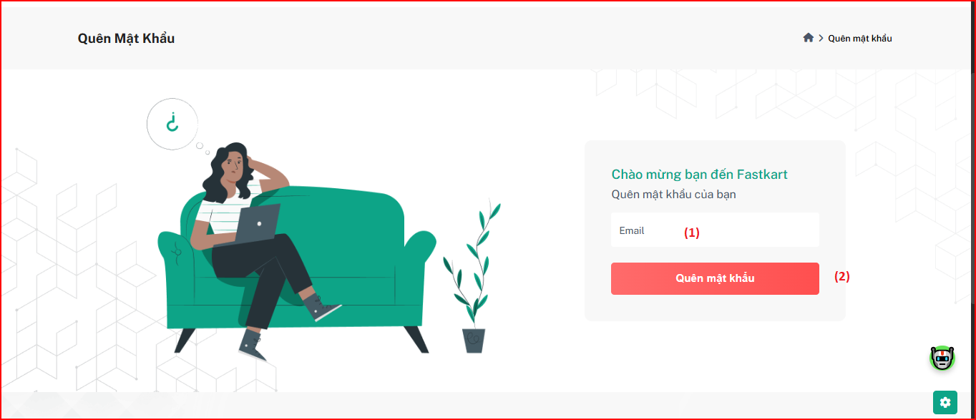

| **Field Name** | **Field Type** | **Description** |
| --- | --- | --- |
| (1) | TEXT INPUT | User’s email |
| (2) | BUTTON | Submits the email for OTP generation. |

Table 113 - Screen description for view order list

***Use case specification***

| UC ID and Name: | **UC-59: Forgot Password** | | |
| --- | --- | --- | --- |
| Created By: | ThanhHVHE186618 | Date Created: | 1/08/2025 |
| Primary Actor: | System Administrator | Secondary Actors: | None |
| Trigger: | User clicks “Quên mật khẩu” (Forgot Password) on the login page. | | |
| Description: | This use case allows a user to reset their password by requesting an OTP via email. | | |
| Preconditions: | User has an existing registered account in the system.  User is not currently logged in. | | |
| Postconditions: | If the email exists, an OTP is sent to that email address.  User is redirected to the OTP verification screen. | | |
| Normal Flow: | **59.0 Forgot Password**   1. User navigates to the "Forgot Password" page. 2. System displays a form with a single input: Email (1), and a button: "Quên mật khẩu" (2). 3. User enters their email address and clicks the "Quên mật khẩu" button. 4. System validates the email format. 5. System checks if the email exists in the system. 6. If valid, system generates an OTP and sends it to the provided email address. | | |
| Alternative Flows: | **59.A1 – Email Not Found**   * If the email does not exist in the system, system displays:  "Email not found!" | | |

| Exceptions: | **59.E1 – Invalid Email Format**   * If the email format is invalid, system displays:  "Invalid email format."   **59.E2 – System Error**   * If there is an internal server error, system displays:  "An error occurred. Please try again later." |
| --- | --- |
| Priority: | High - Critical for user account recovery. |
| Frequency of Use: | Used only when a user forgets their password. |
| Business Rules: | **BR_140**: The email must follow a valid email format (e.g., name@example.com).  **BR_141**: Only registered users are allowed to use the forgot password function.  **BR_142**: The OTP must be a 6-digit numeric code and valid for 5–10 minutes. |
| Other Information: | None |
| Assumptions: | None |

Table 114 - Use case specification for forgot password

### 

### 

### 

### **16.2 Verify OTP for Password Reset**

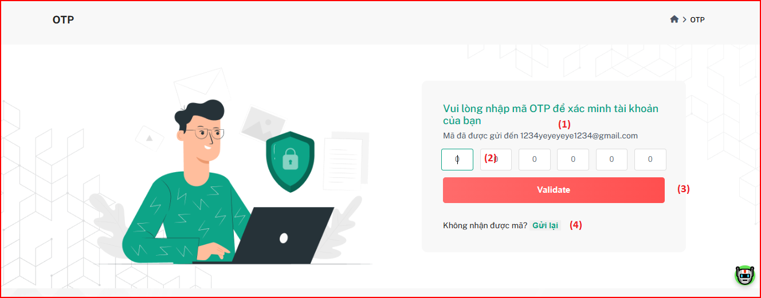

| **Field Name** | **Field Type** | **Description** |
| --- | --- | --- |
| (1) | VARCHAR | User’s email |
| (2) | CHAR | Input fields for the 6-digit OTP sent via email. |
| (3) | BUTTON | Button to submit and verify entered OTP |
| (4) | LINK | Link to resend OTP to user’s email address. |

Table 113 - Screen description for verify OTP

**Use case specification**

| UC ID and Name: | **UC-59: Forgot Password** | | |
| --- | --- | --- | --- |
| Created By: | ThanhHVHE186618 | Date Created: | 1/08/2025 |
| Primary Actor: | System Administrator | Secondary Actors: | None |
| Trigger: | User receives an OTP in their email and navigates to the OTP input screen to continue password reset. | | |
| Description: | This use case describes the steps a user follows to verify the OTP sent to their email during the password reset process. | | |
| Preconditions: | The user has submitted a valid registered email in the "Forgot Password" form.  The system has sent an OTP to the email address.  The OTP is valid (not expired or used). | | |
| Postconditions: | OTP is verified successfully.  System navigates the user to the "Change Password" page. | | |
| Normal Flow: | **60.0 Verify OTP for Password Reset**   1. The user see the OTP input form. 2. The user enter the 6-digits OTP sent via email 3. The user click “Validate” button 4. The system check:    1. Matches with generated code    2. Not expired 5. The system show the success message and redirect to “Change Password” page. | | |
| Alternative Flows: | **59.A1 Resend OTP**   * User click “Gửi lại” Button * The system send new OTP to email of user. * Return step 1 of Normal Flow | | |

| Exceptions: | **59. E1 Invalid OTP**   * If the OTP entered does not match: System shows: “Mã OTP không hợp lệ.”   **59. E2 OTP Expired**   * If the OTP is past its validity period: System shows: “Mã OTP đã hết hạn.”   **59. E2 Empty OTP Fields**   * If the user submits without entering a complete OTP: System displays: “Vui lòng nhập đầy đủ mã OTP.” |
| --- | --- |
| Priority: | High - Required for secure password recovery. |
| Frequency of Use: | Used only when a user reset password |
| Business Rules: | **BR_301:** OTP must be 6 digits, numeric. |
| Other Information: | None |
| Assumptions: | None |

Table 114 - Use case specification for verify OTP

### **16.3 Reset/Change Password**

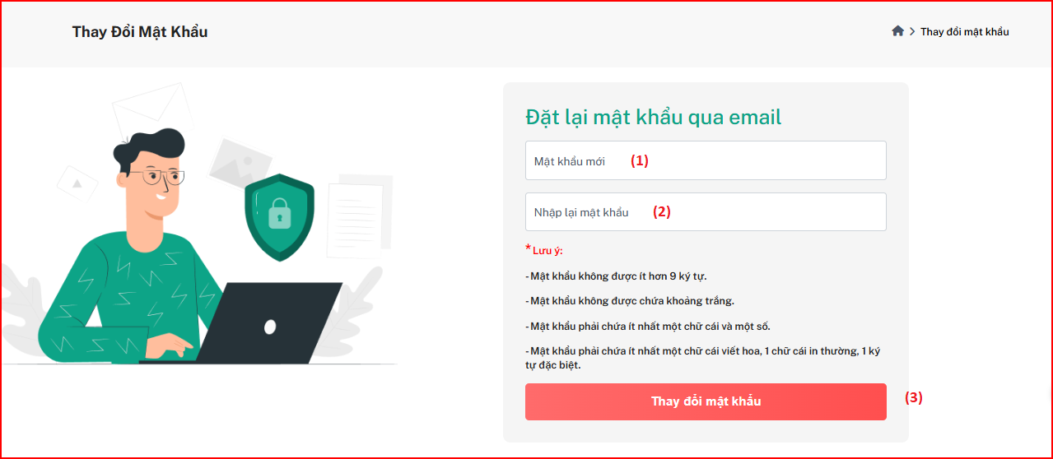

| **Field Name** | **Field Type** | **Description** |
| --- | --- | --- |
| (1) | VARCHAR | User enter new password |
| (2) | VARCHAR | User enter retype password. |
| (3) | BUTTON | Button to submit form. |

Table 113 - Screen description for reset password

**Use case specification**

| UC ID and Name: | **UC-61: Change Password** | | |
| --- | --- | --- | --- |
| Created By: | ThanhHVHE186618 | Date Created: | 1/08/2025 |
| Primary Actor: | System Administrator | Secondary Actors: | None |
| Trigger: | User want to reset their password. | | |
| Description: | This use case allow user change their password. | | |
| Preconditions: | - The user has successfully verified the OTP.  - The user is on the Change Password page. | | |
| Postconditions: | The system updates the password and displays a success message.  The user is redirected to the Forgot Password page. | | |
| Normal Flow: | **61.0**   1. User enter password, and retype password. 2. User click to “Thay đổi mật khẩu” Button 3. The system validates the password | | |
| Alternative Flows: | **61.0 A1 Password and retype password not matches**   1. If user enter password different with retype password, the system show the error message.   **61.1 A2 Invalid Password**   1. If password not valid, the system show the error message and prompt user to re-enter. | | |

| Exceptions: | **61.0.E1 System error**  1. If a server error occurs, the system displays: "An error occurred. Please try again later. |
| --- | --- |
| Priority: | High - Required for secure password recovery. |
| Frequency of Use: | Used only when a user reset password |
| Business Rules: | **BR_301:** Password must be at least 9 characters.  **BR_302:** Password must contain at least 1 lower character, 1 upper character, 1 special character.  **BR_303:** Password must not contain white space. |
| Other Information: | None |
| Assumptions: | None |

Table 114 - Use case specification for change password

### 

### 

## 

## 

## 

## 

## 

## **17.** **Contact User Management**

### **17.1** **View List Contact**

#### **Screen description**

## 

| **Field Name** | **Field Type** | **Description** |
| --- | --- | --- |
| (1) | NVARCHAR | User’s fullname |
| (2) | NVARCHAR | User's phone |
| (3) | NVARCHAR | User's email |
| (4) | NVARCHAR | User's message |
| (5) | BUTTON | Button to delete record |

| UC ID and Name: | **UC-64 View User Contact List** | | |
| --- | --- | --- | --- |
| Created By: | ThanhHVHE186618 | Date Created: | 1/08/2025 |
| Primary Actor: | Admin | Secondary  Actors: | N/A |
| Trigger: | The Admin wants to review the list of all user contact. | | |
| Description: | This use case describes the process by which the Admin views the list of all user contact in the system. The list provides detailed information such as full name, phone, email, and available actions for each user contact. | | |
| Preconditions: | * The Admin must be logged into the system with appropriate permissions. | | |
| Postconditions: | * The Admin is able to view a list of all user contact. * The system displays the list in a tabular format with user information and available actions such as delete. | | |

| Normal Flow: | **UC-64 View User Contact List**  The Admin navigates to the "Contact User" page.   1. The system loads and displays the list of all user contact in a table format. 2. The Admin views the following information for each user:    * Fullname    * Phone    * Email    * Message    * Action buttons (Delete) | | |
| --- | --- | --- | --- |

| Alternative Flows: | **No User Contact Found:  -** If there are no user contact in the system, the system displays a text: "No record found."  **System Error:** -If the system encounters an error while loading the list, it displays: "Unable to load user contact list. Please try again later."  - Admin can retry loading the list. |
| --- | --- |
| Exceptions: | **28.0.E1. Network Issue**   * The system fails to load due to a network error. * An error message is displayed to the Admin. |
| Priority: | High |
| Frequency of Use: | Daily or as needed for user contact management. |
| Business Rules: | BR-51, BR-52 |
| Other Information: | None |

Table 43 - Use case specification for view user contact list

## **18.** **Admin DashBoard Management**

### **18.1** **Admin DashBoard**

#### **Screen description**

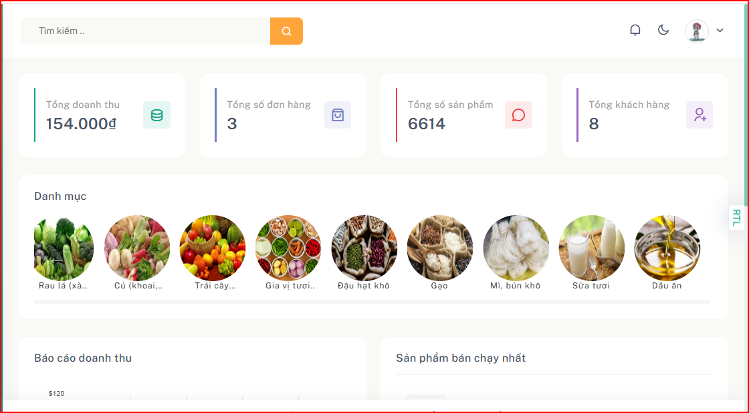

| **Field Name** | **Field Type** | **Description** |
| --- | --- | --- |
| (1) | Number | Total revenue |
| (2) | Number | Total Number of Orders |
| (3) | Number | Total products |
| (4) | Array | List categories |
| (5) | Array | List Best Selling Product |
| (6) | Array | List Recent Order |

***Use case specification***

| UC ID and Name: | **UC-31: View Admin Dashboard** | | |
| --- | --- | --- | --- |
| Created By: | ThanhHVHE186618 | Date Created: | 23/02/2025 |
| Primary Actor: | Admin | Secondary  Actors: | None |
| Trigger: | Admin accesses the system and navigates to the dashboard. | | |
| Description: | This use case allows the admin to view an overview of admin activity, such as list categories, list best selling product, … | | |
| Preconditions: | The user is logged in with appropriate permission.  Data has been recorded in the system. | | |
| Postconditions: | Admin can view statistic about product, category, order, user, revenue. | | |
| Normal Flow: | ***Normal Flow:***  **30.0 View Dashboard Overview**   1. Admin logs into the system. 2. Admin navigate to dashboard interface. | | |
| Alternative Flows | **(AF1) No Data Available**  – If there's no activity yet, the system displays placeholders or empty-state messages. | | |
| Exceptions: | **E1: Failed to Load Dashboard Data**  – If an error occurs while retrieving data, system displays error message. | | |
| Priority: | Daily | | |
| Frequency of Use: | Admin want to view dashboard overview. | | |
| Business Rules: |  | | |
| Other Information: |  | | |
| Assumptions: | The system backend is connected and responsive. | | |

### 

### 

### 

### 

### 

### 

### 

### 

### 

### **18.2 View latest notifications**

## 

| **Field Name** | **Field Type** | **Description** |
| --- | --- | --- |
| (1) | VARCHAR | Notification’s title |
| (2) | VARCHAR | Notification’s content. |
| (3) | BUTTON | Time notification created |
| (4) | BUTTON | Close button to remove notification. |
| (5) | BUTTON | Close button to mark all notifications is seen. |

Table 113 - Screen description for view list notifications

## 

**Use case specification**

| UC ID and Name: | **UC-61: View latest notifications** | | |
| --- | --- | --- | --- |
| Created By: | ThanhHVHE186618 | Date Created: | 1/08/2025 |
| Primary Actor: | System Administrator | Secondary Actors: | None |
| Trigger: | Admin wants to view list latest notifications. | | |
| Description: | This use case describes the process by which the system administrator views a list of the latest notifications from the admin dashboard interface.. | | |
| Preconditions: | The admin logged into the system.  The system successfully loads and displays the list of latest notifications.  The administrator can:   * View each notification, * Select a notification to view its details, * Click a button to remove a notification. | | |
| Postconditions: | The system load success and show the list latest notifications.  Admin can view and can select view notification detail or click to remove button. | | |
| Normal Flow: | **62.0**   1. Admin log in to system and in the admin dashboard interface. 2. Admin click to bell icon in header section. 3. The system retrieves the list of latest notifications. 4. The system displays the notifications to the admin. | | |
| Alternative Flows: | **1: Mark All as Read**   1. Admin is logged into the system. 2. Admin clicks the bell icon to view the list of notifications. 3. Admin clicks the “Mark All as Read” button (“Đánh dấu tất cả đã đọc”). 4. The system updates the status of all notifications to "read". 5. Return to Step 3 of the Normal Flow.   **A2: No Available Notifications**   1. Admin is logged into the system. 2. Admin clicks the bell icon to view the list of notifications. 3. The system displays the message: “Không tìm thấy bản ghi nào” (“No records found”). | | |

| Exceptions: | **62.0.E1 System error**  1. If a server error occurs, the system displays: "An error occurred. Please try again later. |
| --- | --- |
| Priority: | High - This functionality is required for the admin to view notifications. |
| Frequency of Use: | Used whenever the admin wants to check notifications (likely multiple times daily).. |
| Business Rules: | * Notifications must be ordered by timestamp descending. * Notification count badge updates in real-time. * Admin may access all notifications. * Archived notifications are excluded. |
| Other Information: | None |
| Assumptions: | None |

Table 114 - Use case specification for view latest notifications

## **19.** **Warehouse DashBoard**

### **19.1** **Warehouse DashBoard**

#### **Screen description**

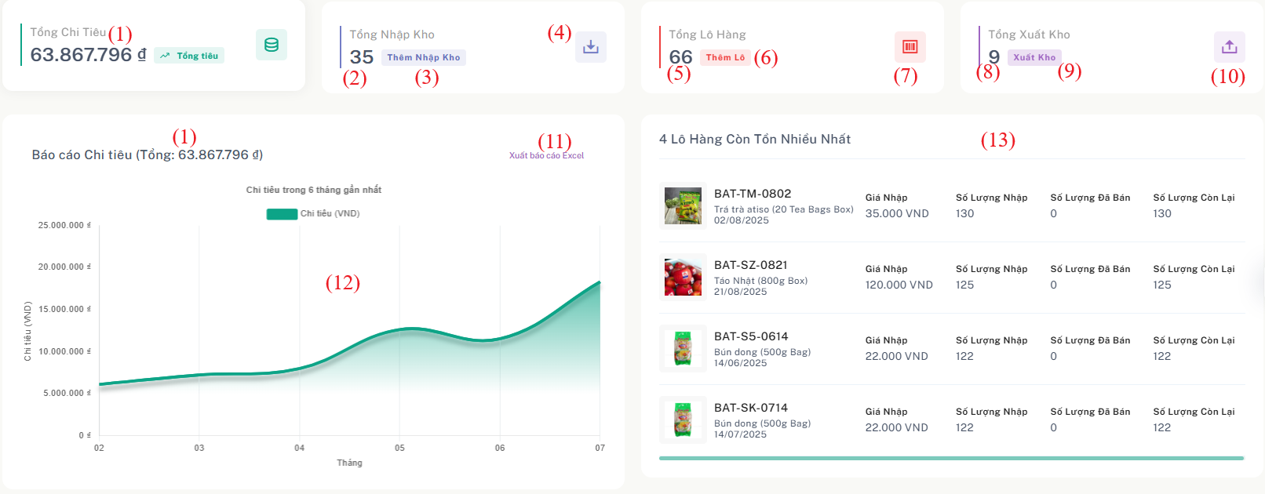

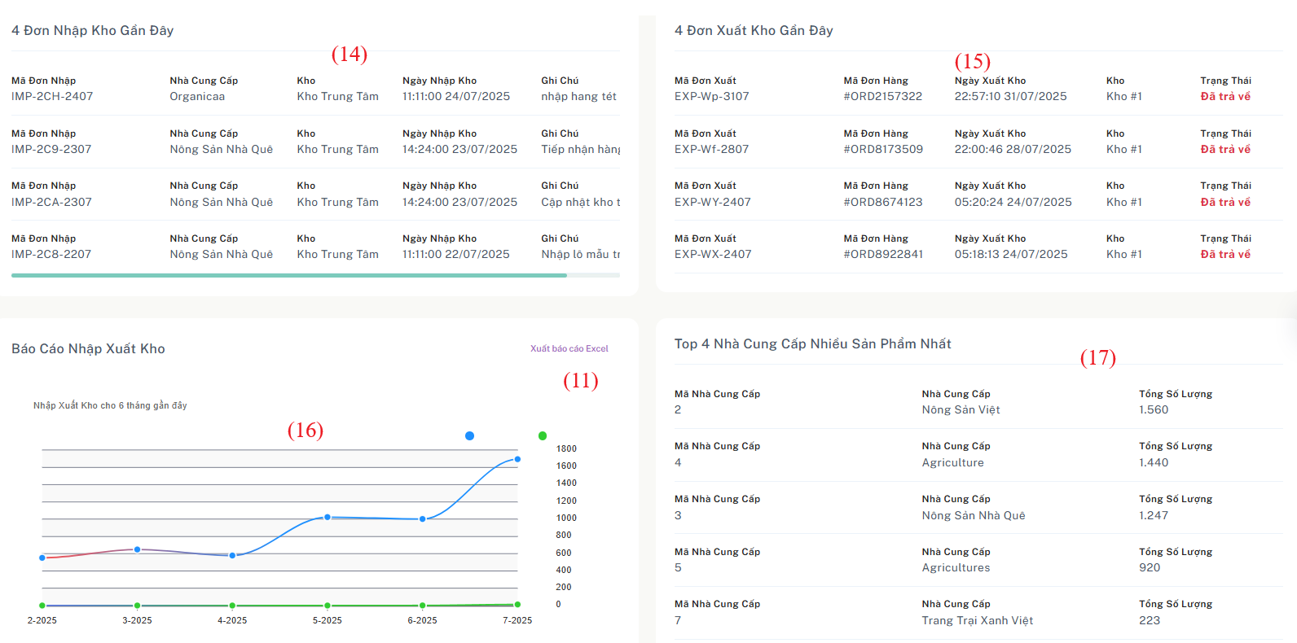

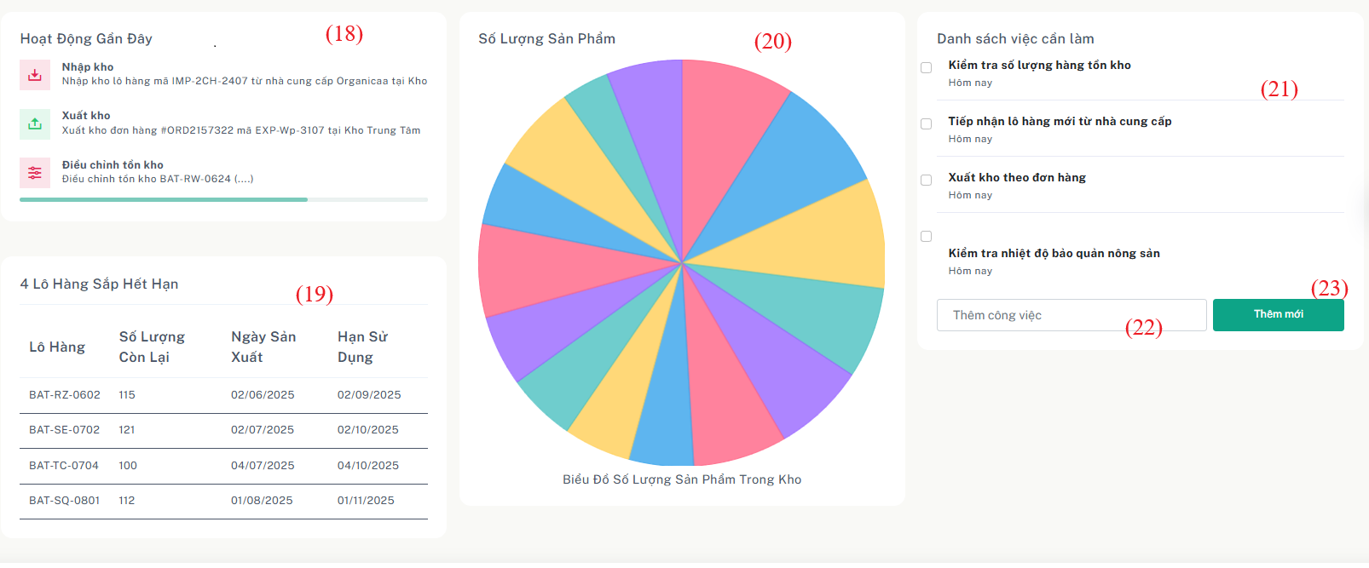

Figure 2.55 - Mockup for view update voucher use case

| **Field Name** | **Field Type** | **Description** |
| --- | --- | --- |
| (1) | Number | Total Spending |
| (2) | Number | Total Number of Stock-In Records |
| (3) | Button | Navigate to "Create New Stock-In" Page |
| (4) | Button | Navigate to "Stock-In List" Page |
| (5) | Number | Total Quantity of Product Batches |
| (6) | Button | Add New Product Batch |
| (7) | Button | Navigate to "Product Batch List" Page |
| (8) | Number | Total Number of Stock-Out Records |
| (9) | Button | Navigate to "Create New Stock-Out" Page |
| (10) | Button | Navigate to "Stock-Out List" Page |
| (11) | Button | Export Data to Excel |
| (12) | Chart | Spending Report Chart |
| (13) | Data Table | Top 4 Batches with Highest Remaining Stock |
| (14) | Data Table | Top 4 Most Recent Stock-In Orders |
| (15) | Data Table | Top 4 Most Recent Stock-Out Orders |
| (16) | Chart | Stock-In/Out Quantity Chart |
| (17) | Data Table | Top 4 nha cung cap nhieu nhat |
| (18) | Data Table | Top 4 Most Frequent Suppliers |
| (19) | Data Table | Product Batches Approaching Expiry |
| (20) | Chart | Product Detail Quantity Chart |
| (21) | Text | Daily Tasks |
| (22) | Text Input | Input New Task for To-Do List |
| (23) | Button | Add New Task to To-Do List |

Table 53 - Screen description for view list warehouse receipts

***Use case specification***

| UC ID and Name: | **UC-31: View Warehouse Dashboard** | | |
| --- | --- | --- | --- |
| Created By: | QuangDNHE186891 | Date Created: | 1/08/2025 |
| Primary Actor: | Warehouse Manager | Secondary  Actors: |  |
| Trigger: | Warehouse Manager accesses the system and navigates to the dashboard. | | |
| Description: | This use case allows the warehouse manager to view an overview of warehouse activity, such as spending, stock-in/out statistics, top suppliers, product batches nearing expiry, and perform quick navigation actions (e.g., add stock-in/out, export data). | | |
| Preconditions: | The user is logged in with appropriate permission.  Warehouse data has been recorded in the system. | | |
| Postconditions: | User views updated dashboard statistics.  Optional navigation or actions (e.g., export, create) can be performed from the dashboard. | | |
| Normal Flow: | ***Normal Flow:***  **30.0 View Dashboard Overview**   1. Warehouse Manager logs into the system. 2. User navigates to the dashboard from the navigation menu. 3. System displays:    * Total Spending    * Total Stock-In / Stock-Out records Product Batch count    * Top 4 suppliers    * Top 4 recent stock-in / stock-out orders    * Top 4 product batches with highest remaining stock    * Top batches nearing expiry    * Quantity chart of product details    * Stock movement chart (in/out)    * Action logs of warehouse manager    * Daily task list (with input and add new) 4. User may click any of the following buttons:    * “Create New Stock-In” / “Create New Stock-Out”    * Navigate to Stock-In List / Stock-Out List / Product Batch List    * Add New Product Batch    * Export to Excel    * Add task to to-do list 5. The system performs the selected action or updates the view accordingly. | | |
| Alternative Flows | **(AF1) No Data Available**  – If there's no warehouse activity yet, the system displays placeholders or empty-state messages.  **(AF2) Task List Empty**  – If the daily to-do list is empty, the system shows a message like “No tasks yet. Add a new task.” | | |
| Exceptions: | **E1: Failed to Load Dashboard Data**  – If an error occurs while retrieving data, system displays: | | |
| Priority: | Daily | | |
| Frequency of Use: | Moderate – often used during stock-in entry corrections. | | |
| Business Rules: | BR-07 | | |
| Other Information: | Dashboard charts and tables are interactive (hover for details).  Task list persists until the user marks a task as done. | | |
| Assumptions: | The system backend is connected and responsive  All dashboard charts are derived from accurate and up-to-date stock data.  Users can only view data from their authorized warehouse scope. | | |

# **III. System Design**

## **1. Database Design**

### **1.1 Database Schema**

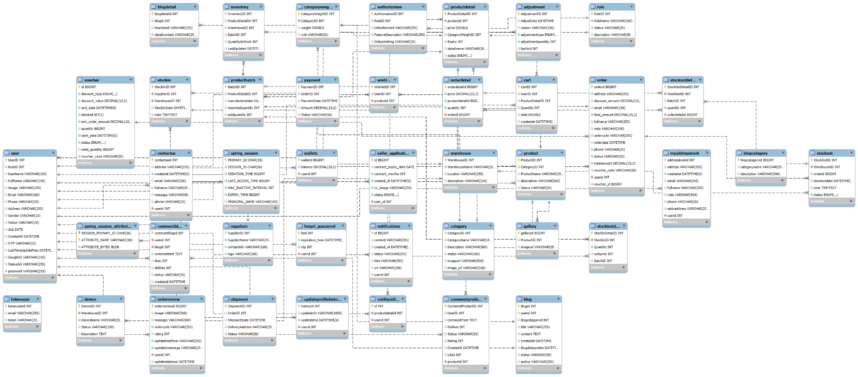

### 

### **1.2 Database ERD**

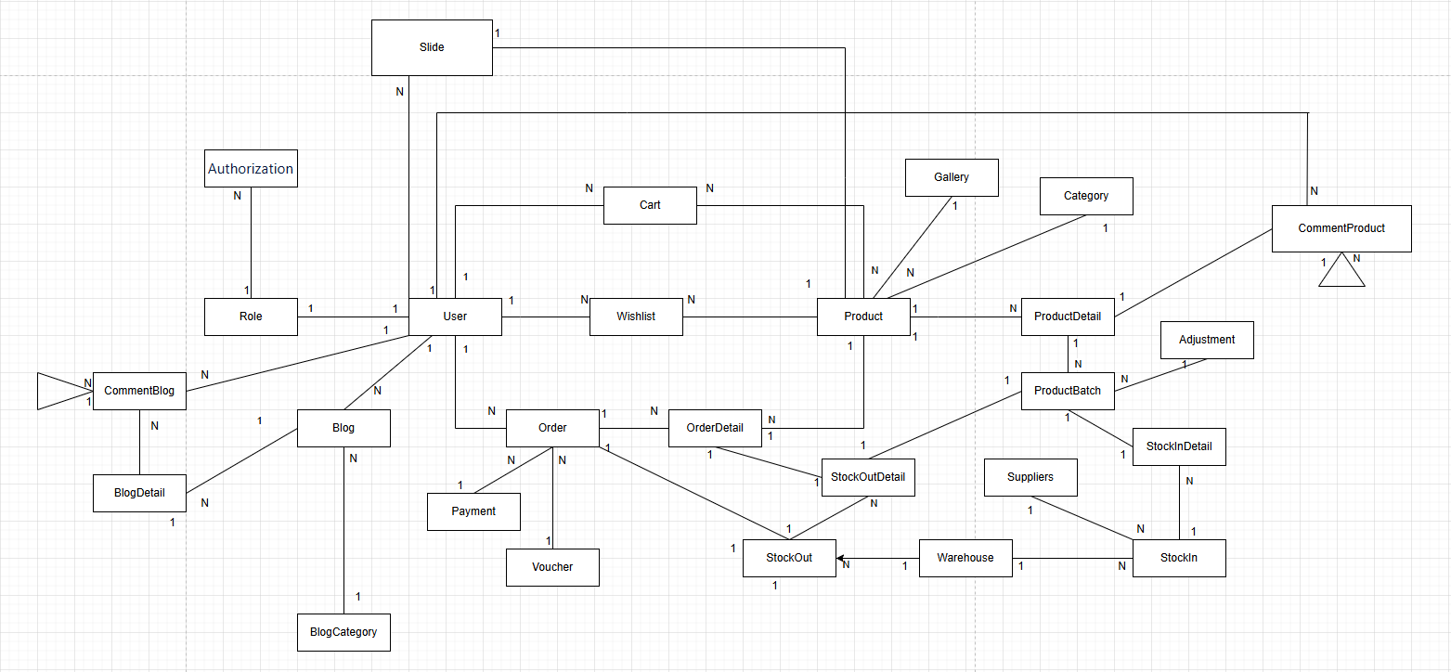

### 

### 

### 

### 

### 

### **1.3 Table Descriptions**

| **STT** | **Table Name** | **Description** | **Primary Keys** | **Foreign Keys** | **Unique Keys** |
| --- | --- | --- | --- | --- | --- |
| 1 | User | Stores user account details | UserID | RoleID | Username / Email (giả định) |
| 2 | Role | Defines roles like Admin, Customer... | RoleID | – | RoleName |
| 3 | Authorization | Permissions linked to a role | AuthorizationID | RoleID | RoleID + PermissionType (giả định) |
| 4 | Product | Product-level info | ProductID | CategoryID | ProductCode / ProductName |
| 5 | Category | Product categories | CategoryID | – | CategoryName |
| 6 | ProductDetail | Variants/details for a product | ProductDetailID | ProductID | ProductID + Variant (giả định) |
| 7 | ProductBatch | Tracks individual product batches | BatchID | ProductDetailID | BatchCode |
| 8 | Adjustment | Inventory adjustments | AdjustmentID | BatchID | – |
| 9 | StockIn | Stock receiving record | StockInID | WarehouseID, SupplierID | StockInCode (giả định) |
| 10 | StockInDetail | Details of received stock per batch | StockInDetailID | StockInID, BatchID | – |
| 11 | StockOut | Items moved out of inventory | StockOutID | WarehouseID | StockOutCode (giả định) |
| 12 | StockOutDetail | Details of each product batch removed | StockOutDetailID | StockOutID, BatchID, OrderID | – |
| 13 | Suppliers | Suppliers of products | SupplierID | – | SupplierName / Phone |
| 14 | Warehouse | Warehouses holding stock | WarehouseID | – | WarehouseName |
| 15 | Order | Customer orders | OrderID | UserID, VoucherID | OrderCode (giả định) |
| 16 | OrderDetail | Order item lines | OrderDetailID | OrderID, ProductID | – |
| 17 | Voucher | Discount vouchers | VoucherID | – | VoucherCode |
| 18 | Payment | Payment transactions | PaymentID | OrderID | TransactionCode (giả định) |
| 19 | Cart | Products added to cart by user | CartID | UserID, ProductID | UserID + ProductID (giả định) |
| 20 | Wishlist | User wishlist items | WishlistID | UserID, ProductID | UserID + ProductID (giả định) |
| 21 | CommentProduct | Comments on products | CommentProductID | UserID, ProductID | – |
| 22 | Slide | Carousel or homepage banners | SlideID | ProductID | – |
| 23 | Gallery | Product images | GalleryID | ProductID | – |
| 24 | Blog | Blog articles | BlogID | UserID, BlogCategoryID | – |
| 25 | BlogCategory | Blog categories | BlogCategoryID | – | CategoryName |
| 26 | BlogDetail | Blog content detail | BlogDetailID | BlogID | – |
| 27 | CommentBlog | User comments on blogs | CommentBlogID | UserID, BlogID | – |

## 

## 

## 

## 

## 

## 

## 

## **2. Code Packages**

### **2.1 Package Diagram**

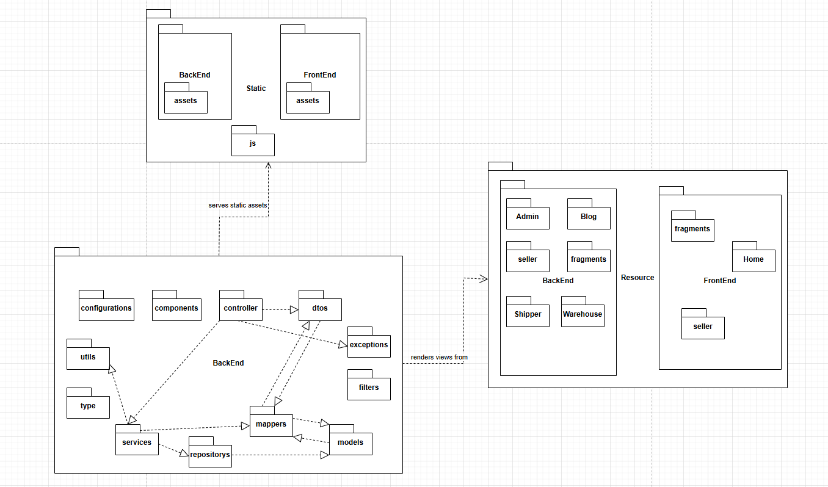

### **2.2 Package Descriptions**

| **No** | **Package** | **Description** |
| --- | --- | --- |
| 01 | BackEnd.configurations | Contains global configurations such as security settings, CORS, and shared beans. |
| 02 | BackEnd.components | Helper components that support controllers or services, e.g., converters or utility beans. |
| 03 | BackEnd.controllers | Handles HTTP requests, interacts with services, and returns responses (JSON or views). |
| 04 | BackEnd.dtos | Data Transfer Objects used for communication between layers. |
| 05 | BackEnd.exceptions | Global exception handling and custom-defined error classes. |
| 06 | BackEnd.filters | Request filters such as JWT authentication, CORS, and logging. |
| 07 | BackEnd.models | Entity classes that map to database tables. |
| 08 | BackEnd.mappers | Classes for converting between models and dtos. |
| 09 | BackEnd.repositories | Interface with the database using JPA or JDBC. |
| 10 | BackEnd.services | Contains core business logic, invokes repositories, and handles validations. |
| 11 | BackEnd.type | Enumeration types for status, roles, and other constants. |
| 12 | BackEnd.utils | Utility classes for common operations like date or string handling. |
| 13 | static | Contains static frontend resources such as JavaScript, images, and CSS. |
| 14 | resource.BackEnd | Server-side rendered views for Admin, Seller, Shipper, Warehouse, Blog, etc. |
| 15 | resource.FrontEnd | Frontend public views such as homepage, seller landing page, and shared fragments. |